UNITED STATES
SECURITIES AND EXCHANGE COMMISSION
WASHINGTON, D.C. 20549
FORM 10-Q
(Mark One)
☒ |  |  | QUARTERLY REPORT PURSUANT TO SECTION 13 OR 15(d) OF THE SECURITIES EXCHANGE ACT OF 1934
For The Quarterly Period Ended June 30, 2026
☐ |  |  | TRANSITION REPORT PURSUANT TO SECTION 13 OR 15(d) OF THE SECURITIES EXCHANGE ACT OF 1934
For the transition period from to

Commission File No. 001-38609
KLX Energy Services Holdings, Inc.
(Exact name of registrant as specified in its charter)
Delaware |  |  | 36-4904146
(State of Incorporation) |  |  | (I.R.S. Employer Identification No.)

3040 Post Oak Boulevard, 15th Floor
Houston, TX 77056
(832) 844-1015

(Address, including zip code, and telephone number, including area code, of principal executive offices of registrant)

Securities registered pursuant to Section 12(b) of the Act:
Title of Each Class |  |  |  |  |  | Trading Symbol(s) |  |  |  |  |  | Name of Each Exchange on Which Registered
Common Stock, $0.01 Par Value |  |  |  |  |  | KLXE |  |  |  |  |  | The Nasdaq Global Select Market

Indicate by check mark whether the registrant (1) has filed all reports required to be filed by Section 13 or 15(d) of the Securities Exchange Act of 1934 during the preceding 12 months (or for such shorter period that the registrant was required to file such reports), and (2) has been subject to such filing requirements for the past 90 days. Yes ☒ No ☐

Indicate by check mark whether the registrant has submitted electronically every Interactive Data File required to be submitted pursuant to Rule 405 of Regulation S-T (§232.405 of this chapter) during the preceding 12 months (or for such shorter period that the registrant was required to submit such files). Yes ☒ No ☐

Indicate by check mark whether the registrant is a large accelerated filer, an accelerated filer, a non-accelerated filer, a smaller reporting company, or an emerging growth company. See the definitions of “large accelerated filer,” “accelerated filer,” “smaller reporting company,” and “emerging growth company” in Rule 12b-2 of the Exchange Act.
Large accelerated filer |  |  |  |  |  | ☐ |  |  |  |  |  | Accelerated filer |  |  |  |  |  | ☐
Non-accelerated filer |  |  |  |  |  | ☒ |  |  |  |  |  | Smaller reporting company |  |  |  |  |  | ☒
 |  |  |  |  |  |  |  |  |  |  |  | Emerging growth company |  |  |  |  |  | ☐

If an emerging growth company, indicate by check mark if the registrant has elected not to use the extended transition period for complying with any new or revised financial accounting standards provided pursuant to Section 13(a) of the Exchange Act. ☐

Indicate by check mark whether the registrant is a shell company (as defined in Rule 12b-2 of the Exchange Act). Yes ☐ No ☒

The registrant has one class of common stock, $0.01 par value, of which 21,273,059 shares were outstanding as of July 31, 2026.

Table of Contents
KLX Energy Services Holdings, Inc.
Form 10-Q
Table of Contents
PART I - FINANCIAL INFORMATION |  |  |  |  |  | 3
 |  |  | Item 1. Condensed Consolidated Financial Statements (Unaudited) |  |  | 3
 |  |  | Balance Sheets as of June 30, 2026 and December 31, 2025 |  |  | 3
 |  |  | Statements of Operations for the Three and Six Months Ended June 30, 2026 and 2025 |  |  | 4
 |  |  | Statements of Stockholders' Equity for the Six Months Ended June 30, 2026 and 2025 |  |  | 5
 |  |  | Statements of Cash Flows for the Six Months Ended June 30, 2026 and 2025 |  |  | 6
 |  |  | Notes to Condensed Consolidated Financial Statements |  |  | 7
 |  |  | Item 2. Management’s Discussion and Analysis of Financial Condition and Results of Operations |  |  | 25
 |  |  | Item 3. Quantitative and Qualitative Disclosures About Market Risk |  |  | 41
 |  |  | Item 4. Controls and Procedures |  |  | 41
PART II - OTHER INFORMATION |  |  |  |  |  | 42
 |  |  | Item 1. Legal Proceedings |  |  | 42
 |  |  | Item 1A. Risk Factors |  |  | 42
 |  |  | Item 2. Unregistered Sales of Equity Securities and Use of Proceeds |  |  | 43
 |  |  | Item 3. Defaults Upon Senior Securities |  |  | 44
 |  |  | Item 4. Mine Safety Disclosures |  |  | 44
 |  |  | Item 5. Other Information |  |  | 45
 |  |  | Item 6. Exhibits |  |  | 45
SIGNATURES |  |  |  |  |  | 46

2
Table of Contents
PART 1 – FINANCIAL INFORMATION

ITEM 1. CONDENSED CONSOLIDATED FINANCIAL STATEMENTS

KLX Energy Services Holdings, Inc.
Condensed Consolidated Balance Sheets
(In millions of U.S. dollars and shares, except per share data)
 |  |  | June 30, 2026 |  |  |  |  |  | December 31, 2025
 |  |  | (Unaudited)
ASSETS
Current assets:
Cash and cash equivalents |  |  | $ | 7.9 |  |  |  |  | $ | 5.7
Accounts receivable–trade, net of allowance for credit losses of $1.9 and $1.7 |  |  | 121.9 |  |  |  |  |  | 102.7
Inventories, net |  |  | 32.0 |  |  |  |  |  | 30.7
Prepaid expenses and other current assets |  |  | 17.1 |  |  |  |  |  | 10.8
Total current assets |  |  | 178.9 |  |  |  |  |  | 149.9
Property and equipment, net |  |  | 164.8 |  |  |  |  |  | 161.1
Operating lease assets |  |  | 21.7 |  |  |  |  |  | 22.3
Intangible assets, net |  |  | 0.9 |  |  |  |  |  | 1.1
Other assets |  |  | 5.6 |  |  |  |  |  | 5.9
Total assets |  |  | $ | 371.9 |  |  |  |  | $ | 340.3
LIABILITIES AND STOCKHOLDERS’ EQUITY
Current liabilities:
Accounts payable |  |  | $ | 77.3 |  |  |  |  | $ | 68.7
Accrued interest |  |  | 0.5 |  |  |  |  |  | 0.4
Accrued liabilities |  |  | 47.7 |  |  |  |  |  | 26.0
Current portion of long-term debt |  |  | 4.6 |  |  |  |  |  | 4.4
Current portion of operating lease liabilities |  |  | 7.5 |  |  |  |  |  | 7.1
Current portion of finance lease liabilities |  |  | 14.0 |  |  |  |  |  | 19.6
Total current liabilities |  |  | 151.6 |  |  |  |  |  | 126.2
Long-term debt |  |  | 284.3 |  |  |  |  |  | 253.9
Long-term operating lease liabilities |  |  | 15.3 |  |  |  |  |  | 15.9
Long-term finance lease liabilities |  |  | 17.3 |  |  |  |  |  | 17.4
Other non-current liabilities |  |  | 5.8 |  |  |  |  |  | 1.1
Commitments, contingencies and off-balance sheet arrangements (Note 7)
Stockholders’ equity:
Common stock, $0.01 par value; 110.0 authorized; 21.6 and 18.9 issued |  |  | 0.2 |  |  |  |  |  | 0.2
Additional paid-in capital |  |  | 575.7 |  |  |  |  |  | 571.3
Treasury stock, at cost, 0.6 shares and 0.5 shares |  |  | (6.4) |  |  |  |  |  | (6.2)
Accumulated deficit |  |  | (671.9) |  |  |  |  |  | (639.5)
Total stockholders’ deficit |  |  | (102.4) |  |  |  |  |  | (74.2)
Total liabilities and stockholders’ deficit |  |  | $ | 371.9 |  |  |  |  | $ | 340.3
See accompanying notes to condensed consolidated financial statements.

3
Table of Contents
KLX Energy Services Holdings, Inc.
Condensed Consolidated Statements of Operations
(In millions of U.S. dollars, except per share data)
(Unaudited)
 |  |  | Three Months Ended |  |  |  |  |  |  |  |  |  |  |  | Six Months Ended
 |  |  | June 30, 2026 |  |  |  |  |  | June 30, 2025 |  |  |  |  |  | June 30, 2026 |  |  |  |  |  | June 30, 2025
Revenues |  |  | $ | 167.3 |  |  |  |  | $ | 159.0 |  |  |  |  | $ | 312.0 |  |  |  |  | $ | 313.0
Costs and expenses:
Cost of sales |  |  | 130.9 |  |  |  |  |  | 125.6 |  |  |  |  |  | 250.0 |  |  |  |  |  | 249.4
Depreciation and amortization |  |  | 20.8 |  |  |  |  |  | 23.7 |  |  |  |  |  | 42.7 |  |  |  |  |  | 48.4
Selling, general and administrative |  |  | 19.0 |  |  |  |  |  | 18.0 |  |  |  |  |  | 34.4 |  |  |  |  |  | 39.6
Research and development costs |  |  | 0.5 |  |  |  |  |  | 0.4 |  |  |  |  |  | 0.9 |  |  |  |  |  | 0.8
Impairment and other charges |  |  | 0.5 |  |  |  |  |  | — |  |  |  |  |  | 0.5 |  |  |  |  |  | —
Bargain purchase gain |  |  | (6.5) |  |  |  |  |  | — |  |  |  |  |  | (6.5) |  |  |  |  |  | —
Operating income (loss) |  |  | 2.1 |  |  |  |  |  | (8.7) |  |  |  |  |  | (10.0) |  |  |  |  |  | (25.2)
Non-operating expense:
Interest income |  |  | (0.0) |  |  |  |  |  | (0.0) |  |  |  |  |  | (0.0) |  |  |  |  |  | (0.3)
Interest expense |  |  | 12.5 |  |  |  |  |  | 11.0 |  |  |  |  |  | 24.2 |  |  |  |  |  | 21.3
(Gain) loss on debt extinguishment |  |  | (0.3) |  |  |  |  |  | — |  |  |  |  |  | (0.3) |  |  |  |  |  | 1.2
Net loss before income tax |  |  | (10.1) |  |  |  |  |  | (19.7) |  |  |  |  |  | (33.9) |  |  |  |  |  | (47.4)
Income tax (benefit) expense |  |  | (1.7) |  |  |  |  |  | 0.2 |  |  |  |  |  | (1.5) |  |  |  |  |  | 0.4
Net loss |  |  | $ | (8.4) |  |  |  |  | $ | (19.9) |  |  |  |  | $ | (32.4) |  |  |  |  | $ | (47.8)
Net loss per share-basic |  |  | $ | (0.41) |  |  |  |  | $ | (1.04) |  |  |  |  | $ | (1.62) |  |  |  |  | $ | (2.63)
Net loss per share-diluted |  |  | $ | (0.41) |  |  |  |  | $ | (1.04) |  |  |  |  | $ | (1.62) |  |  |  |  | $ | (2.63)

See accompanying notes to condensed consolidated financial statements.

4
Table of Contents
KLX Energy Services Holdings, Inc.
Condensed Consolidated Statements of Stockholders' Equity
Six Months Ended June 30, 2026 and June 30, 2025
(In millions of U.S. dollars and shares)
(Unaudited)
 |  |  | Common Stock |  |  |  |  |  |  |  |  |  |  |  | Additional Paid-in Capital |  |  |  |  |  | Treasury Stock |  |  |  |  |  | Accumulated Deficit |  |  |  |  |  | Total Stockholders’ Equity
 |  |  | Shares |  |  |  |  |  | Amount
Balance at December 31, 2025 |  |  | 18.9 |  |  |  |  |  | $ | 0.2 |  |  |  |  | $ | 571.3 |  |  |  |  | $ | (6.2) |  |  |  |  | $ | (639.5) |  |  |  |  | $ | (74.2)
Restricted stock, net of forfeitures |  |  | (0.1) |  |  |  |  |  | 0.0 |  |  |  |  |  | 0.3 |  |  |  |  |  | — |  |  |  |  |  | — |  |  |  |  |  | 0.3
Purchase of treasury stock |  |  | — |  |  |  |  |  | — |  |  |  |  |  | — |  |  |  |  |  | (0.2) |  |  |  |  |  | — |  |  |  |  |  | (0.2)
Issuance of common stock, net of cost |  |  | 0.4 |  |  |  |  |  | 0.0 |  |  |  |  |  | — |  |  |  |  |  | — |  |  |  |  |  | — |  |  |  |  |  | 0.0
Issuance of warrants |  |  | — |  |  |  |  |  | — |  |  |  |  |  | 2.0 |  |  |  |  |  | — |  |  |  |  |  | — |  |  |  |  |  | 2.0
Exercise of warrants |  |  | 1.3 |  |  |  |  |  | 0.0 |  |  |  |  |  | — |  |  |  |  |  | — |  |  |  |  |  | — |  |  |  |  |  | 0.0
Net loss |  |  | — |  |  |  |  |  | — |  |  |  |  |  | — |  |  |  |  |  | — |  |  |  |  |  | (24.0) |  |  |  |  |  | (24.0)
Balance at March 31, 2026 |  |  | 20.5 |  |  |  |  |  | 0.2 |  |  |  |  |  | 573.6 |  |  |  |  |  | (6.4) |  |  |  |  |  | (663.5) |  |  |  |  |  | (96.1)
Restricted stock, net of forfeitures |  |  | (0.0) |  |  |  |  |  | 0.0 |  |  |  |  |  | 0.5 |  |  |  |  |  | — |  |  |  |  |  | — |  |  |  |  |  | 0.5
Issuance of common stock, net of cost |  |  | 0.7 |  |  |  |  |  | 0.0 |  |  |  |  |  | 1.6 |  |  |  |  |  | — |  |  |  |  |  | — |  |  |  |  |  | 1.6
Exercise of warrants |  |  | 0.4 |  |  |  |  |  | 0.0 |  |  |  |  |  | — |  |  |  |  |  | — |  |  |  |  |  | — |  |  |  |  |  | 0.0
Net loss |  |  | — |  |  |  |  |  | — |  |  |  |  |  | — |  |  |  |  |  | — |  |  |  |  |  | (8.4) |  |  |  |  |  | (8.4)
Balance at June 30, 2026 |  |  | 21.6 |  |  |  |  |  | $ | 0.2 |  |  |  |  | $ | 575.7 |  |  |  |  | $ | (6.4) |  |  |  |  | $ | (671.9) |  |  |  |  | $ | (102.4)
 |  |  | Common Stock |  |  |  |  |  |  |  |  |  |  |  | Additional Paid-in Capital |  |  |  |  |  | Treasury  Stock |  |  |  |  |  | Accumulated  Deficit |  |  |  |  |  | Total Stockholders’Equity
 |  |  | Shares |  |  |  |  |  | Amount
Balance at December 31, 2024 |  |  | 17.5 |  |  |  |  |  | $ | 0.2 |  |  |  |  | $ | 557.5 |  |  |  |  | $ | (5.8) |  |  |  |  | $ | (562.4) |  |  |  |  | $ | (10.5)
Restricted stock, net of forfeitures |  |  | — |  |  |  |  |  | — |  |  |  |  |  | 0.8 |  |  |  |  |  | — |  |  |  |  |  | — |  |  |  |  |  | 0.8
Purchase of treasury stock |  |  | — |  |  |  |  |  | — |  |  |  |  |  | — |  |  |  |  |  | (0.4) |  |  |  |  |  | — |  |  |  |  |  | (0.4)
Issuance of common stock, net of cost |  |  | 0.6 |  |  |  |  |  | 0.0 |  |  |  |  |  | 0.4 |  |  |  |  |  | — |  |  |  |  |  | — |  |  |  |  |  | 0.4
Issuance of warrants |  |  | — |  |  |  |  |  | — |  |  |  |  |  | 11.0 |  |  |  |  |  | — |  |  |  |  |  | — |  |  |  |  |  | 11.0
Net loss |  |  | — |  |  |  |  |  | — |  |  |  |  |  | — |  |  |  |  |  | — |  |  |  |  |  | (27.9) |  |  |  |  |  | (27.9)
Balance at March 31, 2025 |  |  | 18.1 |  |  |  |  |  | 0.2 |  |  |  |  |  | 569.7 |  |  |  |  |  | (6.2) |  |  |  |  |  | (590.3) |  |  |  |  |  | (26.6)
Restricted stock, net of forfeitures |  |  | — |  |  |  |  |  | — |  |  |  |  |  | 0.5 |  |  |  |  |  | — |  |  |  |  |  | — |  |  |  |  |  | 0.5
Issuance of common stock, net of cost |  |  | 0.0 |  |  |  |  |  | 0.0 |  |  |  |  |  | 0.0 |  |  |  |  |  | — |  |  |  |  |  | — |  |  |  |  |  | 0.0
Exercise of warrants |  |  | 0.2 |  |  |  |  |  | 0.0 |  |  |  |  |  | (1.2) |  |  |  |  |  | — |  |  |  |  |  | — |  |  |  |  |  | (1.2)
Net loss |  |  | — |  |  |  |  |  | — |  |  |  |  |  | — |  |  |  |  |  | — |  |  |  |  |  | (19.9) |  |  |  |  |  | (19.9)
Balance at June 30, 2025 |  |  | 18.3 |  |  |  |  |  | 0.2 |  |  |  |  |  | $ | 569.0 |  |  |  |  | $ | (6.2) |  |  |  |  | $ | (610.2) |  |  |  |  | $ | (47.2)
See accompanying notes to condensed consolidated financial statements.

5
Table of Contents
KLX Energy Services Holdings, Inc.
Condensed Consolidated Statements of Cash Flows
(In millions of U.S. dollars)
(Unaudited)
 |  |  | Six Months Ended
 |  |  | June 30, 2026 |  |  |  |  |  | June 30, 2025
Cash flows from operating activities:
Net loss |  |  | $ | (32.4) |  |  |  |  | $ | (47.8)
Adjustments to reconcile net loss to net cash flows provided by (used in) operating activities
Depreciation and amortization |  |  | 42.7 |  |  |  |  |  | 48.4
Impairment and other charges |  |  | 0.5 |  |  |  |  |  | —
Non-cash compensation |  |  | 0.9 |  |  |  |  |  | 1.4
Amortization of deferred financing fees |  |  | 3.0 |  |  |  |  |  | 1.2
Provision for inventory reserve |  |  | 0.3 |  |  |  |  |  | 0.6
Change in allowance for credit losses |  |  | 0.5 |  |  |  |  |  | 0.4
Gain on disposal of property, equipment and other |  |  | (4.1) |  |  |  |  |  | (3.8)
Non-cash interest expense |  |  | 15.0 |  |  |  |  |  | 7.1
(Gain) loss on debt extinguishment |  |  | (0.3) |  |  |  |  |  | 1.2
Bargain purchase gain |  |  | (6.5) |  |  |  |  |  | —
Deferred taxes |  |  | (1.8) |  |  |  |  |  | —
Other |  |  | (0.4) |  |  |  |  |  | 0.6
Changes in operating assets and liabilities:
Accounts receivable |  |  | (11.8) |  |  |  |  |  | (9.5)
Inventories |  |  | (1.5) |  |  |  |  |  | (2.0)
Prepaid expenses and other current and non-current assets |  |  | (1.0) |  |  |  |  |  | 0.8
Accounts payable |  |  | 1.3 |  |  |  |  |  | (3.8)
Other current and non-current liabilities |  |  | 6.4 |  |  |  |  |  | (13.3)
Net cash flows provided by (used in) operating activities |  |  | 10.8 |  |  |  |  |  | (18.5)
Cash flows from investing activities:
Purchases of property and equipment |  |  | (17.3) |  |  |  |  |  | (27.7)
Proceeds from sale of property and equipment |  |  | 5.6 |  |  |  |  |  | 6.4
Wolf Pack Acquisition |  |  | (13.5) |  |  |  |  |  | —
Net cash flows used in investing activities |  |  | (25.2) |  |  |  |  |  | (21.3)
Cash flows from financing activities:
Proceeds from stock issuance, net of costs |  |  | (0.1) |  |  |  |  |  | 0.6
Borrowings under 2028 ABL Facility |  |  | 114.9 |  |  |  |  |  | 62.0
Repayments on Prior ABL Facility |  |  | — |  |  |  |  |  | (50.0)
Repayments on 2028 ABL Facility |  |  | (94.9) |  |  |  |  |  | (17.0)
Proceeds from issuance of 2030 Senior Notes and warrants |  |  | — |  |  |  |  |  | 225.2
Repayment of 2025 Senior Notes |  |  | — |  |  |  |  |  | (236.3)
Mandatory redemption on 2030 Senior Notes |  |  | (2.5) |  |  |  |  |  | (2.4)
Payments on finance lease obligations |  |  | (11.0) |  |  |  |  |  | (10.6)
Proceeds from note payable |  |  | 13.2 |  |  |  |  |  | 5.7
Payments of debt issuance costs |  |  | — |  |  |  |  |  | (8.5)
Change in financed payables |  |  | (2.8) |  |  |  |  |  | (2.8)
Other |  |  | (0.2) |  |  |  |  |  | (0.4)
Net cash flows provided by (used in) financing activities |  |  | 16.6 |  |  |  |  |  | (34.5)
Net change in cash and cash equivalents |  |  | 2.2 |  |  |  |  |  | (74.3)
Cash and cash equivalents, beginning of period |  |  | 5.7 |  |  |  |  |  | 91.6
Cash and cash equivalents and restricted cash, end of period |  |  | $ | 7.9 |  |  |  |  | $ | 17.3
Supplemental disclosures of cash flow information:
Cash paid during period for:
Income taxes paid, net of refunds |  |  | $ | 0.2 |  |  |  |  | $ | 1.0
Interest |  |  | 6.1 |  |  |  |  |  | 14.9
Supplemental schedule of non-cash activities:
Accrued capital expenditures |  |  | 11.8 |  |  |  |  |  | 12.0
Non-cash interest expense (paid in kind) |  |  | 15.0 |  |  |  |  |  | 7.1
Debt-for-equity exchanges |  |  | 2.2 |  |  |  |  |  | —
See accompanying notes to condensed consolidated financial statements.

6
Table of Contents

KLX Energy Services Holdings, Inc.
Notes to Condensed Consolidated Financial Statements
(Unaudited – U.S. dollars in millions, except per share data)

NOTE 1 - Description of Business and Basis of Presentation

Description of Business

KLX Energy Services Holdings, Inc. (the “Company”, “KLXE”, “KLX Energy Services”, “we”, “us” or “our”) is a growth-oriented provider of diversified oilfield services to leading onshore oil and natural gas exploration and production (“E&P”) companies operating in both conventional and unconventional plays in major active basins throughout the United States. The Company delivers mission critical oilfield services focused on drilling, completion, production and intervention activities for technically demanding wells in over 60 service and support facilities located throughout the United States.

The Company offers a complementary suite of proprietary products and specialized services that is supported by technically skilled personnel and a broad portfolio of innovative in-house manufacturing, repair and maintenance capabilities. KLXE’s primary services include coiled tubing, directional drilling, fishing, flowback, fluid pumping, hydraulic fracturing rentals, pressure control, pressure pumping, rig-assisted snubbing, special situation services, thru-tubing and wireline. KLXE’s primary rentals include accommodation units, blow out preventers, downhole tools, hydraulic fracturing stacks and tubulars. KLXE’s primary product offering includes a suite of proprietary dissolvable and composite plugs along with casing equipment, float equipment, inflatables, liner hangers and stage cementing tools.

Basis of Presentation

The accompanying unaudited condensed consolidated financial statements have been prepared in accordance with accounting principles generally accepted in the United States (“GAAP”) for interim financial information and pursuant to the rules and regulations of the Securities and Exchange Commission (the “SEC”). Accordingly, they do not include all of the information and footnotes required by GAAP for complete financial statements. All adjustments which, in the opinion of the Company’s management, are considered necessary for a fair presentation of the results of operations for the periods shown are of a normal recurring nature and have been reflected in the condensed consolidated financial statements. The results of operations for the periods presented are not necessarily indicative of the results expected for the full year 2026 or for any future period. The information included in these condensed consolidated financial statements should be read in conjunction with the condensed consolidated financial statements and accompanying notes included in the Company’s 2025 Annual Report on Form 10-K filed with the SEC on March 12, 2026.

The preparation of financial statements in conformity with GAAP requires management to make estimates and assumptions that affect the reported amounts and related disclosures. Actual results could differ from those estimates.

NOTE 2 - Business Combinations

On June 2, 2026 (the “Closing Date”), KLX Energy Services Holdings, Inc., a Delaware corporation (the “Company”), completed the acquisition (the “Wolf Pack Acquisition”) of certain assets owned by Wolf Pack Rentals, LLC, a Texas limited liability company (“Wolf Pack” or the “Seller”), pursuant to an asset purchase agreement, dated June 2, 2026, by and among Wolf Pack, KLX Energy Services LLC, a Delaware limited liability company and indirect wholly owned subsidiary of the Company (the “Buyer”) and the Company (the “Purchase Agreement”). The purchase price for the Wolf Pack Acquisition is $16.9, subject to customary post-closing adjustments and to be paid as follows: (i) on the Closing Date, the Buyer paid the Seller $14.1; (ii) two deferred payments of $1.5 each, to be paid at 180 and 360 days after the Closing Date, either in cash or shares of common stock, par value $0.01 per share, of the Company (the “Common Stock”), in its sole
7
Table of Contents
discretion, with a net present value of $2.7; and (iii) estimated post-closing adjustment to the purchase price of $0.1.

This transaction was accounted for as a purchase under FASB Accounting Standards Codification Topic 805, Business Combinations (“ASC 805”). The results of operations for the Wolf Pack Acquisition are included in the accompanying condensed consolidated statements of operations from the respective date of acquisition.

Under the acquisition method of accounting, we allocate the fair value of purchase consideration transferred to the tangible assets and intangible assets acquired, if any, and liabilities assumed based on their estimated fair values on the date of the acquisition. The fair values assigned, defined as the price that would be received to sell an asset or paid to transfer a liability in an orderly transaction between willing market participants, are based on estimates and assumptions determined by management. The estimated fair value of the assets acquired, net of liabilities assumed, exceeds the purchase consideration, resulting in a bargain purchase gain. The Company believes the bargain purchase gain resulted from an opportunistic transaction. This has been presented as a separate line item on the condensed consolidated statements of operations for the three and six months ended June 30, 2026.

The fair values assigned to certain assets acquired and liabilities assumed in relation to the Wolf Pack Acquisition have been prepared on a preliminary basis with information currently available and are subject to change. The Company expects to finalize its analysis by the second quarter of 2027. The following table summarizes the fair values of assets acquired and liabilities assumed in the Wolf Pack Acquisition in accordance with ASC 805:
 |  |  | Wolf Pack
Accounts receivable-trade |  |  | $ | 7.9
Inventories |  |  | 0.3
Other current and non-current assets |  |  | (0.8)
Property and equipment |  |  | 22.7
Accounts payable |  |  | (4.2)
Accrued liabilities |  |  | (1.6)
Other current and non-current liabilities |  |  | (0.9)
Bargain purchase, net of deferred taxes |  |  | (6.5)
Total purchase price |  |  | $ | 16.9

Unaudited Supplemental Pro Forma Information

The unaudited supplemental pro forma financial information has been provided for illustrative purposes only and does not purport to be indicative of the actual results that would have been achieved by combining the companies for the periods presented, or of the results that may be achieved by the combined companies in the future. Further, actual results may vary significantly from the results reflected in the following unaudited supplemental pro forma financial information because of future events and transactions, as well as other factors. The unaudited supplemental pro forma financial information does not include adjustments to reflect the impact of other cost savings or synergies that may result from the Wolf Pack Acquisition.

On a pro forma basis to give effect to the Wolf Pack Acquisition, as if it occurred on January 1, 2025, revenues and net loss for the three and six months ended June 30, 2026 and June 30, 2025 would have been as follows:
 |  |  | Unaudited Pro Forma
 |  |  | Three Months Ended |  |  |  |  |  |  |  |  |  |  |  | Six Months Ended
 |  |  | June 30, 2026 |  |  |  |  |  | June 30, 2025 |  |  |  |  |  | June 30, 2026 |  |  |  |  |  | June 30, 2025
Revenues |  |  | $ | 174.1 |  |  |  |  | $ | 168.9 |  |  |  |  | $ | 329.0 |  |  |  |  | $ | 332.6
Net loss |  |  | (6.2) |  |  |  |  |  | (19.1) |  |  |  |  |  | (30.5) |  |  |  |  |  | (47.0)
From the acquisition date through June 30, 2026, Wolf Pack contributed approximately $3.4 of revenue and $0.3 of net income (excluding the $6.5 bargain purchase gain and $1.8 tax benefit related to the Wolf Pack
8
Table of Contents
Acquisition) to the Company’s consolidated results. We incurred transaction costs related to the Wolf Pack Acquisition of approximately $0.8 and have included these on the income statement under “Selling, general and administrative”.

NOTE 3 - Inventories, Net

Inventories consisted of the following:
 |  |  |  |  |  | June 30, 2026 |  |  |  |  |  | December 31, 2025
Spare parts |  |  |  |  |  | $ | 19.4 |  |  |  |  | $ | 19.3
Plugs |  |  |  |  |  | 8.4 |  |  |  |  |  | 9.0
Consumables |  |  |  |  |  | 4.6 |  |  |  |  |  | 4.6
Other |  |  |  |  |  | 3.1 |  |  |  |  |  | 1.9
Subtotal |  |  |  |  |  | 35.5 |  |  |  |  |  | 34.8
Less: Inventory reserve |  |  |  |  |  | (3.5) |  |  |  |  |  | (4.1)
Total inventories, net |  |  |  |  |  | $ | 32.0 |  |  |  |  | $ | 30.7

Inventories are made up of spare parts, composite and dissolvable plugs, consumables (including thru-tubing accessory tools, chemicals and cement) and other (including coiled tubing strings and wireline spools) used to perform services for customers. The Company values inventories at the lower of cost or net realizable value. Inventories are reported net of inventory reserve of $3.5 and $4.1 as of June 30, 2026 and December 31, 2025, respectively.

NOTE 4 - Property and Equipment, Net

Property and equipment consisted of the following:
 |  |  | Useful Life (Years) |  |  |  |  |  |  |  |  |  |  |  | June 30, 2026 |  |  |  |  |  | December 31, 2025
Land, buildings and improvements |  |  | 1 |  |  | — |  |  | 40 |  |  |  |  |  | $ | 35.3 |  |  |  |  | $ | 36.1
Machinery |  |  | 1 |  |  | — |  |  | 20 |  |  |  |  |  | 306.4 |  |  |  |  |  | 299.8
Equipment and furniture |  |  | 1 |  |  | — |  |  | 15 |  |  |  |  |  | 277.5 |  |  |  |  |  | 248.6
ROU assets - finance leases |  |  | 1 |  |  | — |  |  | 20 |  |  |  |  |  | 83.5 |  |  |  |  |  | 84.9
Total property and equipment |  |  |  |  |  |  |  |  |  |  |  |  |  |  | 702.7 |  |  |  |  |  | 669.4
Less: Accumulated depreciation and amortization |  |  |  |  |  |  |  |  |  |  |  |  |  |  | (542.0) |  |  |  |  |  | (512.3)
Add: Construction in progress |  |  |  |  |  |  |  |  |  |  |  |  |  |  | 4.1 |  |  |  |  |  | 4.0
Total property and equipment, net |  |  |  |  |  |  |  |  |  |  |  |  |  |  | $ | 164.8 |  |  |  |  | $ | 161.1

Depreciation expense related to non-leased fixed assets was $15.9 and $18.9 for the three months ended June 30, 2026 and 2025, respectively, and $32.8 and $37.9 for the six months ended June 30, 2026 and 2025, respectively. Finance lease amortization expense was $4.8 and $4.6 for the three months ended June 30, 2026 and 2025, respectively, and $9.7 and $10.2 for the six months ended June 30, 2026 and 2025, respectively.

Assets Held for Sale

As of June 30, 2026, the Company’s condensed consolidated balance sheet included assets classified as held for sale of $1.0. The assets held for sale are reported within prepaid expenses and other current assets on the condensed consolidated balance sheet and represent the value of one operational facility and select equipment. These assets were being actively marketed for sale as of June 30, 2026 and are recorded at the lower of their carrying value or fair value less costs to sell.

9
Table of Contents
NOTE 5 - Debt
Outstanding debt consisted of the following:
 |  |  | June 30, 2026 |  |  |  |  |  | December 31, 2025
2030 Senior Notes |  |  | $ | 254.3 |  |  |  |  | $ | 244.1
2028 ABL Facility |  |  | 56.0 |  |  |  |  |  | 36.0
Total principal outstanding |  |  | 310.3 |  |  |  |  |  | 280.1
Less: Unamortized debt issuance costs |  |  | (5.6) |  |  |  |  |  | (6.2)
Less: Unamortized issue discount |  |  | (15.8) |  |  |  |  |  | (15.6)
Total debt |  |  | 288.9 |  |  |  |  |  | 258.3
Less: Current portion of long-term debt |  |  | 4.6 |  |  |  |  |  | 4.4
Long-term debt |  |  | $ | 284.3 |  |  |  |  | $ | 253.9
Refinancing

On March 7, 2025, the Company and certain of our subsidiaries party thereto entered into a Securities Purchase Agreement with certain holders (the “Investors”) of our 11.5% senior secured notes due 2025 (the “2025 Senior Notes”), pursuant to which the Company agreed to issue and sell to the Investors (a) approximately $232.2 in aggregate principal amount of the Senior Secured Floating Rate Cash / PIK Notes due 2030 (the “2030 Senior Notes” and, together with the 2025 Senior Notes, the “Senior Secured Notes”) and (b) warrants entitling the holders thereof to purchase, in the aggregate, up to 2,373,187 shares of Common Stock, at an exercise price of $0.01 per share, subject to adjustment in exchange for (i) approximately $78.4 in aggregate cash consideration and (ii) approximately $143.6 aggregate principal amount of the 2025 Senior Notes, which were cancelled by the Company upon receipt thereof (collectively, the “Refinancing”). The Company consummated the Refinancing on March 12, 2025.
Senior Secured Notes
2030 Senior Notes

On March 12, 2025, as part of the Refinancing, the Company and certain of its subsidiaries entered into an indenture, dated as of March 12, 2025 (the “2030 Senior Notes Indenture”), with U.S. Bank Trust Company, National Association, as the trustee and notes collateral agent, pursuant to which $232.2 of the 2030 Senior Notes were issued. The 2030 Senior Notes will mature on March 12, 2030 and bear a floating rate of interest of Term SOFR plus the Applicable Margin (as defined in the 2030 Senior Notes Indenture) based on the Secured Net Leverage Ratio (as defined in the 2030 Senior Notes Indenture) payable on the last day of the applicable interest period in cash or, at the Company’s election, additional 2030 Senior Notes paid-in-kind on one-, three- or six-month interest periods, which shall include a 100 basis point premium for any period where interest is paid-in-kind. The 2030 Senior Notes are senior secured obligations of the Company and are guaranteed on a senior secured basis by each of the Company’s current domestic subsidiaries and by certain future subsidiaries, subject to agreed guaranty and security principles and certain exclusions.

The 2030 Senior Notes are fully and unconditionally guaranteed by each of the Company’s current subsidiaries. The 2030 Senior Notes will also be guaranteed by each of the Company’s future subsidiaries that guarantee the Company’s indebtedness or indebtedness of guarantors, including under the 2028 ABL Facility (as defined below) and such subsidiaries that become guarantors in the future will also pledge their collateral in support of such guarantees. These guarantees are senior secured obligations of the guarantors secured by a first priority security interest on substantially all of the guarantors’ assets (other than collateral securing the 2028 ABL Facility on a first priority basis) and a second priority security interest on the guarantors’ assets which secure the 2028 ABL Facility on a first priority basis, subject in each case to certain excluded assets.

10
Table of Contents
The Company is required to redeem the 2030 Senior Notes in an amount equal to 2.00% per annum of all 2030 Senior Notes outstanding as of the prior applicable Interest Payment Date (as defined in the 2030 Senior Notes Indenture) on the last business day of each of March, June, September and December.

Additionally, upon certain changes of control, consummation of certain asset sales and other events, the Company will be required to repurchase the 2030 Senior Notes at the applicable redemption prices.

The 2030 Senior Notes Indenture contains certain financial covenants that include (i) a maximum total net leverage ratio of not greater than 4.50 to 1.0 for the test periods ended March 31, 2025 through December 31, 2025, stepping down to 4.00 to 1.0 for the test periods ending March 31, 2026 through December 31, 2026, 3.50 to 1.0 for the test periods ending March 31, 2027 through December 31, 2027, 3.00 to 1.0 for the test periods ending March 31, 2028 through December 31, 2028, and 2.50 to 1.0 for each test period thereafter and (ii) restrictions on making net capital expenditures in any test period in excess of the greater of (x) $65.0 in the aggregate or (y) 7.00% of revenues during such test period.

The 2030 Senior Notes Indenture also restricts, among other things, the Company’s ability to incur indebtedness and liens, pay dividends or make other distributions, make certain other restricted payments or investments, sell assets, enter into restrictive agreements, enter into transactions with the Company’s affiliates, and merge or consolidate with other entities or convey, transfer or lease all or substantially all of the Company’s properties and assets to another person, which, in each case, is subject to certain limitations and exceptions. The 2030 Senior Notes Indenture also contains customary events of default including, among other things, the failure to pay interest for three business days, failure to pay principal when due, failure to observe or perform any other covenants or agreement in the 2030 Senior Notes Indenture subject to grace periods, cross-acceleration to indebtedness with an aggregate principal amount in excess of $7.5, material impairment of liens, failure to pay certain material judgments and certain events of bankruptcy. The 2030 Senior Notes Indenture permits the Company to incur additional pari passu indebtedness of up to $150.0 within twelve months of the Refinancing (including for the purpose of consummating permitted acquisitions and investments) subject to the terms and conditions contained in the 2030 Senior Notes Indenture and contains certain other covenants, events of default and other customary provisions.

On March 6, 2026, the requisite holders agreed to execute the First Amendment to the 2030 Senior Notes Indenture (the “First Amendment to the Indenture”) to provide financial covenant relief in the form of (i) extending the period for which the maximum total net leverage ratio covenant is tested at 4.50 to 1.0 through and including the testing period ending March 31, 2027, stepping down to 3.50 to 1.0 for the testing periods ending June 30, 2027 through and including March 31, 2028, to 3.00 to 1.0 for the testing periods ending June 30, 2028 through and including March 31, 2029, and to 2.50 to 1.0 for the testing periods ending June 30, 2029 and thereafter, (ii) a temporary holiday to exclude capital lease obligations as indebtedness for the purposes of determining compliance with the maximum total net leverage ratio covenant for the testing periods ending December 31, 2025 through and including March 31, 2027 and (iii) clarifying that proceeds from our ATM Offering (as defined below) program may be applied as an equity cure. The First Amendment to the Indenture also establishes additional debt and lien baskets to permit the issuance of letters of credit by third parties for the Company’s account in favor of insurers in connection with a $6.7 substitute insurance collateral facility. As of June 30, 2026, the Company was in compliance with its debt covenants under the 2030 Senior Notes.

During the second quarter of 2026, the Company entered into debt-for-equity exchange agreements (the “Exchange Agreements” and each, an “Exchange Agreement”) with certain holders (the “Noteholders”) of the 2030 Senior Notes. Pursuant to the Exchange Agreements, the Noteholders exchanged $2.2 in aggregate principal amount of the Company’s outstanding Notes for an aggregate of 627,521 shares of Common Stock.
As of June 30, 2026, the principal amount outstanding under the 2030 Senior Notes was $254.3. On a net basis, after taking into consideration unamortized debt issuance costs and issue discount for the 2030 Senior Notes, total debt related to the 2030 Senior Notes as of June 30, 2026 was $232.9. The effective interest rate under the 2030 Senior Notes was approximately 12.12% on June 30, 2026. Accrued interest related to the 2030 Senior Notes was $— as of June 30, 2026 and $— as of December 31, 2025.
11
Table of Contents

2025 Senior Notes

The previously-issued 2025 Senior Notes were redeemed on March 30, 2025 and the related indenture was satisfied and discharged in full.

ABL Facilities

2028 ABL Facility

On March 7, 2025, the Company also entered into a Credit Agreement, dated as of March 7, 2025 (the “2028 ABL Facility”), with the Company, as borrower, Eclipse Business Capital LLC, as administrative agent, as collateral agent and as FILO administrative agent and the lenders party thereto. The 2028 ABL Facility is comprised of an asset-based revolving credit facility with a $125.0 commitment (the “Revolving Facility”), a first-in-last-out asset-based credit facility with a $10.0 commitment (the “FILO Facility”), and a committed incremental loan option under the Revolving Facility with a $25.0 commitment (the “Incremental Revolving Loans”). The availability of the Incremental Revolving Loans are subject to usual and customary conditions to effectiveness, including, for example, the Company electing to utilize such Incremental Revolving Loans by a date certain and the payment of required fees. Borrowings under the Revolving Facility (including, to the extent incurred, the Incremental Revolving Loans) bear interest at a rate equal to adjusted term SOFR plus an applicable margin of 4.625%. Borrowings under the FILO Facility bear interest at a rate equal to adjusted term SOFR plus an applicable margin of 6.00%. The applicable margin under the Revolving Facility is subject to a 0.125% reduction and the applicable margin under the FILO Facility is subject to a 0.50% reduction, in each case upon the repayment in full of a $5.0 over-advance provided on the initial funding date under the Revolving Facility. The 2028 ABL Facility is secured by, among other things, a first priority lien on accounts receivable and inventory and contains customary conditions precedent to borrowing and affirmative and negative covenants.

The initial funding under the 2028 ABL Facility occurred on March 12, 2025, and the proceeds therefrom were used to repay the Company’s 2018 credit facility with JPMorgan Chase Bank, N.A. as administrative agent (the “Prior ABL Facility”) in full. After giving effect to the foregoing, we had approximately $39.9 of available borrowing capacity under the 2028 ABL Facility. The 2028 ABL Facility includes a springing financial covenant which requires the Company’s consolidated fixed charge coverage ratio to be at least 1.00 to 1.0 if availability under the Revolving Facility falls below $7.0.

The 2028 ABL Facility includes financial, operating and negative covenants that limit our ability to incur indebtedness, to create liens or other encumbrances, to make certain payments and investments, including dividend payments, to engage in transactions with affiliates, to engage in sale/leaseback transactions, to guarantee indebtedness and to sell or otherwise dispose of assets and merge or consolidate with other entities. It also includes a covenant to deliver annual audited financial statements that are not qualified by a “going concern” or like qualification or exception. A failure to comply with the obligations contained in the 2028 ABL Facility could result in an event of default, which could permit acceleration of the debt, termination of undrawn commitments and enforcement against any liens securing the debt. The 2028 ABL Facility contains certain other covenants (including the ability to incur indebtedness for the purpose of consummating permitted acquisitions, subject to the terms of the 2028 ABL Facility), events of default and other customary provisions. As of June 30, 2026, the Company was in compliance with its financial covenants under the 2028 ABL Facility.
As of June 30, 2026, the borrowings outstanding under the 2028 ABL Facility were $56.0. The effective interest rate under the 2028 ABL Facility was approximately 8.36% on June 30, 2026. Accrued interest related to the 2028 ABL Facility was $0.5 as of June 30, 2026 and $0.4 as of December 31, 2025.
We have funds available under the 2028 ABL Facility of $45.4 on the June 30, 2026 borrowing base certificate, which includes the undrawn availability on the FILO Facility.

12
Table of Contents
Prior ABL Facility

On March 12, 2025, in connection with the completion of the Refinancing, the Prior ABL Facility was repaid in full using borrowings under the 2028 ABL Facility and the commitments thereunder terminated.

Other debt-related items

The Company uses standby letters of credit to facilitate commercial transactions with third parties and to secure our performance to certain vendors. Total letters of credit outstanding under the 2028 ABL Facility were $6.8 at June 30, 2026 and $6.9 at December 31, 2025. To the extent liabilities are incurred as a result of the activities covered by the letters of credit, such liabilities are included on the accompanying consolidated balance sheets.

As of June 30, 2026, the Company had $12.3 of outstanding indebtedness related to the financing of various insurance premiums and vehicles and equipment at a weighted average interest rate of approximately 11.80%. Included in this amount is $7.2 of lease agreements for vehicles and equipment we entered into during the three months ended in June 30, 2026, which qualify for failed sale-leaseback treatment in conjunction with the Wolf Pack Acquisition and consequently are treated as financing agreements. These agreements are included on the balance sheet under “Accrued liabilities” at $2.1 Other non-current liabilities” at $5.1.

NOTE 6 - Fair Value Information

All financial instruments are carried at amounts that approximate estimated fair value. The fair value is the price at which an asset could be exchanged in a current transaction between knowledgeable, willing parties. Assets measured at fair value are categorized based upon the lowest level of significant input to the valuations.

Level 1 – quoted prices in active markets for identical assets and liabilities.

Level 2 – quoted prices for identical assets and liabilities in markets that are not active or observable inputs other than quoted prices in active markets for identical assets and liabilities.

Level 3 – unobservable inputs in which there is little or no market data available, which require the reporting entity to develop its own assumptions.

The carrying amounts of cash and cash equivalents, accounts receivable-trade and accounts payable represent their respective fair values due to their short-term nature. There was $56.0 and $36.0 debt outstanding under the 2028 ABL Facility as of June 30, 2026 and December 31, 2025, respectively. The fair value of the 2028 ABL Facility approximates its carrying value as of June 30, 2026.

The following tables present the placement in the fair value hierarchy of the 2030 Senior Notes, based on market prices for publicly traded debt, as of June 30, 2026 and December 31, 2025:

 |  |  |  |  |  |  |  |  | Fair value measurements at reporting date
 |  |  | June 30, 2026 |  |  |  |  |  | Level 1 |  |  |  |  |  | Level 2 |  |  |  |  |  | Level 3
2030 Senior Notes |  |  | $ | 237.7 |  |  |  |  | $ | — |  |  |  |  | $ | — |  |  |  |  | $ | 237.7
Total Senior Notes |  |  | $ | 237.7 |  |  |  |  | $ | — |  |  |  |  | $ | — |  |  |  |  | $ | 237.7

13
Table of Contents
 |  |  |  |  |  |  |  |  | Fair value measurements at reporting date
 |  |  | December 31, 2025 |  |  |  |  |  | Level 1 |  |  |  |  |  | Level 2 |  |  |  |  |  | Level 3
2030 Senior Notes |  |  | $ | 246.0 |  |  |  |  | $ | — |  |  |  |  | $ | — |  |  |  |  | $ | 246.0
Total Senior Notes |  |  | $ | 246.0 |  |  |  |  | $ | — |  |  |  |  | $ | — |  |  |  |  | $ | 246.0

The following tables present the placement in the fair value hierarchy of Assets Held for Sale, as disclosed in Note 4 - Property and Equipment, Net, based on sales contracts and comparative price quotes, as of June 30, 2026 and December 31, 2025:

 |  |  |  |  |  |  |  |  | Fair value measurements at reporting date using
 |  |  | June 30, 2026 |  |  |  |  |  | Level 1 |  |  |  |  |  | Level 2 |  |  |  |  |  | Level 3
Assets Held for Sale |  |  | $ | 2.2 |  |  |  |  | $ | — |  |  |  |  | $ | 2.2 |  |  |  |  | $ | —
Total Assets Held for Sale |  |  | $ | 2.2 |  |  |  |  | $ | — |  |  |  |  | $ | 2.2 |  |  |  |  | $ | —

 |  |  |  |  |  |  |  |  | Fair value measurements at reporting date using
 |  |  | December 31, 2025 |  |  |  |  |  | Level 1 |  |  |  |  |  | Level 2 |  |  |  |  |  | Level 3
Assets Held for Sale |  |  | $ | — |  |  |  |  | $ | — |  |  |  |  | $ | — |  |  |  |  | $ | —
Total Assets Held for Sale |  |  | $ | — |  |  |  |  | $ | — |  |  |  |  | $ | — |  |  |  |  | $ | —

During the three and six months ended June 30, 2026, there was no before-tax loss (gain) related to Assets Held for Sale. During the three and six months ended June 30, 2025, the before-tax loss related to Assets Held for Sale was $0.4 and $0.4.

NOTE 7 - Commitments, Contingencies and Off-Balance-Sheet Arrangements

Environmental Regulations & Liabilities

The Company is subject to various federal, state and local environmental laws and regulations that establish standards and requirements for the protection of the environment. The Company continues to monitor the status of these laws and regulations. However, the Company cannot predict the future impact of such laws and regulations, as well as standards and requirements, on our business, which are subject to change and can have retroactive effectiveness. Currently, the Company has not been fined, cited or notified of any environmental violations or liabilities that would have a material adverse effect on its condensed consolidated financial statement position, results of operations, liquidity or capital resources. However, management does recognize that by the very nature of its business, material costs could be incurred in the future to maintain compliance. The amount of such future expenditures is not determinable due to several factors, including the unknown magnitude of possible regulation or liabilities, the unknown timing and extent of the corrective actions that may be required, the determination of the Company’s liability in proportion to other responsible parties and the extent to which such expenditures are recoverable from insurance or indemnification.

Litigation

The Company is at times either a plaintiff or a defendant in various legal actions arising in the normal course of business, the outcomes of which, in the opinion of management, neither individually nor in the aggregate
14
Table of Contents
are likely to result in a material adverse effect on the Company’s condensed consolidated financial statements.

Indemnities, Commitments and Guarantees

During its ordinary course of business, the Company has made certain indemnities, commitments and guarantees under which it may be required to make payments in relation to certain transactions. These indemnities include indemnities to various lessors in connection with facility leases for certain claims arising from such facility or lease, as well as indemnities to other parties to certain acquisition agreements. The duration of these indemnities, commitments and guarantees varies and, in certain cases, is indefinite. Many of these indemnities, commitments and guarantees provide for limitations on the maximum potential future payments the Company could be obligated to make. However, the Company is unable to estimate the maximum amount of liability related to its indemnities, commitments and guarantees because such liabilities are contingent upon the occurrence of events that are not reasonably determinable. Management believes that any liability for these indemnities, commitments and guarantees would not be material to the accompanying condensed consolidated financial statements. Accordingly, no significant amounts have been accrued for indemnities, commitments and guarantees.

NOTE 8 - Equity and Stock-Based Compensation

Equity Distribution Agreement

On June 14, 2021, the Company entered into an Equity Distribution Agreement (as amended from time to time, the “Equity Distribution Agreement”) with Piper Sandler & Co. as sales agent (the “Agent”). Pursuant to the terms of the Equity Distribution Agreement, the Company may sell from time to time through the Agent (the “ATM Offering”) the Company’s common stock, par value $0.01 per share (“Common Stock”), having an aggregate offering price of up to $50.0. On November 16, 2022, the Company entered into Amendment No. 1 to the Equity Distribution Agreement, which, among other things, allows for debt-for-equity exchanges in accordance with Section 3(a)(9) of the Securities Act of 1933, as amended (the “Securities Act”). On March 14, 2025, the Company entered into Amendment No. 2 to the Equity Distribution Agreement (the “EDA Amendment”), which, among other things, increased the aggregate offering price to up to approximately $57.8 (which amount includes all of the Common Stock previously sold pursuant to the Equity Distribution Agreement prior to the EDA Amendment) and provides for the Company's election not to deliver a placement notice.

Common Stock offered and sold in the ATM Offering was issued pursuant to the Company’s shelf registration statement on Form S-3 (Registration No. 333-271182) filed with the SEC on April 7, 2023 and declared effective on April 19, 2023 (the “Registration Statement”), the prospectus supplement relating to the ATM Offering filed with the SEC on March 14, 2025 and any applicable additional prospectus supplements related to the ATM Offering that formed a part of the Registration Statement. Sales of Common Stock under the Equity Distribution Agreement were made in transactions that are deemed to be “at the market offerings” as defined in Rule 415 under the Securities Act. The Registration Statement expired on April 19, 2026 pursuant to Rule 415(a)(5) under the Securities Act. Sales under the ATM Offering program may restart when and if the Company files a prospectus supplement under a successor registration statement.

The Equity Distribution Agreement contains customary representations, warranties and agreements by the Company, indemnification obligations of the Company and the Agent, including for liabilities under the Securities Act, other obligations of the parties and termination provisions. Under the terms of the Equity Distribution Agreement, the Company will pay the Agent a commission equal to 3.0% of the gross sales price of the Common Stock sold.

The Company has used and plans to use the net proceeds from the ATM Offering, after deducting the Agent’s commissions and the Company’s offering expenses, for general corporate purposes, which may include, among other things, paying or refinancing all or a portion of the Company’s then-outstanding indebtedness and funding acquisitions, capital expenditures and working capital.
15
Table of Contents

During the three and six months ended June 30, 2026, the Company did not sell any shares of Common Stock and incurred legal and administrative fees of $0.2 and $0.2, respectively.

During the three and six months ended June 30, 2025, the Company sold 25,000 and 167,769 shares of Common Stock, respectively, in exchange for gross proceeds of approximately $0.1 and $0.6, respectively, and incurred legal and administrative fees of $0.1 and $0.1, respectively.

Stock-Based Compensation

The Company has a Long-Term Incentive Plan (“LTIP”) under which the compensation committee of the Board of Directors (the “Board”) of the Company (the “Compensation Committee”) has the authority to grant stock options, stock appreciation rights, restricted stock, restricted stock units or other forms of equity-based or equity-related awards. Compensation cost for the LTIP grants is generally recorded on a straight-line basis over the vesting term of the shares based on the grant date value using the closing trading price.

On May 10, 2023, the stockholders of KLXE approved the Second Amended and Restated KLX Energy Services Holdings, Inc. Long-Term Incentive Plan, amended and restated as of March 8, 2023 (the “Amended and Restated LTIP”), which, among other things, increased the total number of shares of Company Common Stock, par value $0.01 per share, for issuance by 1,200,000 shares, resulting in an increase of the total number of shares of our Common Stock reserved for issuance to 1,256,289, and extended the expiration date to March 8, 2033. A description of the Amended and Restated LTIP is included in the Company’s proxy statement, filed with the SEC on March 28, 2023.

Compensation cost recognized during the three and six months ended June 30, 2026 and June 30, 2025 was related to grants of restricted stock as approved by the Compensation Committee. Stock-based compensation was $0.6 and $0.6 for the three months ended June 30, 2026 and 2025, respectively, and $0.9 and $1.4 for the six months ended June 30, 2026 and 2025, respectively. Unrecognized compensation cost related to restricted stock awards made by the Company was $2.9 at June 30, 2026 and $3.0 at December 31, 2025.

NOTE 9 - Income Taxes

Income tax benefit was $1.7 and $1.5 for the three and six months ended June 30, 2026, respectively, and was comprised primarily of state and local taxes, offset by a deferred tax benefit recognized from a reduction in the valuation allowance related to the Wolf Pack Acquisition. Comparatively, income tax expense was $0.2 and $0.4 for the three and six months ended June 30, 2025, respectively, and was comprised primarily of state and local taxes. The Company has a full valuation allowance recorded against its net deferred tax assets and, as a result, it was unable to recognize a federal tax benefit on its year-to-date losses.

The Company continues to monitor additional guidance issued by the U.S. Treasury Department, the Internal Revenue Service and others.

NOTE 10 - Segment Reporting

The Company is organized on a geographic basis into three reportable segments. These reportable segments, which are also the Company's operating segments, are comprised of the Rocky Mountains Region (the Bakken, Williston, DJ, Uinta, Powder River, Piceance and Niobrara basins), the Southwest Region (the Permian Basin and the Eagle Ford Shale) and the Northeast/Mid-Con Region (the Marcellus and Utica Shale as well as the Mid-Continent STACK and SCOOP and Haynesville Shale). The segments regularly report their results of operations and make requests for capital expenditures and acquisition funding to the Chief Operating Decision Maker (“CODM”). The Company’s CODM is our Chief Executive Officer.

The following tables present revenues, significant expenses and operating (loss) income by reportable segment:

16
Table of Contents

 |  |  |  |  |  | Three Months Ended
 |  |  |  |  |  | June 30, 2026 |  |  |  |  |  |  |  |  |  |  |  |  |  |  |  |  |  |  |  |  |  |  |  |  |  |  |  |  |  | June 30, 2025
 |  |  |  |  |  | Rocky  Mountains |  |  |  |  |  | Southwest |  |  |  |  |  | Northeast  /Mid-Con |  |  |  |  |  | Eliminations |  |  |  |  |  | Total |  |  |  |  |  | Rocky  Mountains |  |  |  |  |  | Southwest |  |  |  |  |  | Northeast  /Mid-Con |  |  |  |  |  | Eliminations |  |  |  |  |  | Total
Revenues |  |  |  |  |  | $ | 50.8 |  |  |  |  | $ | 64.7 |  |  |  |  | $ | 52.0 |  |  |  |  | $ | (0.2) |  |  |  |  | $ | 167.3 |  |  |  |  | $ | 54.2 |  |  |  |  | $ | 59.0 |  |  |  |  | $ | 46.2 |  |  |  |  | $ | (0.4) |  |  |  |  | $ | 159.0
Less
Cost of sales |  |  |  |  |  | 40.9 |  |  |  |  |  | 52.4 |  |  |  |  |  | 36.7 |  |  |  |  |  | (0.2) |  |  |  |  |  |  |  |  |  |  |  | 40.2 |  |  |  |  |  | 48.7 |  |  |  |  |  | 36.6 |  |  |  |  |  | (0.4)
Depreciation and amortization |  |  |  |  |  | 5.4 |  |  |  |  |  | 7.5 |  |  |  |  |  | 7.2 |  |  |  |  |  |  |  |  |  |  |  |  |  |  |  |  |  | 6.5 |  |  |  |  |  | 8.4 |  |  |  |  |  | 8.4
Selling, general and administrative(1) |  |  |  |  |  | 2.0 |  |  |  |  |  | 2.9 |  |  |  |  |  | 1.6 |  |  |  |  |  |  |  |  |  |  |  |  |  |  |  |  |  | 1.9 |  |  |  |  |  | 3.0 |  |  |  |  |  | 1.5
Other segment items |  |  |  |  |  | 2.3 |  |  |  |  |  | 1.7 |  |  |  |  |  | 1.4 |  |  |  |  |  |  |  |  |  |  |  |  |  |  |  |  |  | 2.3 |  |  |  |  |  | 0.6 |  |  |  |  |  | 1.0
Segment operating income |  |  |  |  |  | $ | 0.2 |  |  |  |  | $ | 0.2 |  |  |  |  | $ | 5.1 |  |  |  |  | $ | — |  |  |  |  | $ | 5.5 |  |  |  |  | $ | 3.3 |  |  |  |  | $ | (1.7) |  |  |  |  | $ | (1.3) |  |  |  |  | $ | — |  |  |  |  | $ | 0.3
Reconciliation of profit or loss (segment profit/(loss))
Unallocated corporate expenses(2) |  |  |  |  |  |  |  |  |  |  |  |  |  |  |  |  |  |  |  |  |  |  |  |  |  |  |  |  |  | (3.4) |  |  |  |  |  |  |  |  |  |  |  |  |  |  |  |  |  |  |  |  |  |  |  |  |  |  |  |  |  | (9.0)
Interest income |  |  |  |  |  |  |  |  |  |  |  |  |  |  |  |  |  |  |  |  |  |  |  |  |  |  |  |  |  | 0.0 |  |  |  |  |  |  |  |  |  |  |  |  |  |  |  |  |  |  |  |  |  |  |  |  |  |  |  |  |  | 0.0
Interest expense |  |  |  |  |  |  |  |  |  |  |  |  |  |  |  |  |  |  |  |  |  |  |  |  |  |  |  |  |  | (12.5) |  |  |  |  |  |  |  |  |  |  |  |  |  |  |  |  |  |  |  |  |  |  |  |  |  |  |  |  |  | (11.0)
Gain on debt extinguishment |  |  |  |  |  |  |  |  |  |  |  |  |  |  |  |  |  |  |  |  |  |  |  |  |  |  |  |  |  | 0.3 |  |  |  |  |  |  |  |  |  |  |  |  |  |  |  |  |  |  |  |  |  |  |  |  |  |  |  |  |  | —
Loss before income tax |  |  |  |  |  |  |  |  |  |  |  |  |  |  |  |  |  |  |  |  |  |  |  |  |  |  |  |  |  | $ | (10.1) |  |  |  |  |  |  |  |  |  |  |  |  |  |  |  |  |  |  |  |  |  |  |  |  |  |  |  |  | $ | (19.7)
(1) Note that the Selling, general and administrative line item in the Consolidated Statement of Operations contains the Other segment items line item here, less the Research and development costs line item.
(2) For the three months ended June 30, 2026, these consist of $1.0 of cost of sales, $0.7 of depreciation and amortization, $7.4 of selling, general and administrative, and $(5.7) of other expenses. For the three months ended June 30, 2025, these consist of $0.6 of cost of sales, $0.4 of depreciation and amortization, $7.6 of selling, general and administrative, and $0.4 of other expenses.

17
Table of Contents
 |  |  |  |  |  | Six Months Ended
 |  |  |  |  |  | June 30, 2026 |  |  |  |  |  |  |  |  |  |  |  |  |  |  |  |  |  |  |  |  |  |  |  |  |  |  |  |  |  | June 30, 2025
 |  |  |  |  |  | Rocky  Mountains |  |  |  |  |  | Southwest |  |  |  |  |  | Northeast  /Mid-Con |  |  |  |  |  | Eliminations |  |  |  |  |  | Total |  |  |  |  |  | Rocky  Mountains |  |  |  |  |  | Southwest |  |  |  |  |  | Northeast  /Mid-Con |  |  |  |  |  | Eliminations |  |  |  |  |  | Total
Revenues |  |  |  |  |  | $ | 89.4 |  |  |  |  | $ | 118.4 |  |  |  |  | $ | 104.6 |  |  |  |  | $ | (0.4) |  |  |  |  | $ | 312.0 |  |  |  |  | $ | 102.1 |  |  |  |  | $ | 124.4 |  |  |  |  | $ | 87.2 |  |  |  |  | $ | (0.7) |  |  |  |  | $ | 313.0
Less
Cost of sales |  |  |  |  |  | 74.7 |  |  |  |  |  | 98.2 |  |  |  |  |  | 75.5 |  |  |  |  |  | (0.4) |  |  |  |  |  |  |  |  |  |  |  | 77.9 |  |  |  |  |  | 98.4 |  |  |  |  |  | 72.4 |  |  |  |  |  | (0.7)
Depreciation and amortization |  |  |  |  |  | 11.3 |  |  |  |  |  | 15.4 |  |  |  |  |  | 15.1 |  |  |  |  |  |  |  |  |  |  |  |  |  |  |  |  |  | 13.3 |  |  |  |  |  | 16.7 |  |  |  |  |  | 17.4
Selling, general and administrative(1) |  |  |  |  |  | 3.9 |  |  |  |  |  | 6.0 |  |  |  |  |  | 3.2 |  |  |  |  |  |  |  |  |  |  |  |  |  |  |  |  |  | 3.8 |  |  |  |  |  | 6.4 |  |  |  |  |  | 3.1
Other segment items |  |  |  |  |  | 3.1 |  |  |  |  |  | 2.0 |  |  |  |  |  | 2.7 |  |  |  |  |  |  |  |  |  |  |  |  |  |  |  |  |  | 4.0 |  |  |  |  |  | 1.6 |  |  |  |  |  | 3.7
Segment operating income |  |  |  |  |  | $ | (3.6) |  |  |  |  | $ | (3.2) |  |  |  |  | $ | 8.1 |  |  |  |  | $ | — |  |  |  |  | $ | 1.3 |  |  |  |  | $ | 3.1 |  |  |  |  | $ | 1.3 |  |  |  |  | $ | (9.4) |  |  |  |  | $ | — |  |  |  |  | $ | (5.0)
Reconciliation of profit or loss (segment profit/(loss))
Unallocated corporate expenses(2) |  |  |  |  |  |  |  |  |  |  |  |  |  |  |  |  |  |  |  |  |  |  |  |  |  |  |  |  |  | (11.3) |  |  |  |  |  |  |  |  |  |  |  |  |  |  |  |  |  |  |  |  |  |  |  |  |  |  |  |  |  | (20.2)
Interest income |  |  |  |  |  |  |  |  |  |  |  |  |  |  |  |  |  |  |  |  |  |  |  |  |  |  |  |  |  | 0.0 |  |  |  |  |  |  |  |  |  |  |  |  |  |  |  |  |  |  |  |  |  |  |  |  |  |  |  |  |  | 0.3
Interest expense |  |  |  |  |  |  |  |  |  |  |  |  |  |  |  |  |  |  |  |  |  |  |  |  |  |  |  |  |  | (24.2) |  |  |  |  |  |  |  |  |  |  |  |  |  |  |  |  |  |  |  |  |  |  |  |  |  |  |  |  |  | (21.3)
Gain (loss) on debt extinguishment |  |  |  |  |  |  |  |  |  |  |  |  |  |  |  |  |  |  |  |  |  |  |  |  |  |  |  |  |  | 0.3 |  |  |  |  |  |  |  |  |  |  |  |  |  |  |  |  |  |  |  |  |  |  |  |  |  |  |  |  |  | (1.2)
Loss before income tax |  |  |  |  |  |  |  |  |  |  |  |  |  |  |  |  |  |  |  |  |  |  |  |  |  |  |  |  |  | $ | (33.9) |  |  |  |  |  |  |  |  |  |  |  |  |  |  |  |  |  |  |  |  |  |  |  |  |  |  |  |  | $ | (47.4)
(1) Note that the Selling, general and administrative line item in the Consolidated Statement of Operations contains the Other segment items line item here, less the Research and development costs line item.
(2) For the six months ended June 30, 2026, these consist of $1.9 of cost of sales, $0.9 of depreciation and amortization, $13.8 of selling, general and administrative, and $(5.3) of other expenses. For the six months ended June 30, 2025, these consist of $1.4 of cost of sales, $1.0 of depreciation and amortization, $17.0 of selling, general and administrative, and $0.8 of other expenses.

Other segment items include research and development costs, allocations and other expenses.

The following tables present revenues by service offering by reportable segment:

 |  |  | Three Months Ended
 |  |  | June 30, 2026 |  |  |  |  |  |  |  |  |  |  |  |  |  |  |  |  |  |  |  |  |  |  |  |  |  |  |  |  |  | June 30, 2025
 |  |  | Rocky  Mountains |  |  |  |  |  | Southwest |  |  |  |  |  | Northeast  /Mid-Con |  |  |  |  |  | Eliminations |  |  |  |  |  | Total |  |  |  |  |  | Rocky  Mountains |  |  |  |  |  | Southwest |  |  |  |  |  | Northeast  /Mid-Con |  |  |  |  |  | Eliminations |  |  |  |  |  | Total
Drilling |  |  | $ | 7.6 |  |  |  |  | $ | 15.8 |  |  |  |  | $ | 15.0 |  |  |  |  | $ | (0.2) |  |  |  |  | $ | 38.2 |  |  |  |  | $ | 5.4 |  |  |  |  | $ | 10.4 |  |  |  |  | $ | 10.4 |  |  |  |  | $ | (0.4) |  |  |  |  | $ | 25.8
Completion |  |  | 25.8 |  |  |  |  |  | 33.4 |  |  |  |  |  | 28.3 |  |  |  |  |  |  |  |  |  |  |  | 87.5 |  |  |  |  |  | 30.6 |  |  |  |  |  | 30.9 |  |  |  |  |  | 27.0 |  |  |  |  |  |  |  |  |  |  |  | 88.5
Production |  |  | 12.2 |  |  |  |  |  | 10.1 |  |  |  |  |  | 3.9 |  |  |  |  |  |  |  |  |  |  |  | 26.2 |  |  |  |  |  | 13.4 |  |  |  |  |  | 10.9 |  |  |  |  |  | 4.0 |  |  |  |  |  |  |  |  |  |  |  | 28.3
Intervention |  |  | 5.2 |  |  |  |  |  | 5.4 |  |  |  |  |  | 4.8 |  |  |  |  |  |  |  |  |  |  |  | 15.4 |  |  |  |  |  | 4.8 |  |  |  |  |  | 6.8 |  |  |  |  |  | 4.8 |  |  |  |  |  |  |  |  |  |  |  | 16.4
Total revenues |  |  | $ | 50.8 |  |  |  |  | $ | 64.7 |  |  |  |  | $ | 52.0 |  |  |  |  | $ | (0.2) |  |  |  |  | $ | 167.3 |  |  |  |  | $ | 54.2 |  |  |  |  | $ | 59.0 |  |  |  |  | $ | 46.2 |  |  |  |  | $ | (0.4) |  |  |  |  | $ | 159.0

18
Table of Contents
 |  |  | Six Months Ended
 |  |  | June 30, 2026 |  |  |  |  |  |  |  |  |  |  |  |  |  |  |  |  |  |  |  |  |  |  |  |  |  |  |  |  |  | June 30, 2025
 |  |  | Rocky  Mountains |  |  |  |  |  | Southwest |  |  |  |  |  | Northeast  /Mid-Con |  |  |  |  |  | Eliminations |  |  |  |  |  | Total |  |  |  |  |  | Rocky  Mountains |  |  |  |  |  | Southwest |  |  |  |  |  | Northeast  /Mid-Con |  |  |  |  |  | Eliminations |  |  |  |  |  | Total
Drilling |  |  | $ | 13.5 |  |  |  |  | $ | 26.5 |  |  |  |  | $ | 27.5 |  |  |  |  | $ | (0.4) |  |  |  |  | $ | 67.1 |  |  |  |  | $ | 12.9 |  |  |  |  | $ | 22.4 |  |  |  |  | $ | 21.8 |  |  |  |  | $ | (0.7) |  |  |  |  | $ | 56.4
Completion |  |  | 43.5 |  |  |  |  |  | 61.6 |  |  |  |  |  | 60.4 |  |  |  |  |  |  |  |  |  |  |  | 165.5 |  |  |  |  |  | 52.9 |  |  |  |  |  | 63.8 |  |  |  |  |  | 49.9 |  |  |  |  |  |  |  |  |  |  |  | 166.6
Production |  |  | 22.9 |  |  |  |  |  | 19.6 |  |  |  |  |  | 7.6 |  |  |  |  |  |  |  |  |  |  |  | 50.1 |  |  |  |  |  | 25.8 |  |  |  |  |  | 23.3 |  |  |  |  |  | 6.9 |  |  |  |  |  |  |  |  |  |  |  | 56.0
Intervention |  |  | 9.5 |  |  |  |  |  | 10.7 |  |  |  |  |  | 9.1 |  |  |  |  |  |  |  |  |  |  |  | 29.3 |  |  |  |  |  | 10.5 |  |  |  |  |  | 14.9 |  |  |  |  |  | 8.6 |  |  |  |  |  |  |  |  |  |  |  | 34.0
Total revenues |  |  | $ | 89.4 |  |  |  |  | $ | 118.4 |  |  |  |  | $ | 104.6 |  |  |  |  | $ | (0.4) |  |  |  |  | $ | 312.0 |  |  |  |  | $ | 102.1 |  |  |  |  | $ | 124.4 |  |  |  |  | $ | 87.2 |  |  |  |  | $ | (0.7) |  |  |  |  | $ | 313.0

The following table presents total assets by segment:
 |  |  | As of
 |  |  | June 30, 2026 |  |  |  |  |  | December 31, 2025
Rocky Mountains |  |  | $ | 93.3 |  |  |  |  | $ | 103.0
Southwest |  |  | 162.0 |  |  |  |  |  | 139.2
Northeast/Mid-Con |  |  | 108.7 |  |  |  |  |  | 92.4
Total |  |  | 364.0 |  |  |  |  |  | 334.6
Unallocated assets |  |  | 7.9 |  |  |  |  |  | 5.7
Total assets |  |  | $ | 371.9 |  |  |  |  | $ | 340.3

The following table presents cash capital expenditures by reportable segment:
 |  |  | Three Months Ended |  |  |  |  |  |  |  |  |  |  |  | Six Months Ended
 |  |  | June 30, 2026 |  |  |  |  |  | June 30, 2025 |  |  |  |  |  | June 30, 2026 |  |  |  |  |  | June 30, 2025
Rocky Mountains |  |  | $ | 2.2 |  |  |  |  | $ | 1.3 |  |  |  |  | $ | 3.9 |  |  |  |  | $ | 2.8
Southwest |  |  | 2.0 |  |  |  |  |  | 3.9 |  |  |  |  |  | 3.8 |  |  |  |  |  | 10.0
Northeast/Mid-Con |  |  | 4.3 |  |  |  |  |  | 7.4 |  |  |  |  |  | 9.5 |  |  |  |  |  | 14.5
Unallocated expenditures |  |  | 0.1 |  |  |  |  |  | 0.1 |  |  |  |  |  | 0.1 |  |  |  |  |  | 0.4
Total capital expenditures |  |  | $ | 8.6 |  |  |  |  | $ | 12.7 |  |  |  |  | $ | 17.3 |  |  |  |  | $ | 27.7

NOTE 11 - Net Loss Per Common Share

Basic net loss per common share is computed using the weighted average common shares outstanding during the period. Diluted net loss per common share is computed by using the weighted average common shares outstanding, including the dilutive effect of restricted shares based on an average share price during the period. For the three months ended June 30, 2026 and 2025, 0.3 and 0.8 million shares of Common Stock, respectively, and for the six months ended June 30, 2026 and 2025, 0.4 and 0.7 million shares of Common Stock, respectively, were excluded from the determination of diluted net loss per common share because their effect would have been anti-dilutive. The computations of basic and diluted net loss per share for the three and six months ended June 30, 2026 and 2025 are as follows:
19
Table of Contents
 |  |  | Three Months Ended |  |  |  |  |  |  |  |  |  |  |  | Six Months Ended
 |  |  | June 30, 2026 |  |  |  |  |  | June 30, 2025 |  |  |  |  |  | June 30, 2026 |  |  |  |  |  | June 30, 2025
Net loss |  |  | $ | (8.4) |  |  |  |  | $ | (19.9) |  |  |  |  | $ | (32.4) |  |  |  |  | $ | (47.8)
(Shares in millions)
Basic weighted average common shares |  |  | 20.5 |  |  |  |  |  | 19.2 |  |  |  |  |  | 20.0 |  |  |  |  |  | 18.2
Effect of dilutive securities - dilutive securities |  |  | — |  |  |  |  |  | — |  |  |  |  |  | — |  |  |  |  |  | —
Diluted weighted average common shares |  |  | 20.5 |  |  |  |  |  | 19.2 |  |  |  |  |  | 20.0 |  |  |  |  |  | 18.2
Basic net loss per common share |  |  | $ | (0.41) |  |  |  |  | $ | (1.04) |  |  |  |  | $ | (1.62) |  |  |  |  | $ | (2.63)
Diluted net loss per common share |  |  | $ | (0.41) |  |  |  |  | $ | (1.04) |  |  |  |  | $ | (1.62) |  |  |  |  | $ | (2.63)

NOTE 12 - Related Party Transactions

Stuart Porter, a greater than 5% passive shareholder of the company, is the Senior Partner of Trace Capital. From time to time and in the ordinary course of business and at arms-length, certain Trace Capital portfolio companies engage us as service providers. The revenue associated with these related party transactions was $1.4 and $0.1 for the three months ended June 30, 2026 and 2025, respectively, and $4.8 and $0.5 for the six months ended June 30, 2026 and 2025, respectively. The related accounts receivable balance was $0.7 and $3.9 as of June 30, 2026 and December 31, 2025, respectively.

NOTE 13 - Subsequent Events

Backstop Agreement

On August 6, 2026, the Company entered into a Rights Offering Backstop Agreement (the “Backstop Agreement”) with the holders of the 2030 Senior Notes (the “Backstop Parties”), in connection with the Rights Offering (as defined below), to purchase aggregate Individual Backstop Commitments (as defined below) of $94.0. Pursuant to the Rights Offering, the Company will distribute to all eligible holders of record of its Common Stock, as of 5:00 p.m., New York City time on August 21, 2026 (the “Record Date”), at no cost and on a pro rata basis, transferable subscription rights to purchase shares of Common Stock at the Subscription Price (as defined below).

Pursuant to the terms of the Backstop Agreement, and subject to the satisfaction of certain conditions thereunder, the Backstop Parties have committed, severally and not jointly, to purchase from the Company, at the Subscription Price, any unsubscribed shares in the Rights Offering following the expiration of the Rights Offering, through an exchange of the Backstop Parties’ 2030 Senior Notes for such shares, whereby (x) the exchange price for any exchanged 2030 Senior Notes shall be 100% of the principal amount thereof and (y) any accrued and unpaid interest on any exchanged 2030 Senior Notes shall also be exchanged for additional shares of Common Stock at the Subscription Price (the “Backstop Exchange”). Each Backstop Party’s individual backstop commitment (the “Individual Backstop Commitment”) shall decrease automatically, as necessary, (x) to ensure that such Backstop Party, together with its affiliates, will own no more than 30.0% of the Company’s outstanding Common Stock on a pro forma fully diluted basis, including all Common Stock held by such Backstop Party and any Common Stock to be purchased pursuant to the exercise of Subscription Rights and the Backstop Exchange, and (y) to the extent that the aggregate gross cash proceeds received from Rights Offering subscriptions, together with the aggregate Individual Backstop Commitments, exceeds $125.0. Each Backstop Party shall have the right, but shall not be obligated, to increase its Individual Backstop Commitment prior to August 21, 2026.

20
Table of Contents
Each Backstop Party shall have the right, but shall not be obligated, to exercise all Basic Subscription Rights (as defined below) and Over-Subscription Rights (as defined below) allocated to such Backstop Party in the Rights Offering; provided that any such exercise shall be the purchase of shares of Common Stock for cash in accordance with the Rights Offering prospectus and shall not reduce the Backstop Party’s Individual Backstop Commitment.

Shares of Common Stock acquired by the Backstop Parties pursuant to the Backstop Exchange are not registered under the Securities Act, and will be issued in a private placement exempt from registration under Section 4(a)(2) of the Securities Act. The Backstop Parties are entitled to customary registration rights in respect of such shares pursuant to a registration rights agreement to be entered into at closing (the “Registration Rights Agreement”). The Backstop Agreement contains customary representations and warranties from the Company, on the one hand, and from the Backstop Parties on the other hand. The Backstop Agreement also contains customary covenants and agreements by the Company and the Backstop Parties. The closing of the Backstop Exchange is subject to certain closing conditions, including consummation of the Rights Offering, the accuracy of the representations and warranties of each party (subject to certain customary exceptions), material compliance by each party with its covenants under the Backstop Agreement, execution and delivery of the Registration Rights Agreement, execution and delivery of the A&R Indenture (as defined below) governing the 2030 Senior Notes, and, with respect to the obligations of the Backstop Parties, aggregate Individual Backstop Commitments of at least $94.0.

The Backstop Agreement shall terminate automatically without any action by or on behalf of any party (i) if the Rights Offering is validly terminated in accordance with its terms without being consummated or (ii) upon the parties’ mutual written consent. Effective as of the closing of the Backstop Exchange, each of Cross Ocean Partners Management LP and Whitebox Advisors LLC (each on behalf of certain of their respective advised funds), for so long as such entity, together with its controlled affiliates, holds at least 10% of the Company’s outstanding Common Stock after giving effect to the closing (each, a “Designating Holder”), shall have the right to designate one individual (each, a “Designated Director”) for appointment to the Board, subject to certain eligibility requirements. The Company agreed to use its reasonable best efforts to cause each Designated Director to be appointed to the Board effective as of the closing. Each Designating Holder will have the right to have its Designated Director nominated for election as a director at each subsequent annual meeting of stockholders of the Company and included among the slate of nominees recommended by the Board for election at each such annual meeting of stockholders for so long as such Designating Holder (together with its controlled affiliates) continues to beneficially own at least 7.5% of the Company’s outstanding Common Stock.

Amended and Restated Indenture

Substantially concurrently with the closing of the Backstop Exchange, and in connection with the Rights Offering, the Company, the subsidiaries party thereto, as guarantors, and U.S. Bank Trust Company, National Association, as trustee and notes collateral agent, will enter into an Amended and Restated Indenture (the “A&R Indenture”). The A&R Indenture will amend and restate in its entirety the 2030 Senior Notes Indenture, governing the 2030 Senior Notes. The 2030 Senior Notes will remain guaranteed and secured on substantially the same terms other than as described below.

21
Table of Contents
The 2030 Senior Notes Indenture will be amended and restated to provide additional covenant flexibility and other amendments, including, among other things: (i) reset the total net leverage ratio maintenance covenant step-down schedule to: (w) 4.50:1.00, commencing with the fiscal quarter ending September 30, 2026, (x) 4.00:1.00, commencing on the fiscal quarter ending June 30, 2027, (y) 3.50:1.00, commencing on the fiscal quarter ending June 30, 2028, and (z) 3.00:1.00, commencing on the fiscal quarter ending June 30, 2029, (ii) relax the total net leverage ratio incurrence test for additional indebtedness from 2.50:1.00 to 3.00:1.00, (iii) permanently exclude capital lease obligations from the definition of “Consolidated Total Indebtedness” for purposes of the financial maintenance covenant, incurrence-based tests/ratios/baskets, and the Secured Net Leverage Ratio (as defined in the A&R Indenture), (iv) increase the basket for indebtedness in respect of purchase money obligations and capital lease obligations from $75.0 to $85.0, (v) provide for par redemption of 2030 Senior Notes in connection with the Backstop Agreement and exclude Rights Offering redemption proceeds from the excess cash flow sweep, (vi) reset the make-whole expiry date to two years from the effective date of the A&R Indenture and reduce the premium from 102% to 101%, (vii) grant the holders of the 2030 Senior Notes a right of first offer with respect to any debtor-in-possession financing secured by notes priority collateral on a pro rata basis and (viii) require that any opportunity to provide permitted pari passu notes lien indebtedness be offered first to existing holders on a pro rata basis.

Rights Offering

On August 10, 2026, the Company announced that its Board approved the Rights Offering, which will be available to all holders of record of Common Stock, as of 5:00 p.m., New York City time, on the Record Date. The Rights Offering will be made through a distribution to all holders of record of Common Stock as of the Record Date of transferable subscription rights to purchase shares of Common Stock at a subscription price of $1.49 per share (the “Subscription Price”). The Rights Offering is currently expected to commence on August 24, 2026, and expire at 5:00 p.m., New York City time, on September 23, 2026 (the “Expiration Date”). The rights being issued in the offering are expected to be listed for trading on The Nasdaq Stock Market LLC under the symbol “KLXER” and therefore will be transferable.

Pursuant to the Rights Offering, each stockholder of the Company of record as of the Record Date will receive one subscription right for each share of Common Stock held by such stockholder as of the Record Date, and each subscription right will entitle the holder to purchase 3.885 shares of Common Stock at the Subscription Price per share (the “Basic Subscription Right”). Each stockholder who exercises its Basic Subscription Rights may subscribe for additional shares of Common Stock to the extent they are available, at the Subscription Price (the “Over-Subscription Right” and, together with the Basic Subscription Right, the “Subscription Rights”); provided that no stockholder (other than the Backstop Parties) shall be entitled to exercise Subscription Rights to the extent that such exercise would result in such stockholder, together with its affiliates and any persons acting in concert with such stockholder, beneficially owning more than 9.995% of the Company’s outstanding Common Stock on a pro forma basis after giving effect to such exercise. The Company will not issue any fractional shares of Common Stock in the Rights Offering, and all exercises of Subscription Rights will be rounded down to the nearest whole share. In addition, the Company will not issue fractional Subscription Rights or pay cash in lieu of fractional Subscription Rights.

The Company intends to use any net cash proceeds it receives in connection with the Rights Offering up to $31.0 for general corporate purposes, and for any amounts over $31.0, the Company intends to repurchase 2030 Senior Notes at par, which is permitted under the Backstop Agreement.

The Rights Offering will be made pursuant to the Company’s existing effective shelf registration statement on Form S-3 (Reg. No. 333-295905) on file with the Securities and Exchange Commission (the “SEC”) and a prospectus supplement (and the accompanying base prospectus) to be filed with the SEC prior to the commencement of the Rights Offering. The Company reserves the right to extend, amend or terminate the planned Rights Offering, subject to certain conditions, at any time.

CAUTIONARY STATEMENT REGARDING FORWARD-LOOKING STATEMENTS

The Private Securities Litigation Reform Act of 1995 provides a “safe harbor” for forward-looking statements to encourage companies to provide prospective information to investors. This Quarterly Report on Form 10-Q (this “Quarterly Report”) includes forward-looking statements that reflect our current expectations and projections about our future results, performance and prospects. Forward-looking statements include all statements that are not historical in nature or are not current facts. When used in this Quarterly Report, the
22
Table of Contents
words “believe,” “expect,” “plan,” “intend,” “anticipate,” “estimate,” “predict,” “potential,” “continue,” “may,” “might,” “should,” “could,” “will” or the negative of these terms or similar expressions are intended to identify forward-looking statements, although not all forward-looking statements contain such identifying words. These forward-looking statements are based on our current expectations and assumptions about future events and are based on currently available information as to the outcome and timing of future events.

These forward-looking statements are subject to a number of risks, uncertainties, assumptions and other factors that could cause our actual results, performance and prospects to differ materially from those expressed in, or implied by, these forward-looking statements. Factors that might cause such a difference include those discussed in our filings with the SEC, in particular those discussed under the headings “Risk Factors” in our Annual Report on Form 10-K for the year ended December 31, 2025 and in this Quarterly Report, including the following factors:

•general economic conditions, such as inflation and government efforts to reduce inflation or a recession;
•persistent volatility in national and global crude oil demand and crude oil prices;
•the possibility of inefficiencies, curtailments or shutdowns in our customers’ operations, whether in response to reductions in demand or other factors;
•uncertainty regarding our future operating results;
•regulation of and dependence upon the energy industry;
•the cyclical nature of the energy industry;
•fluctuations in market prices for fuel, oil and natural gas;
•overall domestic and global political and economic conditions, including the imposition of increased, new and retaliatory tariffs or trade or other economic sanctions, political instability or armed conflict, including the ongoing conflicts in Ukraine, the Israel-Gaza region and elsewhere in the Middle East, including the conflict with Iran, as well as conditions in South America, including most recently in Venezuela;
•the level of capital spending and access to capital markets by our customers in response to changes in demand and crude oil prices;
•our ability to maintain acceptable pricing for our services;
•our ability to maintain compliance with the covenants in our debt agreements and our liquidity levels and the need to obtain additional capital or financing, and the availability and/or cost of obtaining such capital or financing;
•competitive conditions within the industry;
•the loss of or interruption in operations of one or more key suppliers;
•legislative or regulatory changes and potential liability under federal and state laws and regulations;
•decreases in the rate at which oil and/or natural gas reserves are discovered and/or developed;
•the impact of technological advances on the demand for our products and services;
•customers’ delays in obtaining permits for their operations;
•hazards and operational risks that may not be fully covered by insurance;
•limitations originating from our organizational documents, debt instruments and U.S. federal income tax obligations may impact our financial flexibility, our ability to engage in strategic transactions or our ability to declare and pay cash dividends on our Common Stock;
•changes in supply, demand and costs of equipment, including as a result of tariffs;
•oilfield anti-indemnity provisions;
•seasonal and adverse weather conditions that can affect oil and natural gas operations;
•reliance on information technology resources and the inability to implement new technology and services;
•the possibility of terrorist or cyberattacks and the consequences of any such events;
•increased labor costs or our ability to employ, or maintain the employment of, a sufficient number of key employees, technical personnel, and other skilled and qualified workers;
•the market environment and impacts resulting from a global pandemic and subsequent variants;
•the inability to successfully consummate or integrate our acquisitions or inability to manage potential growth;
•our ability to launch and complete the Rights Offering and related transactions as expected; and
23
Table of Contents
•our ability to remediate any material weakness in, or to maintain effective, internal controls over financial reporting and disclosure controls and procedures.

In light of these risks and uncertainties, you are cautioned not to put undue reliance on any forward-looking statements in this Quarterly Report. These statements should be considered only after carefully reading this entire Quarterly Report. Except as required under the federal securities laws and rules and regulations of the SEC, we undertake no obligation to publicly update or revise any forward-looking statements, whether as a result of new information, future events or otherwise. Additional risks that we may currently deem immaterial or that are not presently known to us could also cause the forward-looking events discussed in this Quarterly Report not to occur.

All forward-looking statements, expressed or implied, included in this Quarterly Report are expressly qualified in their entirety by this cautionary statement. This cautionary statement should also be considered in connection with any subsequent written or oral forward-looking statement that we or persons acting on our behalf may issue.

24
Table of Contents
ITEM 2. MANAGEMENT’S DISCUSSION AND ANALYSIS OF FINANCIAL CONDITION AND RESULTS OF OPERATIONS (U.S. dollars in millions, except per share data)

The following discussion and analysis should be read in conjunction with the historical condensed consolidated financial statements and related notes included elsewhere in this Quarterly Report as well as our Annual Report on Form 10-K for the year ended December 31, 2025. This discussion contains forward-looking statements reflecting our current expectations and estimates and assumptions concerning events and financial trends that may affect our future operating results or financial position. Actual results and the timing of events may differ materially from those contained in these forward-looking statements due to a number of factors, including those discussed in the sections entitled “Risk Factors” and “Cautionary Statement Regarding Forward-Looking Statements” appearing elsewhere in this Quarterly Report.

The following discussion and analysis addresses the results of our operations for the three and six months ended June 30, 2026, as compared to our results of operations for the three and six months ended June 30, 2025. In addition, the discussion and analysis addresses our liquidity, financial condition and other matters for these periods.

Company History

KLX Energy Services was initially formed from the combination of seven private oilfield service companies acquired during 2013 and 2014. The Company continued to selectively acquire regional and product line specific businesses through 2019 to expand our service capabilities and broaden our geographic presence. Once the acquisitions were completed, we undertook a comprehensive integration of these businesses to align our services, our people and our assets across all the geographic regions where we maintain a presence. We acquired Quintana Energy Services, Inc. (“QES”) during the second quarter of 2020 and, by doing so, helped establish KLXE as an industry leading provider of asset-light oilfield solutions across the full well lifecycle to the major onshore oil and gas producing regions of the United States.

The merger of KLXE and QES (the “QES Merger”) provided increased scale to serve a blue-chip customer base across the onshore oil and gas basins in the United States. The QES Merger combined two strong company cultures comprised of highly talented teams with shared commitments to safety, performance, customer service and profitability. The combination leveraged two of the largest fleets of coiled tubing and wireline assets, resulting in KLXE becoming a leading diversified provider of drilling, completions and production services, with market leadership positions in coiled tubing and fishing services. After closing the QES Merger, the Company integrated personnel, facilities, processes and systems across all functional areas of the organization.

On March 8, 2023, KLXE acquired all of the equity interests of Greene’s Energy Group, LLC (“Greene’s”), in an all-stock transaction, including $1.7 in cash remaining at Greene's, which was subsequently adjusted to $1.1 due to a $0.6 working capital adjustment.

On June 2, 2026 (the “Closing Date”), KLXE completed the acquisition of certain assets owned by Wolf Pack Rentals, LLC (the “Wolf Pack Acquisition”). The purchase price for the Wolf Pack Acquisition is $16.9, subject to customary post-closing adjustments and to be paid as follows: (i) on the Closing Date, the Buyer paid the Seller $14.1; (ii) two deferred payments of $1.5 each, to be paid at 180 and 360 days after the Closing Date, either in cash or shares of common stock, par value $0.01 per share, of the Company (the “Common Stock”), in its sole discretion, with a net present value of $2.7; and (iii) estimated post-closing adjustment to the purchase price of $0.1.

Looking ahead, the Company expects to continue to pursue opportunistic, strategic, accretive acquisitions that would be expected to further strengthen the Company’s competitive positioning and capital structure and drive efficiencies, accelerate growth and create long-term stockholder value.

Company Overview

25
Table of Contents
We serve many of the leading companies engaged in the exploration and development of onshore conventional and unconventional oil and natural gas reserves in the United States. Our customers are primarily large independent and major oil and gas companies. We currently support these customer operations from over 60 service facilities located in the key major shale basins. We operate in three segments on a geographic basis, including the Rocky Mountains Region (the Bakken, Williston, DJ, Uinta, Powder River, Piceance and Niobrara basins), the Southwest Region (the Permian Basin, Eagle Ford Shale and the Gulf Coast as well as in industrial and petrochemical facilities) and the Northeast/Mid-Con Region (the Marcellus and Utica Shale as well as the Mid-Continent STACK and SCOOP and Haynesville Shale). Our revenues, operating earnings and identifiable assets are primarily attributable to these three reportable geographic segments. While we manage our business based upon these geographic groupings, our assets and our technical personnel are deployed on a dynamic basis across all of our service facilities to optimize utilization and profitability.

These expansive operating areas provide us with access to a number of nearby unconventional crude oil and natural gas basins, both with existing customers expanding their production footprint and third parties acquiring new acreage. Our proximity to existing and prospective customer activities allows us to anticipate and respond quickly to such customers’ needs and efficiently deploy our assets. We believe that our strategic geographic positioning will benefit us as activity increases in our core operating areas. Our broad geographic footprint provides us with exposure to the ongoing recovery in drilling, completion, production and intervention related service activity and will allow us to opportunistically pursue new business in basins with active drilling environments.

We work with our customers to provide engineered solutions across the lifecycle of the well by streamlining operations, reducing non-productive time and developing cost effective solutions and customized tools for our customers’ challenging service needs, including their technically complex extended reach horizontal wells. We believe future revenue growth opportunities will continue to be driven by increases in the number of new customers served and the breadth of services we offer to existing and prospective customers.

We offer a variety of targeted services that are differentiated by the technical competence and experience of our field service engineers and their deployment of a broad portfolio of specialized tools and proprietary equipment. Our innovative and adaptive approach to proprietary tool design has been employed by our in-house research and development (“R&D”) organization and, in selected instances, by our technology partners to develop tools covered by 40 patents and 6 pending patent applications, which we believe differentiates us from our regional competitors and also allows us to deliver more focused service and better outcomes in our specialized services than larger national competitors that do not discretely dedicate their resources to the services we provide.

We utilize contract manufacturers to produce our products, which, in many cases, our engineers have developed from input and requests from our customers and customer-facing managers, thereby maintaining the integrity of our intellectual property while avoiding manufacturing startup and maintenance costs. This approach leverages our technical strengths, as well as those of our technology partners. These services and related products are modest in cost to the customer relative to other well construction expenditures but have a high cost of failure and are, therefore, critical to our customers’ outcomes. We believe our customers have come to depend on our decades of field experience to execute on some of the most challenging problems they face. We believe we are well positioned as a company to service customers when they are drilling and completing complex wells, and remediating both newer and older legacy wells.

We invest in innovative technology and equipment designed for modern production techniques that increase efficiencies and production for our customers. North American unconventional onshore wells are increasingly characterized by extended lateral lengths, tighter spacing between hydraulic fracturing stages, increased cluster density and heightened proppant loads. Drilling and completion activities for wells in unconventional resource plays are extremely complex, and downhole challenges and operating costs increase as the complexity and lateral length of these wells increase. For these reasons, E&P companies with complex wells increasingly prefer service providers with the scale and resources to deliver best-in-class solutions that evolve in real-time with the technology used for extraction. We believe we offer best-in-class service execution at the
26
Table of Contents
wellsite and innovative downhole technologies, positioning us to benefit from our ability to service technically complex wells where the potential for increased operating leverage is high due to the large number of stages per well.

We endeavor to create a next generation oilfield services company in terms of management controls, processes and operating metrics, and have driven these processes down through the operating management structure in every region, which we believe differentiates us from many of our competitors. This allows us to offer our customers in all of our geographic regions discrete, comprehensive and differentiated services that leverage both the technical expertise of our skilled engineers and our in-house R&D team.

Recent Trends and Outlook

Demand for services in the oil and natural gas industry is cyclical and subject to sudden and significant volatility. So far in 2026, factors affecting oil prices have included instability and conflict in the Middle East, output increases from the largest oil-producing countries and changes in the growth rate of the U.S. and world economies. Oil and natural gas prices have been, and may remain, volatile, which impacts demand for our business. West Texas Intermediate’s (“WTI") average daily price per barrel increased by approximately 48.1%, to $95.65 per Bbl during the three months ended June 30, 2026, compared to the WTI average daily price per barrel of $64.57 per Bbl during the three months ended June 30, 2025. Prices during the quarter were volatile, swinging between $70.30 at their lowest and $114.58 at their highest. As of June 30, 2026, U.S. land rig count stood at 561, which is an increase of 5.8% compared to the rig count at the prior quarter-end of 530 and an increase of 6.5% compared to December 31, 2025, when the U.S. land rig count was 527.

Looking ahead to the year ending December 31, 2026, assuming economic activity holds at the recent level and commodity prices remain volatile, we anticipate that our customers will continue to cautiously allocate capital. So far in the year ending December 31, 2026, WTI prices have increased when the conflict with Iran intensified and have decreased when the conflict deescalated. Although we expect this dynamic to hold for the foreseeable future, it is difficult to anticipate future changes in price. As oil price remains above the break-even level for most operators, we expect the industry to retain a cautious approach to drilling and completion expansion.

Oil and natural gas prices may fluctuate with changes in demand due to, among other things, the ongoing war in Ukraine, the Israel-Hamas conflict, the conflict with Iran, international sanctions, speculation as to future actions by OPEC+, gas prices, interest rates, inflation and government efforts to reduce inflation, and possible changes in the overall health of the global economy, including a perceived economic recovery or any increased volatility in financial and credit markets, the imposition of increased, new and retaliatory tariffs or a recession. To what extent these and other external factors (such as government action with respect to climate change regulation) ultimately impact our future business, liquidity, financial condition, and results of operations is highly uncertain and dependent on numerous factors, including future developments, that are not within our control and cannot be accurately predicted.

We believe our diverse product and service offerings uniquely position KLXE to respond to a rapidly evolving marketplace where we can provide a comprehensive suite of engineered solutions for our customers with one call and one master services agreement.

How We Generate Revenue and the Costs of Conducting Our Business

Our business strategy seeks to generate attractive returns on capital by providing differentiated services and prudently applying our cash flow to select targeted opportunities, with the potential to deliver high returns that we believe offer superior margins over the long-term and short payback periods. Our services generally require equipment that is less expensive to maintain and is operated by a smaller staff than many other oilfield services providers. As part of our returns-focused approach to capital spending, we are focused on efficiently utilizing capital to develop new products. We support our existing asset base with targeted investments in R&D, which we believe allows us to maintain a technical advantage over our competitors providing similar services using standard equipment.
27
Table of Contents

Demand for services in the oil and natural gas industry is cyclical and subject to sudden and significant volatility. We remain focused on serving the needs of our customers by providing a broad portfolio of product service lines across major basins, while preserving a solid balance sheet, maintaining sufficient operating liquidity and prudently managing our capital expenditures.

We believe we have strong management systems in place, which will allow us to manage our operating resources and associated expenses relative to market conditions. Historically, we believe our services have generated margins superior to our competitors based upon the differential quality of our performance, and that these margins may contribute to future cash flow generation. The required investment in our business includes both working capital (principally for accounts receivable, inventory and accounts payable growth tied to increasing activity) and capital expenditures for both maintenance of existing assets and ultimately growth when economic returns justify the spending. Our required maintenance capital expenditures tend to be lower than other oilfield service providers due to the generally asset-light nature of our services, the lower average age of our assets and our ability to charge back a portion of asset maintenance to customers for a number of our assets.

28
Table of Contents
Results of Operations
Three Months Ended June 30, 2026 Compared to Three Months Ended June 30, 2025

Revenue. The following is a summary of revenue by segment and product line for the periods indicated:
 |  |  |  |  |  | Three Months Ended
 |  |  |  |  |  | June 30, 2026 |  |  |  |  |  | June 30, 2025 |  |  |  |  |  | % Change
Revenue:
Rocky Mountains |  |  |  |  |  | $ | 50.8 |  |  |  |  | $ | 54.1 |  |  |  |  | (6.1) |  | %
Southwest |  |  |  |  |  | 64.5 |  |  |  |  |  | 58.8 |  |  |  |  |  | 9.7 |  | %
Northeast/Mid-Con |  |  |  |  |  | 52.0 |  |  |  |  |  | 46.1 |  |  |  |  |  | 12.8 |  | %
Total revenue |  |  |  |  |  | $ | 167.3 |  |  |  |  | $ | 159.0 |  |  |  |  | 5.2 |  | %
 |  |  |  |  |  | Three Months Ended
 |  |  |  |  |  | June 30, 2026 |  |  |  |  |  | June 30, 2025 |  |  |  |  |  | % Change
Revenue:
Drilling |  |  |  |  |  | $ | 38.2 |  |  |  |  | $ | 25.8 |  |  |  |  | 48.1 |  | %
Completion |  |  |  |  |  | 87.5 |  |  |  |  |  | 88.5 |  |  |  |  |  | (1.1) |  | %
Production |  |  |  |  |  | 26.2 |  |  |  |  |  | 28.3 |  |  |  |  |  | (7.4) |  | %
Intervention |  |  |  |  |  | 15.4 |  |  |  |  |  | 16.4 |  |  |  |  |  | (6.1) |  | %
Total revenue |  |  |  |  |  | $ | 167.3 |  |  |  |  | $ | 159.0 |  |  |  |  | 5.2 |  | %

For the quarter ended June 30, 2026, revenues were $167.3, an increase of $8.3, or 5.2%, as compared with the prior year period. The overall increase in revenues reflects an increase in activity during the quarter, leading to higher demand for our services. Higher weighted average volume contributed to approximately all of the $8.3 increase. On a segment basis, Rocky Mountains segment revenue decreased by $3.3 or 6.1%. Lower weighted average volume contributed to approximately all of the dollar decrease. Southwest segment revenue increased by $5.7 or 9.7%. Higher weighted average price contributed to approximately 22% of the dollar increase, and higher weighted average volume contributed to the remaining approximately 78%. Northeast/Mid-Con segment revenue increased by $5.9 or 12.8%. Higher weighted average volume contributed to approximately all of the dollar increase.

Cost of sales. For the quarter ended June 30, 2026, cost of sales were $130.9, or 78.2% of sales, as compared to the three months ended June 30, 2025 of $125.6, or 79.0% of sales. Cost of sales as a percentage of revenues decreased primarily due to higher leverage of fixed costs during the quarter. The two largest components of cost of sales are labor and repair & maintenance. As cost of sales as a percentage of revenues increased, labor costs per employee increased by 5.7% as compared with the three months ended June 30, 2025. Repair & maintenance costs as a percentage of revenues decreased by 9.0% as compared to the three months ended June 30, 2025, due to the higher pricing during the quarter.

Selling, general and administrative expenses (“SG&A”). For the quarter ended June 30, 2026, SG&A expenses were $19.0, or 11.4% of revenues, as compared with $18.0, or 11.3% of revenues, in the prior year period. SG&A expenses decreased slightly while revenues increased during the quarter, which caused the percentage of revenues to improve compared to the three months ended June 30, 2025.

Operating (loss) income. The following is a summary of operating (loss) income by segment:
29
Table of Contents
 |  |  |  |  |  | Three Months Ended
 |  |  |  |  |  | June 30, 2026 |  |  |  |  |  | June 30, 2025 |  |  |  |  |  | % Change
Operating income (loss):
Rocky Mountains |  |  |  |  |  | $ | 0.2 |  |  |  |  | $ | 3.3 |  |  |  |  | (93.9) |  | %
Southwest |  |  |  |  |  | 0.2 |  |  |  |  |  | (1.7) |  |  |  |  |  | 111.8 |  | %
Northeast/Mid-Con |  |  |  |  |  | 5.1 |  |  |  |  |  | (1.3) |  |  |  |  |  | 492.3 |  | %
Corporate and other |  |  |  |  |  | (3.4) |  |  |  |  |  | (9.0) |  |  |  |  |  | 62.2 |  | %
Total operating income (loss) |  |  |  |  |  | $ | 2.1 |  |  |  |  | $ | (8.7) |  |  |  |  | 124.1 |  | %

For the quarter ended June 30, 2026, operating income was $2.1 compared to operating loss of $8.7 in the prior year period, due to an increase in activity and pricing.

The operating results across our three geographic segments broadly declined as a function of lower revenues compared to the prior year period. Rocky Mountains segment operating income was $0.2, Southwest segment operating income was $0.2, and Northeast/Mid-Con segment operating income was $5.1 for the three months ended June 30, 2026.

Income tax (benefit) expense. For the quarter ended June 30, 2026, income tax benefit was $1.7, as compared to income tax expense of $0.2 in the prior year period, with the change primarily due to a deferred tax benefit recognized from the reduction in the valuation allowance, offset by state and local taxes. The Company did not recognize a federal tax benefit on its year-to-date losses because it has a full valuation allowance recorded against its net deferred tax assets.

Net loss. For the quarter ended June 30, 2026, net loss was $8.4, as compared to net loss of $19.9 in the prior year period, improving primarily as a result of higher leverage of fixed costs as discussed above.

30
Table of Contents
Results of Operations
Six Months Ended June 30, 2026 Compared to Six Months Ended June 30, 2025

Revenue. The following is a summary of revenue by segment and product line for the periods indicated:
 |  |  |  |  |  | Six Months Ended
 |  |  |  |  |  | June 30, 2026 |  |  |  |  |  | June 30, 2025 |  |  |  |  |  | % Change
Revenue:
Rocky Mountains |  |  |  |  |  | $ | 89.4 |  |  |  |  | $ | 101.9 |  |  |  |  | (12.3) |  | %
Southwest |  |  |  |  |  | 118.1 |  |  |  |  |  | 124.0 |  |  |  |  |  | (4.8) |  | %
Northeast/Mid-Con |  |  |  |  |  | 104.5 |  |  |  |  |  | 87.1 |  |  |  |  |  | 20.0 |  | %
Total revenue |  |  |  |  |  | $ | 312.0 |  |  |  |  | $ | 313.0 |  |  |  |  | (0.3) |  | %
 |  |  |  |  |  | Six Months Ended
 |  |  |  |  |  | June 30, 2026 |  |  |  |  |  | June 30, 2025 |  |  |  |  |  | % Change
Revenue:
Drilling |  |  |  |  |  | $ | 67.1 |  |  |  |  | $ | 56.4 |  |  |  |  | 19.0 |  | %
Completion |  |  |  |  |  | 165.5 |  |  |  |  |  | 166.6 |  |  |  |  |  | (0.7) |  | %
Production |  |  |  |  |  | 50.1 |  |  |  |  |  | 56.0 |  |  |  |  |  | (10.5) |  | %
Intervention |  |  |  |  |  | 29.3 |  |  |  |  |  | 34.0 |  |  |  |  |  | (13.8) |  | %
Total revenue |  |  |  |  |  | $ | 312.0 |  |  |  |  | $ | 313.0 |  |  |  |  | (0.3) |  | %

For the six months ended June 30, 2026, revenues were $312.0, a decrease of $1.0, or 0.3%, as compared with the prior year period. The overall decrease in revenues reflects a slight decline in activity during the six months ended, leading to lower demand for our services. Lower weighted average price contributed to approximately all of the $1.0 decrease. On a segment basis, Rocky Mountains segment revenue decreased by $12.5 or 12.3%. This decrease was driven predominantly by a decrease in weighted average price. Southwest segment revenue decreased by $5.9 or 4.8%. Lower weighted average price contributed to approximately 71% of the decrease, and lower weighted average volume contributed to the remaining approximately 29%. Northeast/Mid-Con segment revenue increased by $17.4 or 20.0%. Higher weighted average price contributed to approximately 51% of the dollar increase, and higher weighted average volume contributed to the remaining approximately 49%.

Cost of sales. For the six months ended June 30, 2026, cost of sales were $250.0, or 80.1% of sales, as compared to the six months ended June 30, 2025 of $249.4, or 79.7% of sales. Cost of sales as a percentage of revenues increased primarily due to lower leverage of fixed costs during the six months ended. The two largest components of cost of sales are labor and repair & maintenance. As cost of sales as a percentage of revenues increased, labor costs per employee increased by 3.3% as compared with the six months ended June 30, 2025. Repair & maintenance costs as a percentage of revenues decreased by (1.5)% as compared to the six months ended June 30, 2025, due to lower utilization during the six months ended.

Selling, general and administrative expenses (“SG&A”). For the six months ended June 30, 2026, SG&A expenses were $34.4, or 11.0% of revenues, as compared with $39.6, or 12.7% of revenues, in the prior year period. The decrease in percentage of revenues is due to SG&A decreasing at a higher rate than revenues compared to the six months ended June 30, 2025.

Operating (loss) income. The following is a summary of operating (loss) income by segment:
31
Table of Contents
 |  |  |  |  |  | Six Months Ended
 |  |  |  |  |  | June 30, 2026 |  |  |  |  |  | June 30, 2025 |  |  |  |  |  | % Change
Operating (loss) income:
Rocky Mountains |  |  |  |  |  | $ | (3.6) |  |  |  |  | $ | 3.1 |  |  |  |  | NM
Southwest |  |  |  |  |  | (3.2) |  |  |  |  |  | 1.3 |  |  |  |  |  | NM
Northeast/Mid-Con |  |  |  |  |  | 8.1 |  |  |  |  |  | (9.4) |  |  |  |  |  | NM
Corporate and other |  |  |  |  |  | (11.3) |  |  |  |  |  | (20.2) |  |  |  |  |  | 44.1 |  | %
Total operating loss |  |  |  |  |  | $ | (10.0) |  |  |  |  | $ | (25.2) |  |  |  |  | 60.3 |  | %

For the six months ended June 30, 2026, operating loss was $10.0 compared to operating loss of $25.2 in the prior year period, due to a reduction in activity and pricing.

The operating results across our three geographic segments were mixed compared to the prior year period. Rocky Mountains segment operating loss was $3.6, Southwest segment operating loss was $3.2, and Northeast/Mid-Con segment operating income was $8.1 for the six months ended June 30, 2026.

Income tax (benefit) expense. For the six months ended June 30, 2026, income tax benefit was $1.5, compared to income tax expense of $0.4 in the prior year period, with the change primarily due to a deferred tax benefit recognized from the reduction in the valuation allowance, offset by state and local taxes. The Company did not recognize a federal tax benefit on its year-to-date losses because it has a full valuation allowance recorded against its net deferred tax assets.

Net loss. For the six months ended June 30, 2026, net loss was $32.4, as compared to net loss of $47.8 in the prior year period, improving primarily as a result of improvements in profitability in the Northeast/Mid-Con and Corporate.

Liquidity and Capital Resources

Overview

We require capital to fund ongoing operations, including maintenance expenditures on our existing fleet and equipment, organic growth initiatives, debt service obligations, investments and acquisitions. Our primary sources of liquidity to date have been capital contributions from our equity and note holders, borrowings under our Prior ABL Facility (as defined below) and 2028 ABL Facility (as defined below) and cash flows from operations. At June 30, 2026, we had $7.9 of cash and cash equivalents, and $45.4 available capacity under the 2028 ABL Facility.

We have taken several actions to continue to improve our liquidity position, including efficiencies gained from the QES Merger, equity issuances under our ATM Offering program, debt-for-equity exchanges that have reduced interest burden and monetized non-core and obsolete assets. Most recently, we completed a refinancing of our long-term indebtedness on March 12, 2025, as described in greater detail under “—Refinancing”, “—ABL Facilities—2028 ABL Facility” and “—Senior Secured Notes—2030 Senior Notes” below. As market conditions warrant and subject to our contractual restrictions, liquidity position and other factors, we may further access the public or private debt and equity markets or seek to recapitalize, refinance or otherwise restructure our capital structure. On August 6, 2026, our Board approved a backstopped Rights Offering expected to result in gross proceeds of up to $125.0 and a $94.0 reduction in the outstanding principal amount of the 2030 Senior Notes. The Company intends to use any net cash proceeds it receives in connection with the Rights Offering up to $31.0 for general corporate purposes, and for any amounts over $31.0, the Company intends to repurchase 2030 Senior Notes at par, which is permitted under the Backstop Agreement. For additional information, see “Note 13 - Subsequent Events” above.

32
Table of Contents
Our ability to comply with the covenants in our debt instruments and pay the principal and interest on our debt and to satisfy our other liabilities will depend on our future operating performance and our ability to refinance our debt as it becomes due. Our future operating performance and ability to refinance such indebtedness will be affected by prevailing economic and political conditions, the level of drilling, completion, production and intervention services activity for North American onshore oil and natural gas resources, the willingness of capital providers to lend to our industry and other financial and business factors, many of which are beyond our control. In addition, incurring additional debt in excess of our existing outstanding indebtedness would result in increased interest expense and financial leverage, and issuing Common Stock may result in dilution to our current stockholders.

In order to ensure our continued compliance with the maximum total net leverage ratio covenant under the 2030 Senior Notes Indenture, on March 6, 2026, the requisite Investors (as defined below) agreed to execute the First Amendment to the 2030 Senior Notes Indenture (the “First Amendment to the Indenture”) to provide financial covenant relief, described more fully below under “2030 Senior Notes.” In connection with the entry into the First Amendment to the Indenture, we issued warrants for our Common Stock (the “Warrants”) to our Investors, based on their pro rata ownership of principal amount of the 2030 Senior Notes, providing for the purchase of up to 803,712 shares of Common Stock at an exercise price of $0.01 per share, subject to adjustment, pursuant to Section 4(a)(2) of the Securities Act.

Our 2028 ABL Facility matures on March 7, 2028 and we intend to work with our existing lenders or other sources of capital to refinance the 2028 ABL Facility.

In light of our substantial leverage position, as market conditions warrant and subject to our contractual restrictions, liquidity position and other factors, we have evaluated several alternatives for deleveraging including debt for equity exchanges, non-core asset sales or other potential transactions to recapitalize, refinance or otherwise restructure our capital structure and our Board has determined to move forward with the Rights Offering described above. For risks associated with the Rights Offering, please see “Part II. Item 1A Risk Factors-Risks Related to the Rights Offering” below.

We actively manage our capital spending and are focused primarily on required maintenance spending. For the past couple of years, due to increasing oil prices leading to an increase in demand for our services, our operating cash flow has been positive. Based on our current forecasts, we believe our cash on hand, availability under the New ABL Facility and our cash flows will provide us with the ability to fund our operations for at least the next twelve months.

Refinancing

On March 7, 2025, the Company and certain of our subsidiaries party thereto entered into a Securities Purchase Agreement with certain holders (the “Investors”) of our 11.5% senior secured notes due 2025 (the “2025 Senior Notes”), pursuant to which the Company agreed to issue and sell to the Investors (a) approximately $232.2 in aggregate principal amount of the Senior Secured Floating Rate Cash / PIK Notes due 2030 (the “2030 Senior Notes” and, together with the 2025 Senior Notes, the “Senior Secured Notes”) and (b) warrants entitling the holders thereof to purchase, in the aggregate, up to 2,373,187 shares of Common Stock, at an exercise price of $0.01 per share, subject to adjustment in exchange for (i) approximately $78.4 in aggregate cash consideration and (ii) approximately $143.6 aggregate principal amount of the 2025 Senior Notes, which were cancelled by the Company upon receipt thereof (collectively, the “Refinancing”). The Company consummated the Refinancing on March 12, 2025.
Senior Secured Notes

2030 Senior Notes

On March 12, 2025, as part of the Refinancing, the Company and certain of its subsidiaries entered into the 2030 Senior Notes Indenture, with U.S. Bank Trust Company, National Association, as the trustee and notes collateral agent, pursuant to which $232.2 of the 2030 Senior Notes were issued. The 2030 Senior Notes will
33
Table of Contents
mature on March 12, 2030 and bear a floating rate of interest of Term SOFR plus the Applicable Margin (as defined in the 2030 Senior Notes Indenture) based on the Secured Net Leverage Ratio (as defined in the 2030 Senior Notes Indenture) payable on the last day of the applicable interest period in cash or, at the Company’s election, additional 2030 Senior Notes paid-in-kind on one-, three- or six-month interest periods, which shall include a 100 basis point premium for any period where interest is paid-in-kind. The 2030 Senior Notes are senior secured obligations of the Company and are guaranteed on a senior secured basis by each of the Company’s current domestic subsidiaries and by certain future subsidiaries, subject to agreed guaranty and security principles and certain exclusions.

The 2030 Senior Notes are fully and unconditionally guaranteed by each of the Company’s current subsidiaries. The 2030 Senior Notes will also be guaranteed by each of the Company’s future subsidiaries that guarantee the Company’s indebtedness or indebtedness of guarantors, including under the 2028 ABL Facility and such subsidiaries that become guarantors in the future will also pledge their collateral in support of such guarantees. These guarantees are senior secured obligations of the guarantors secured by a first priority security interest on substantially all of the guarantors’ assets (other than collateral securing the 2028 ABL Facility on a first priority basis) and a second priority security interest on the guarantors’ assets which secure the 2028 ABL Facility on a first priority basis, subject in each case to certain excluded assets.

The Company is required to redeem the 2030 Senior Notes in an amount equal to 2.00% per annum of all 2030 Senior Notes outstanding as of the prior applicable Interest Payment Date (as defined in the 2030 Senior Notes Indenture) on the last business day of each of March, June, September and December. Additionally, upon certain changes of control, consummation of certain asset sales and other events, the Company will be required to repurchase the 2030 Senior Notes at the applicable redemption prices.

The 2030 Senior Notes Indenture contains certain financial covenants that include (i) a maximum total net leverage ratio of not greater than 4.50 to 1.0 for the test periods ended March 31, 2025 through December 31, 2025, stepping down to 4.00 to 1.0 for the test periods ending March 31, 2026 through December 31, 2026, 3.50 to 1.0 for the test periods ending March 31, 2027 through December 31, 2027, 3.00 to 1.0 for the test periods ending March 31, 2028 through December 31, 2028, and 2.50 to 1.0 for each test period thereafter and (ii) restrictions on making net capital expenditures in any test period in excess of the greater of (x) $65.0 in the aggregate or (y) 7.00% of revenues during such test period.

The 2030 Senior Notes Indenture also restricts, among other things, the Company’s ability to incur indebtedness and liens, pay dividends or make other distributions, make certain other restricted payments or investments, sell assets, enter into restrictive agreements, enter into transactions with the Company’s affiliates, and merge or consolidate with other entities or convey, transfer or lease all or substantially all of the Company’s properties and assets to another person, which, in each case, is subject to certain limitations and exceptions. The 2030 Senior Notes Indenture also contains customary events of default including, among other things, the failure to pay interest for three business days, failure to pay principal when due, failure to observe or perform any other covenants or agreement in the 2030 Senior Notes Indenture subject to grace periods, cross-acceleration to indebtedness with an aggregate principal amount in excess of $7.5, material impairment of liens, failure to pay certain material judgments and certain events of bankruptcy. The 2030 Senior Notes Indenture permits the Company to incur additional pari passu indebtedness of up to $150.0 within twelve months of the Refinancing (including for the purpose of consummating permitted acquisitions and investments) subject to the terms and conditions contained in the 2030 Senior Notes Indenture and contains certain other covenants, events of default and other customary provisions.

On March 6, 2026, the requisite Investors agreed to execute the First Amendment to the Indenture to provide financial covenant relief in the form of (i) extending the period for which the maximum total net leverage ratio covenant is tested at 4.50 to 1.0 through and including the testing period ending March 31, 2027, stepping down to 3.50 to 1.0 for the testing periods ending June 30, 2027 through and including March 31, 2028, to 3.00 to 1.0 for the testing periods ending June 30, 2028 through and including March 31, 2029, and to 2.50 to 1.0 for the testing periods ending June 30, 2029 and thereafter, (ii) a temporary holiday to exclude capital lease obligations as indebtedness for the purposes of determining compliance with the maximum total net leverage ratio covenant for the testing periods ending December 31, 2025 through and including March 31,
34
Table of Contents
2027 and (iii) clarifying that proceeds from our ATM Offering program may be applied as an equity cure. The First Amendment to the Indenture also establishes additional debt and lien baskets to permit the issuance of letters of credit by third parties for the Company’s account in favor of insurers in connection with a $6.7 substitute insurance collateral facility. As of June 30, 2026, the Company was in compliance with its financial covenants under the 2030 Senior Notes.

There is no certainty that the First Amendment to the Indenture will be sufficient to allow us to comply with our covenants under the 2030 Senior Notes Indenture or that we will be able to obtain future amendments in the event we are unable to comply with such covenants. For additional details, see “Part I. Item 1A. Risk Factors—Risks Relating to Financial Considerations—The 2030 Senior Notes Indenture and the 2028 ABL Facility have significant financial and operating restrictions that may have an adverse effect on our business, financial condition and results of operations. A failure to comply with the obligations contained in any such agreement governing our indebtedness could result in an event of default under such agreement, which could permit acceleration of the related debt, enforcement against any liens securing the related debt and acceleration of debt under other instruments that may contain cross acceleration or cross default provisions. We may not have, or may not be able to obtain, sufficient funds to make any required accelerated payments” in our Annual Report on Form 10-K for the year ended December 31, 2025. Also in connection with our entry into the First Amendment to the Indenture, we issued Warrants to our noteholders, based on their pro rata ownership of principal amount of the 2030 Senior Notes, providing for the purchase of up to 803,712 shares of Common Stock at an exercise price of $0.01 per share, subject to adjustment, pursuant to Section 4(a)(2) of the Securities Act.

During the second quarter of 2026, the Company entered into debt-for-equity exchange agreements (the “Exchange Agreements” and each, an “Exchange Agreement”) with certain holders (the “Noteholders”) of the 2030 Senior Notes. Pursuant to the Exchange Agreements, the Noteholders exchanged $2.2 in aggregate principal amount of the Company’s outstanding Notes for an aggregate of 627,521 shares of Common Stock.

As of June 30, 2026, the principal amount outstanding under the 2030 Senior Notes was $254.3. On a net basis, after taking into consideration unamortized debt issuance costs and issue discount for the 2030 Senior Notes, total debt related to the 2030 Senior Notes as of June 30, 2026 was $232.9. The effective interest rate under the 2030 Senior Notes was approximately 12.12% on June 30, 2026. Accrued interest related to the 2030 Senior Notes was $— as of June 30, 2026 and $— as of December 31, 2025.

In connection with the Rights Offering (as described above), substantially concurrently with the closing of the Backstop Exchange, the Company, the subsidiaries party thereto, as guarantors, and U.S. Bank Trust Company, National Association, as trustee and notes collateral agent, will enter into the A&R Indenture (as defined above). The A&R Indenture will amend and restate in its entirety the 2030 Senior Notes Indenture. The 2030 Senior Notes will remain guaranteed and secured on substantially the same terms other than as described below. For additional information, see “Note 13 - Subsequent Events” above.
2025 Senior Notes

The previously-issued 2025 Senior Notes were redeemed on March 30, 2025 and the related indenture was satisfied and discharged in full.
ABL Facilities

35
Table of Contents
2028 ABL Facility

On March 7, 2025, the Company also entered into a Credit Agreement, dated as of March 7, 2025 (the “2028 ABL Facility”), with the Company, as borrower, Eclipse Business Capital LLC, as administrative agent, as collateral agent and as FILO administrative agent and the lenders party thereto. The 2028 ABL Facility is comprised of an asset-based revolving credit facility with a $125.0 commitment (the “Revolving Facility”), a first-in-last-out asset-based credit facility with a $10.0 commitment (the “FILO Facility”), and a committed incremental loan option under the Revolving Facility with a $25.0 commitment (the “Incremental Revolving Loans”).

The availability of the Incremental Revolving Loans are subject to usual and customary conditions to effectiveness, including, for example, the Company electing to utilize such Incremental Revolving Loans by a date certain and the payment of required fees. Borrowings under the Revolving Facility (including, to the extent incurred, the Incremental Revolving Loans) bear interest at a rate equal to adjusted term SOFR plus an applicable margin of 4.625%. Borrowings under the FILO Facility bear interest at a rate equal to adjusted term SOFR plus an applicable margin of 6.00%. The applicable margin under the Revolving Facility is subject to a 0.125% reduction and the applicable margin under the FILO Facility is subject to a 0.500% reduction, in each case upon the repayment in full of a $5.0 over-advance provided on the initial funding date under the Revolving Facility. The 2028 ABL Facility is secured by, among other things, a first priority lien on accounts receivable and inventory and contains customary conditions precedent to borrowing and affirmative and negative covenants.

The initial funding under the 2028 ABL Facility occurred on March 12, 2025, and the proceeds therefrom were used to repay the Prior ABL Facility in full. After giving effect to the foregoing, we had approximately $39.9 of available borrowing capacity under the 2028 ABL Facility. Our 2028 ABL Facility matures on March 7, 2028.

The 2028 ABL Facility includes a springing financial covenant which requires the Company’s consolidated fixed charge coverage ratio to be at least 1.0 to 1.0 if availability under the Revolving Facility falls below $7.0.

The 2028 ABL Facility includes financial, operating and negative covenants that limit our ability to incur indebtedness, to create liens or other encumbrances, to make certain payments and investments, including dividend payments, to engage in transactions with affiliates, to engage in sale/leaseback transactions, to guarantee indebtedness and to sell or otherwise dispose of assets and merge or consolidate with other entities. It also includes a covenant to deliver annual audited financial statements that are not qualified by a “going concern” or like qualification or exception. A failure to comply with the obligations contained in the 2028 ABL Facility could result in an event of default, which could permit acceleration of the debt, termination of undrawn commitments and enforcement against any liens securing the debt. The 2028 ABL Facility contains certain other covenants (including the ability to incur indebtedness for the purpose of consummating permitted acquisitions, subject to the terms of the 2028 ABL Facility), events of default and other customary provisions. As of June 30, 2026, the Company was in compliance with its financial covenants under the 2028 ABL Facility.
As of June 30, 2026, the borrowings outstanding under the 2028 ABL Facility were $56.0. The effective interest rate under the 2028 ABL Facility was approximately 8.36% on June 30, 2026. Accrued interest related to the 2028 ABL Facility was $0.5 as of June 30, 2026 and $0.4 as of December 31, 2025.

Indemnities, Commitments and Guarantees

In the normal course of our business, we make certain indemnities, commitments and guarantees under which we may be required to make payments in relation to certain transactions. These indemnities include indemnities to various lessors in connection with facility leases for certain claims arising from such facility or lease and indemnities to other parties to certain acquisition agreements. The duration of these indemnities, commitments and guarantees varies and, in certain cases, is indefinite. Many of these indemnities, commitments and guarantees provide for limitations on the maximum potential future payments we could be obligated to make. However, we are unable to estimate the maximum amount of liability related to our
36
Table of Contents
indemnities, commitments and guarantees because such liabilities are contingent upon the occurrence of events that are not reasonably determinable. Our management believes that any liability for these indemnities, commitments and guarantees would not be material to our financial statements. Accordingly, no significant amounts have been accrued for indemnities, commitments and guarantees.

We have employment agreements with certain key members of management expiring on various dates. Our employment agreements generally provide for certain protections in the event of a change of control. These protections generally include the payment of severance and related benefits under certain circumstances in the event of a change in control.

Capital Expenditures

Our capital expenditures were $17.3 during the six months ended June 30, 2026, compared to $27.7 in the six months ended June 30, 2025. We offset $5.6 of capital spending during the six months ended June 30, 2026 with the same amount of proceeds from asset sales. Based on current industry conditions and our significant investments in capital expenditures over the past several years, we expect to incur approximately $40.0 in total capital expenditures for the year ending December 31, 2026. The nature of our capital expenditures is comprised of a base level of investment required to support our current operations and amounts related to growth and Company initiatives. Capital expenditures for growth and Company initiatives are discretionary. We continually evaluate our capital expenditures, and the amount we ultimately spend will depend on a number of factors, including expected industry activity levels and Company initiatives.

Equity Distribution Agreement

On June 14, 2021, the Company entered into an Equity Distribution Agreement (as amended from time to time, the “Equity Distribution Agreement”) with Piper Sandler & Co. as sales agent (the “Agent”). Pursuant to the terms of the Equity Distribution Agreement, the Company may sell from time to time through the Agent (the “ATM Offering”) the Company’s common stock, par value $0.01 per share (“Common Stock”), having an aggregate offering price of up to $50.0. On November 16, 2022, the Company entered into Amendment No. 1 to the Equity Distribution Agreement, which, among other things, allows for debt-for-equity exchanges in accordance with Section 3(a)(9) of the Securities Act. On March 14, 2025, the Company entered into Amendment No. 2 to the Equity Distribution Agreement (the “EDA Amendment”), which, among other things, increased the aggregate offering price to up to approximately $57.75 (which amount includes all of the Common Stock previously sold pursuant to the Equity Distribution Agreement prior to the EDA Amendment) and provides for the Company's election not to deliver a placement notice. Under the terms of the Equity Distribution Agreement, the Company will pay the Agent a commission equal to 3.0% of the gross sales price of the Common Stock sold.

Common Stock offered and sold in the ATM Offering was issued pursuant to the Registration Statement, the prospectus supplement relating to the ATM Offering filed with the SEC on March 14, 2025 and any applicable additional prospectus supplements related to the ATM Offering that formed a part of the Registration Statement. Sales of Common Stock under the Equity Distribution Agreement were made in transactions that are deemed to be “at the market offerings” as defined in Rule 415 under the Securities Act. The Registration Statement expired on April 19, 2026 pursuant to Rule 415(a)(5) under the Securities Act. Sales under the ATM Offering program may restart when and if the Company files a prospectus supplement under a successor registration statement.

The Company has used and plans to use the net proceeds from the ATM Offering, after deducting the Agent’s commissions and the Company’s offering expenses, for general corporate purposes, which may include, among other things, paying or refinancing all or a portion of the Company’s then-outstanding indebtedness, and funding acquisitions, capital expenditures and working capital.

During the three and six months ended June 30, 2026, the Company did not sell any shares of Common Stock and incurred legal and administrative fees of $0.2 and $0.2, respectively.

37
Table of Contents
During the three and six months ended June 30, 2025, the Company sold 25,000 and 167,769 shares of Common Stock, respectively, in exchange for gross proceeds of approximately $0.1 and $0.6, respectively, and incurred legal and administrative fees of $0.1 and $0.1, respectively.

38
Table of Contents
Cash Flows

Our cash flows provided by operating activities for the six months ended June 30, 2026 were approximately $10.8 as compared to approximately $18.5 used in operating activities for the six months ended June 30, 2025. Our operating cash flows are sensitive to many variables, the most significant of which are utilization and profitability, the timing of billing and customer collections, payments to our vendors, repair and maintenance costs and personnel, any of which may affect our available cash. Additionally, should our customers experience financial distress for any reason, they could default on their payments owed to us, which would affect our cash flows and liquidity.

At June 30, 2026, we had $7.9 of cash and cash equivalents. Cash on hand at June 30, 2026 increased by $2.2, as a result of $10.8 of cash flows provided by operating activities, $25.2 of cash flows used in investing activities and $16.6 provided by financing activities. Our liquidity requirements consist of working capital needs, debt service obligations and ongoing capital expenditure requirements. Our primary requirements for working capital are directly related to the activity level of our operations.

The following table sets forth our cash flows for the periods presented below:
 |  |  |  |  |  | Six Months Ended
 |  |  |  |  |  | June 30, 2026 |  |  |  |  |  | June 30, 2025
Cash and cash equivalents and restricted cash, beginning of period |  |  |  |  |  | $ | 5.7 |  |  |  |  | $ | 91.6
Net cash flows provided by (used in) operating activities |  |  |  |  |  | 10.8 |  |  |  |  |  | (18.5)
Net cash flows used in investing activities |  |  |  |  |  | (25.2) |  |  |  |  |  | (21.3)
Net cash flows provided by (used in) financing activities |  |  |  |  |  | 16.6 |  |  |  |  |  | (34.5)
Net change in cash and cash equivalents and restricted cash |  |  |  |  |  | 2.2 |  |  |  |  |  | (74.3)
Cash and cash equivalents and restricted cash balance end of period |  |  |  |  |  | $ | 7.9 |  |  |  |  | $ | 17.3

Net cash provided by (used in) operating activities

Net cash provided by operating activities was $10.8 for the six months ended June 30, 2026, as compared to net cash used in operating activities of $18.5 for the six months ended June 30, 2025. The positive operating cash flows were attributable to improvements in working capital requirements in the current year.

Net cash used in investing activities

Net cash used in investing activities was $25.2 for the six months ended June 30, 2026, as compared to net cash used in investing activities of $21.3 for the six months ended June 30, 2025. Outside of the cash paid for the Wolf Pack Acquisition, the cash flows used in investing activities for the six months ended June 30, 2026 were primarily driven by maintenance capital spending tied to the operation of our existing asset base offset by sales of property and equipment.

Net cash provided by (used in) financing activities

Net cash provided by financing activities was $16.6 for the six months ended June 30, 2026, compared to net cash used in financing activities of $34.5 for the six months ended June 30, 2025. We refinanced both our 2025 Senior Notes and Prior ABL Facility during the six months ended June 30, 2025, which brought additional cash outlays in the prior year.

Critical Accounting Estimates

The discussion and analysis of our financial condition and results of operations are based upon our condensed consolidated financial statements, which have been prepared in accordance with GAAP. The preparation of our financial statements requires us to make estimates and assumptions that affect the
39
Table of Contents
reported amounts of assets, liabilities, revenues and expenses and related disclosure of contingent assets and liabilities. Certain accounting policies involve judgments and uncertainties to such an extent that there is a reasonable likelihood that materially different amounts could have been reported under different conditions, or if different assumptions had been used. We evaluate our estimates and assumptions on a regular basis. We base our estimates on historical experience and various other assumptions that are believed to be reasonable under the circumstances, the results of which form the basis for making judgments about the carrying values of assets and liabilities that are not readily apparent from other sources. Actual results may differ from these estimates and assumptions used in preparation of our financial statements. Other than the critical accounting policy included below, we believe that our critical accounting policies are limited to those described in the Critical Accounting Estimates section of Management’s Discussion and Analysis of Financial Condition and Results of Operations included in our 2025 Annual Report on Form 10-K filed with the SEC on March 12, 2026.

Business Combinations

We completed the Wolf Pack Acquisition on June 2, 2026. Wolf Pack’s results of operations have been included in our financial results for the period subsequent to the acquisition date.

Under the acquisition method of accounting, we allocate the fair value of purchase consideration transferred to the tangible assets and intangible assets acquired, if any, and liabilities assumed based on their estimated fair values on the date of the acquisition. The fair values assigned, defined as the price that would be received to sell an asset or paid to transfer a liability in an orderly transaction between willing market participants, are based on estimates and assumptions determined by management. The estimated fair value of the assets acquired, net of liabilities assumed, exceeds the purchase consideration, resulting in a bargain purchase gain.

When determining the fair value of assets acquired and liabilities assumed, we make significant estimates and assumptions. Our estimates of fair value are based upon assumptions believed to be reasonable, but which are inherently uncertain and unpredictable and, as a result, actual results may differ from estimates.

During the measurement period, not to exceed one year from the date of acquisition, we may record adjustments to the assets acquired and liabilities assumed, with a corresponding offset to bargain purchase gain if new information is obtained related to facts and circumstances that existed as of the acquisition date. After the measurement period, any subsequent adjustments are reflected in the consolidated statements of operations. Acquisition costs, such as legal and consulting fees, are expensed as incurred.

Recent Accounting Pronouncements

We continue to evaluate any recently issued accounting pronouncements for future adoption.

How We Evaluate Our Operations

Key Financial Performance Indicators
We recognize the highly cyclical nature of our business and the need for metrics to (1) best measure the trends in our operations and (2) provide baselines and targets to assess the performance of our managers.

The measures we believe most effective to achieve the above stated goals include:

•Revenue
•Operating income
•Adjusted Earnings before interest, taxes, depreciation and amortization (“Adjusted EBITDA”): Adjusted EBITDA is a supplemental non-GAAP financial measure that is used by management and external users of our financial statements, such as industry analysts, investors, lenders and rating agencies. Adjusted EBITDA is not a measure of net earnings or cash flows as determined
40
Table of Contents
by GAAP. We define Adjusted EBITDA as net earnings (loss) before interest, taxes, depreciation and amortization, further adjusted for (i) goodwill and/or long-lived asset impairment charges, (ii) stock-based compensation expense, (iii) restructuring charges, (iv) transaction and integration costs related to acquisitions and (v) other expenses or charges to exclude certain items that we believe are not reflective of ongoing performance of our business.
•Adjusted EBITDA Margin: Adjusted EBITDA Margin is defined as Adjusted EBITDA, as defined above, as a percentage of revenue.
We believe Adjusted EBITDA is useful because it allows us to supplement the GAAP measures in order to evaluate our operating performance and compare the results of our operations from period to period without regard to our financing methods or capital structure. We exclude the items listed above in arriving at Adjusted EBITDA (Loss) because these amounts can vary substantially from company to company within our industry depending upon accounting methods, book values of assets, capital structures and the method by which the assets were acquired. Adjusted EBITDA should not be considered as an alternative to, or more meaningful than, net (loss) earnings as determined in accordance with GAAP, or as an indicator of our operating performance or liquidity. Certain items excluded from Adjusted EBITDA are significant components in understanding and assessing a company’s financial performance, such as a company’s cost of capital and tax structure, as well as the historic costs of depreciable assets, none of which are components of Adjusted EBITDA. Our computations of Adjusted EBITDA may not be comparable to other similarly titled measures of other companies.

ITEM 3. |  |  | QUANTITATIVE AND QUALITATIVE DISCLOSURES ABOUT MARKET RISK

As a smaller reporting company, we are not required to provide the information required by Item 305 of Regulation S-K.

ITEM 4. |  |  | CONTROLS AND PROCEDURES

Evaluation of Disclosure Controls and Procedures

We have established disclosure controls and procedures that are designed to ensure that the information required to be disclosed by the Company in the reports that it files or submits under the Securities Exchange Act of 1934, as amended (the “Exchange Act”), is recorded, processed, summarized and reported within the time periods specified in the SEC’s rules and forms. Disclosure controls and procedures include, without limitation, controls and procedures designed to provide reasonable assurance that information required to be disclosed by the Company in the reports that it files or submits under the Exchange Act is accumulated and communicated to the Company’s management, including its principal executive and principal financial officers (who are our Chief Executive Officer and Chief Financial Officer, respectively), or persons performing similar functions, as appropriate to allow timely decisions regarding required disclosure. In designing and evaluating our disclosure controls and procedures, management recognized that disclosure controls and procedures can provide only reasonable, not absolute, assurance that the objectives of the disclosure controls and procedures are met.

In connection with the preparation of this Quarterly Report for the quarter ended June 30, 2026, an evaluation was performed under the supervision of and with the participation of management, including the Chief Executive Officer and Chief Financial Officer, of the effectiveness of the Company’s disclosure controls and procedures. Based on that evaluation, the Chief Executive Officer and Chief Financial Officer have concluded that its disclosure controls and procedures were effective as of June 30, 2026.

Changes in Internal Control over Financial Reporting

There have been no changes in our internal control over financial reporting during the period covered by this Quarterly Report that have materially affected or, are reasonably likely to materially affect, our internal control over financial reporting.

41
Table of Contents
PART II – OTHER INFORMATION

ITEM 1. |  |  | LEGAL PROCEEDINGS (U.S. dollars in millions)

The Company is at times either a plaintiff or a defendant in various legal actions arising in the normal course of business, the outcomes of which, in the opinion of management, neither individually nor in the aggregate are likely to result in a material adverse effect on the Company’s consolidated financial statements, except as noted herein.

ITEM 1A. |  |  | RISK FACTORS

In addition to the information set forth in this Quarterly Report, you should carefully consider the risk factors previously described in Part I, Item IA. “Risk Factors” in our Annual Report on Form 10-K for the year ended December 31, 2025.

Risks Related to the Rights Offering

The Rights Offering may not be consummated on the terms described herein, or at all, and the anticipated benefits of the Rights Offering may not be realized.

The Rights Offering and the Backstop Exchange are subject to the satisfaction of various closing conditions, including the accuracy of representations and warranties, compliance with covenants, and execution of ancillary documents. There can be no assurance that these conditions will be satisfied or waived, that the Rights Offering will be consummated on the terms described herein or at all, or that the anticipated benefits of the Rights Offering, including deleveraging of the Company’s balance sheet, will be realized. If the Rights Offering is not completed, we may not have sufficient liquidity to meet our obligations as they become due or to comply with the covenants in our debt instruments, and we may need to pursue alternative financing or restructuring transactions on terms that may be less favorable to the Company and its stockholders. Additionally, the consummation of the Rights Offering is subject to prevailing market conditions, and holders of record may not exercise their subscription rights to purchase Common Stock if the trading price of the Common Stock is below the subscription price. While the Backstop Parties have committed to purchase unsubscribed shares through the Backstop Exchange, such purchases would be made through an exchange of 2030 Senior Notes for Common Stock rather than through the payment of cash, and would not bring additional cash proceeds to the Company.

If you do not fully exercise your subscription rights, your proportionate voting interest may be reduced and your relative ownership interest in the Company may be diluted.

As described above, we intend to offer transferable subscription rights to purchase up to $125.0 million in shares of Common Stock, which will result in the issuance of additional shares of our Common Stock. If stockholders choose not to fully exercise their subscription rights prior to the expiration of the Rights Offering, their proportionate voting interest may be reduced and their relative ownership interest in the Company may be diluted.

The sale of substantial amounts of our Common Stock could adversely affect the price of our Common Stock.

Sales of substantial amounts of our Common Stock in the public market, and the availability of shares of our Common Stock for future sale, including shares of our Common Stock to be issued in this Rights Offering, could cause the market price of our Common Stock to remain low for a substantial amount of time.

We cannot foresee the impact of such potential sales on the market, but it is possible that if a significant percentage of such available shares of Common Stock were attempted to be sold within a short period of
42
Table of Contents
time, the market for shares of our Common Stock would be adversely affected. Even if a substantial number of sales do not occur within a short period of time, the mere existence of this “market overhang” could have a negative impact on the market for our Common Stock and our ability to raise additional capital. Any disposition by the Backstop Parties or any other substantial stockholders of our Common Stock in the public market, or the perception that such dispositions could occur, could adversely affect prevailing market prices of our Common Stock.

The Company will have broad discretion in determining how the net proceeds from the Rights Offering will be used.

Although we intend to use any net cash proceeds we receive in connection with the Rights Offering for general corporate purposes, and for any amounts over $31.0 million, to repurchase 2030 Senior Notes at par, we will have broad discretion in determining how the remaining net proceeds from the Rights Offering will be used. Our flexibility in the use of the remaining net proceeds may result in increased risks to the investors in our Common Stock, as our stockholders may not agree with the manner in which we choose to allocate and spend the net proceeds.

The Backstop Parties may acquire a significant ownership position in the Company, which may allow them to exert significant influence over corporate matters.

Under the Backstop Agreement, the Backstop Parties have committed, severally and not jointly, to purchase from the Company any shares of Common Stock not otherwise sold in the Rights Offering through an exchange of their 2030 Senior Notes for shares of Common Stock at the subscription price. Pursuant to the Backstop Agreement, the aggregate backstop commitment amount is $94.0 million, which may be increased to up to $125.0 million prior to August 21, 2026, and each individual Backstop Party is subject to an aggregate 30% ownership limitation. If stockholders do not fully subscribe in the Rights Offering, we will issue all of the unsubscribed shares of Common Stock offered in the Rights Offering to the Backstop Parties pursuant to the Backstop Exchange, and our stockholders could experience significant and immediate dilution.

As a result of the Backstop Parties’ potential substantial ownership of our capital stock following the Rights Offering, certain Backstop Parties may be able to significantly influence matters requiring stockholder approval, including the election of directors and approval of significant corporate transactions, such as a merger or other sale of our Company or our assets. This concentration of ownership may limit the ability of other stockholders to influence corporate matters and may cause us to make strategic decisions that could involve risks to you or that may not be aligned with your interests. Additionally, pursuant to the Backstop Agreement, each Designating Holder (as defined above) shall have the right to designate one individual for appointment to our Board of Directors. This control may adversely affect the market price of our Common Stock.

ITEM 2. |  |  | UNREGISTERED SALES OF EQUITY SECURITIES AND USE OF PROCEEDS

Purchases of Equity Securities by the Issuer and Affiliated Purchasers

The following table presents the total number of shares of our Common Stock that we repurchased during the three months ended June 30, 2026:

43
Table of Contents
Period |  |  | Total number of shares purchased(1) |  |  |  |  |  | Average price paid per share(2) |  |  |  |  |  | Total number of shares purchased as part of publicly announced plans or programs(3) |  |  |  |  |  | Approximate dollar value of shares that may yet be purchased under the plans or programs
April 1, 2026 - April 30, 2026 |  |  | — |  |  |  |  |  | $ | — |  |  |  |  | — |  |  |  |  |  | $ | 48,859,603
May 1, 2026 - May 31, 2026 |  |  | — |  |  |  |  |  | $ | — |  |  |  |  | — |  |  |  |  |  | $ | 48,859,603
June 1, 2026 - June 30, 2026 |  |  | — |  |  |  |  |  | $ | — |  |  |  |  | — |  |  |  |  |  | $ | 48,859,603
Total |  |  | — |  |  |  |  |  |  |  |  |  |  |  | —
(1) Includes shares purchased from employees in connection with the settlement of income tax and related benefit withholding obligations arising from vesting of restricted stock grants under the Company’s Amended and Restated LTIP.
(2) The average price paid per share of Common Stock repurchased includes commissions paid to the brokers.
(3) In August 2019, our Board authorized a share repurchase program for the repurchase of outstanding shares of the Company’s Common Stock having an aggregate purchase price up to $50.0 million.

ITEM 3. |  |  | DEFAULTS UPON SENIOR SECURITIES

Not applicable.

ITEM 4. |  |  | MINE SAFETY DISCLOSURES

Not applicable.

ITEM 5. |  |  | OTHER INFORMATION
Not applicable.

44
Table of Contents
ITEM 6. |  |  | EXHIBITS
3.1 |  |  | Amended and Restated Certificate of Incorporation of KLX Energy Services Holdings, Inc. (incorporated by reference to Exhibit 3.1 of KLX Energy Services Holdings, Inc.’s Quarterly Report on Form 10-Q, filed on September 8, 2020, File No. 001-38609).
3.2 |  |  | Fourth Amended and Restated Bylaws of KLX Energy Services Holdings, Inc. (incorporated by reference to Exhibit 3.1 of KLX Energy Services Holdings, Inc.'s Current Report on Form 8-K, filed on September 9, 2021, File No. 001-38609).
10.1 |  |  | Rights Offering Backstop Agreement, dated August 6, 2026, by and among KLX Energy Services Holdings, Inc. and the credit parties thereto (incorporated by reference to Exhibit 10.1 of KLX Energy Services Holdings, Inc.’s Current Report on Form 8-K, filed on August 10, 2026, File No. 001-38609).
10.2† |  |  | Amended and Restated Executive Employment Agreement, dated as of August 11, 2026, between Christopher J. Baker and KLX Energy Services Holdings, Inc.
31.1* |  |  | Certification of Principal Executive Officer Pursuant to Rules 13a-14(a) and 15d-14(a) under the Securities Exchange Act of 1934, as Adopted Pursuant to Section 302 of the Sarbanes-Oxley Act of 2002.
31.2* |  |  | Certification of Principal Financial Officer Pursuant to Rules 13a-14(a) and 15d-14(a) under the Securities Exchange Act of 1934, as Adopted Pursuant to Section 302 of the Sarbanes-Oxley Act of 2002.
32.1** |  |  | Certification of Principal Executive Officer Pursuant to 18 U.S.C. Section 1350, as Adopted Pursuant to Section 906 of the Sarbanes-Oxley Act of 2002.
32.2** |  |  | Certification of Principal Financial Officer Pursuant to 18 U.S.C. Section 1350, as Adopted Pursuant to Section 906 of the Sarbanes-Oxley Act of 2002.
101.INS* |  |  | XBRL Instance Document
101.SCH* |  |  | XBRL Taxonomy Extension Schema Document
101.CAL* |  |  | XBRL Taxonomy Extension Calculation Linkbase Document
101.DEF* |  |  | XBRL Taxonomy Extension Definition Linkbase Document
101.LAB* |  |  | XBRL Taxonomy Extension Label Linkbase Document
101.PRE* |  |  | XBRL Taxonomy Extension Presentation Linkbase Document
104 |  |  | Cover Page Interactive Data File (formatted as Inline XBRL and contained in Exhibit 101)
* Filed herewith.
** Furnished herewith.
† Management contract or compensatory plan or arrangement

45
Table of Contents
SIGNATURES
Pursuant to the requirements of the Securities Exchange Act of 1934, the registrant has duly caused this report to be signed on its behalf by the undersigned, thereunto duly authorized.

KLX ENERGY SERVICES HOLDINGS, INC.
By: |  |  |  |  |  | /s/ Christopher J. Baker
 |  |  |  |  |  | Christopher J. Baker
 |  |  |  |  |  | President, Chief Executive Officer and Director
Date: August 11, 2026
By: |  |  |  |  |  | /s/ Geoffrey C. Stanford
 |  |  |  |  |  | Geoffrey C. Stanford
 |  |  |  |  |  | Senior Vice President, Interim Chief Financial Officer and Chief Accounting Officer
Date: August 11, 2026

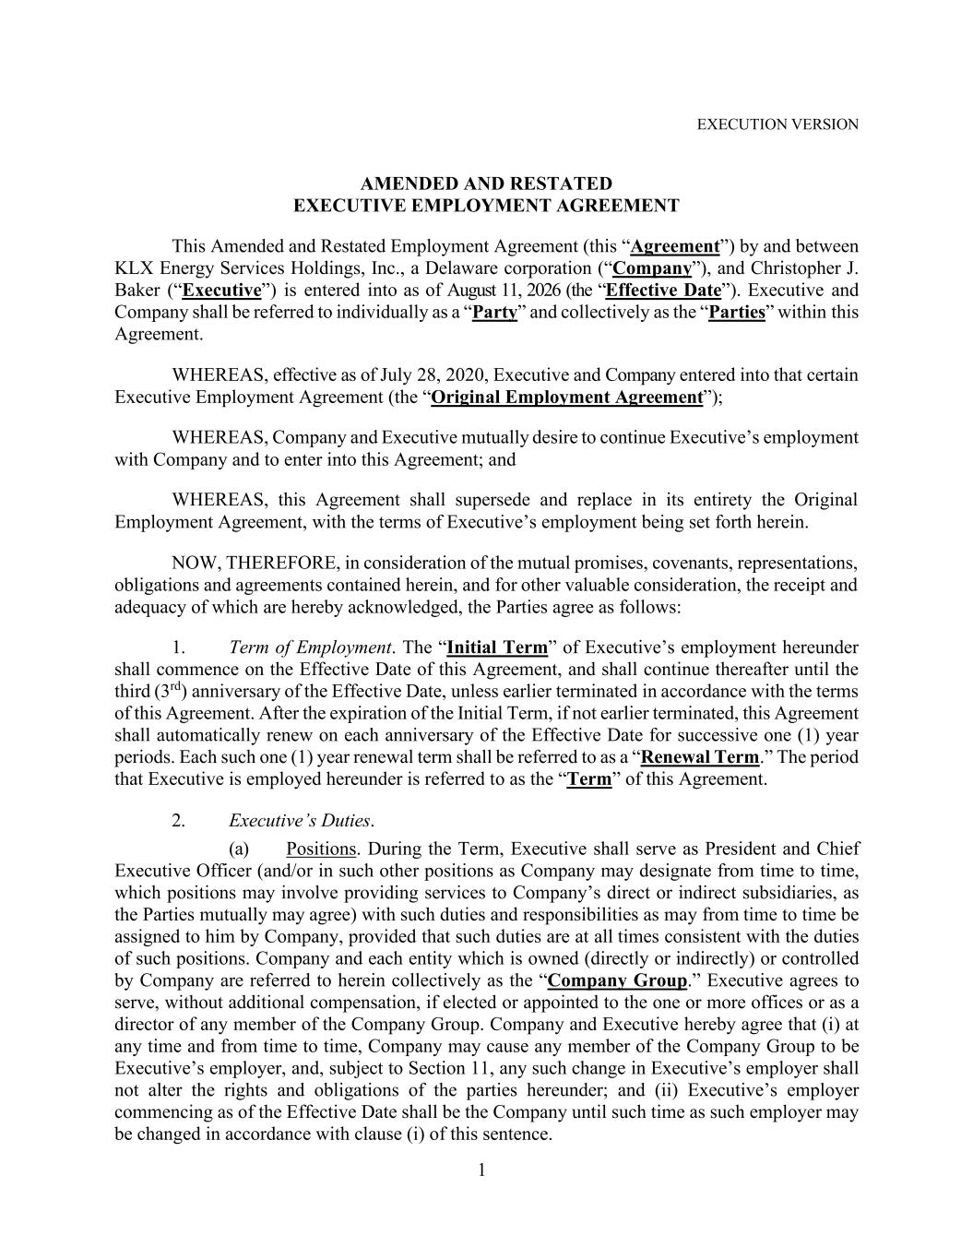
46
1 EXECUTION VERSION AMENDED AND RESTATED EXECUTIVE EMPLOYMENT AGREEMENT This Amended and Restated Employment Agreement (this “Agreement”) by and between KLX Energy Services Holdings, Inc., a Delaware corporation (“Company”), and Christopher J. Baker (“Executive”) is entered into as of August 11, 2026 (the “Effective Date”). Executive and Company shall be referred to individually as a “Party” and collectively as the “Parties” within this Agreement. WHEREAS, effective as of July 28, 2020, Executive and Company entered into that certain Executive Employment Agreement (the “Original Employment Agreement”); WHEREAS, Company and Executive mutually desire to continue Executive’s employment with Company and to enter into this Agreement; and WHEREAS, this Agreement shall supersede and replace in its entirety the Original Employment Agreement, with the terms of Executive’s employment being set forth herein. NOW, THEREFORE, in consideration of the mutual promises, covenants, representations, obligations and agreements contained herein, and for other valuable consideration, the receipt and adequacy of which are hereby acknowledged, the Parties agree as follows: 1. Term of Employment. The “Initial Term” of Executive’s employment hereunder shall commence on the Effective Date of this Agreement, and shall continue thereafter until the third (3rd) anniversary of the Effective Date, unless earlier terminated in accordance with the terms of this Agreement. After the expiration of the Initial Term, if not earlier terminated, this Agreement shall automatically renew on each anniversary of the Effective Date for successive one (1) year periods. Each such one (1) year renewal term shall be referred to as a “Renewal Term.” The period that Executive is employed hereunder is referred to as the “Term” of this Agreement. 2. Executive’s Duties. (a) Positions. During the Term, Executive shall serve as President and Chief Executive Officer (and/or in such other positions as Company may designate from time to time, which positions may involve providing services to Company’s direct or indirect subsidiaries, as the Parties mutually may agree) with such duties and responsibilities as may from time to time be assigned to him by Company, provided that such duties are at all times consistent with the duties of such positions. Company and each entity which is owned (directly or indirectly) or controlled by Company are referred to herein collectively as the “Company Group.” Executive agrees to serve, without additional compensation, if elected or appointed to the one or more offices or as a director of any member of the Company Group. Company and Executive hereby agree that (i) at any time and from time to time, Company may cause any member of the Company Group to be Executive’s employer, and, subject to Section 11, any such change in Executive’s employer shall not alter the rights and obligations of the parties hereunder; and (ii) Executive’s employer commencing as of the Effective Date shall be the Company until such time as such employer may be changed in accordance with clause (i) of this sentence.

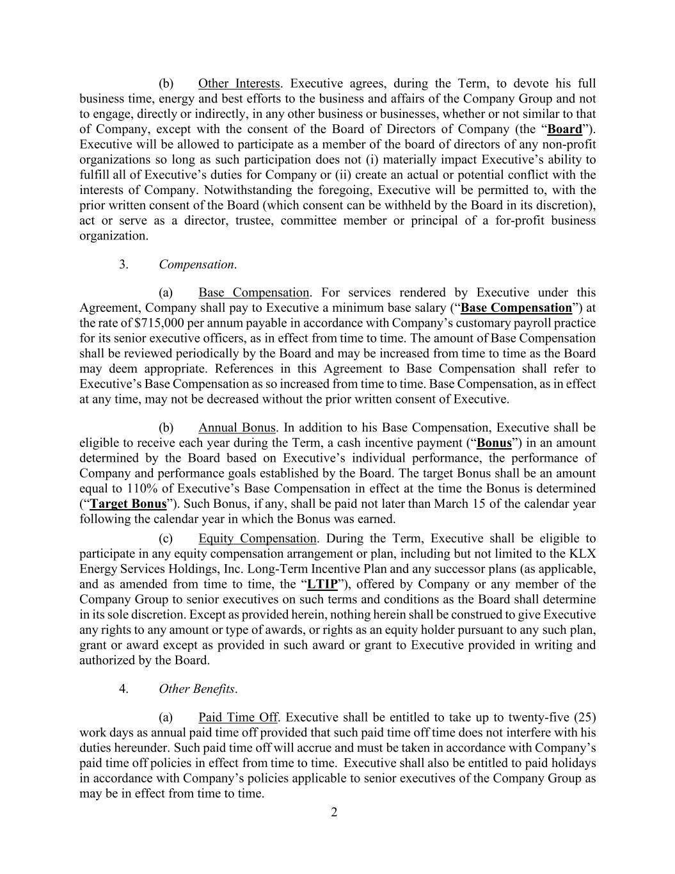
2 (b) Other Interests. Executive agrees, during the Term, to devote his full business time, energy and best efforts to the business and affairs of the Company Group and not to engage, directly or indirectly, in any other business or businesses, whether or not similar to that of Company, except with the consent of the Board of Directors of Company (the “Board”). Executive will be allowed to participate as a member of the board of directors of any non-profit organizations so long as such participation does not (i) materially impact Executive’s ability to fulfill all of Executive’s duties for Company or (ii) create an actual or potential conflict with the interests of Company. Notwithstanding the foregoing, Executive will be permitted to, with the prior written consent of the Board (which consent can be withheld by the Board in its discretion), act or serve as a director, trustee, committee member or principal of a for-profit business organization. 3. Compensation. (a) Base Compensation. For services rendered by Executive under this Agreement, Company shall pay to Executive a minimum base salary (“Base Compensation”) at the rate of $715,000 per annum payable in accordance with Company’s customary payroll practice for its senior executive officers, as in effect from time to time. The amount of Base Compensation shall be reviewed periodically by the Board and may be increased from time to time as the Board may deem appropriate. References in this Agreement to Base Compensation shall refer to Executive’s Base Compensation as so increased from time to time. Base Compensation, as in effect at any time, may not be decreased without the prior written consent of Executive. (b) Annual Bonus. In addition to his Base Compensation, Executive shall be eligible to receive each year during the Term, a cash incentive payment (“Bonus”) in an amount determined by the Board based on Executive’s individual performance, the performance of Company and performance goals established by the Board. The target Bonus shall be an amount equal to 110% of Executive’s Base Compensation in effect at the time the Bonus is determined (“Target Bonus”). Such Bonus, if any, shall be paid not later than March 15 of the calendar year following the calendar year in which the Bonus was earned. (c) Equity Compensation. During the Term, Executive shall be eligible to participate in any equity compensation arrangement or plan, including but not limited to the KLX Energy Services Holdings, Inc. Long-Term Incentive Plan and any successor plans (as applicable, and as amended from time to time, the “LTIP”), offered by Company or any member of the Company Group to senior executives on such terms and conditions as the Board shall determine in its sole discretion. Except as provided herein, nothing herein shall be construed to give Executive any rights to any amount or type of awards, or rights as an equity holder pursuant to any such plan, grant or award except as provided in such award or grant to Executive provided in writing and authorized by the Board. 4. Other Benefits. (a) Paid Time Off. Executive shall be entitled to take up to twenty-five (25) work days as annual paid time off provided that such paid time off time does not interfere with his duties hereunder. Such paid time off will accrue and must be taken in accordance with Company’s paid time off policies in effect from time to time. Executive shall also be entitled to paid holidays in accordance with Company’s policies applicable to senior executives of the Company Group as may be in effect from time to time.

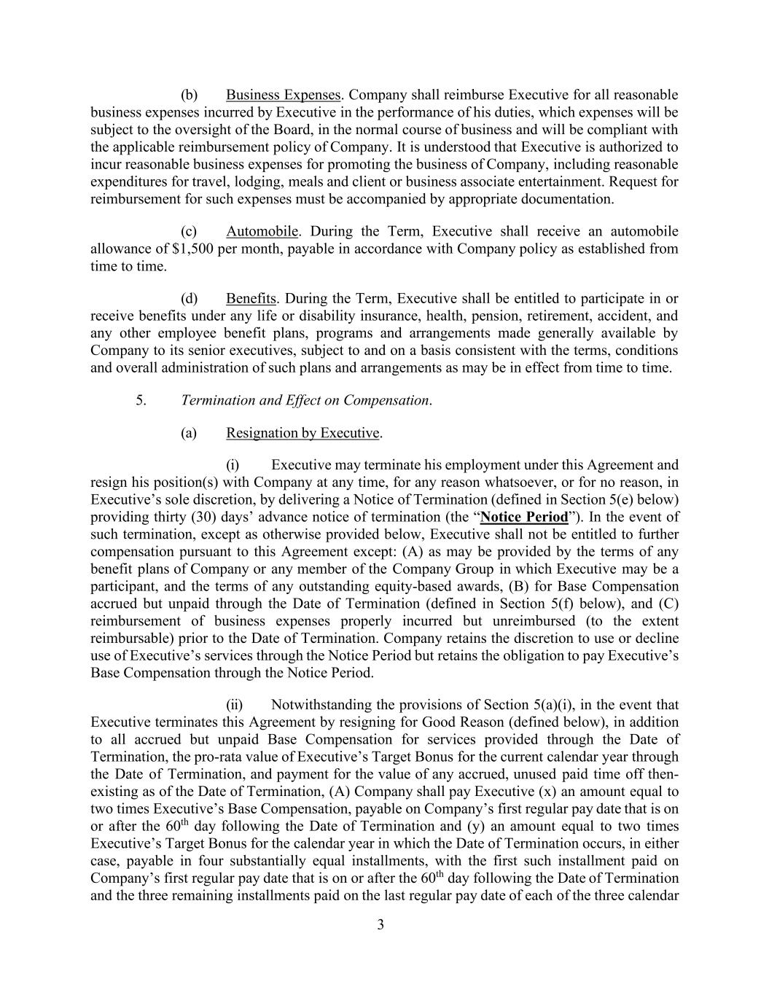
3 (b) Business Expenses. Company shall reimburse Executive for all reasonable business expenses incurred by Executive in the performance of his duties, which expenses will be subject to the oversight of the Board, in the normal course of business and will be compliant with the applicable reimbursement policy of Company. It is understood that Executive is authorized to incur reasonable business expenses for promoting the business of Company, including reasonable expenditures for travel, lodging, meals and client or business associate entertainment. Request for reimbursement for such expenses must be accompanied by appropriate documentation. (c) Automobile. During the Term, Executive shall receive an automobile allowance of $1,500 per month, payable in accordance with Company policy as established from time to time. (d) Benefits. During the Term, Executive shall be entitled to participate in or receive benefits under any life or disability insurance, health, pension, retirement, accident, and any other employee benefit plans, programs and arrangements made generally available by Company to its senior executives, subject to and on a basis consistent with the terms, conditions and overall administration of such plans and arrangements as may be in effect from time to time. 5. Termination and Effect on Compensation. (a) Resignation by Executive. (i) Executive may terminate his employment under this Agreement and resign his position(s) with Company at any time, for any reason whatsoever, or for no reason, in Executive’s sole discretion, by delivering a Notice of Termination (defined in Section 5(e) below) providing thirty (30) days’ advance notice of termination (the “Notice Period”). In the event of such termination, except as otherwise provided below, Executive shall not be entitled to further compensation pursuant to this Agreement except: (A) as may be provided by the terms of any benefit plans of Company or any member of the Company Group in which Executive may be a participant, and the terms of any outstanding equity-based awards, (B) for Base Compensation accrued but unpaid through the Date of Termination (defined in Section 5(f) below), and (C) reimbursement of business expenses properly incurred but unreimbursed (to the extent reimbursable) prior to the Date of Termination. Company retains the discretion to use or decline use of Executive’s services through the Notice Period but retains the obligation to pay Executive’s Base Compensation through the Notice Period. (ii) Notwithstanding the provisions of Section 5(a)(i), in the event that Executive terminates this Agreement by resigning for Good Reason (defined below), in addition to all accrued but unpaid Base Compensation for services provided through the Date of Termination, the pro-rata value of Executive’s Target Bonus for the current calendar year through the Date of Termination, and payment for the value of any accrued, unused paid time off then- existing as of the Date of Termination, (A) Company shall pay Executive (x) an amount equal to two times Executive’s Base Compensation, payable on Company’s first regular pay date that is on or after the 60th day following the Date of Termination and (y) an amount equal to two times Executive’s Target Bonus for the calendar year in which the Date of Termination occurs, in either case, payable in four substantially equal installments, with the first such installment paid on Company’s first regular pay date that is on or after the 60th day following the Date of Termination and the three remaining installments paid on the last regular pay date of each of the three calendar

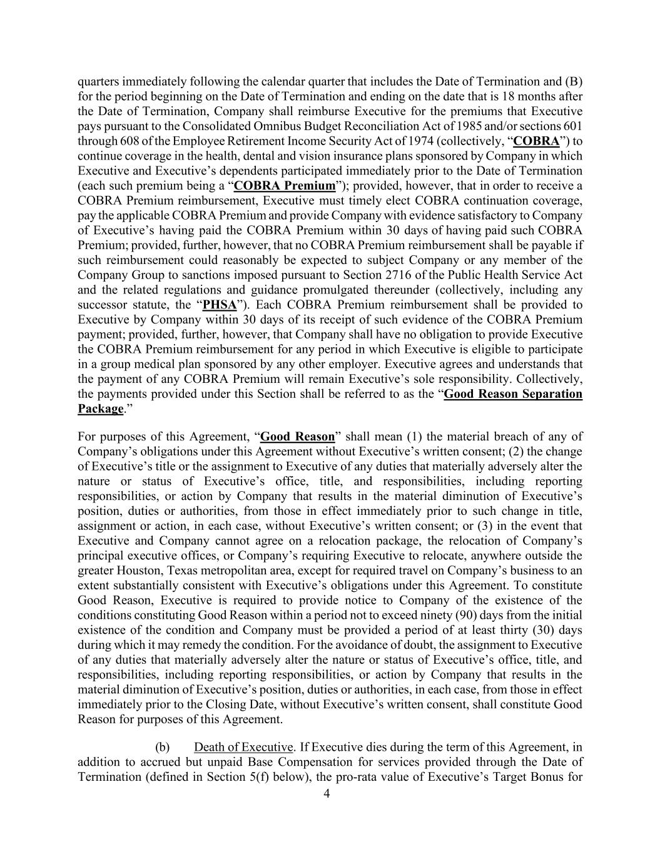
4 quarters immediately following the calendar quarter that includes the Date of Termination and (B) for the period beginning on the Date of Termination and ending on the date that is 18 months after the Date of Termination, Company shall reimburse Executive for the premiums that Executive pays pursuant to the Consolidated Omnibus Budget Reconciliation Act of 1985 and/or sections 601 through 608 of the Employee Retirement Income Security Act of 1974 (collectively, “COBRA”) to continue coverage in the health, dental and vision insurance plans sponsored by Company in which Executive and Executive’s dependents participated immediately prior to the Date of Termination (each such premium being a “COBRA Premium”); provided, however, that in order to receive a COBRA Premium reimbursement, Executive must timely elect COBRA continuation coverage, pay the applicable COBRA Premium and provide Company with evidence satisfactory to Company of Executive’s having paid the COBRA Premium within 30 days of having paid such COBRA Premium; provided, further, however, that no COBRA Premium reimbursement shall be payable if such reimbursement could reasonably be expected to subject Company or any member of the Company Group to sanctions imposed pursuant to Section 2716 of the Public Health Service Act and the related regulations and guidance promulgated thereunder (collectively, including any successor statute, the “PHSA”). Each COBRA Premium reimbursement shall be provided to Executive by Company within 30 days of its receipt of such evidence of the COBRA Premium payment; provided, further, however, that Company shall have no obligation to provide Executive the COBRA Premium reimbursement for any period in which Executive is eligible to participate in a group medical plan sponsored by any other employer. Executive agrees and understands that the payment of any COBRA Premium will remain Executive’s sole responsibility. Collectively, the payments provided under this Section shall be referred to as the “Good Reason Separation Package.” For purposes of this Agreement, “Good Reason” shall mean (1) the material breach of any of Company’s obligations under this Agreement without Executive’s written consent; (2) the change of Executive’s title or the assignment to Executive of any duties that materially adversely alter the nature or status of Executive’s office, title, and responsibilities, including reporting responsibilities, or action by Company that results in the material diminution of Executive’s position, duties or authorities, from those in effect immediately prior to such change in title, assignment or action, in each case, without Executive’s written consent; or (3) in the event that Executive and Company cannot agree on a relocation package, the relocation of Company’s principal executive offices, or Company’s requiring Executive to relocate, anywhere outside the greater Houston, Texas metropolitan area, except for required travel on Company’s business to an extent substantially consistent with Executive’s obligations under this Agreement. To constitute Good Reason, Executive is required to provide notice to Company of the existence of the conditions constituting Good Reason within a period not to exceed ninety (90) days from the initial existence of the condition and Company must be provided a period of at least thirty (30) days during which it may remedy the condition. For the avoidance of doubt, the assignment to Executive of any duties that materially adversely alter the nature or status of Executive’s office, title, and responsibilities, including reporting responsibilities, or action by Company that results in the material diminution of Executive’s position, duties or authorities, in each case, from those in effect immediately prior to the Closing Date, without Executive’s written consent, shall constitute Good Reason for purposes of this Agreement. (b) Death of Executive. If Executive dies during the term of this Agreement, in addition to accrued but unpaid Base Compensation for services provided through the Date of Termination (defined in Section 5(f) below), the pro-rata value of Executive’s Target Bonus for

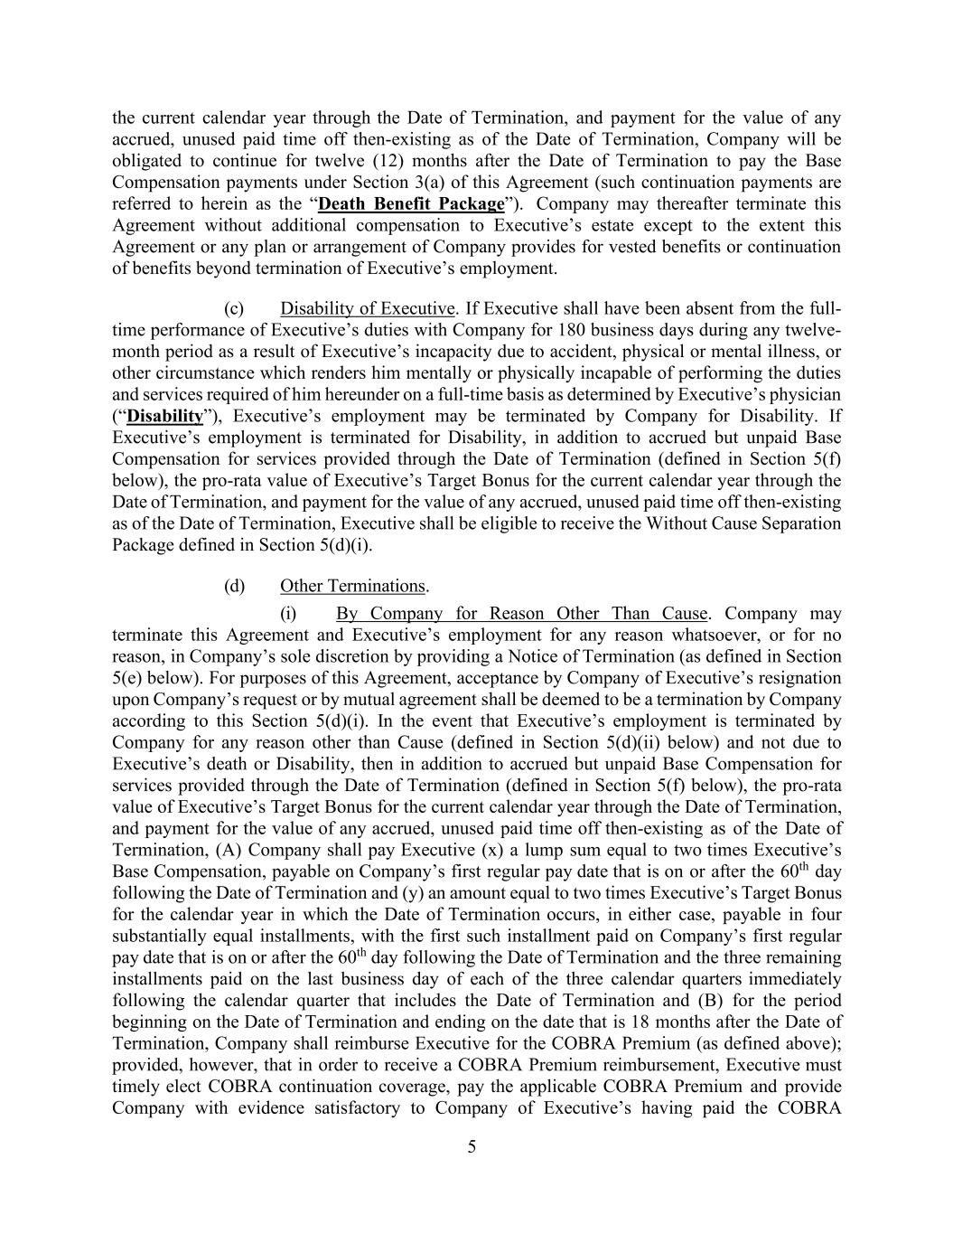
5 the current calendar year through the Date of Termination, and payment for the value of any accrued, unused paid time off then-existing as of the Date of Termination, Company will be obligated to continue for twelve (12) months after the Date of Termination to pay the Base Compensation payments under Section 3(a) of this Agreement (such continuation payments are referred to herein as the “Death Benefit Package”). Company may thereafter terminate this Agreement without additional compensation to Executive’s estate except to the extent this Agreement or any plan or arrangement of Company provides for vested benefits or continuation of benefits beyond termination of Executive’s employment. (c) Disability of Executive. If Executive shall have been absent from the full- time performance of Executive’s duties with Company for 180 business days during any twelve- month period as a result of Executive’s incapacity due to accident, physical or mental illness, or other circumstance which renders him mentally or physically incapable of performing the duties and services required of him hereunder on a full-time basis as determined by Executive’s physician (“Disability”), Executive’s employment may be terminated by Company for Disability. If Executive’s employment is terminated for Disability, in addition to accrued but unpaid Base Compensation for services provided through the Date of Termination (defined in Section 5(f) below), the pro-rata value of Executive’s Target Bonus for the current calendar year through the Date of Termination, and payment for the value of any accrued, unused paid time off then-existing as of the Date of Termination, Executive shall be eligible to receive the Without Cause Separation Package defined in Section 5(d)(i). (d) Other Terminations. (i) By Company for Reason Other Than Cause. Company may terminate this Agreement and Executive’s employment for any reason whatsoever, or for no reason, in Company’s sole discretion by providing a Notice of Termination (as defined in Section 5(e) below). For purposes of this Agreement, acceptance by Company of Executive’s resignation upon Company’s request or by mutual agreement shall be deemed to be a termination by Company according to this Section 5(d)(i). In the event that Executive’s employment is terminated by Company for any reason other than Cause (defined in Section 5(d)(ii) below) and not due to Executive’s death or Disability, then in addition to accrued but unpaid Base Compensation for services provided through the Date of Termination (defined in Section 5(f) below), the pro-rata value of Executive’s Target Bonus for the current calendar year through the Date of Termination, and payment for the value of any accrued, unused paid time off then-existing as of the Date of Termination, (A) Company shall pay Executive (x) a lump sum equal to two times Executive’s Base Compensation, payable on Company’s first regular pay date that is on or after the 60th day following the Date of Termination and (y) an amount equal to two times Executive’s Target Bonus for the calendar year in which the Date of Termination occurs, in either case, payable in four substantially equal installments, with the first such installment paid on Company’s first regular pay date that is on or after the 60th day following the Date of Termination and the three remaining installments paid on the last business day of each of the three calendar quarters immediately following the calendar quarter that includes the Date of Termination and (B) for the period beginning on the Date of Termination and ending on the date that is 18 months after the Date of Termination, Company shall reimburse Executive for the COBRA Premium (as defined above); provided, however, that in order to receive a COBRA Premium reimbursement, Executive must timely elect COBRA continuation coverage, pay the applicable COBRA Premium and provide Company with evidence satisfactory to Company of Executive’s having paid the COBRA

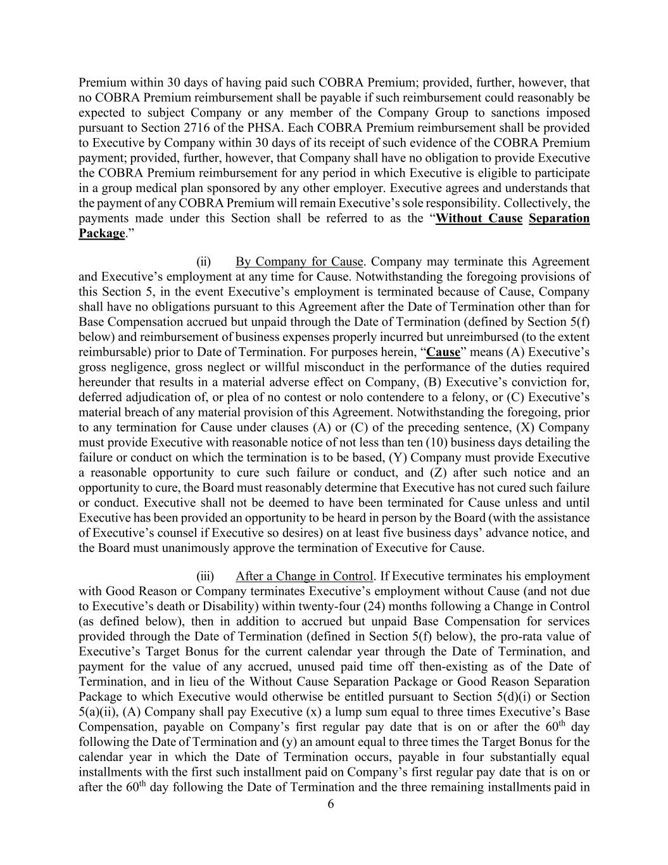
6 Premium within 30 days of having paid such COBRA Premium; provided, further, however, that no COBRA Premium reimbursement shall be payable if such reimbursement could reasonably be expected to subject Company or any member of the Company Group to sanctions imposed pursuant to Section 2716 of the PHSA. Each COBRA Premium reimbursement shall be provided to Executive by Company within 30 days of its receipt of such evidence of the COBRA Premium payment; provided, further, however, that Company shall have no obligation to provide Executive the COBRA Premium reimbursement for any period in which Executive is eligible to participate in a group medical plan sponsored by any other employer. Executive agrees and understands that the payment of any COBRA Premium will remain Executive’s sole responsibility. Collectively, the payments made under this Section shall be referred to as the “Without Cause Separation Package.” (ii) By Company for Cause. Company may terminate this Agreement and Executive’s employment at any time for Cause. Notwithstanding the foregoing provisions of this Section 5, in the event Executive’s employment is terminated because of Cause, Company shall have no obligations pursuant to this Agreement after the Date of Termination other than for Base Compensation accrued but unpaid through the Date of Termination (defined by Section 5(f) below) and reimbursement of business expenses properly incurred but unreimbursed (to the extent reimbursable) prior to Date of Termination. For purposes herein, “Cause” means (A) Executive’s gross negligence, gross neglect or willful misconduct in the performance of the duties required hereunder that results in a material adverse effect on Company, (B) Executive’s conviction for, deferred adjudication of, or plea of no contest or nolo contendere to a felony, or (C) Executive’s material breach of any material provision of this Agreement. Notwithstanding the foregoing, prior to any termination for Cause under clauses (A) or (C) of the preceding sentence, (X) Company must provide Executive with reasonable notice of not less than ten (10) business days detailing the failure or conduct on which the termination is to be based, (Y) Company must provide Executive a reasonable opportunity to cure such failure or conduct, and (Z) after such notice and an opportunity to cure, the Board must reasonably determine that Executive has not cured such failure or conduct. Executive shall not be deemed to have been terminated for Cause unless and until Executive has been provided an opportunity to be heard in person by the Board (with the assistance of Executive’s counsel if Executive so desires) on at least five business days’ advance notice, and the Board must unanimously approve the termination of Executive for Cause. (iii) After a Change in Control. If Executive terminates his employment with Good Reason or Company terminates Executive’s employment without Cause (and not due to Executive’s death or Disability) within twenty-four (24) months following a Change in Control (as defined below), then in addition to accrued but unpaid Base Compensation for services provided through the Date of Termination (defined in Section 5(f) below), the pro-rata value of Executive’s Target Bonus for the current calendar year through the Date of Termination, and payment for the value of any accrued, unused paid time off then-existing as of the Date of Termination, and in lieu of the Without Cause Separation Package or Good Reason Separation Package to which Executive would otherwise be entitled pursuant to Section 5(d)(i) or Section 5(a)(ii), (A) Company shall pay Executive (x) a lump sum equal to three times Executive’s Base Compensation, payable on Company’s first regular pay date that is on or after the 60th day following the Date of Termination and (y) an amount equal to three times the Target Bonus for the calendar year in which the Date of Termination occurs, payable in four substantially equal installments with the first such installment paid on Company’s first regular pay date that is on or after the 60th day following the Date of Termination and the three remaining installments paid in

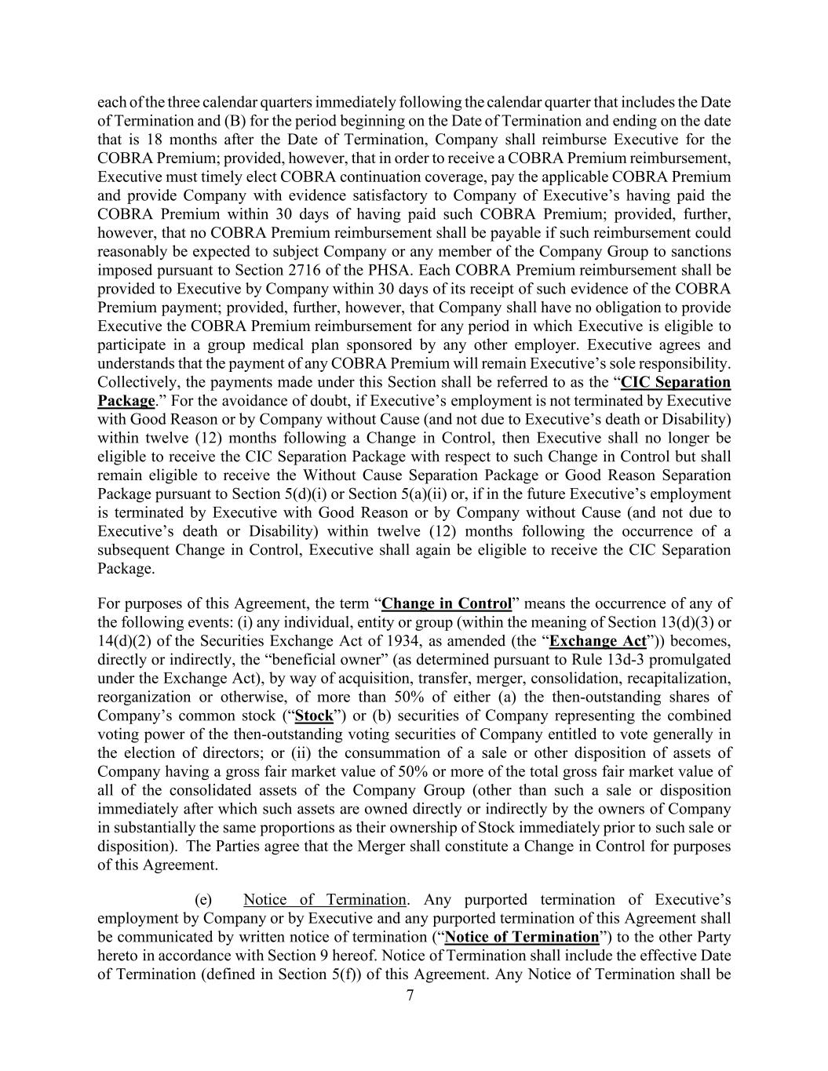
7 each of the three calendar quarters immediately following the calendar quarter that includes the Date of Termination and (B) for the period beginning on the Date of Termination and ending on the date that is 18 months after the Date of Termination, Company shall reimburse Executive for the COBRA Premium; provided, however, that in order to receive a COBRA Premium reimbursement, Executive must timely elect COBRA continuation coverage, pay the applicable COBRA Premium and provide Company with evidence satisfactory to Company of Executive’s having paid the COBRA Premium within 30 days of having paid such COBRA Premium; provided, further, however, that no COBRA Premium reimbursement shall be payable if such reimbursement could reasonably be expected to subject Company or any member of the Company Group to sanctions imposed pursuant to Section 2716 of the PHSA. Each COBRA Premium reimbursement shall be provided to Executive by Company within 30 days of its receipt of such evidence of the COBRA Premium payment; provided, further, however, that Company shall have no obligation to provide Executive the COBRA Premium reimbursement for any period in which Executive is eligible to participate in a group medical plan sponsored by any other employer. Executive agrees and understands that the payment of any COBRA Premium will remain Executive’s sole responsibility. Collectively, the payments made under this Section shall be referred to as the “CIC Separation Package.” For the avoidance of doubt, if Executive’s employment is not terminated by Executive with Good Reason or by Company without Cause (and not due to Executive’s death or Disability) within twelve (12) months following a Change in Control, then Executive shall no longer be eligible to receive the CIC Separation Package with respect to such Change in Control but shall remain eligible to receive the Without Cause Separation Package or Good Reason Separation Package pursuant to Section 5(d)(i) or Section 5(a)(ii) or, if in the future Executive’s employment is terminated by Executive with Good Reason or by Company without Cause (and not due to Executive’s death or Disability) within twelve (12) months following the occurrence of a subsequent Change in Control, Executive shall again be eligible to receive the CIC Separation Package. For purposes of this Agreement, the term “Change in Control” means the occurrence of any of the following events: (i) any individual, entity or group (within the meaning of Section 13(d)(3) or 14(d)(2) of the Securities Exchange Act of 1934, as amended (the “Exchange Act”)) becomes, directly or indirectly, the “beneficial owner” (as determined pursuant to Rule 13d-3 promulgated under the Exchange Act), by way of acquisition, transfer, merger, consolidation, recapitalization, reorganization or otherwise, of more than 50% of either (a) the then-outstanding shares of Company’s common stock (“Stock”) or (b) securities of Company representing the combined voting power of the then-outstanding voting securities of Company entitled to vote generally in the election of directors; or (ii) the consummation of a sale or other disposition of assets of Company having a gross fair market value of 50% or more of the total gross fair market value of all of the consolidated assets of the Company Group (other than such a sale or disposition immediately after which such assets are owned directly or indirectly by the owners of Company in substantially the same proportions as their ownership of Stock immediately prior to such sale or disposition). The Parties agree that the Merger shall constitute a Change in Control for purposes of this Agreement. (e) Notice of Termination. Any purported termination of Executive’s employment by Company or by Executive and any purported termination of this Agreement shall be communicated by written notice of termination (“Notice of Termination”) to the other Party hereto in accordance with Section 9 hereof. Notice of Termination shall include the effective Date of Termination (defined in Section 5(f)) of this Agreement. Any Notice of Termination shall be

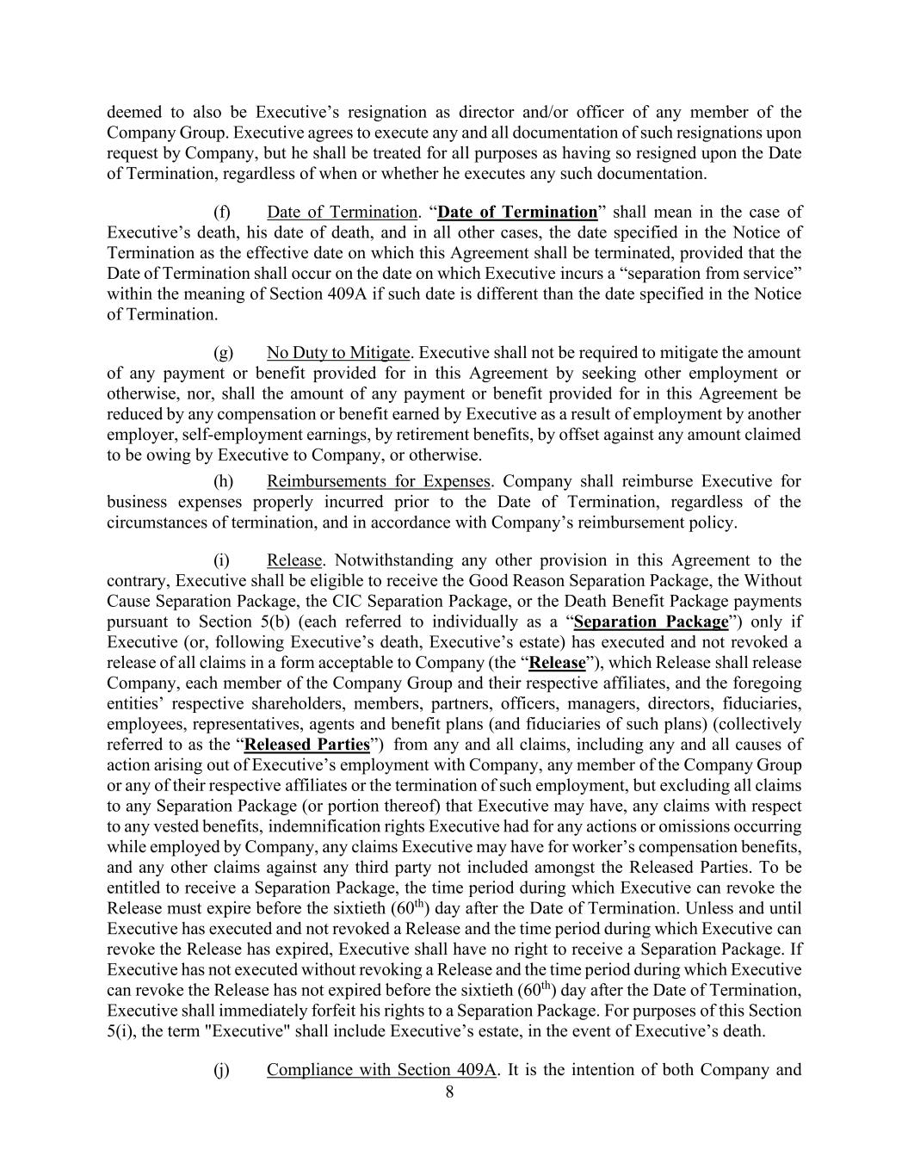
8 deemed to also be Executive’s resignation as director and/or officer of any member of the Company Group. Executive agrees to execute any and all documentation of such resignations upon request by Company, but he shall be treated for all purposes as having so resigned upon the Date of Termination, regardless of when or whether he executes any such documentation. (f) Date of Termination. “Date of Termination” shall mean in the case of Executive’s death, his date of death, and in all other cases, the date specified in the Notice of Termination as the effective date on which this Agreement shall be terminated, provided that the Date of Termination shall occur on the date on which Executive incurs a “separation from service” within the meaning of Section 409A if such date is different than the date specified in the Notice of Termination. (g) No Duty to Mitigate. Executive shall not be required to mitigate the amount of any payment or benefit provided for in this Agreement by seeking other employment or otherwise, nor, shall the amount of any payment or benefit provided for in this Agreement be reduced by any compensation or benefit earned by Executive as a result of employment by another employer, self-employment earnings, by retirement benefits, by offset against any amount claimed to be owing by Executive to Company, or otherwise. (h) Reimbursements for Expenses. Company shall reimburse Executive for business expenses properly incurred prior to the Date of Termination, regardless of the circumstances of termination, and in accordance with Company’s reimbursement policy. (i) Release. Notwithstanding any other provision in this Agreement to the contrary, Executive shall be eligible to receive the Good Reason Separation Package, the Without Cause Separation Package, the CIC Separation Package, or the Death Benefit Package payments pursuant to Section 5(b) (each referred to individually as a “Separation Package”) only if Executive (or, following Executive’s death, Executive’s estate) has executed and not revoked a release of all claims in a form acceptable to Company (the “Release”), which Release shall release Company, each member of the Company Group and their respective affiliates, and the foregoing entities’ respective shareholders, members, partners, officers, managers, directors, fiduciaries, employees, representatives, agents and benefit plans (and fiduciaries of such plans) (collectively referred to as the “Released Parties”) from any and all claims, including any and all causes of action arising out of Executive’s employment with Company, any member of the Company Group or any of their respective affiliates or the termination of such employment, but excluding all claims to any Separation Package (or portion thereof) that Executive may have, any claims with respect to any vested benefits, indemnification rights Executive had for any actions or omissions occurring while employed by Company, any claims Executive may have for worker’s compensation benefits, and any other claims against any third party not included amongst the Released Parties. To be entitled to receive a Separation Package, the time period during which Executive can revoke the Release must expire before the sixtieth (60th) day after the Date of Termination. Unless and until Executive has executed and not revoked a Release and the time period during which Executive can revoke the Release has expired, Executive shall have no right to receive a Separation Package. If Executive has not executed without revoking a Release and the time period during which Executive can revoke the Release has not expired before the sixtieth (60th) day after the Date of Termination, Executive shall immediately forfeit his rights to a Separation Package. For purposes of this Section 5(i), the term "Executive" shall include Executive’s estate, in the event of Executive’s death. (j) Compliance with Section 409A. It is the intention of both Company and

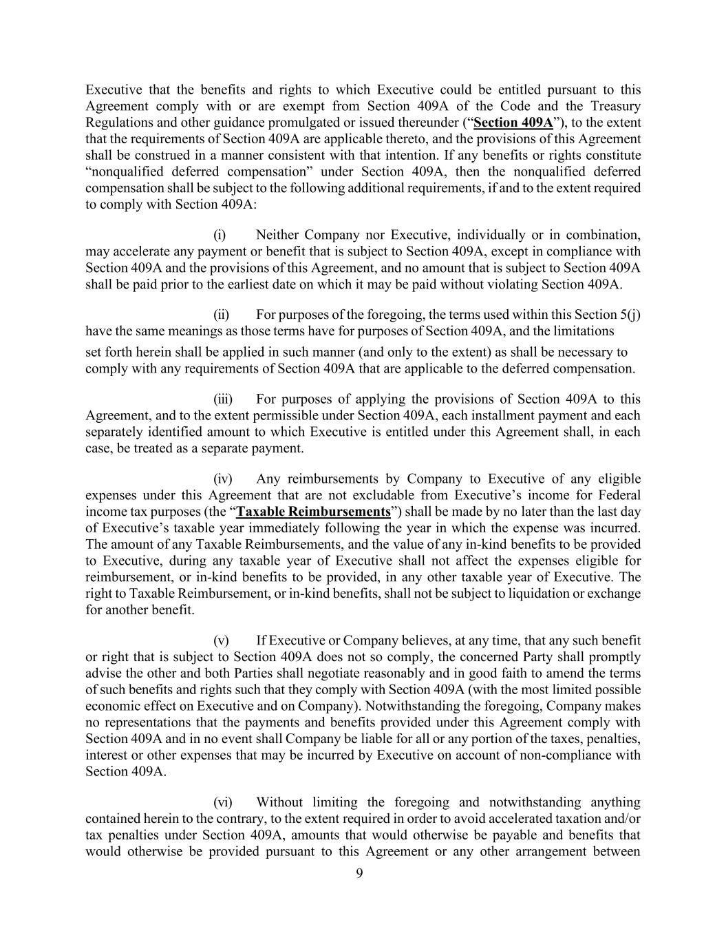
9 Executive that the benefits and rights to which Executive could be entitled pursuant to this Agreement comply with or are exempt from Section 409A of the Code and the Treasury Regulations and other guidance promulgated or issued thereunder (“Section 409A”), to the extent that the requirements of Section 409A are applicable thereto, and the provisions of this Agreement shall be construed in a manner consistent with that intention. If any benefits or rights constitute “nonqualified deferred compensation” under Section 409A, then the nonqualified deferred compensation shall be subject to the following additional requirements, if and to the extent required to comply with Section 409A: (i) Neither Company nor Executive, individually or in combination, may accelerate any payment or benefit that is subject to Section 409A, except in compliance with Section 409A and the provisions of this Agreement, and no amount that is subject to Section 409A shall be paid prior to the earliest date on which it may be paid without violating Section 409A. (ii) For purposes of the foregoing, the terms used within this Section 5(j) have the same meanings as those terms have for purposes of Section 409A, and the limitations set forth herein shall be applied in such manner (and only to the extent) as shall be necessary to comply with any requirements of Section 409A that are applicable to the deferred compensation. (iii) For purposes of applying the provisions of Section 409A to this Agreement, and to the extent permissible under Section 409A, each installment payment and each separately identified amount to which Executive is entitled under this Agreement shall, in each case, be treated as a separate payment. (iv) Any reimbursements by Company to Executive of any eligible expenses under this Agreement that are not excludable from Executive’s income for Federal income tax purposes (the “Taxable Reimbursements”) shall be made by no later than the last day of Executive’s taxable year immediately following the year in which the expense was incurred. The amount of any Taxable Reimbursements, and the value of any in-kind benefits to be provided to Executive, during any taxable year of Executive shall not affect the expenses eligible for reimbursement, or in-kind benefits to be provided, in any other taxable year of Executive. The right to Taxable Reimbursement, or in-kind benefits, shall not be subject to liquidation or exchange for another benefit. (v) If Executive or Company believes, at any time, that any such benefit or right that is subject to Section 409A does not so comply, the concerned Party shall promptly advise the other and both Parties shall negotiate reasonably and in good faith to amend the terms of such benefits and rights such that they comply with Section 409A (with the most limited possible economic effect on Executive and on Company). Notwithstanding the foregoing, Company makes no representations that the payments and benefits provided under this Agreement comply with Section 409A and in no event shall Company be liable for all or any portion of the taxes, penalties, interest or other expenses that may be incurred by Executive on account of non-compliance with Section 409A. (vi) Without limiting the foregoing and notwithstanding anything contained herein to the contrary, to the extent required in order to avoid accelerated taxation and/or tax penalties under Section 409A, amounts that would otherwise be payable and benefits that would otherwise be provided pursuant to this Agreement or any other arrangement between

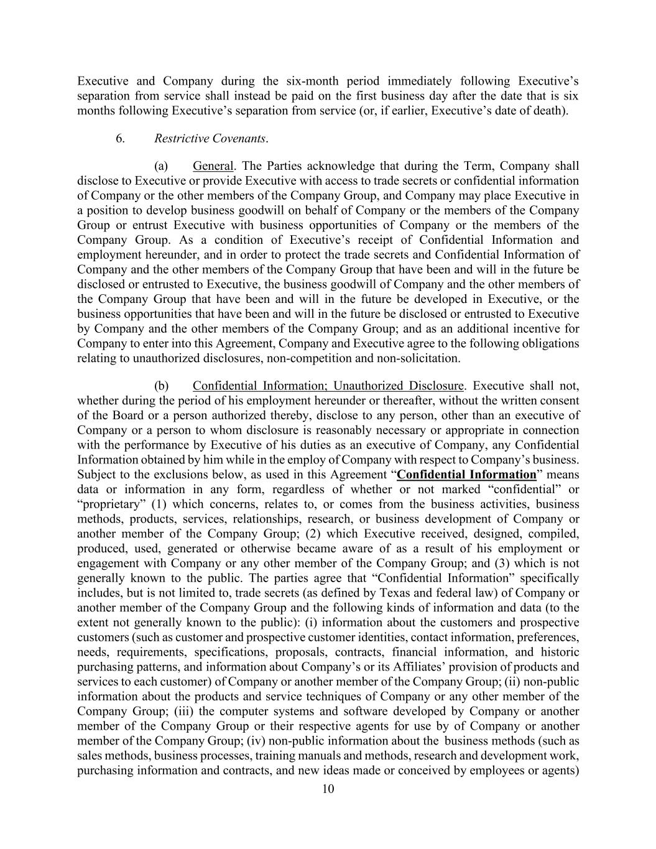
10 Executive and Company during the six-month period immediately following Executive’s separation from service shall instead be paid on the first business day after the date that is six months following Executive’s separation from service (or, if earlier, Executive’s date of death). 6. Restrictive Covenants. (a) General. The Parties acknowledge that during the Term, Company shall disclose to Executive or provide Executive with access to trade secrets or confidential information of Company or the other members of the Company Group, and Company may place Executive in a position to develop business goodwill on behalf of Company or the members of the Company Group or entrust Executive with business opportunities of Company or the members of the Company Group. As a condition of Executive’s receipt of Confidential Information and employment hereunder, and in order to protect the trade secrets and Confidential Information of Company and the other members of the Company Group that have been and will in the future be disclosed or entrusted to Executive, the business goodwill of Company and the other members of the Company Group that have been and will in the future be developed in Executive, or the business opportunities that have been and will in the future be disclosed or entrusted to Executive by Company and the other members of the Company Group; and as an additional incentive for Company to enter into this Agreement, Company and Executive agree to the following obligations relating to unauthorized disclosures, non-competition and non-solicitation. (b) Confidential Information; Unauthorized Disclosure. Executive shall not, whether during the period of his employment hereunder or thereafter, without the written consent of the Board or a person authorized thereby, disclose to any person, other than an executive of Company or a person to whom disclosure is reasonably necessary or appropriate in connection with the performance by Executive of his duties as an executive of Company, any Confidential Information obtained by him while in the employ of Company with respect to Company’s business. Subject to the exclusions below, as used in this Agreement “Confidential Information” means data or information in any form, regardless of whether or not marked “confidential” or “proprietary” (1) which concerns, relates to, or comes from the business activities, business methods, products, services, relationships, research, or business development of Company or another member of the Company Group; (2) which Executive received, designed, compiled, produced, used, generated or otherwise became aware of as a result of his employment or engagement with Company or any other member of the Company Group; and (3) which is not generally known to the public. The parties agree that “Confidential Information” specifically includes, but is not limited to, trade secrets (as defined by Texas and federal law) of Company or another member of the Company Group and the following kinds of information and data (to the extent not generally known to the public): (i) information about the customers and prospective customers (such as customer and prospective customer identities, contact information, preferences, needs, requirements, specifications, proposals, contracts, financial information, and historic purchasing patterns, and information about Company’s or its Affiliates’ provision of products and services to each customer) of Company or another member of the Company Group; (ii) non-public information about the products and service techniques of Company or any other member of the Company Group; (iii) the computer systems and software developed by Company or another member of the Company Group or their respective agents for use by of Company or another member of the Company Group; (iv) non-public information about the business methods (such as sales methods, business processes, training manuals and methods, research and development work, purchasing information and contracts, and new ideas made or conceived by employees or agents)

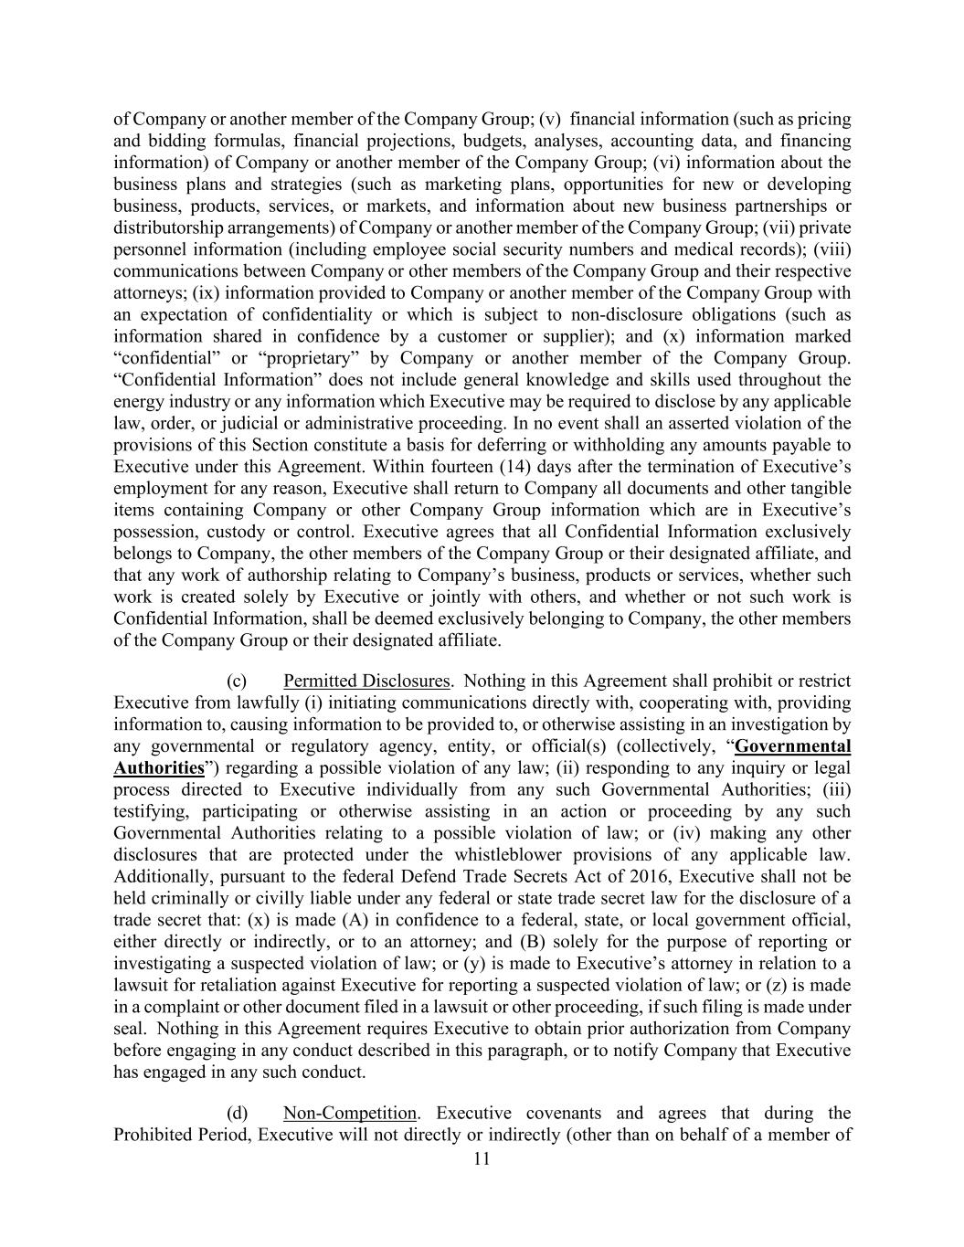
11 of Company or another member of the Company Group; (v) financial information (such as pricing and bidding formulas, financial projections, budgets, analyses, accounting data, and financing information) of Company or another member of the Company Group; (vi) information about the business plans and strategies (such as marketing plans, opportunities for new or developing business, products, services, or markets, and information about new business partnerships or distributorship arrangements) of Company or another member of the Company Group; (vii) private personnel information (including employee social security numbers and medical records); (viii) communications between Company or other members of the Company Group and their respective attorneys; (ix) information provided to Company or another member of the Company Group with an expectation of confidentiality or which is subject to non-disclosure obligations (such as information shared in confidence by a customer or supplier); and (x) information marked “confidential” or “proprietary” by Company or another member of the Company Group. “Confidential Information” does not include general knowledge and skills used throughout the energy industry or any information which Executive may be required to disclose by any applicable law, order, or judicial or administrative proceeding. In no event shall an asserted violation of the provisions of this Section constitute a basis for deferring or withholding any amounts payable to Executive under this Agreement. Within fourteen (14) days after the termination of Executive’s employment for any reason, Executive shall return to Company all documents and other tangible items containing Company or other Company Group information which are in Executive’s possession, custody or control. Executive agrees that all Confidential Information exclusively belongs to Company, the other members of the Company Group or their designated affiliate, and that any work of authorship relating to Company’s business, products or services, whether such work is created solely by Executive or jointly with others, and whether or not such work is Confidential Information, shall be deemed exclusively belonging to Company, the other members of the Company Group or their designated affiliate. (c) Permitted Disclosures. Nothing in this Agreement shall prohibit or restrict Executive from lawfully (i) initiating communications directly with, cooperating with, providing information to, causing information to be provided to, or otherwise assisting in an investigation by any governmental or regulatory agency, entity, or official(s) (collectively, “Governmental Authorities”) regarding a possible violation of any law; (ii) responding to any inquiry or legal process directed to Executive individually from any such Governmental Authorities; (iii) testifying, participating or otherwise assisting in an action or proceeding by any such Governmental Authorities relating to a possible violation of law; or (iv) making any other disclosures that are protected under the whistleblower provisions of any applicable law. Additionally, pursuant to the federal Defend Trade Secrets Act of 2016, Executive shall not be held criminally or civilly liable under any federal or state trade secret law for the disclosure of a trade secret that: (x) is made (A) in confidence to a federal, state, or local government official, either directly or indirectly, or to an attorney; and (B) solely for the purpose of reporting or investigating a suspected violation of law; or (y) is made to Executive’s attorney in relation to a lawsuit for retaliation against Executive for reporting a suspected violation of law; or (z) is made in a complaint or other document filed in a lawsuit or other proceeding, if such filing is made under seal. Nothing in this Agreement requires Executive to obtain prior authorization from Company before engaging in any conduct described in this paragraph, or to notify Company that Executive has engaged in any such conduct. (d) Non-Competition. Executive covenants and agrees that during the Prohibited Period, Executive will not directly or indirectly (other than on behalf of a member of

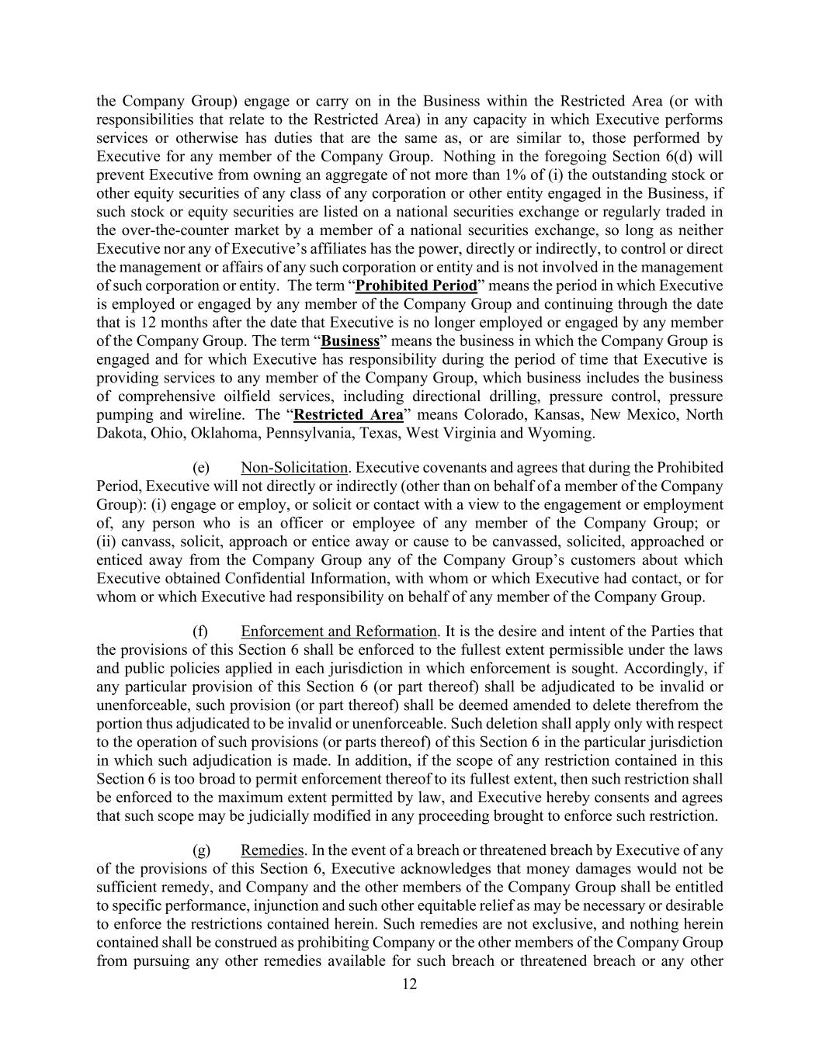
12 the Company Group) engage or carry on in the Business within the Restricted Area (or with responsibilities that relate to the Restricted Area) in any capacity in which Executive performs services or otherwise has duties that are the same as, or are similar to, those performed by Executive for any member of the Company Group. Nothing in the foregoing Section 6(d) will prevent Executive from owning an aggregate of not more than 1% of (i) the outstanding stock or other equity securities of any class of any corporation or other entity engaged in the Business, if such stock or equity securities are listed on a national securities exchange or regularly traded in the over-the-counter market by a member of a national securities exchange, so long as neither Executive nor any of Executive’s affiliates has the power, directly or indirectly, to control or direct the management or affairs of any such corporation or entity and is not involved in the management of such corporation or entity. The term “Prohibited Period” means the period in which Executive is employed or engaged by any member of the Company Group and continuing through the date that is 12 months after the date that Executive is no longer employed or engaged by any member of the Company Group. The term “Business” means the business in which the Company Group is engaged and for which Executive has responsibility during the period of time that Executive is providing services to any member of the Company Group, which business includes the business of comprehensive oilfield services, including directional drilling, pressure control, pressure pumping and wireline. The “Restricted Area” means Colorado, Kansas, New Mexico, North Dakota, Ohio, Oklahoma, Pennsylvania, Texas, West Virginia and Wyoming. (e) Non-Solicitation. Executive covenants and agrees that during the Prohibited Period, Executive will not directly or indirectly (other than on behalf of a member of the Company Group): (i) engage or employ, or solicit or contact with a view to the engagement or employment of, any person who is an officer or employee of any member of the Company Group; or (ii) canvass, solicit, approach or entice away or cause to be canvassed, solicited, approached or enticed away from the Company Group any of the Company Group’s customers about which Executive obtained Confidential Information, with whom or which Executive had contact, or for whom or which Executive had responsibility on behalf of any member of the Company Group. (f) Enforcement and Reformation. It is the desire and intent of the Parties that the provisions of this Section 6 shall be enforced to the fullest extent permissible under the laws and public policies applied in each jurisdiction in which enforcement is sought. Accordingly, if any particular provision of this Section 6 (or part thereof) shall be adjudicated to be invalid or unenforceable, such provision (or part thereof) shall be deemed amended to delete therefrom the portion thus adjudicated to be invalid or unenforceable. Such deletion shall apply only with respect to the operation of such provisions (or parts thereof) of this Section 6 in the particular jurisdiction in which such adjudication is made. In addition, if the scope of any restriction contained in this Section 6 is too broad to permit enforcement thereof to its fullest extent, then such restriction shall be enforced to the maximum extent permitted by law, and Executive hereby consents and agrees that such scope may be judicially modified in any proceeding brought to enforce such restriction. (g) Remedies. In the event of a breach or threatened breach by Executive of any of the provisions of this Section 6, Executive acknowledges that money damages would not be sufficient remedy, and Company and the other members of the Company Group shall be entitled to specific performance, injunction and such other equitable relief as may be necessary or desirable to enforce the restrictions contained herein. Such remedies are not exclusive, and nothing herein contained shall be construed as prohibiting Company or the other members of the Company Group from pursuing any other remedies available for such breach or threatened breach or any other

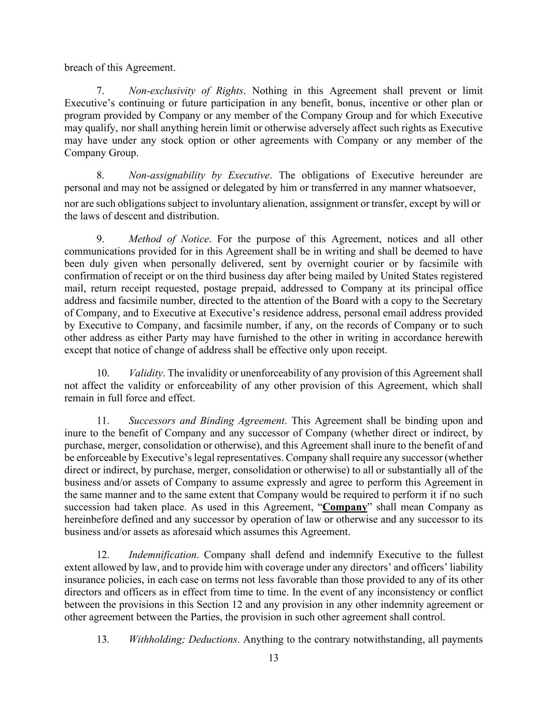
13 breach of this Agreement. 7. Non-exclusivity of Rights. Nothing in this Agreement shall prevent or limit Executive’s continuing or future participation in any benefit, bonus, incentive or other plan or program provided by Company or any member of the Company Group and for which Executive may qualify, nor shall anything herein limit or otherwise adversely affect such rights as Executive may have under any stock option or other agreements with Company or any member of the Company Group. 8. Non-assignability by Executive. The obligations of Executive hereunder are personal and may not be assigned or delegated by him or transferred in any manner whatsoever, nor are such obligations subject to involuntary alienation, assignment or transfer, except by will or the laws of descent and distribution. 9. Method of Notice. For the purpose of this Agreement, notices and all other communications provided for in this Agreement shall be in writing and shall be deemed to have been duly given when personally delivered, sent by overnight courier or by facsimile with confirmation of receipt or on the third business day after being mailed by United States registered mail, return receipt requested, postage prepaid, addressed to Company at its principal office address and facsimile number, directed to the attention of the Board with a copy to the Secretary of Company, and to Executive at Executive’s residence address, personal email address provided by Executive to Company, and facsimile number, if any, on the records of Company or to such other address as either Party may have furnished to the other in writing in accordance herewith except that notice of change of address shall be effective only upon receipt. 10. Validity. The invalidity or unenforceability of any provision of this Agreement shall not affect the validity or enforceability of any other provision of this Agreement, which shall remain in full force and effect. 11. Successors and Binding Agreement. This Agreement shall be binding upon and inure to the benefit of Company and any successor of Company (whether direct or indirect, by purchase, merger, consolidation or otherwise), and this Agreement shall inure to the benefit of and be enforceable by Executive’s legal representatives. Company shall require any successor (whether direct or indirect, by purchase, merger, consolidation or otherwise) to all or substantially all of the business and/or assets of Company to assume expressly and agree to perform this Agreement in the same manner and to the same extent that Company would be required to perform it if no such succession had taken place. As used in this Agreement, “Company” shall mean Company as hereinbefore defined and any successor by operation of law or otherwise and any successor to its business and/or assets as aforesaid which assumes this Agreement. 12. Indemnification. Company shall defend and indemnify Executive to the fullest extent allowed by law, and to provide him with coverage under any directors’ and officers’ liability insurance policies, in each case on terms not less favorable than those provided to any of its other directors and officers as in effect from time to time. In the event of any inconsistency or conflict between the provisions in this Section 12 and any provision in any other indemnity agreement or other agreement between the Parties, the provision in such other agreement shall control. 13. Withholding; Deductions. Anything to the contrary notwithstanding, all payments

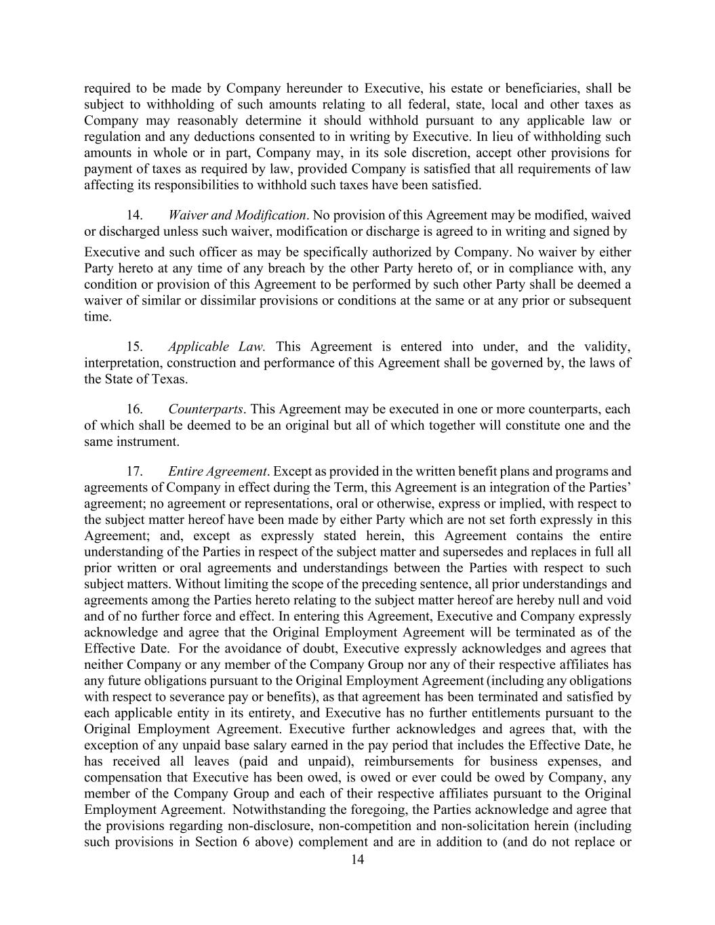
14 required to be made by Company hereunder to Executive, his estate or beneficiaries, shall be subject to withholding of such amounts relating to all federal, state, local and other taxes as Company may reasonably determine it should withhold pursuant to any applicable law or regulation and any deductions consented to in writing by Executive. In lieu of withholding such amounts in whole or in part, Company may, in its sole discretion, accept other provisions for payment of taxes as required by law, provided Company is satisfied that all requirements of law affecting its responsibilities to withhold such taxes have been satisfied. 14. Waiver and Modification. No provision of this Agreement may be modified, waived or discharged unless such waiver, modification or discharge is agreed to in writing and signed by Executive and such officer as may be specifically authorized by Company. No waiver by either Party hereto at any time of any breach by the other Party hereto of, or in compliance with, any condition or provision of this Agreement to be performed by such other Party shall be deemed a waiver of similar or dissimilar provisions or conditions at the same or at any prior or subsequent time. 15. Applicable Law. This Agreement is entered into under, and the validity, interpretation, construction and performance of this Agreement shall be governed by, the laws of the State of Texas. 16. Counterparts. This Agreement may be executed in one or more counterparts, each of which shall be deemed to be an original but all of which together will constitute one and the same instrument. 17. Entire Agreement. Except as provided in the written benefit plans and programs and agreements of Company in effect during the Term, this Agreement is an integration of the Parties’ agreement; no agreement or representations, oral or otherwise, express or implied, with respect to the subject matter hereof have been made by either Party which are not set forth expressly in this Agreement; and, except as expressly stated herein, this Agreement contains the entire understanding of the Parties in respect of the subject matter and supersedes and replaces in full all prior written or oral agreements and understandings between the Parties with respect to such subject matters. Without limiting the scope of the preceding sentence, all prior understandings and agreements among the Parties hereto relating to the subject matter hereof are hereby null and void and of no further force and effect. In entering this Agreement, Executive and Company expressly acknowledge and agree that the Original Employment Agreement will be terminated as of the Effective Date. For the avoidance of doubt, Executive expressly acknowledges and agrees that neither Company or any member of the Company Group nor any of their respective affiliates has any future obligations pursuant to the Original Employment Agreement (including any obligations with respect to severance pay or benefits), as that agreement has been terminated and satisfied by each applicable entity in its entirety, and Executive has no further entitlements pursuant to the Original Employment Agreement. Executive further acknowledges and agrees that, with the exception of any unpaid base salary earned in the pay period that includes the Effective Date, he has received all leaves (paid and unpaid), reimbursements for business expenses, and compensation that Executive has been owed, is owed or ever could be owed by Company, any member of the Company Group and each of their respective affiliates pursuant to the Original Employment Agreement. Notwithstanding the foregoing, the Parties acknowledge and agree that the provisions regarding non-disclosure, non-competition and non-solicitation herein (including such provisions in Section 6 above) complement and are in addition to (and do not replace or

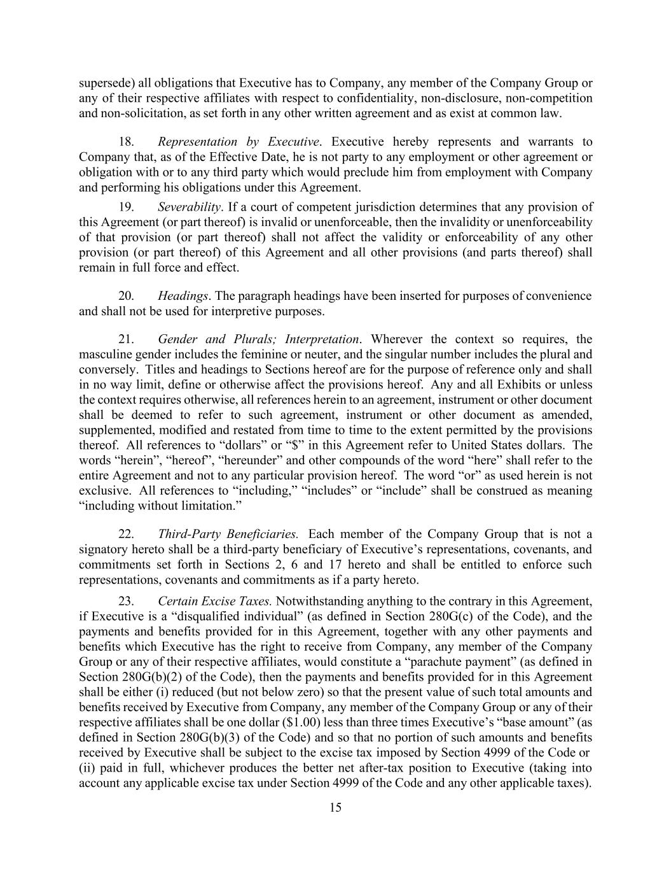
15 supersede) all obligations that Executive has to Company, any member of the Company Group or any of their respective affiliates with respect to confidentiality, non-disclosure, non-competition and non-solicitation, as set forth in any other written agreement and as exist at common law. 18. Representation by Executive. Executive hereby represents and warrants to Company that, as of the Effective Date, he is not party to any employment or other agreement or obligation with or to any third party which would preclude him from employment with Company and performing his obligations under this Agreement. 19. Severability. If a court of competent jurisdiction determines that any provision of this Agreement (or part thereof) is invalid or unenforceable, then the invalidity or unenforceability of that provision (or part thereof) shall not affect the validity or enforceability of any other provision (or part thereof) of this Agreement and all other provisions (and parts thereof) shall remain in full force and effect. 20. Headings. The paragraph headings have been inserted for purposes of convenience and shall not be used for interpretive purposes. 21. Gender and Plurals; Interpretation. Wherever the context so requires, the masculine gender includes the feminine or neuter, and the singular number includes the plural and conversely. Titles and headings to Sections hereof are for the purpose of reference only and shall in no way limit, define or otherwise affect the provisions hereof. Any and all Exhibits or unless the context requires otherwise, all references herein to an agreement, instrument or other document shall be deemed to refer to such agreement, instrument or other document as amended, supplemented, modified and restated from time to time to the extent permitted by the provisions thereof. All references to “dollars” or “$” in this Agreement refer to United States dollars. The words “herein”, “hereof”, “hereunder” and other compounds of the word “here” shall refer to the entire Agreement and not to any particular provision hereof. The word “or” as used herein is not exclusive. All references to “including,” “includes” or “include” shall be construed as meaning “including without limitation.” 22. Third-Party Beneficiaries. Each member of the Company Group that is not a signatory hereto shall be a third-party beneficiary of Executive’s representations, covenants, and commitments set forth in Sections 2, 6 and 17 hereto and shall be entitled to enforce such representations, covenants and commitments as if a party hereto. 23. Certain Excise Taxes. Notwithstanding anything to the contrary in this Agreement, if Executive is a “disqualified individual” (as defined in Section 280G(c) of the Code), and the payments and benefits provided for in this Agreement, together with any other payments and benefits which Executive has the right to receive from Company, any member of the Company Group or any of their respective affiliates, would constitute a “parachute payment” (as defined in Section 280G(b)(2) of the Code), then the payments and benefits provided for in this Agreement shall be either (i) reduced (but not below zero) so that the present value of such total amounts and benefits received by Executive from Company, any member of the Company Group or any of their respective affiliates shall be one dollar ($1.00) less than three times Executive’s “base amount” (as defined in Section 280G(b)(3) of the Code) and so that no portion of such amounts and benefits received by Executive shall be subject to the excise tax imposed by Section 4999 of the Code or (ii) paid in full, whichever produces the better net after-tax position to Executive (taking into account any applicable excise tax under Section 4999 of the Code and any other applicable taxes).

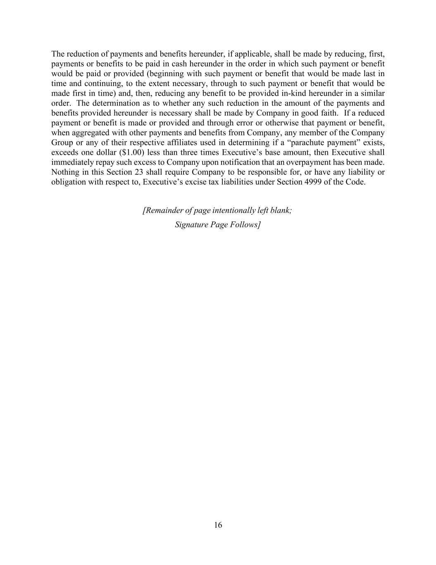
16 The reduction of payments and benefits hereunder, if applicable, shall be made by reducing, first, payments or benefits to be paid in cash hereunder in the order in which such payment or benefit would be paid or provided (beginning with such payment or benefit that would be made last in time and continuing, to the extent necessary, through to such payment or benefit that would be made first in time) and, then, reducing any benefit to be provided in-kind hereunder in a similar order. The determination as to whether any such reduction in the amount of the payments and benefits provided hereunder is necessary shall be made by Company in good faith. If a reduced payment or benefit is made or provided and through error or otherwise that payment or benefit, when aggregated with other payments and benefits from Company, any member of the Company Group or any of their respective affiliates used in determining if a “parachute payment” exists, exceeds one dollar ($1.00) less than three times Executive’s base amount, then Executive shall immediately repay such excess to Company upon notification that an overpayment has been made. Nothing in this Section 23 shall require Company to be responsible for, or have any liability or obligation with respect to, Executive’s excise tax liabilities under Section 4999 of the Code. [Remainder of page intentionally left blank; Signature Page Follows]

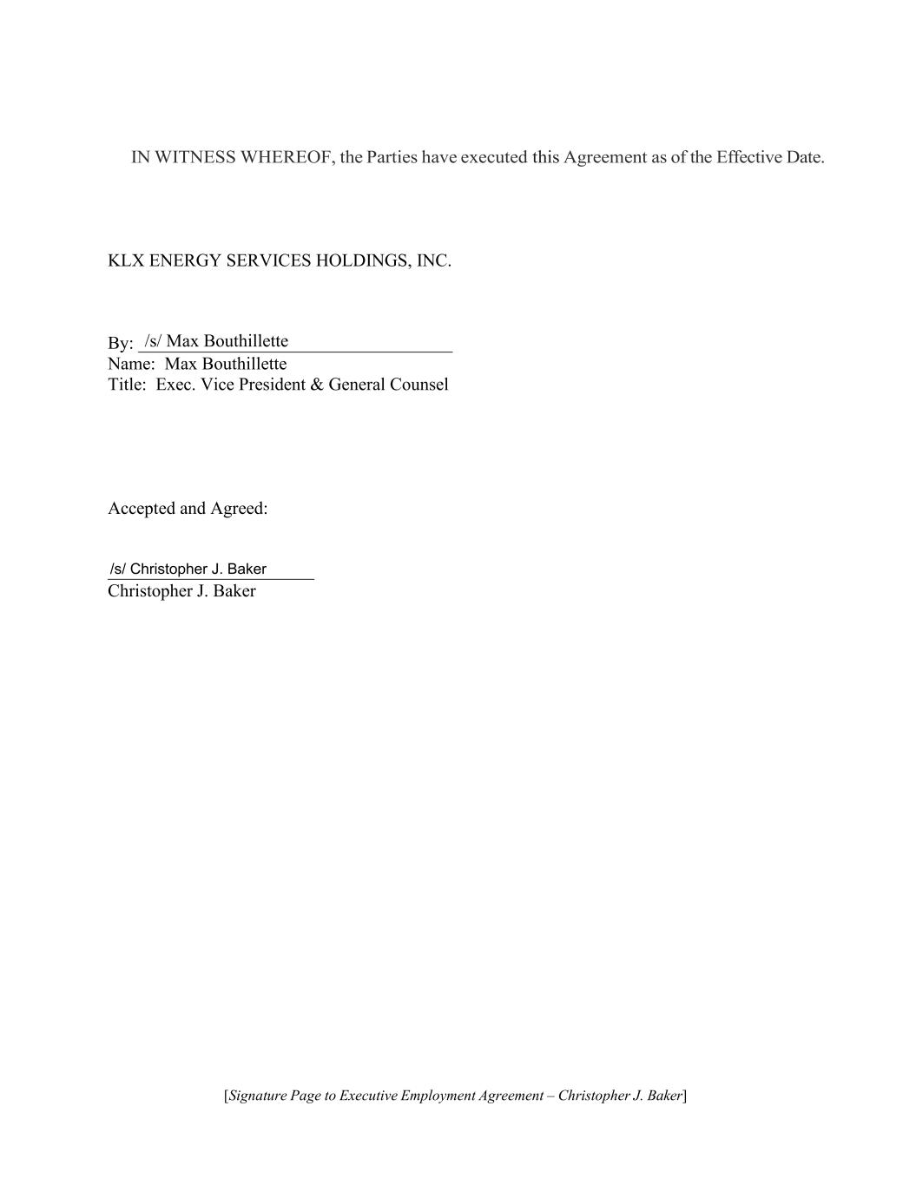
[Signature Page to Executive Employment Agreement – Christopher J. Baker] IN WITNESS WHEREOF, the Parties have executed this Agreement as of the Effective Date. KLX ENERGY SERVICES HOLDINGS, INC. By: ___________________________________ Name: Max Bouthillette Title: Exec. Vice President & General Counsel Accepted and Agreed: _______________________ Christopher J. Baker /s/ Max Bouthillette /s/ Christopher J. Baker

Exhibit 31.1
CERTIFICATION OF CHIEF EXECUTIVE OFFICER
PURSUANT TO RULE 13a-14(a) AND RULE 15d-14(a)
OF THE SECURITIES EXCHANGE ACT OF 1934, AS AMENDED,
AS ADOPTED PURSUANT TO SECTION 302 OF
THE SARBANES-OXLEY ACT OF 2002
I, Christopher J. Baker, certify that:
1. |  |  | I have reviewed this Quarterly Report on Form 10-Q for the quarter ended June 30, 2026 of KLX Energy Services Holdings, Inc. (the “registrant”);
2. |  |  | Based on my knowledge, this report does not contain any untrue statement of a material fact or omit to state a material fact necessary to make the statements made, in light of the circumstances under which such statements were made, not misleading with respect to the period covered by this report;
3. |  |  | Based on my knowledge, the financial statements, and other financial information included in this report, fairly present in all material respects the financial condition, results of operations and cash flows of the registrant as of, and for, the periods presented in this report;
4. |  |  | The registrant’s other certifying officer(s) and I are responsible for establishing and maintaining disclosure controls and procedures (as defined in Exchange Act Rules 13a-15(e) and 15d-15(e)) and internal control over financial reporting (as defined in Exchange Act Rules 13a-15(f) and 15d-15(f)) for the registrant and have:
 |  |  | a. |  |  | Designed such disclosure controls and procedures, or caused such disclosure controls and procedures to be designed under our supervision, to ensure that material information relating to the registrant, including its consolidated subsidiaries, is made known to us by others within those entities, particularly during the period in which this report is being prepared;
 |  |  | b. |  |  | Designed such internal control over financial reporting, or caused such internal control over financial reporting to be designed under our supervision, to provide reasonable assurance regarding the reliability of financial reporting and the preparation of financial statements for external purposes in accordance with generally accepted accounting principles;
 |  |  | c. |  |  | Evaluated the effectiveness of the registrant’s disclosure controls and procedures and presented in this report our conclusions about the effectiveness of the disclosure controls and procedures, as of the end of the period covered by this report based on such evaluation; and
 |  |  | d. |  |  | Disclosed in this report any change in the registrant’s internal control over financial reporting that occurred during the registrant’s most recent fiscal quarter (the registrant’s fourth fiscal quarter in the case of an annual report) that has materially affected, or is reasonably likely to materially affect, the registrant’s internal control over financial reporting; and
5. |  |  | The registrant’s other certifying officer(s) and I have disclosed, based on our most recent evaluation of internal control over financial reporting, to the registrant’s auditors and the audit committee of the registrant’s board of directors (or persons performing the equivalent functions):
 |  |  | a. |  |  | All significant deficiencies and material weaknesses in the design or operation of internal control over financial reporting which are reasonably likely to adversely affect the registrant’s ability to record, process, summarize and report financial information; and
 |  |  | b. |  |  | Any fraud, whether or not material, that involves management or other employees who have a significant role in the registrant’s internal control over financial reporting.

Date: August 11, 2026 |  |  |  |  |  |  |  |  |  |  |  |  |  |  |  |  |  | /s/ Christopher J. Baker
 |  |  |  |  |  |  |  |  |  |  |  |  |  |  |  |  |  | Christopher J. Baker
 |  |  |  |  |  |  |  |  |  |  |  |  |  |  |  |  |  | President and Chief Executive Officer

Exhibit 31.2
CERTIFICATION OF CHIEF FINANCIAL OFFICER
PURSUANT TO RULE 13a-14(a) AND RULE 15d-14(a)
OF THE SECURITIES EXCHANGE ACT OF 1934, AS AMENDED,
AS ADOPTED PURSUANT TO SECTION 302 OF
THE SARBANES-OXLEY ACT OF 2002
I, Geoffrey C. Stanford, certify that:
1. |  |  | I have reviewed this Quarterly Report on Form 10-Q for the quarter ended June 30, 2026 of KLX Energy Services Holdings, Inc. (the “registrant”);
2. |  |  | Based on my knowledge, this report does not contain any untrue statement of a material fact or omit to state a material fact necessary to make the statements made, in light of the circumstances under which such statements were made, not misleading with respect to the period covered by this report;
3. |  |  | Based on my knowledge, the financial statements, and other financial information included in this report, fairly present in all material respects the financial condition, results of operations and cash flows of the registrant as of, and for, the periods presented in this report;
4. |  |  | The registrant’s other certifying officer(s) and I are responsible for establishing and maintaining disclosure controls and procedures (as defined in Exchange Act Rules 13a-15(e) and 15d-15(e)) and internal control over financial reporting (as defined in Exchange Act Rules 13a-15(f) and 15d-15(f)) for the registrant and have:

 |  |  | a. |  |  | Designed such disclosure controls and procedures, or caused such disclosure controls and procedures to be designed under our supervision, to ensure that material information relating to the registrant, including its consolidated subsidiaries, is made known to us by others within those entities, particularly during the period in which this report is being prepared;
 |  |  | b. |  |  | Designed such internal control over financial reporting, or caused such internal control over financial reporting to be designed under our supervision, to provide reasonable assurance regarding the reliability of financial reporting and the preparation of financial statements for external purposes in accordance with generally accepted accounting principles;
 |  |  | c. |  |  | Evaluated the effectiveness of the registrant’s disclosure controls and procedures and presented in this report our conclusions about the effectiveness of the disclosure controls and procedures, as of the end of the period covered by this report based on such evaluation; and
 |  |  | d. |  |  | Disclosed in this report any change in the registrant’s internal control over financial reporting that occurred during the registrant’s most recent fiscal quarter (the registrant’s fourth fiscal quarter in the case of an annual report) that has materially affected, or is reasonably likely to materially affect, the registrant’s internal control over financial reporting; and
5. |  |  | The registrant’s other certifying officer(s) and I have disclosed, based on our most recent evaluation of internal control over financial reporting, to the registrant’s auditors and the audit committee of the registrant’s board of directors (or persons performing the equivalent functions):

 |  |  | a. |  |  | All significant deficiencies and material weaknesses in the design or operation of internal control over financial reporting which are reasonably likely to adversely affect the registrant’s ability to record, process, summarize and report financial information; and
 |  |  | b. |  |  | Any fraud, whether or not material, that involves management or other employees who have a significant role in the registrant’s internal control over financial reporting.
Date: August 11, 2026 |  |  |  |  |  |  |  |  |  |  |  |  |  |  |  |  |  | /s/ Geoffrey C. Stanford
 |  |  |  |  |  |  |  |  |  |  |  |  |  |  |  |  |  | Geoffrey C. Stanford
 |  |  |  |  |  |  |  |  |  |  |  |  |  |  |  |  |  | Senior Vice President, Interim Chief Financial Officer and Chief Accounting Officer

Exhibit 32.1
CERTIFICATION OF
CHIEF EXECUTIVE OFFICER
PURSUANT TO 18 U.S.C. SECTION 1350,
AS ADOPTED PURSUANT TO SECTION 906 OF THE
SARBANES OXLEY ACT OF 2002
Pursuant to 18 U.S.C. Section 1350, as adopted pursuant to Section 906 of the Sarbanes-Oxley Act of 2002, in connection with the Quarterly Report of KLX Energy Services Holdings, Inc. (the “Company”) on Form 10-Q for the period ended June 30, 2026, as filed with the Securities and Exchange Commission on the date hereof (the “Periodic Report”), I, Christopher J. Baker, as President and Chief Executive Officer of the Company, hereby certify that:

(1)the Periodic Report fully complies with the requirements of Section 13(a) or 15(d) of the Securities Exchange Act of 1934, as amended; and
(2)the information contained in the Periodic Report fairly presents, in all material respects, the financial condition and results of operations of the Company.
Date: August 11, 2026 |  |  |  |  |  |  |  |  |  |  |  |  |  |  |  |  |  | /s/ Christopher J. Baker
 |  |  |  |  |  |  |  |  |  |  |  |  |  |  |  |  |  | Christopher J. Baker
 |  |  |  |  |  |  |  |  |  |  |  |  |  |  |  |  |  | President and Chief Executive Officer
 |  |  |  |  |  |  |  |  |  |  |  |  |  |  |  |  |  | (Principal Executive Officer)

Exhibit 32.2
CERTIFICATION OF
CHIEF FINANCIAL OFFICER
PURSUANT TO 18 U.S.C. SECTION 1350,
AS ADOPTED PURSUANT TO SECTION 906 OF THE
SARBANES OXLEY ACT OF 2002
Pursuant to 18 U.S.C. Section 1350, as adopted pursuant to Section 906 of the Sarbanes-Oxley Act of 2002, in connection with the Quarterly Report of KLX Energy Services Holdings, Inc. (the “Company”) on Form 10-Q for the period ended June 30, 2026, as filed with the Securities and Exchange Commission on the date hereof (the “Periodic Report”), I, Geoffrey C. Stanford, as Interim Chief Financial Officer of the Company, hereby certify that:

(1)the Periodic Report fully complies with the requirements of Section 13(a) or 15(d) of the Securities Exchange Act of 1934, as amended; and
(2)the information contained in the Periodic Report fairly presents, in all material respects, the financial condition and results of operations of the Company.
Date: August 11, 2026 |  |  |  |  |  |  |  |  |  |  |  |  |  |  |  |  |  | /s/ Geoffrey C. Stanford
 |  |  |  |  |  |  |  |  |  |  |  |  |  |  |  |  |  | Geoffrey C. Stanford
 |  |  |  |  |  |  |  |  |  |  |  |  |  |  |  |  |  | Senior Vice President, Interim Chief Financial Officer and Chief Accounting Officer
 |  |  |  |  |  |  |  |  |  |  |  |  |  |  |  |  |  | (Principal Financial Officer)

