UNITED STATES
SECURITIES AND EXCHANGE COMMISSION
Washington, D.C. 20549

FORM 8-K/A

CURRENT REPORT
Pursuant to Section 13 or 15(d)
of the Securities Exchange Act of 1934

Date of Report (Date of earliest event reported): June 2, 2026

_____________________

KLX ENERGY SERVICES HOLDINGS, INC.
(Exact name of registrant as specified in its charter)
_____________________

Delaware |  |  | 001-38609 |  |  | 36-4904146
(State or Other Jurisdiction of Incorporation) |  |  | (Commission File Number) |  |  | (IRS Employer Identification No.)
3040 Post Oak Boulevard, 15th Floor
Houston, Texas 77056
(Address of Principal Executive Offices)
(832) 844-1015
(Registrant’s Telephone Number, Including Area Code)
_____________________

Check the appropriate box below if the Form 8-K filing is intended to simultaneously satisfy the filing obligation of the registrant under any of the following provisions:
☐ |  |  | Written communications pursuant to Rule 425 under the Securities Act (17 CFR 230.425)
☐ |  |  | Soliciting material pursuant to Rule 14a-12 under the Exchange Act (17 CFR 240.14a-12)
☐ |  |  | Pre-commencement communications pursuant to Rule 14d-2(b) under the Exchange Act (17 CFR 240.14d-2(b))
☐ |  |  | Pre-commencement communications pursuant to Rule 13e-4(c) under the Exchange Act (17 CFR 240.13e-4(c))
Securities registered pursuant to Section 12(b) of the Act:

 |  |  |  |  |  | Trading |  |  |  |  |  | Name of each exchange
Title of each class |  |  |  |  |  | symbol(s) |  |  |  |  |  | on which registered
Common Stock, $0.01 Par Value |  |  |  |  |  | KLXE |  |  |  |  |  | The Nasdaq Global Select Market
_____________________

Indicate by check mark whether the registrant is an emerging growth company as defined in Rule 405 of the Securities Act of 1933 (§230.405 of this chapter) or Rule 12b-2 of the Securities Exchange Act of 1934 (§240.12b-2 of this chapter).
☐ |  |  | Emerging growth company
If an emerging growth company, indicate by check mark if the registrant has elected not to use the extended transition period for complying with any new or revised financial accounting standards provided pursuant to Section 13(a) of the Exchange Act ☐

Explanatory Note

This Amendment No. 1 on Form 8-K/A (this “Amendment”) is being filed by KLX Energy Services Holdings, Inc., a Delaware corporation (the “Company”), to amend and supplement its Current Report on Form 8-K filed with the Securities and Exchange Commission on June 2, 2026 (the “Original Report”). As previously disclosed in the Original Report, on June 2, 2026, the Company completed the acquisition of certain assets owned by Wolf Pack Rentals, LLC, a Texas limited liability company (“Wolf Pack”), pursuant to that certain asset purchase agreement, dated June 2, 2026, by and among Wolf Pack, KLX Energy Services LLC, a Delaware limited liability company and indirect wholly owned subsidiary of the Company (the “Buyer”), the Company and, solely for purposes of Section 8.05 thereto, Stevie Cooper and Stewart Cooper (the “Purchase Agreement”).

The Company is filing this Amendment solely to supplement Item 9.01 of the Original Report to file (i) the audited financial statements of Wolf Pack for the year ended December 31, 2025, (ii) the unaudited condensed financial statements of Wolf Pack as of and for the three months ended March 31, 2026 and (iii) the unaudited pro forma combined financial information of the Company as of and for three months ended March 31, 2026 and for the year ended December 31, 2025, which gives effect to the acquisition as if it had been consummated on January 1, 2025. Except for the foregoing, this Amendment does not modify or update any other disclosure contained in the Original Report.

Item 9.01 Financial Statements and Exhibits.

(a) Financial statements of businesses acquired.

The audited financial statements of Wolf Pack as of and for the year ended December 31, 2025 and the unaudited condensed financial statements of Wolf Pack as of and for the three months ended March 31, 2026 are filed herewith and attached hereto as Exhibits 99.1 and 99.2, respectively, and are incorporated by reference herein.

(b) Pro forma financial information.

The Company’s unaudited pro forma condensed combined balance sheet as of March 31, 2026, the unaudited pro forma condensed combined statement of operations for the three months ended March 31, 2026 and the year ended December 31, 2025 are filed herewith and attached hereto as Exhibit 99.3 and are incorporated by reference herein.

(d) Exhibits.

Exhibit
No. |  |  |  |  |  | Description
23.1 |  |  |  |  |  | Consent of Weaver and Tidwell, L.L.P.
99.1 |  |  |  |  |  | Audited Financial Statements of Wolfpack Energy Services, LLC as of and for the year ended December 31, 2025
99.2 |  |  |  |  |  | Unaudited Interim Condensed Consolidated Financial Statements of Wolfpack Energy Services, LLC as of and for the three months ended March 31, 2026
99.3 |  |  |  |  |  | Unaudited Pro Forma Condensed Combined Financial Information of the Company as of and for the three months ended March 31, 2026 and for the year ended December 31, 2025
104 |  |  |  |  |  | Cover Page Interactive Data File (embedded within Inline XBRL document).

SIGNATURES

Pursuant to the requirements of the Securities Exchange Act of 1934, as amended, the registrant has duly caused this report to be signed on its behalf by the undersigned, thereunto duly authorized.

 |  |  | KLX Energy Services Holdings, Inc.
 |  |  | By: |  |  | /s/ Geoffrey C. Stanford
 |  |  | Name: |  |  | Geoffrey Stanford
 |  |  | Title: |  |  | Senior Vice President, Interim Chief Financial Officer and Chief Accounting Officer
 |  |  | Date: |  |  | August 12, 2026

Exhibit 23.1

CONSENT OF INDEPENDENT AUDITORS

We consent to the incorporation in the Registration Statement Nos. 333-227321, 333-253151 and 333-272556 on Form S-8 No. 333-238870 on Form S-4 and Registration Statement Nos. 333-256149, 333-271182, 333-287774 and 333-295905 on Form S-3 of KLX Energy Services Holdings, Inc. of our report dated August 6, 2026, with respect to the consolidated balance sheets of Wolfpack Energy Services, LLC of December 31, 2025 and 2024 and the related consolidated statements of operations, changes in members’ equity, and cash flows for the years then ended, and the related notes to the consolidated financial statements, included in this Current Report on Form 8-K/A dated August 12, 2026.

/s/ Weaver & Tidwell L.L.P.

Houston, Texas
August 12, 2026
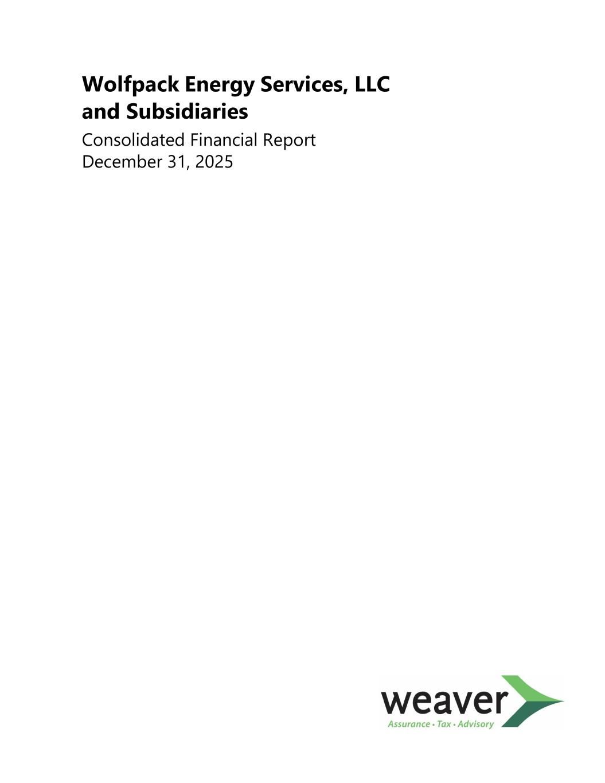

Wolfpack Energy Services, LLC and Subsidiaries Consolidated Financial Report December 31, 2025

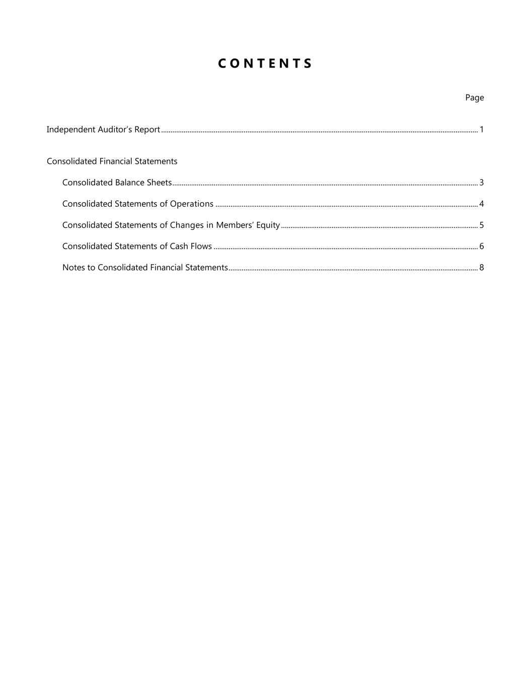
C O N T E N T S Page Independent Auditor’s Report ......................................................................................................................................................................... 1 Consolidated Financial Statements Consolidated Balance Sheets ................................................................................................................................................................... 3 Consolidated Statements of Operations ............................................................................................................................................ 4 Consolidated Statements of Changes in Members’ Equity ......................................................................................................... 5 Consolidated Statements of Cash Flows ............................................................................................................................................. 6 Notes to Consolidated Financial Statements ..................................................................................................................................... 8

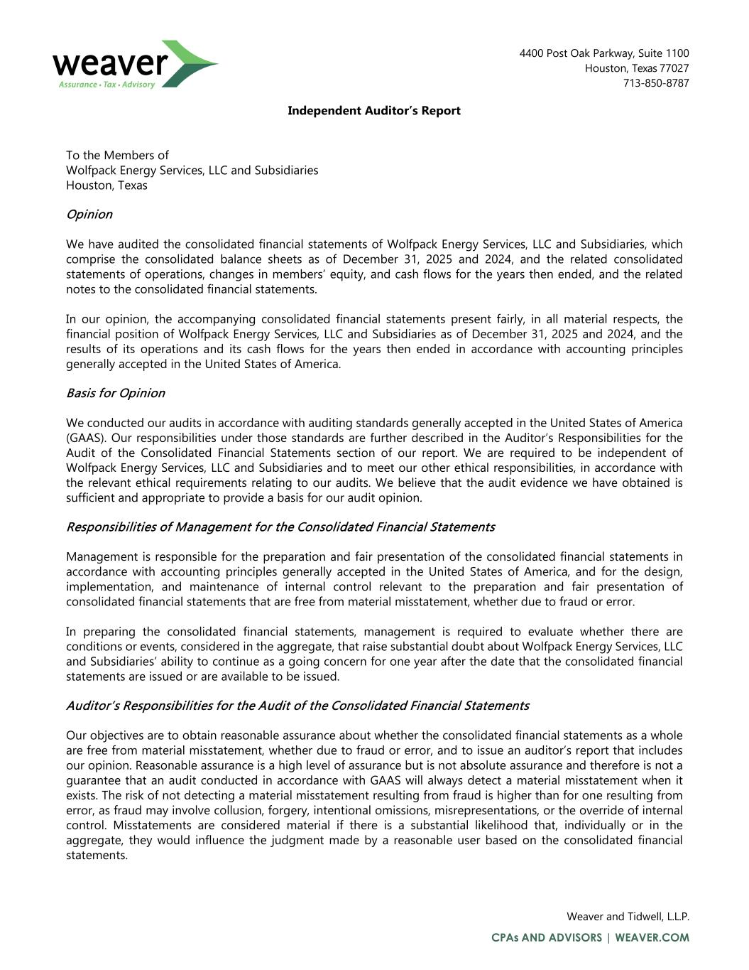
Independent Auditor’s Report To the Members of Wolfpack Energy Services, LLC and Subsidiaries Houston, Texas Opinion We have audited the consolidated financial statements of Wolfpack Energy Services, LLC and Subsidiaries, which comprise the consolidated balance sheets as of December 31, 2025 and 2024, and the related consolidated statements of operations, changes in members’ equity, and cash flows for the years then ended, and the related notes to the consolidated financial statements. In our opinion, the accompanying consolidated financial statements present fairly, in all material respects, the financial position of Wolfpack Energy Services, LLC and Subsidiaries as of December 31, 2025 and 2024, and the results of its operations and its cash flows for the years then ended in accordance with accounting principles generally accepted in the United States of America. Basis for Opinion We conducted our audits in accordance with auditing standards generally accepted in the United States of America (GAAS). Our responsibilities under those standards are further described in the Auditor’s Responsibilities for the Audit of the Consolidated Financial Statements section of our report. We are required to be independent of Wolfpack Energy Services, LLC and Subsidiaries and to meet our other ethical responsibilities, in accordance with the relevant ethical requirements relating to our audits. We believe that the audit evidence we have obtained is sufficient and appropriate to provide a basis for our audit opinion. Responsibilities of Management for the Consolidated Financial Statements Management is responsible for the preparation and fair presentation of the consolidated financial statements in accordance with accounting principles generally accepted in the United States of America, and for the design, implementation, and maintenance of internal control relevant to the preparation and fair presentation of consolidated financial statements that are free from material misstatement, whether due to fraud or error. In preparing the consolidated financial statements, management is required to evaluate whether there are conditions or events, considered in the aggregate, that raise substantial doubt about Wolfpack Energy Services, LLC and Subsidiaries’ ability to continue as a going concern for one year after the date that the consolidated financial statements are issued or are available to be issued. Auditor’s Responsibilities for the Audit of the Consolidated Financial Statements Our objectives are to obtain reasonable assurance about whether the consolidated financial statements as a whole are free from material misstatement, whether due to fraud or error, and to issue an auditor’s report that includes our opinion. Reasonable assurance is a high level of assurance but is not absolute assurance and therefore is not a guarantee that an audit conducted in accordance with GAAS will always detect a material misstatement when it exists. The risk of not detecting a material misstatement resulting from fraud is higher than for one resulting from error, as fraud may involve collusion, forgery, intentional omissions, misrepresentations, or the override of internal control. Misstatements are considered material if there is a substantial likelihood that, individually or in the aggregate, they would influence the judgment made by a reasonable user based on the consolidated financial statements.

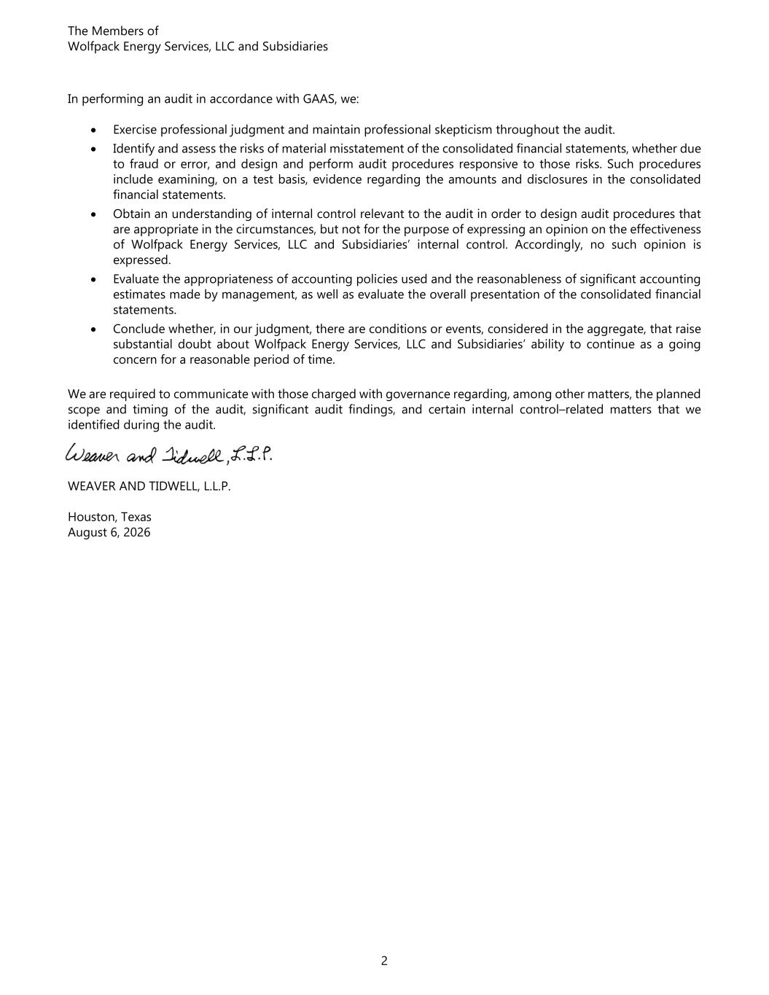
The Members of Wolfpack Energy Services, LLC and Subsidiaries 2 In performing an audit in accordance with GAAS, we: • Exercise professional judgment and maintain professional skepticism throughout the audit. • Identify and assess the risks of material misstatement of the consolidated financial statements, whether due to fraud or error, and design and perform audit procedures responsive to those risks. Such procedures include examining, on a test basis, evidence regarding the amounts and disclosures in the consolidated financial statements. • Obtain an understanding of internal control relevant to the audit in order to design audit procedures that are appropriate in the circumstances, but not for the purpose of expressing an opinion on the effectiveness of Wolfpack Energy Services, LLC and Subsidiaries’ internal control. Accordingly, no such opinion is expressed. • Evaluate the appropriateness of accounting policies used and the reasonableness of significant accounting estimates made by management, as well as evaluate the overall presentation of the consolidated financial statements. • Conclude whether, in our judgment, there are conditions or events, considered in the aggregate, that raise substantial doubt about Wolfpack Energy Services, LLC and Subsidiaries’ ability to continue as a going concern for a reasonable period of time. We are required to communicate with those charged with governance regarding, among other matters, the planned scope and timing of the audit, significant audit findings, and certain internal control–related matters that we identified during the audit. WEAVER AND TIDWELL, L.L.P. Houston, Texas August 6, 2026

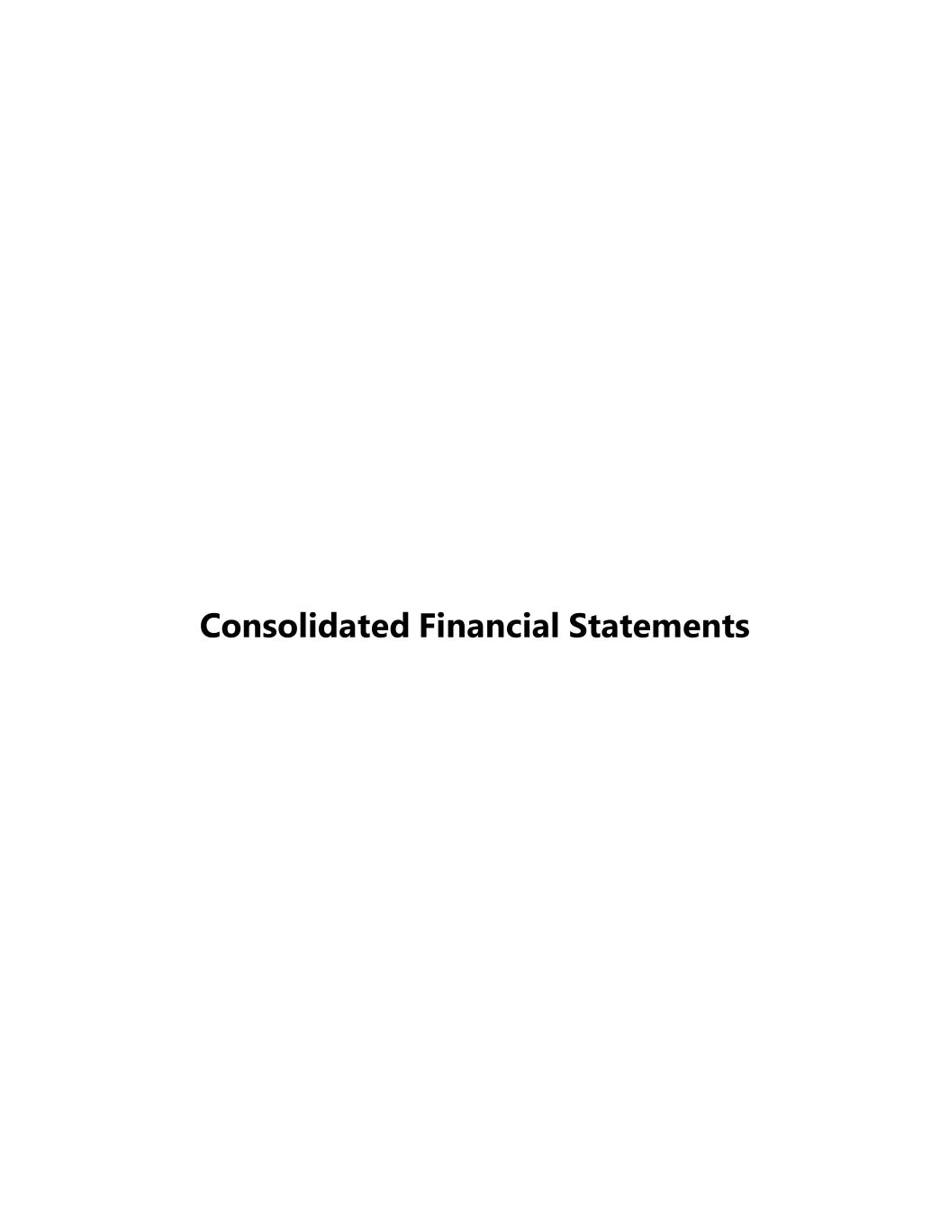
Consolidated Financial Statements

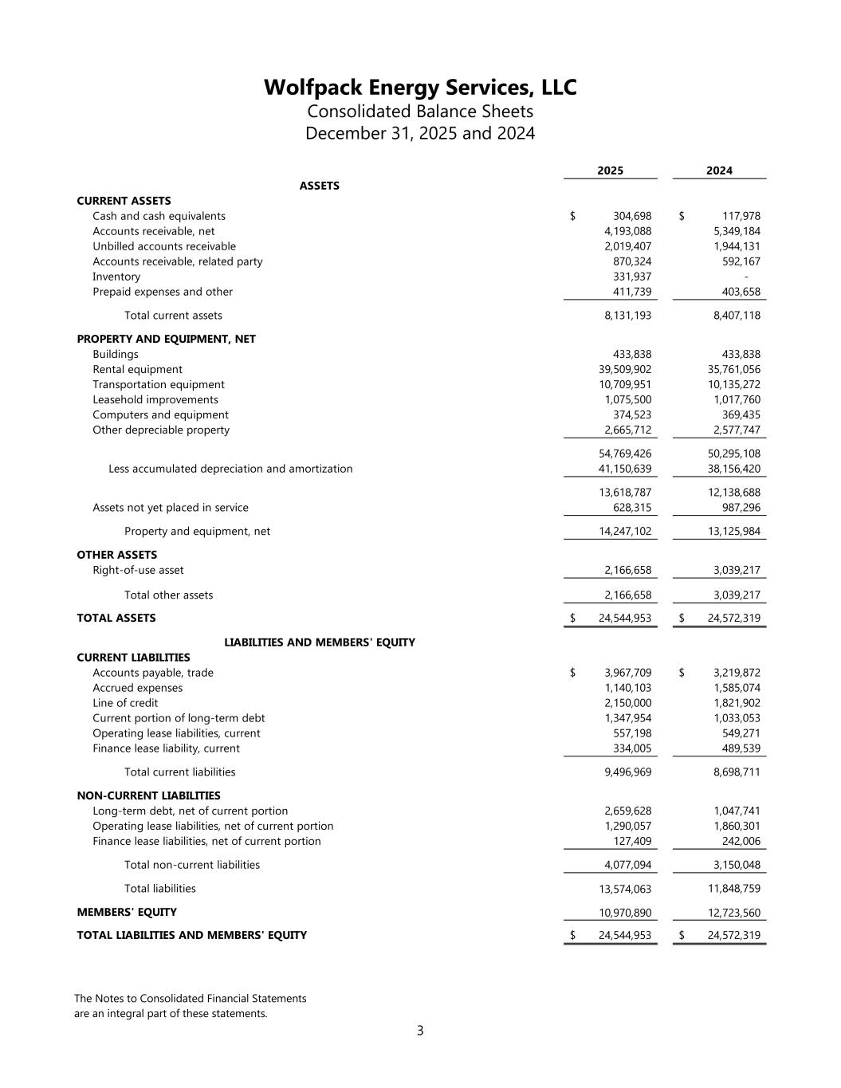
Wolfpack Energy Services, LLC Consolidated Balance Sheets December 31, 2025 and 2024 The Notes to Consolidated Financial Statements are an integral part of these statements. 3 2025 2024 CURRENT ASSETS Cash and cash equivalents 304,698$ 117,978$ Accounts receivable, net 4,193,088 5,349,184 Unbilled accounts receivable 2,019,407 1,944,131 Accounts receivable, related party 870,324 592,167 Inventory 331,937 - Prepaid expenses and other 411,739 403,658 Total current assets 8,131,193 8,407,118 PROPERTY AND EQUIPMENT, NET Buildings 433,838 433,838 Rental equipment 39,509,902 35,761,056 Transportation equipment 10,709,951 10,135,272 Leasehold improvements 1,075,500 1,017,760 Computers and equipment 374,523 369,435 Other depreciable property 2,665,712 2,577,747 54,769,426 50,295,108 Less accumulated depreciation and amortization 41,150,639 38,156,420 13,618,787 12,138,688 Assets not yet placed in service 628,315 987,296 Property and equipment, net 14,247,102 13,125,984 OTHER ASSETS Right-of-use asset 2,166,658 3,039,217 Total other assets 2,166,658 3,039,217 TOTAL ASSETS 24,544,953$ 24,572,319$ CURRENT LIABILITIES Accounts payable, trade 3,967,709$ 3,219,872$ Accrued expenses 1,140,103 1,585,074 Line of credit 2,150,000 1,821,902 Current portion of long-term debt 1,347,954 1,033,053 Operating lease liabilities, current 557,198 549,271 Finance lease liability, current 334,005 489,539 Total current liabilities 9,496,969 8,698,711 NON-CURRENT LIABILITIES Long-term debt, net of current portion 2,659,628 1,047,741 Operating lease liabilities, net of current portion 1,290,057 1,860,301 Finance lease liabilities, net of current portion 127,409 242,006 Total non-current liabilities 4,077,094 3,150,048 Total liabilities 13,574,063 11,848,759 MEMBERS' EQUITY 10,970,890 12,723,560 TOTAL LIABILITIES AND MEMBERS' EQUITY 24,544,953$ 24,572,319$ LIABILITIES AND MEMBERS' EQUITY ASSETS

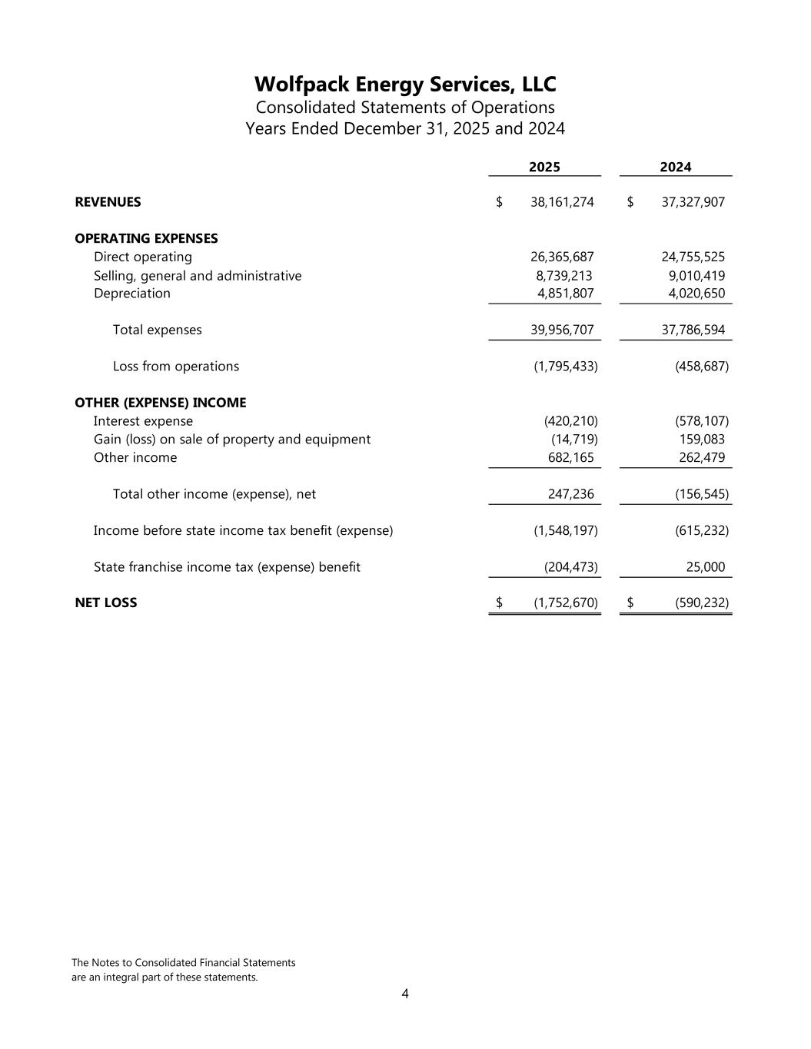
Wolfpack Energy Services, LLC Consolidated Statements of Operations Years Ended December 31, 2025 and 2024 The Notes to Consolidated Financial Statements are an integral part of these statements. 4 2025 2024 REVENUES 38,161,274$ 37,327,907$ OPERATING EXPENSES Direct operating 26,365,687 24,755,525 Selling, general and administrative 8,739,213 9,010,419 Depreciation 4,851,807 4,020,650 Total expenses 39,956,707 37,786,594 Loss from operations (1,795,433) (458,687) OTHER (EXPENSE) INCOME Interest expense (420,210) (578,107) Gain (loss) on sale of property and equipment (14,719) 159,083 Other income 682,165 262,479 Total other income (expense), net 247,236 (156,545) Income before state income tax benefit (expense) (1,548,197) (615,232) State franchise income tax (expense) benefit (204,473) 25,000 NET LOSS (1,752,670)$ (590,232)$

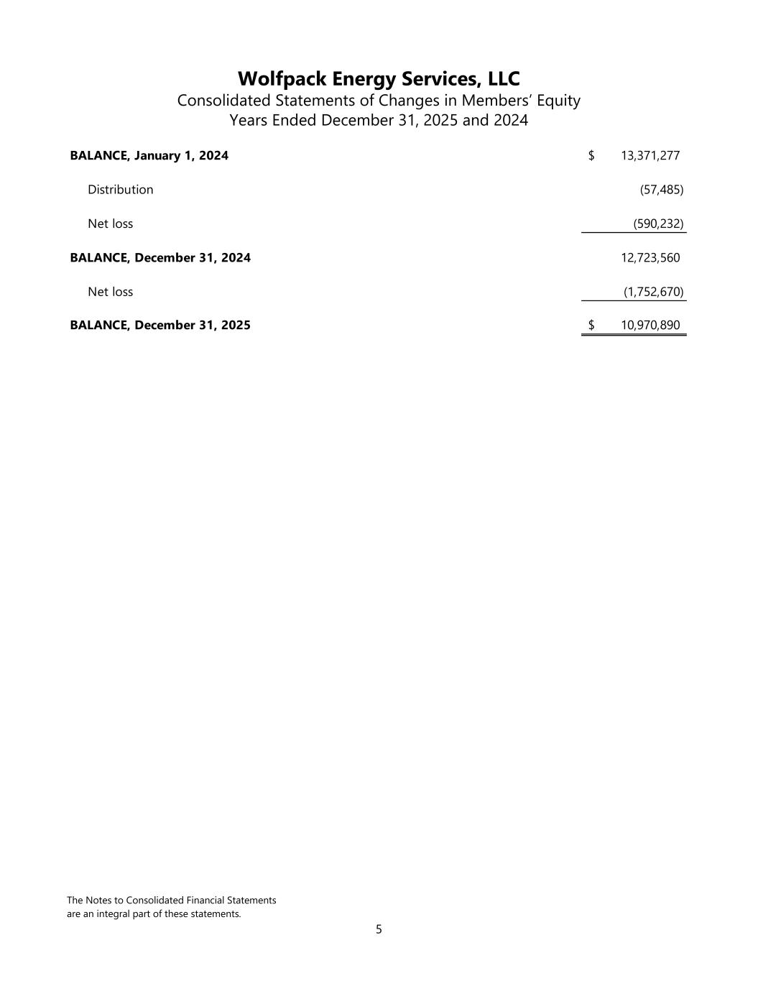
Wolfpack Energy Services, LLC Consolidated Statements of Changes in Members’ Equity Years Ended December 31, 2025 and 2024 The Notes to Consolidated Financial Statements are an integral part of these statements. 5 BALANCE, January 1, 2024 13,371,277$ Distribution (57,485) Net loss (590,232) BALANCE, December 31, 2024 12,723,560 Net loss (1,752,670) BALANCE, December 31, 2025 10,970,890$

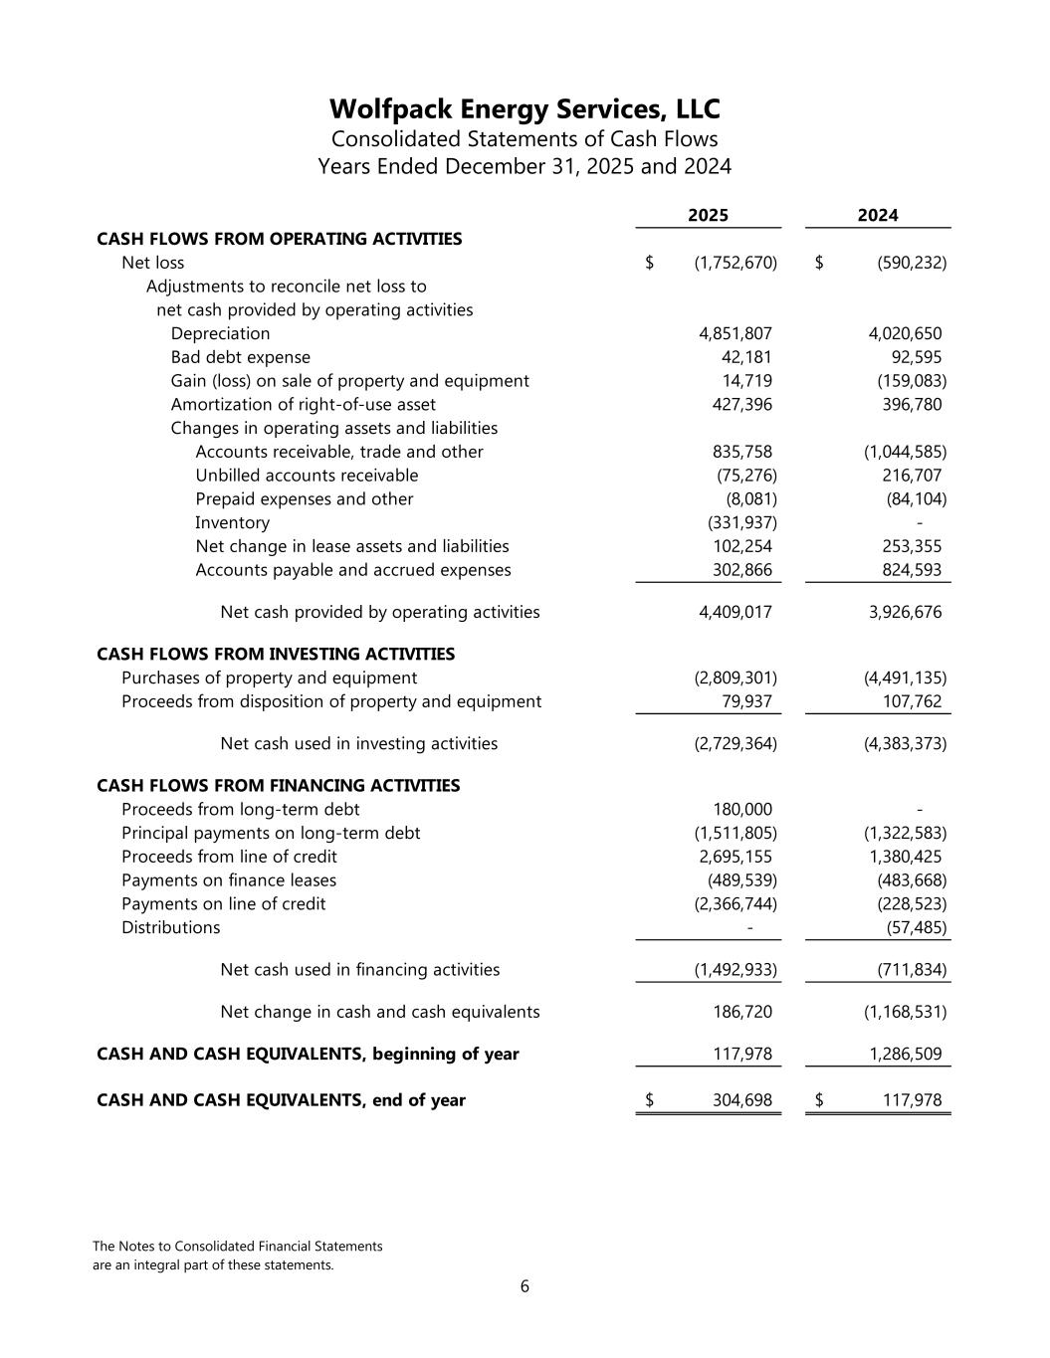
Wolfpack Energy Services, LLC Consolidated Statements of Cash Flows Years Ended December 31, 2025 and 2024 The Notes to Consolidated Financial Statements are an integral part of these statements. 6 2025 2024 CASH FLOWS FROM OPERATING ACTIVITIES Net loss (1,752,670)$ (590,232)$ Adjustments to reconcile net loss to net cash provided by operating activities Depreciation 4,851,807 4,020,650 Bad debt expense 42,181 92,595 Gain (loss) on sale of property and equipment 14,719 (159,083) Amortization of right-of-use asset 427,396 396,780 Changes in operating assets and liabilities Accounts receivable, trade and other 835,758 (1,044,585) Unbilled accounts receivable (75,276) 216,707 Prepaid expenses and other (8,081) (84,104) Inventory (331,937) - Net change in lease assets and liabilities 102,254 253,355 Accounts payable and accrued expenses 302,866 824,593 Net cash provided by operating activities 4,409,017 3,926,676 CASH FLOWS FROM INVESTING ACTIVITIES Purchases of property and equipment (2,809,301) (4,491,135) Proceeds from disposition of property and equipment 79,937 107,762 Net cash used in investing activities (2,729,364) (4,383,373) CASH FLOWS FROM FINANCING ACTIVITIES Proceeds from long-term debt 180,000 - Principal payments on long-term debt (1,511,805) (1,322,583) Proceeds from line of credit 2,695,155 1,380,425 Payments on finance leases (489,539) (483,668) Payments on line of credit (2,366,744) (228,523) Distributions - (57,485) Net cash used in financing activities (1,492,933) (711,834) Net change in cash and cash equivalents 186,720 (1,168,531) CASH AND CASH EQUIVALENTS, beginning of year 117,978 1,286,509 CASH AND CASH EQUIVALENTS, end of year 304,698$ 117,978$

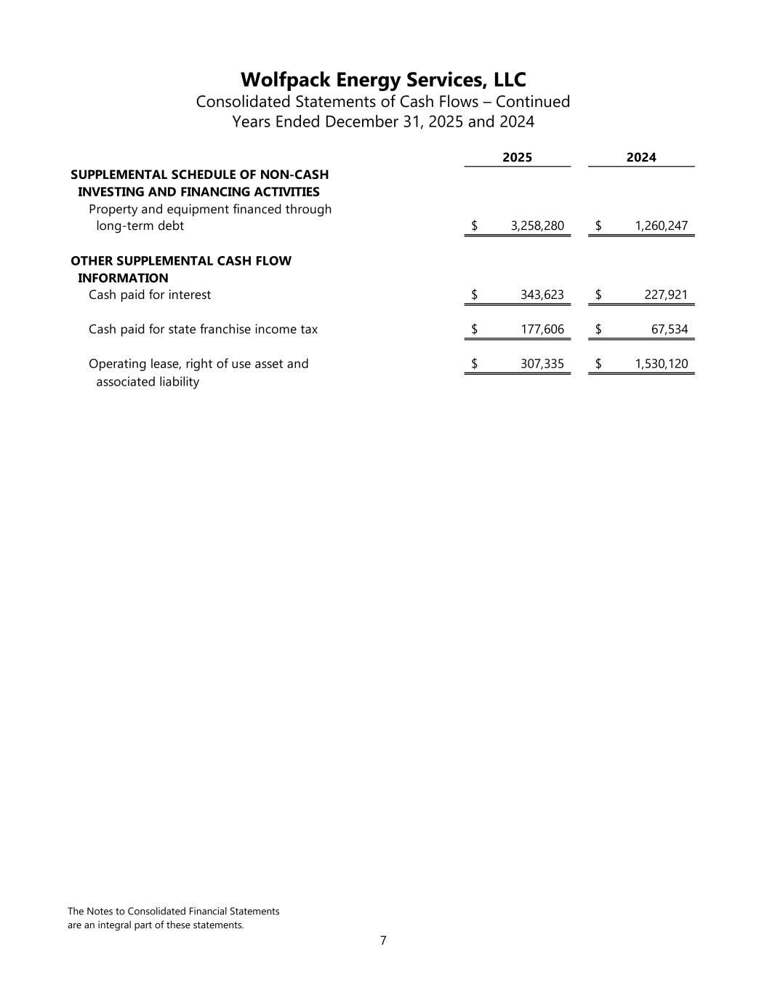
Wolfpack Energy Services, LLC Consolidated Statements of Cash Flows – Continued Years Ended December 31, 2025 and 2024 The Notes to Consolidated Financial Statements are an integral part of these statements. 7 2025 2024 SUPPLEMENTAL SCHEDULE OF NON-CASH INVESTING AND FINANCING ACTIVITIES Property and equipment financed through long-term debt 3,258,280$ 1,260,247$ OTHER SUPPLEMENTAL CASH FLOW INFORMATION Cash paid for interest 343,623$ 227,921$ Cash paid for state franchise income tax 177,606$ 67,534$ Operating lease, right of use asset and 307,335$ 1,530,120$ associated liability

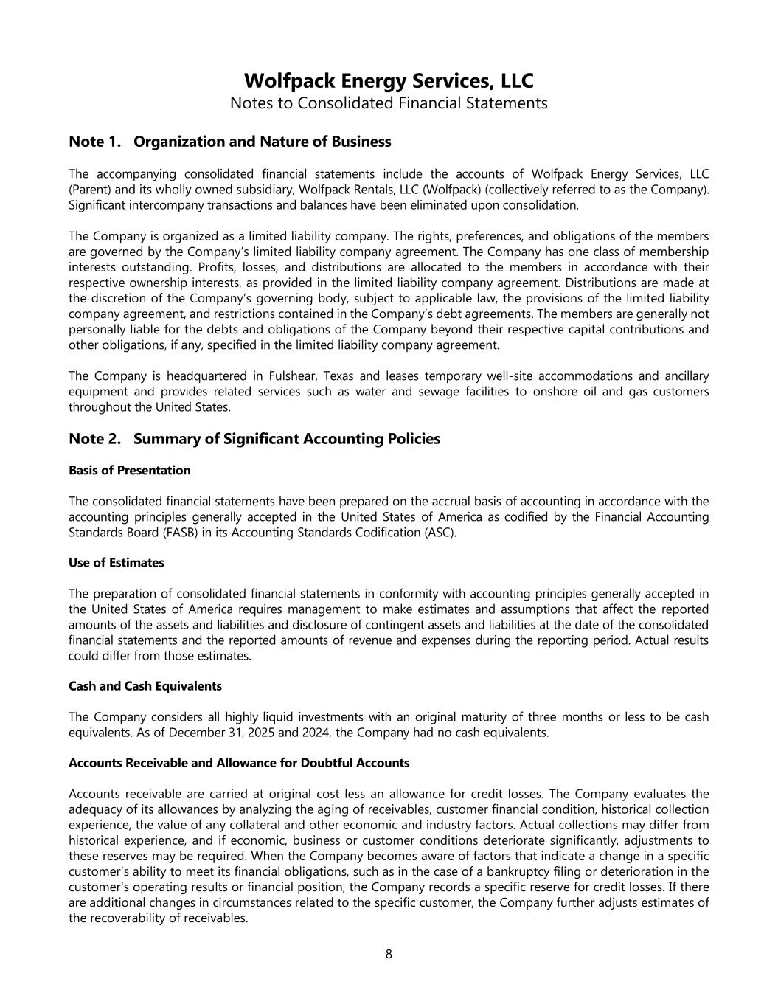
Wolfpack Energy Services, LLC Notes to Consolidated Financial Statements 8 Note 1. Organization and Nature of Business The accompanying consolidated financial statements include the accounts of Wolfpack Energy Services, LLC (Parent) and its wholly owned subsidiary, Wolfpack Rentals, LLC (Wolfpack) (collectively referred to as the Company). Significant intercompany transactions and balances have been eliminated upon consolidation. The Company is organized as a limited liability company. The rights, preferences, and obligations of the members are governed by the Company’s limited liability company agreement. The Company has one class of membership interests outstanding. Profits, losses, and distributions are allocated to the members in accordance with their respective ownership interests, as provided in the limited liability company agreement. Distributions are made at the discretion of the Company’s governing body, subject to applicable law, the provisions of the limited liability company agreement, and restrictions contained in the Company’s debt agreements. The members are generally not personally liable for the debts and obligations of the Company beyond their respective capital contributions and other obligations, if any, specified in the limited liability company agreement. The Company is headquartered in Fulshear, Texas and leases temporary well-site accommodations and ancillary equipment and provides related services such as water and sewage facilities to onshore oil and gas customers throughout the United States. Note 2. Summary of Significant Accounting Policies Basis of Presentation The consolidated financial statements have been prepared on the accrual basis of accounting in accordance with the accounting principles generally accepted in the United States of America as codified by the Financial Accounting Standards Board (FASB) in its Accounting Standards Codification (ASC). Use of Estimates The preparation of consolidated financial statements in conformity with accounting principles generally accepted in the United States of America requires management to make estimates and assumptions that affect the reported amounts of the assets and liabilities and disclosure of contingent assets and liabilities at the date of the consolidated financial statements and the reported amounts of revenue and expenses during the reporting period. Actual results could differ from those estimates. Cash and Cash Equivalents The Company considers all highly liquid investments with an original maturity of three months or less to be cash equivalents. As of December 31, 2025 and 2024, the Company had no cash equivalents. Accounts Receivable and Allowance for Doubtful Accounts Accounts receivable are carried at original cost less an allowance for credit losses. The Company evaluates the adequacy of its allowances by analyzing the aging of receivables, customer financial condition, historical collection experience, the value of any collateral and other economic and industry factors. Actual collections may differ from historical experience, and if economic, business or customer conditions deteriorate significantly, adjustments to these reserves may be required. When the Company becomes aware of factors that indicate a change in a specific customer’s ability to meet its financial obligations, such as in the case of a bankruptcy filing or deterioration in the customer's operating results or financial position, the Company records a specific reserve for credit losses. If there are additional changes in circumstances related to the specific customer, the Company further adjusts estimates of the recoverability of receivables.

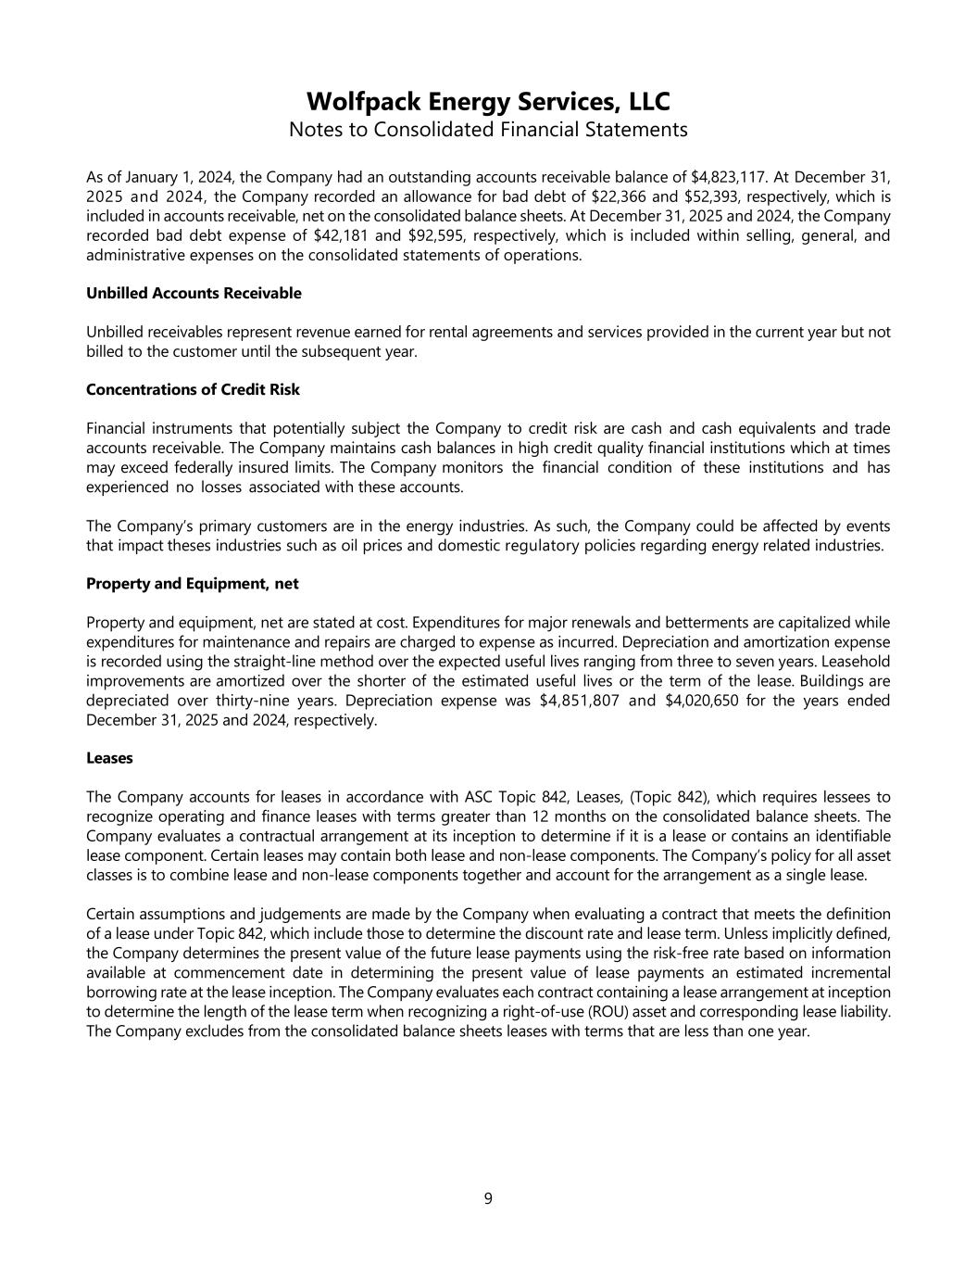
Wolfpack Energy Services, LLC Notes to Consolidated Financial Statements 9 As of January 1, 2024, the Company had an outstanding accounts receivable balance of $4,823,117. At December 31, 2025 and 2024, the Company recorded an allowance for bad debt of $22,366 and $52,393, respectively, which is included in accounts receivable, net on the consolidated balance sheets. At December 31, 2025 and 2024, the Company recorded bad debt expense of $42,181 and $92,595, respectively, which is included within selling, general, and administrative expenses on the consolidated statements of operations. Unbilled Accounts Receivable Unbilled receivables represent revenue earned for rental agreements and services provided in the current year but not billed to the customer until the subsequent year. Concentrations of Credit Risk Financial instruments that potentially subject the Company to credit risk are cash and cash equivalents and trade accounts receivable. The Company maintains cash balances in high credit quality financial institutions which at times may exceed federally insured limits. The Company monitors the financial condition of these institutions and has experienced no losses associated with these accounts. The Company’s primary customers are in the energy industries. As such, the Company could be affected by events that impact theses industries such as oil prices and domestic regulatory policies regarding energy related industries. Property and Equipment, net Property and equipment, net are stated at cost. Expenditures for major renewals and betterments are capitalized while expenditures for maintenance and repairs are charged to expense as incurred. Depreciation and amortization expense is recorded using the straight-line method over the expected useful lives ranging from three to seven years. Leasehold improvements are amortized over the shorter of the estimated useful lives or the term of the lease. Buildings are depreciated over thirty-nine years. Depreciation expense was $4,851,807 and $4,020,650 for the years ended December 31, 2025 and 2024, respectively. Leases The Company accounts for leases in accordance with ASC Topic 842, Leases, (Topic 842), which requires lessees to recognize operating and finance leases with terms greater than 12 months on the consolidated balance sheets. The Company evaluates a contractual arrangement at its inception to determine if it is a lease or contains an identifiable lease component. Certain leases may contain both lease and non-lease components. The Company’s policy for all asset classes is to combine lease and non-lease components together and account for the arrangement as a single lease. Certain assumptions and judgements are made by the Company when evaluating a contract that meets the definition of a lease under Topic 842, which include those to determine the discount rate and lease term. Unless implicitly defined, the Company determines the present value of the future lease payments using the risk-free rate based on information available at commencement date in determining the present value of lease payments an estimated incremental borrowing rate at the lease inception. The Company evaluates each contract containing a lease arrangement at inception to determine the length of the lease term when recognizing a right-of-use (ROU) asset and corresponding lease liability. The Company excludes from the consolidated balance sheets leases with terms that are less than one year.

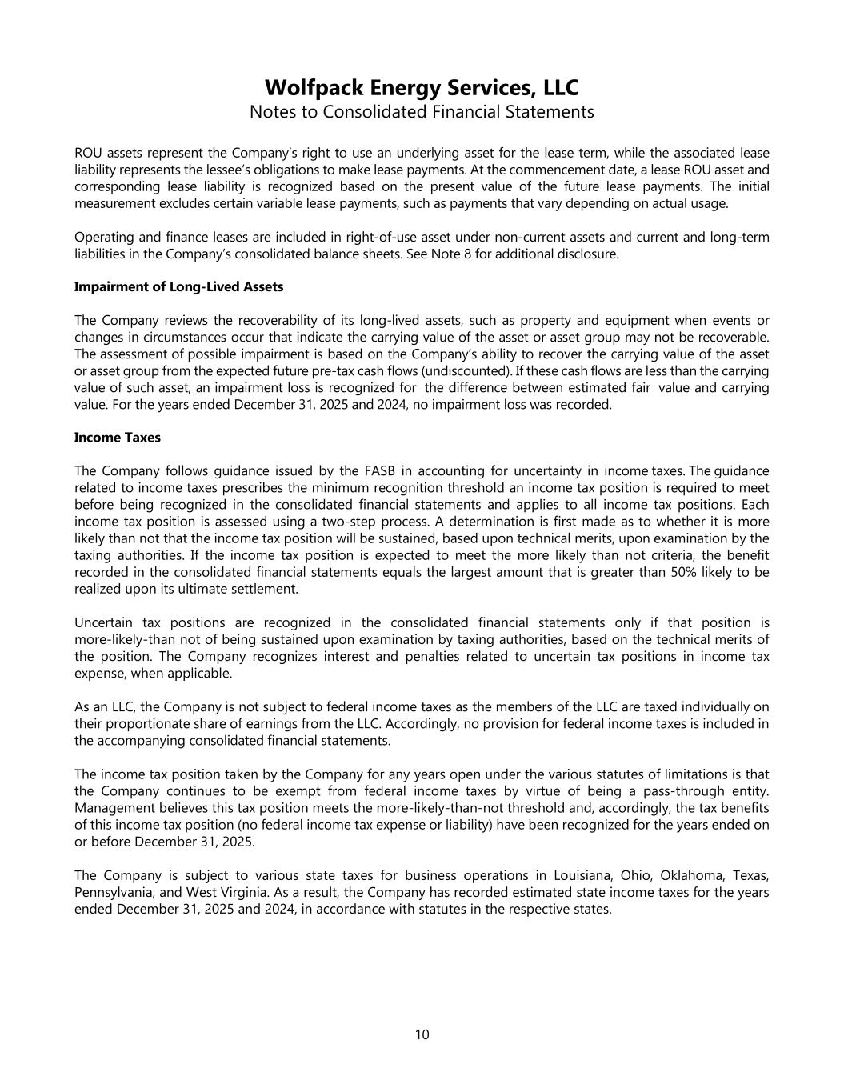
Wolfpack Energy Services, LLC Notes to Consolidated Financial Statements 10 ROU assets represent the Company’s right to use an underlying asset for the lease term, while the associated lease liability represents the lessee’s obligations to make lease payments. At the commencement date, a lease ROU asset and corresponding lease liability is recognized based on the present value of the future lease payments. The initial measurement excludes certain variable lease payments, such as payments that vary depending on actual usage. Operating and finance leases are included in right-of-use asset under non-current assets and current and long-term liabilities in the Company’s consolidated balance sheets. See Note 8 for additional disclosure. Impairment of Long-Lived Assets The Company reviews the recoverability of its long-lived assets, such as property and equipment when events or changes in circumstances occur that indicate the carrying value of the asset or asset group may not be recoverable. The assessment of possible impairment is based on the Company’s ability to recover the carrying value of the asset or asset group from the expected future pre-tax cash flows (undiscounted). If these cash flows are less than the carrying value of such asset, an impairment loss is recognized for the difference between estimated fair value and carrying value. For the years ended December 31, 2025 and 2024, no impairment loss was recorded. Income Taxes The Company follows guidance issued by the FASB in accounting for uncertainty in income taxes. The guidance related to income taxes prescribes the minimum recognition threshold an income tax position is required to meet before being recognized in the consolidated financial statements and applies to all income tax positions. Each income tax position is assessed using a two-step process. A determination is first made as to whether it is more likely than not that the income tax position will be sustained, based upon technical merits, upon examination by the taxing authorities. If the income tax position is expected to meet the more likely than not criteria, the benefit recorded in the consolidated financial statements equals the largest amount that is greater than 50% likely to be realized upon its ultimate settlement. Uncertain tax positions are recognized in the consolidated financial statements only if that position is more-likely-than not of being sustained upon examination by taxing authorities, based on the technical merits of the position. The Company recognizes interest and penalties related to uncertain tax positions in income tax expense, when applicable. As an LLC, the Company is not subject to federal income taxes as the members of the LLC are taxed individually on their proportionate share of earnings from the LLC. Accordingly, no provision for federal income taxes is included in the accompanying consolidated financial statements. The income tax position taken by the Company for any years open under the various statutes of limitations is that the Company continues to be exempt from federal income taxes by virtue of being a pass-through entity. Management believes this tax position meets the more-likely-than-not threshold and, accordingly, the tax benefits of this income tax position (no federal income tax expense or liability) have been recognized for the years ended on or before December 31, 2025. The Company is subject to various state taxes for business operations in Louisiana, Ohio, Oklahoma, Texas, Pennsylvania, and West Virginia. As a result, the Company has recorded estimated state income taxes for the years ended December 31, 2025 and 2024, in accordance with statutes in the respective states.

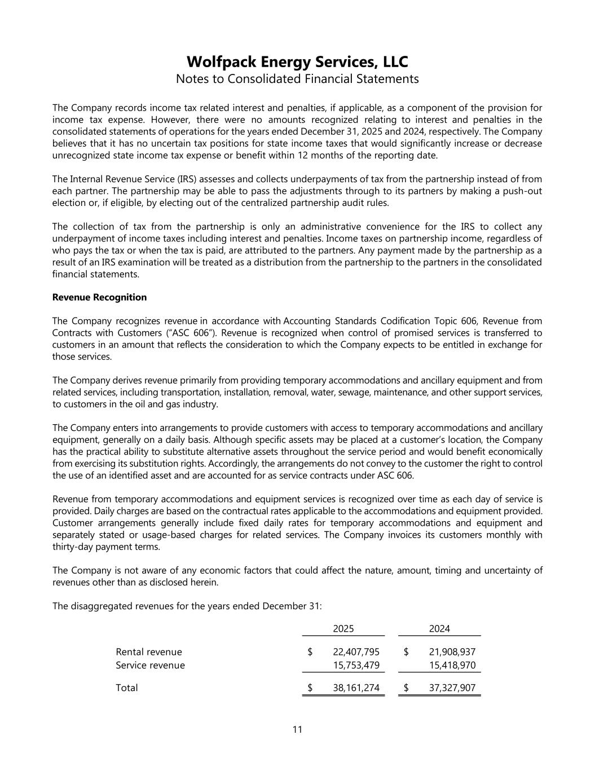
Wolfpack Energy Services, LLC Notes to Consolidated Financial Statements 11 The Company records income tax related interest and penalties, if applicable, as a component of the provision for income tax expense. However, there were no amounts recognized relating to interest and penalties in the consolidated statements of operations for the years ended December 31, 2025 and 2024, respectively. The Company believes that it has no uncertain tax positions for state income taxes that would significantly increase or decrease unrecognized state income tax expense or benefit within 12 months of the reporting date. The Internal Revenue Service (IRS) assesses and collects underpayments of tax from the partnership instead of from each partner. The partnership may be able to pass the adjustments through to its partners by making a push-out election or, if eligible, by electing out of the centralized partnership audit rules. The collection of tax from the partnership is only an administrative convenience for the IRS to collect any underpayment of income taxes including interest and penalties. Income taxes on partnership income, regardless of who pays the tax or when the tax is paid, are attributed to the partners. Any payment made by the partnership as a result of an IRS examination will be treated as a distribution from the partnership to the partners in the consolidated financial statements. Revenue Recognition The Company recognizes revenue in accordance with Accounting Standards Codification Topic 606, Revenue from Contracts with Customers (“ASC 606”). Revenue is recognized when control of promised services is transferred to customers in an amount that reflects the consideration to which the Company expects to be entitled in exchange for those services. The Company derives revenue primarily from providing temporary accommodations and ancillary equipment and from related services, including transportation, installation, removal, water, sewage, maintenance, and other support services, to customers in the oil and gas industry. The Company enters into arrangements to provide customers with access to temporary accommodations and ancillary equipment, generally on a daily basis. Although specific assets may be placed at a customer’s location, the Company has the practical ability to substitute alternative assets throughout the service period and would benefit economically from exercising its substitution rights. Accordingly, the arrangements do not convey to the customer the right to control the use of an identified asset and are accounted for as service contracts under ASC 606. Revenue from temporary accommodations and equipment services is recognized over time as each day of service is provided. Daily charges are based on the contractual rates applicable to the accommodations and equipment provided. Customer arrangements generally include fixed daily rates for temporary accommodations and equipment and separately stated or usage-based charges for related services. The Company invoices its customers monthly with thirty-day payment terms. The Company is not aware of any economic factors that could affect the nature, amount, timing and uncertainty of revenues other than as disclosed herein. The disaggregated revenues for the years ended December 31: 2025 2024 Rental revenue 22,407,795$ 21,908,937$ Service revenue 15,753,479 15,418,970 Total 38,161,274$ 37,327,907$

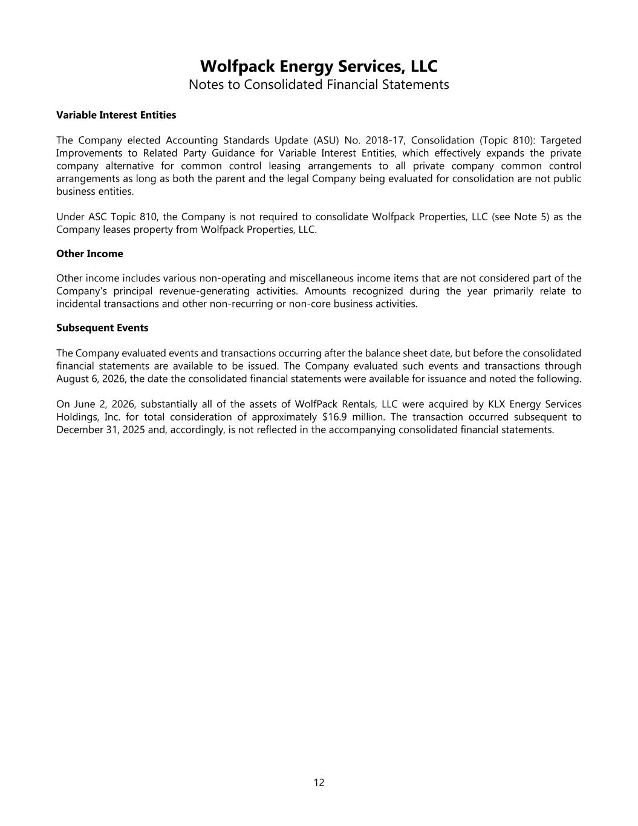
12 Wolfpack Energy Services, LLC Notes to Consolidated Financial Statements Variable Interest Entities The Company elected Accounting Standards Update (ASU) No. 2018-17, Consolidation (Topic 810): Targeted Improvements to Related Party Guidance for Variable Interest Entities, which effectively expands the private company alternative for common control leasing arrangements to all private company common control arrangements as long as both the parent and the legal Company being evaluated for consolidation are not public business entities. Under ASC Topic 810, the Company is not required to consolidate Wolfpack Properties, LLC (see Note 5) as the Company leases property from Wolfpack Properties, LLC. Other Income Other income includes various non-operating and miscellaneous income items that are not considered part of the Company's principal revenue-generating activities. Amounts recognized during the year primarily relate to incidental transactions and other non-recurring or non-core business activities. Subsequent Events The Company evaluated events and transactions occurring after the balance sheet date, but before the consolidated financial statements are available to be issued. The Company evaluated such events and transactions through August 6, 2026, the date the consolidated financial statements were available for issuance and noted the following. On June 2, 2026, substantially all of the assets of WolfPack Rentals, LLC were acquired by KLX Energy Services Holdings, Inc. for total consideration of approximately $16.9 million. The transaction occurred subsequent to December 31, 2025 and, accordingly, is not reflected in the accompanying consolidated financial statements.

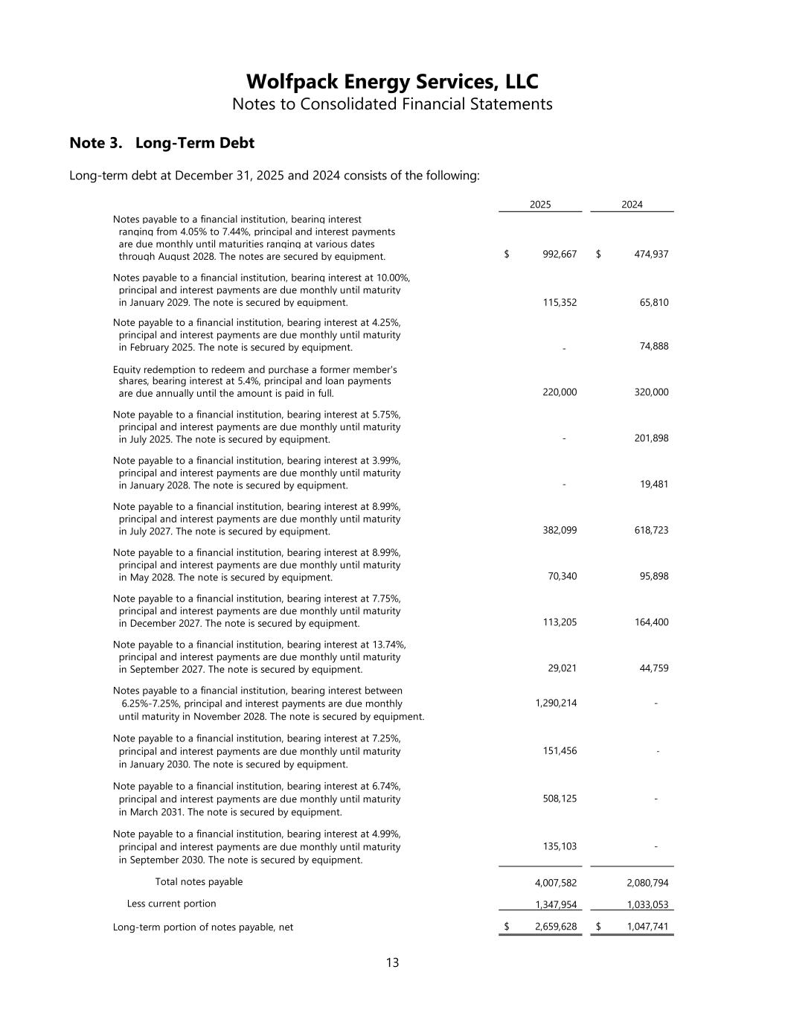
Wolfpack Energy Services, LLC Notes to Consolidated Financial Statements 13 Note 3. Long-Term Debt Long-term debt at December 31, 2025 and 2024 consists of the following: 2025 2024 Notes payable to a financial institution, bearing interest ranging from 4.05% to 7.44%, principal and interest payments are due monthly until maturities ranging at various dates through August 2028. The notes are secured by equipment. 992,667$ 474,937$ Notes payable to a financial institution, bearing interest at 10.00%, principal and interest payments are due monthly until maturity in January 2029. The note is secured by equipment. 115,352 65,810 Note payable to a financial institution, bearing interest at 4.25%, principal and interest payments are due monthly until maturity in February 2025. The note is secured by equipment. - 74,888 Equity redemption to redeem and purchase a former member's shares, bearing interest at 5.4%, principal and loan payments are due annually until the amount is paid in full. 220,000 320,000 Note payable to a financial institution, bearing interest at 5.75%, principal and interest payments are due monthly until maturity in July 2025. The note is secured by equipment. - 201,898 Note payable to a financial institution, bearing interest at 3.99%, principal and interest payments are due monthly until maturity in January 2028. The note is secured by equipment. - 19,481 Note payable to a financial institution, bearing interest at 8.99%, principal and interest payments are due monthly until maturity in July 2027. The note is secured by equipment. 382,099 618,723 Note payable to a financial institution, bearing interest at 8.99%, principal and interest payments are due monthly until maturity in May 2028. The note is secured by equipment. 70,340 95,898 Note payable to a financial institution, bearing interest at 7.75%, principal and interest payments are due monthly until maturity in December 2027. The note is secured by equipment. 113,205 164,400 Note payable to a financial institution, bearing interest at 13.74%, principal and interest payments are due monthly until maturity in September 2027. The note is secured by equipment. 29,021 44,759 Notes payable to a financial institution, bearing interest between 6.25%-7.25%, principal and interest payments are due monthly 1,290,214 - until maturity in November 2028. The note is secured by equipment. Note payable to a financial institution, bearing interest at 7.25%, principal and interest payments are due monthly until maturity 151,456 - in January 2030. The note is secured by equipment. Note payable to a financial institution, bearing interest at 6.74%, principal and interest payments are due monthly until maturity 508,125 - in March 2031. The note is secured by equipment. Note payable to a financial institution, bearing interest at 4.99%, principal and interest payments are due monthly until maturity 135,103 - in September 2030. The note is secured by equipment. Total notes payable 4,007,582 2,080,794 Less current portion 1,347,954 1,033,053 Long-term portion of notes payable, net 2,659,628$ 1,047,741$

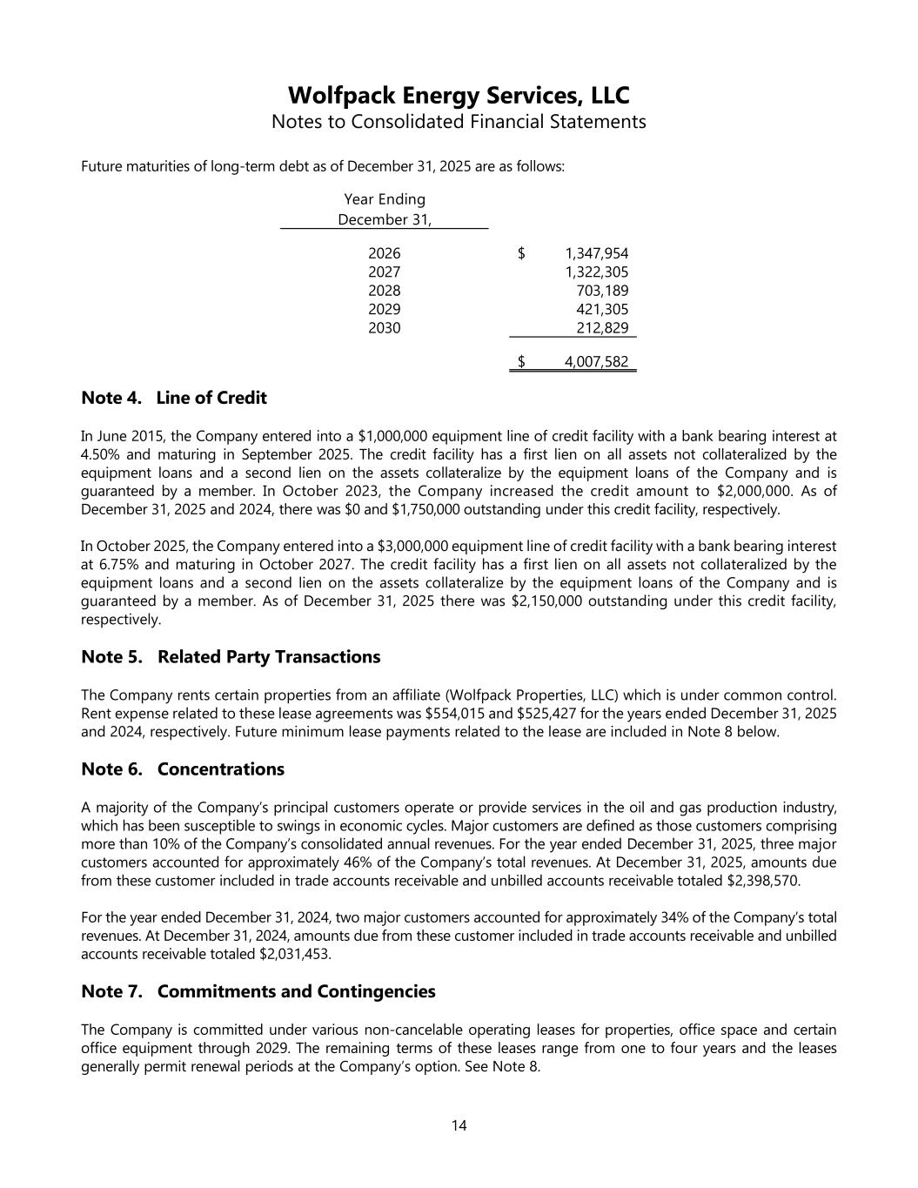
Wolfpack Energy Services, LLC Notes to Consolidated Financial Statements 14 Future maturities of long-term debt as of December 31, 2025 are as follows: Year Ending December 31, 2026 1,347,954$ 2027 1,322,305 2028 703,189 2029 421,305 2030 212,829 4,007,582$ Note 4. Line of Credit In June 2015, the Company entered into a $1,000,000 equipment line of credit facility with a bank bearing interest at 4.50% and maturing in September 2025. The credit facility has a first lien on all assets not collateralized by the equipment loans and a second lien on the assets collateralize by the equipment loans of the Company and is guaranteed by a member. In October 2023, the Company increased the credit amount to $2,000,000. As of December 31, 2025 and 2024, there was $0 and $1,750,000 outstanding under this credit facility, respectively. In October 2025, the Company entered into a $3,000,000 equipment line of credit facility with a bank bearing interest at 6.75% and maturing in October 2027. The credit facility has a first lien on all assets not collateralized by the equipment loans and a second lien on the assets collateralize by the equipment loans of the Company and is guaranteed by a member. As of December 31, 2025 there was $2,150,000 outstanding under this credit facility, respectively. Note 5. Related Party Transactions The Company rents certain properties from an affiliate (Wolfpack Properties, LLC) which is under common control. Rent expense related to these lease agreements was $554,015 and $525,427 for the years ended December 31, 2025 and 2024, respectively. Future minimum lease payments related to the lease are included in Note 8 below. Note 6. Concentrations A majority of the Company’s principal customers operate or provide services in the oil and gas production industry, which has been susceptible to swings in economic cycles. Major customers are defined as those customers comprising more than 10% of the Company’s consolidated annual revenues. For the year ended December 31, 2025, three major customers accounted for approximately 46% of the Company’s total revenues. At December 31, 2025, amounts due from these customer included in trade accounts receivable and unbilled accounts receivable totaled $2,398,570. For the year ended December 31, 2024, two major customers accounted for approximately 34% of the Company’s total revenues. At December 31, 2024, amounts due from these customer included in trade accounts receivable and unbilled accounts receivable totaled $2,031,453. Note 7. Commitments and Contingencies The Company is committed under various non-cancelable operating leases for properties, office space and certain office equipment through 2029. The remaining terms of these leases range from one to four years and the leases generally permit renewal periods at the Company’s option. See Note 8.

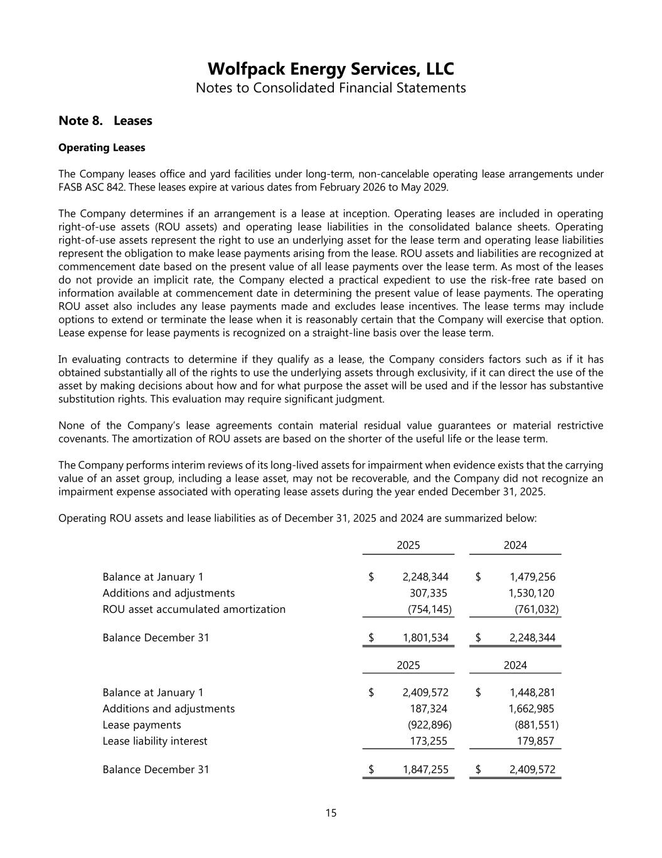
Wolfpack Energy Services, LLC Notes to Consolidated Financial Statements 15 Note 8. Leases Operating Leases The Company leases office and yard facilities under long-term, non-cancelable operating lease arrangements under FASB ASC 842. These leases expire at various dates from February 2026 to May 2029. The Company determines if an arrangement is a lease at inception. Operating leases are included in operating right-of-use assets (ROU assets) and operating lease liabilities in the consolidated balance sheets. Operating right-of-use assets represent the right to use an underlying asset for the lease term and operating lease liabilities represent the obligation to make lease payments arising from the lease. ROU assets and liabilities are recognized at commencement date based on the present value of all lease payments over the lease term. As most of the leases do not provide an implicit rate, the Company elected a practical expedient to use the risk-free rate based on information available at commencement date in determining the present value of lease payments. The operating ROU asset also includes any lease payments made and excludes lease incentives. The lease terms may include options to extend or terminate the lease when it is reasonably certain that the Company will exercise that option. Lease expense for lease payments is recognized on a straight-line basis over the lease term. In evaluating contracts to determine if they qualify as a lease, the Company considers factors such as if it has obtained substantially all of the rights to use the underlying assets through exclusivity, if it can direct the use of the asset by making decisions about how and for what purpose the asset will be used and if the lessor has substantive substitution rights. This evaluation may require significant judgment. None of the Company’s lease agreements contain material residual value guarantees or material restrictive covenants. The amortization of ROU assets are based on the shorter of the useful life or the lease term. The Company performs interim reviews of its long-lived assets for impairment when evidence exists that the carrying value of an asset group, including a lease asset, may not be recoverable, and the Company did not recognize an impairment expense associated with operating lease assets during the year ended December 31, 2025. Operating ROU assets and lease liabilities as of December 31, 2025 and 2024 are summarized below: 2025 2024 Balance at January 1 2,248,344$ 1,479,256$ Additions and adjustments 307,335 1,530,120 ROU asset accumulated amortization (754,145) (761,032) Balance December 31 1,801,534$ 2,248,344$ 2025 2024 Balance at January 1 2,409,572$ 1,448,281$ Additions and adjustments 187,324 1,662,985 Lease payments (922,896) (881,551) Lease liability interest 173,255 179,857 Balance December 31 1,847,255$ 2,409,572$

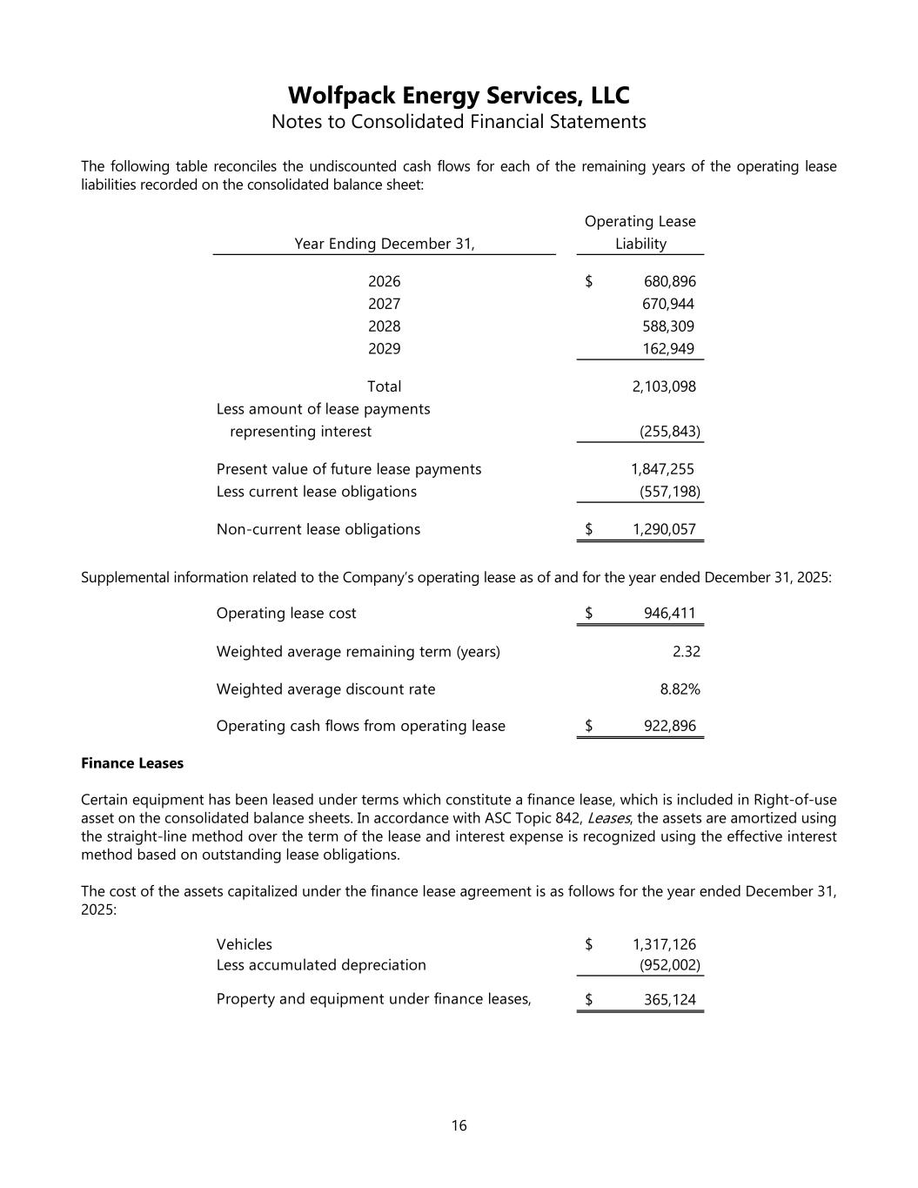
Wolfpack Energy Services, LLC Notes to Consolidated Financial Statements 16 The following table reconciles the undiscounted cash flows for each of the remaining years of the operating lease liabilities recorded on the consolidated balance sheet: Year Ending December 31, Operating Lease Liability 2026 680,896$ 2027 670,944 2028 588,309 2029 162,949 Total 2,103,098 Less amount of lease payments representing interest (255,843) Present value of future lease payments 1,847,255 Less current lease obligations (557,198) Non-current lease obligations 1,290,057$ Supplemental information related to the Company’s operating lease as of and for the year ended December 31, 2025: Operating lease cost 946,411$ Weighted average remaining term (years) 2.32 Weighted average discount rate 8.82% Operating cash flows from operating lease 922,896$ Finance Leases Certain equipment has been leased under terms which constitute a finance lease, which is included in Right-of-use asset on the consolidated balance sheets. In accordance with ASC Topic 842, Leases, the assets are amortized using the straight-line method over the term of the lease and interest expense is recognized using the effective interest method based on outstanding lease obligations. The cost of the assets capitalized under the finance lease agreement is as follows for the year ended December 31, 2025: Vehicles 1,317,126$ Less accumulated depreciation (952,002) Property and equipment under finance leases, 365,124$

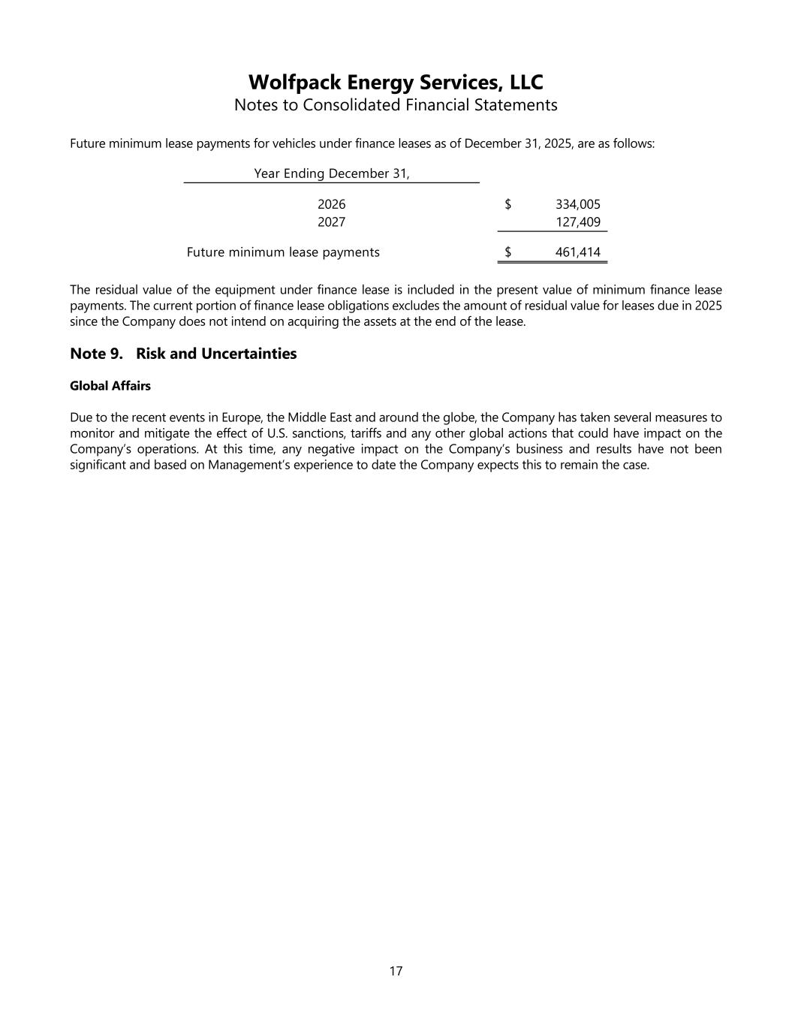
Wolfpack Energy Services, LLC Notes to Consolidated Financial Statements 17 Future minimum lease payments for vehicles under finance leases as of December 31, 2025, are as follows: Year Ending December 31, 2026 334,005$ 2027 127,409 Future minimum lease payments 461,414$ The residual value of the equipment under finance lease is included in the present value of minimum finance lease payments. The current portion of finance lease obligations excludes the amount of residual value for leases due in 2025 since the Company does not intend on acquiring the assets at the end of the lease. Note 9. Risk and Uncertainties Global Affairs Due to the recent events in Europe, the Middle East and around the globe, the Company has taken several measures to monitor and mitigate the effect of U.S. sanctions, tariffs and any other global actions that could have impact on the Company’s operations. At this time, any negative impact on the Company’s business and results have not been significant and based on Management’s experience to date the Company expects this to remain the case.

Wolfpack Energy Services, LLC and Subsidiaries

Consolidated Financial Report
March 31, 2026

Table of Contents

Wolfpack Energy Services, LLC

Table of Contents
 |  |  | Condensed Consolidated Financial Statements (Unaudited) |  |  | 3
 |  |  | Balance Sheets as of March 31, 2026 and December 31, 2025 |  |  | 3
 |  |  | Statement of Operations for the Three Months Ended March 31, 2026 |  |  | 4
 |  |  | Statement of Stockholders' Equity for the Three Months Ended March 31, 2026 |  |  | 5
 |  |  | Statement of Cash Flows for the Three Months Ended March 31, 2026 |  |  | 6
 |  |  | Notes to Condensed Consolidated Financial Statements |  |  | 7

2

Wolfpack Energy Services, LLC
Condensed Consolidated Balance Sheets
(In millions of U.S. dollars)
 |  |  | March 31, 2026 |  |  |  |  |  | December 31, 2025
 |  |  | (Unaudited)
ASSETS
Current assets:
Cash and cash equivalents |  |  | $0.1 |  |  |  |  |  | $0.3
Accounts receivable–trade, net of allowance of $0.0 and $0.0 |  |  | 7.6 |  |  |  |  |  | 7.1
Inventories, net |  |  | 0.4 |  |  |  |  |  | 0.3
Prepaid expenses and other current assets |  |  | 1.4 |  |  |  |  |  | 0.4
Total current assets |  |  | 9.5 |  |  |  |  |  | 8.1
Property and equipment, net |  |  | 13.5 |  |  |  |  |  | 14.2
Right-of-use asset |  |  | 1.9 |  |  |  |  |  | 2.2
Total assets |  |  | 24.9 |  |  |  |  |  | 24.5
LIABILITIES AND STOCKHOLDERS’ EQUITY
Current liabilities:
Accounts payable |  |  | $4.5 |  |  |  |  |  | $4.0
Accrued liabilities |  |  | 1.5 |  |  |  |  |  | 1.1
Current portion of long-term debt |  |  | 2.6 |  |  |  |  |  | 3.5
Current portion of operating lease liabilities |  |  | 0.5 |  |  |  |  |  | 0.6
Current portion of finance lease liabilities |  |  | 0.2 |  |  |  |  |  | 0.3
Total current liabilities |  |  | 9.3 |  |  |  |  |  | 9.5
Long-term debt, net of current portion |  |  | 4.1 |  |  |  |  |  | 2.6
Long-term operating lease liabilities |  |  | 1.2 |  |  |  |  |  | 1.3
Long-term finance lease liabilities |  |  | 0.2 |  |  |  |  |  | 0.1
Members’ Equity |  |  | 10.1 |  |  |  |  |  | 11.0
Total liabilities and members’ equity |  |  | 24.9 |  |  |  |  |  | 24.5
See accompanying notes to condensed consolidated financial statements.

3
Wolfpack Energy Services, LLC
Condensed Consolidated Statement of Operations
(In millions of U.S. dollars)
(Unaudited)
 |  |  | Three Months Ended
 |  |  | March 31, 2026
Revenues |  |  | $10.2
Costs and expenses:
Cost of sales |  |  | 7.9
Depreciation and amortization |  |  | 1.5
Selling, general and administrative |  |  | 1.6
Operating (loss) income |  |  | (0.8)
Non-operating expense:
Interest expense |  |  | 0.1
Net (loss) income before income tax |  |  | (0.9)
Income tax expense |  |  | 0.0
Net (loss) income |  |  | (0.9)

See accompanying notes to condensed consolidated financial statements.

4
Wolfpack Energy Services, LLC
Condensed Consolidated Statement of Members’ Equity
Three Months Ended March 31, 2026
(In millions of U.S. dollars and shares)
(Unaudited)
Balance at December 31, 2025 |  |  | 11.0
Net loss |  |  | (0.9)
Balance at March 31, 2026 |  |  | 10.1

See accompanying notes to condensed consolidated financial statements.

5
Wolfpack Energy Services, LLC
Condensed Consolidated Statement of Cash Flows
(In millions of U.S. dollars)
(Unaudited)
 |  |  | Three Months Ended
 |  |  | March 31, 2026
Cash flows from operating activities:
Net (loss) income |  |  | $(0.9)
Adjustments to reconcile net loss to net cash flows used in operating activities
Depreciation and amortization |  |  | 1.5
Changes in operating assets and liabilities:
Accounts receivable |  |  | (1.7)
Inventories |  |  | 0.0
Prepaid expenses and other current and non-current assets |  |  | 0.3
Accounts payable |  |  | 1.1
Other current and non-current liabilities |  |  | (0.2)
Net cash flows used in operating activities |  |  | 0.1
Cash flows from investing activities:
Purchases of property and equipment |  |  | (0.6)
Net cash flows used in investing activities |  |  | (0.6)
Cash flows from financing activities:
Proceeds from note payable |  |  | 0.3
Net cash flows used in financing activities |  |  | 0.3
Net change in cash and cash equivalents |  |  | (0.2)
Cash and cash equivalents, beginning of period |  |  | 0.3
Cash and cash equivalents, end of period |  |  | 0.1
Supplemental disclosures of cash flow information:
Cash paid during period for interest |  |  | 0.1
Supplemental schedule of non-cash activities:
Property and equipment financed through long-term debt |  |  | 0.4

See accompanying notes to condensed consolidated financial statements.

6

Wolfpack Energy Services, LLC
Notes to Condensed Consolidated Financial Statements
(Unaudited – U.S. dollars in millions, except per share data)

NOTE 1 - Description of Business and Basis of Presentation

Description of Business

Wolfpack Energy Services, LLC (the “Company”, “Wolfpack”, “Wolfpack Energy Services”, “we”, “us” or “our”) is a provider of temporary well-site accommodations and ancillary equipment and provides related services such as water and sewage facilities to onshore oil and gas companies throughout the United States. The Company is headquartered in Fulshear, Texas.

Basis of Presentation

The accompanying unaudited condensed consolidated financial statements have been prepared in accordance with accounting principles generally accepted in the United States (“GAAP”) for interim financial information. Accordingly, they do not include all of the information and footnotes required by GAAP for complete financial statements. All adjustments which, in the opinion of the Company’s management, are considered necessary for a fair presentation of the results of operations for the periods shown are of a normal recurring nature and have been reflected in the condensed consolidated financial statements. The results of operations for the periods presented are not necessarily indicative of the results expected for the full year 2026 or for any future period. The information included in these condensed consolidated financial statements should be read in conjunction with the condensed consolidated financial statements and accompanying notes included in the Company’s 2025 Consolidated Financial Report issued on August 6, 2026.

The preparation of financial statements in conformity with GAAP requires management to make estimates and assumptions that affect the reported amounts and related disclosures. Actual results could differ from those estimates.

Certain items in the 2025 consolidated financial statements have been reclassified to conform to the 2026 consolidated financial statements. These items have no impact on net income for the year ended December 31, 2025.

NOTE 2 – Long-Term Debt
Long-term debt consisted of the following:
7
 |  |  |  |  |  | March 31, 2026 |  |  |  |  |  | December 31, 2025
Notes payable to a financial institution, bearing interest ranging from 4.05% to 7.44%, principal and interest payments are due monthly until maturities ranging at various dates through August 2028. The notes are secured by equipment. |  |  |  |  |  | $ | 1.1 |  |  |  |  | $ | 1.0
Equity redemption to redeem and purchase a former member’s shares, bearing interest at 5.4%, principal and interest payments are due annually until the amount is paid in full. |  |  |  |  |  | 0.2 |  |  |  |  |  | 0.2
Notes payable to a financial institution, bearing interest at 10.00%, principal and interest payments are due monthly until maturity in January 2029. The note is secured by equipment. |  |  |  |  |  | 0.1 |  |  |  |  |  | 0.1
Note payable to a financial institution, bearing interest at 8.99%, principal and interest payments are due monthly until maturity in July 2027. The note is secured by equipment. |  |  |  |  |  | 0.3 |  |  |  |  |  | 0.4
Note payable to a financial institution, bearing interest at 8.99%, principal and interest payments are due monthly until maturity in May 2028. The note is secured by equipment. |  |  |  |  |  | 0.1 |  |  |  |  |  | 0.1
Note payable to a financial institution, bearing interest at 7.75%, principal and interest payments are due monthly until maturity in December 2027. The note is secured by equipment. |  |  |  |  |  | 0.1 |  |  |  |  |  | 0.1
Note payable to a financial institution, bearing interest at 13.74%, principal and interest payments are due monthly until maturity in September 2027. The note is secured by equipment. |  |  |  |  |  | 0.0 |  |  |  |  |  | 0.0
Notes payable to a financial institution, bearing interest between 6.25%-7.25%, principal and interest payments are due monthly until maturity in November 2028. The notes are secured by equipment. |  |  |  |  |  | 1.2 |  |  |  |  |  | 1.3
Note payable to a financial institution, bearing interest at 7.25%, principal and interest payments are due monthly until maturity in January 2030. The note is secured by equipment. |  |  |  |  |  | 0.1 |  |  |  |  |  | 0.2
Note payable to a financial institution, bearing interest at 6.74%, principal and interest payments are due monthly until maturity in March 2031. The note is secured by equipment. |  |  |  |  |  | 0.7 |  |  |  |  |  | 0.5
Note payable to a financial institution, bearing interest at 4.99%, principal and interest payments are due monthly until maturity in September 2030. The note is secured by equipment. |  |  |  |  |  | 0.1 |  |  |  |  |  | 0.1
Total notes payable |  |  |  |  |  | 4.1 |  |  |  |  |  | 4.0
Less current portion |  |  |  |  |  | 1.3 |  |  |  |  |  | 1.3
Long-term portion of notes payable, net |  |  |  |  |  | 2.8 |  |  |  |  |  | 2.7

NOTE 3 – Line of Credit

In June 2015, the Company entered into a $1 million equipment line of credit facility with a bank bearing interest at 4.5% and maturing in September 2025. The credit facility has a first lien on all assets not collateralized by the equipment loans and a second lien on the assets collateralized by the equipment loans of the Company and is guaranteed by a member. In October 2023, the Company increased the credit amount to $2 million. The Company entered into a replacement equipment line of credit in October 2025 with a new bank and increased the credit amount to $3.0 million. As of March 31, 2026 and December 31, 2025, there was $2.6 million and $2.2 million outstanding under this credit facility, respectively.
8
NOTE 4 – Commitments and Contingencies
The Company is committed under various non-cancelable operating leases for properties, office space and certain office equipment through 2029. The remaining terms of these leases range from one to four years and the leases generally permit renewal periods at the Company’s option.
NOTE 5 – Risk and Uncertainties
Global Affairs
Due to recent event in the Middle East and around the globe, the Company has taken several measures to monitor and mitigate the effect of US sanctions, tariffs and any other global actions that could have impact on the Company’s operations. At this time, any negative impact on the Company’s business and results have not been significant and based on Management’s experience to date the Company expects this to remain the case.
NOTE 6 – Subsequent Events
The Company evaluated events and transactions occurring after the balance sheet date, but before the consolidated financial statements are available to be issued. The Company evaluated such events and transactions through the date the financial statements were available for issuance and noted the following:
On June 2, 2026, substantially all of the assets of WolfPack Rentals, LLC were acquired by KLX Energy Services Holdings, Inc. for total consideration of approximately $16.9 million. The transaction occurred subsequent to March 31, 2026 and, accordingly, is not reflected in the accompanying consolidated financial statements.

9
KLX ENERGY SERVICES HOLDINGS, INC.
UNAUDITED PRO FORMA CONDENSED COMBINED FINANCIAL INFORMATION

Introduction
On June 2, 2026 (the “Closing Date”), KLX Energy Services Holdings, Inc., a Delaware corporation (the “Company”), completed the acquisition (the “Wolf Pack Acquisition”) of certain assets owned by Wolf Pack Rentals, LLC, a Texas limited liability company (“Wolf Pack” or the “Seller”), pursuant to an asset purchase agreement, dated June 2, 2026, by and among Wolf Pack, KLX Energy Services LLC, a Delaware limited liability company and indirect wholly owned subsidiary of the Company (the “Buyer”) and the Company (the “Purchase Agreement”). The purchase price for the Wolf Pack Acquisition is $16.9, subject to customary post-closing adjustments and to be paid as follows: (i) on the Closing Date, the Buyer paid the Seller $14.1; (ii) two deferred payments of $1.5 each, to be paid at 180 and 360 days after the Closing Date, either in cash or shares of common stock, par value $0.01 per share, of the Company (the “Common Stock”), in its sole discretion, with a net present value of $2.7; and (iii) estimated post-closing adjustment to the purchase price of $0.1.

The underlying historical financial information has been derived from the unaudited condensed consolidated financial statements as of and for the three months ended March 31, 2026 and the audited consolidated financial statements for the year ended December 31, 2025 of KLX and Wolf Pack.

Information in the unaudited pro forma condensed combined financial statements is presented as follows:
•The unaudited pro forma condensed combined statement of operations for the three months ended March 31, 2026 and for the year ended December 31, 2025 includes adjustments for the Wolf Pack Acquisition, as if it had been completed as of January 1, 2025.
•The unaudited pro forma condensed combined balance sheet as of March 31, 2026 includes adjustments for the Wolf Pack Acquisition, as if it had been completed on March 31, 2026.

The historical condensed financial information has been adjusted to give effect to adjustments that are necessary to account for the Wolf Pack Acquisition. The adjustments are based on currently available information and certain estimates and assumptions and therefore the actual effects of these transactions will differ from the pro forma adjustments.

The unaudited condensed pro forma financial information was prepared in accordance with Article 11 of Regulation S-X. The Wolf Pack Acquisition was accounted for using the acquisition method of accounting under the Financial Accounting Standards Board (“FASB”) Accounting Standards Codification 805, Business Combinations (“ASC 805”). Accordingly, the preliminary purchase price as it relates to Wolf Pack was allocated to the assets acquired and liabilities assumed based upon management’s preliminary estimates of fair value. The determination of the final fair values is dependent upon valuations as of the Closing Date and the final adjustments to the purchase price, which when they occur may result in an adjustment to the value of the acquired assets reflected in the unaudited pro forma condensed combined financial statements.

The unaudited pro forma condensed combined financial statements should be read in conjunction with the accompanying notes and with:
•Unaudited interim condensed consolidated financial statements of KLX as of and for the three months ended March 31, 2026 contained in the Form 10-Q filed on May 13, 2026.
•Audited consolidated financial statements of KLX as of and for the year ended December 31, 2025, contained in the Form 10-K filed on March 12, 2026.
1

•Audited consolidated financial statements of Wolf Pack as of and for the year ended December 31, 2025 contained in the Current Report on Form 8-K/A filed on August 12, 2026.
•Unaudited interim condensed consolidated financial statements of Wolf Pack as of and for the three months ended March 31, 2026 contained in the Current Report on Form 8-K/A filed on August 12, 2026.

The unaudited pro forma condensed combined financial information is presented for illustrative purposes only and does not purport to indicate the financial condition or results of operations of future periods or the financial condition or results of operations that actually would have been realized had the Wolf Pack Acquisition been consummated on the dates or for the periods presented. The unaudited pro forma condensed combined financial statements are subject to certain risks and uncertainties that could cause actual results to differ materially from those illustrated.

2

KLX Energy Services Holdings, Inc.
Unaudited Pro Forma Condensed Combined Balance Sheet
As of March 31, 2026
(In millions of U.S. dollars and shares, except per share data)
 |  |  | Historical
 |  |  | KLX |  |  |  |  |  | Wolf Pack |  |  |  |  |  | Reclass |  |  |  |  |  | Transaction Accounting Adjustments |  |  |  |  |  |  |  |  |  | Note |  |  |  |  |  | Pro Forma
ASSETS
Current assets:
Cash and cash equivalents |  |  | $ | 5.6 |  |  |  |  | $ | 0.1 |  |  |  |  |  |  |  |  |  |  | $ | (0.9) |  |  |  |  |  |  |  |  | 3a, 3b |  |  |  |  |  | $ | 4.8
Accounts receivable–trade |  |  | 107.3 |  |  |  |  |  | 7.6 |  |  |  |  |  |  |  |  |  |  |  |  |  |  |  |  |  |  |  |  |  |  |  |  |  |  |  | 114.9
Inventories, net |  |  | 31.9 |  |  |  |  |  | 0.4 |  |  |  |  |  |  |  |  |  |  |  |  |  |  |  |  |  |  |  |  |  |  |  |  |  |  |  | 32.3
Prepaid expenses and other current assets |  |  | 9.3 |  |  |  |  |  | 1.4 |  |  |  |  |  |  |  |  |  |  |  | (1.0) |  |  |  |  |  |  |  |  |  | 3a |  |  |  |  |  | 9.7
Total current assets |  |  | 154.1 |  |  |  |  |  | 9.5 |  |  |  |  |  | — |  |  |  |  |  | (1.9) |  |  |  |  |  |  |  |  |  |  |  |  |  |  |  | 161.7
Property and equipment, net(1) |  |  | 149.0 |  |  |  |  |  | 13.5 |  |  |  |  |  | 0.2 |  |  |  |  |  | 8.9 |  |  |  |  |  |  |  |  |  | 3c, 3d |  |  |  |  |  | 171.6
Operating lease assets |  |  | 21.6 |  |  |  |  |  | — |  |  |  |  |  | 0.8 |  |  |  |  |  |  |  |  |  |  |  |  |  |  |  | 3d |  |  |  |  |  | 22.4
Right-of-use asset |  |  | — |  |  |  |  |  | 1.9 |  |  |  |  |  | (1.0) |  |  |  |  |  | (0.9) |  |  |  |  |  |  |  |  |  | 3a, 3d |  |  |  |  |  | —
Intangible assets, net |  |  | 1.0 |  |  |  |  |  | — |  |  |  |  |  |  |  |  |  |  |  |  |  |  |  |  |  |  |  |  |  |  |  |  |  |  |  | 1.0
Other assets |  |  | 5.8 |  |  |  |  |  | — |  |  |  |  |  |  |  |  |  |  |  | (1.8) |  |  |  |  |  |  |  |  |  | 3a |  |  |  |  |  | 4.0
Total assets |  |  | $ | 331.5 |  |  |  |  | $ | 24.9 |  |  |  |  | $ | — |  |  |  |  | $ | 4.3 |  |  |  |  |  |  |  |  |  |  |  |  |  |  | $ | 360.7
LIABILITIES AND STOCKHOLDERS’ EQUITY
Current liabilities:
Accounts payable |  |  | $ | 69.7 |  |  |  |  | $ | 4.5 |  |  |  |  |  |  |  |  |  |  |  |  |  |  |  |  |  |  |  |  |  |  |  |  |  |  | $ | 74.2
Accrued interest |  |  | 0.4 |  |  |  |  |  | — |  |  |  |  |  |  |  |  |  |  |  |  |  |  |  |  |  |  |  |  |  |  |  |  |  |  |  | 0.4
Accrued liabilities |  |  | 24.4 |  |  |  |  |  | 1.5 |  |  |  |  |  |  |  |  |  |  |  | 2.8 |  |  |  |  |  |  |  |  |  | 3b |  |  |  |  |  | 28.7
Current portion of long-term debt |  |  | 4.5 |  |  |  |  |  | 2.6 |  |  |  |  |  |  |  |  |  |  |  | (2.6) |  |  |  |  |  |  |  |  |  | 3a |  |  |  |  |  | 4.5
Current portion of operating lease liabilities |  |  | 7.4 |  |  |  |  |  | 0.5 |  |  |  |  |  |  |  |  |  |  |  | (0.3) |  |  |  |  |  |  |  |  |  | 3a |  |  |  |  |  | 7.6
Current portion of finance lease liabilities |  |  | 16.6 |  |  |  |  |  | 0.2 |  |  |  |  |  |  |  |  |  |  |  | (0.2) |  |  |  |  |  |  |  |  |  | 3a |  |  |  |  |  | 16.6
Total current liabilities |  |  | 123.0 |  |  |  |  |  | 9.3 |  |  |  |  |  | — |  |  |  |  |  | (0.3) |  |  |  |  |  |  |  |  |  |  |  |  |  |  |  | 132.0
Long-term debt |  |  | 271.3 |  |  |  |  |  | 4.1 |  |  |  |  |  |  |  |  |  |  |  | 1.3 |  |  |  |  |  |  |  |  |  | 3a, 3b |  |  |  |  |  | 276.7
Long-term operating lease liabilities |  |  | 14.7 |  |  |  |  |  | 1.2 |  |  |  |  |  |  |  |  |  |  |  | (0.6) |  |  |  |  |  |  |  |  |  | 3a |  |  |  |  |  | 15.3
Long-term finance lease liabilities |  |  | 17.8 |  |  |  |  |  | 0.2 |  |  |  |  |  |  |  |  |  |  |  | 0.1 |  |  |  |  |  |  |  |  |  | 3a, 3b |  |  |  |  |  | 18.1
Other non-current liabilities |  |  | 0.8 |  |  |  |  |  | — |  |  |  |  |  |  |  |  |  |  |  | 7.6 |  |  |  |  |  |  |  |  |  | 3b |  |  |  |  |  | 8.4
Commitments, contingencies and off-balance sheet arrangements
Stockholders’ equity:
Common stock, $0.01 par value; 110.0 authorized; 20.5 issued |  |  | 0.2 |  |  |  |  |  | — |  |  |  |  |  |  |  |  |  |  |  |  |  |  |  |  |  |  |  |  |  |  |  |  |  |  |  | 0.2
Additional paid-in capital |  |  | 573.6 |  |  |  |  |  | — |  |  |  |  |  |  |  |  |  |  |  |  |  |  |  |  |  |  |  |  |  |  |  |  |  |  |  | 573.6
Treasury stock, at cost, 0.6 shares |  |  | (6.4) |  |  |  |  |  | — |  |  |  |  |  |  |  |  |  |  |  |  |  |  |  |  |  |  |  |  |  |  |  |  |  |  |  | (6.4)
Accumulated deficit |  |  | (663.5) |  |  |  |  |  | — |  |  |  |  |  |  |  |  |  |  |  | 6.3 |  |  |  |  |  |  |  |  |  | 3e |  |  |  |  |  | (657.2)
Members' equity |  |  | — |  |  |  |  |  | 10.1 |  |  |  |  |  |  |  |  |  |  |  | (10.1) |  |  |  |  |  |  |  |  |  | 3f |  |  |  |  |  | —
Total stockholders’ deficit |  |  | (96.1) |  |  |  |  |  | 10.1 |  |  |  |  |  | — |  |  |  |  |  | (3.8) |  |  |  |  |  |  |  |  |  |  |  |  |  |  |  | (89.8)
Total liabilities and stockholders’ deficit |  |  | $ | 331.5 |  |  |  |  | $ | 24.9 |  |  |  |  | $ | — |  |  |  |  | $ | 4.3 |  |  |  |  |  |  |  |  |  |  |  |  |  |  | $ | 360.7

The accompanying notes are an integral part of the unaudited pro forma condensed combined financial statements

3

KLX Energy Services Holdings, Inc.
Unaudited Pro Forma Condensed Combined Statement of Operations
For the Three Months Ended March 31, 2026
(In millions of U.S. dollars and shares, except per share data)

 |  |  | KLX |  |  |  |  |  | Wolf Pack |  |  |  |  |  | Transaction Accounting Adjustments |  |  |  |  |  | Note |  |  |  |  |  | Pro Forma
Revenues |  |  | $ | 144.7 |  |  |  |  | $ | 10.2 |  |  |  |  | $ | — |  |  |  |  |  |  |  |  |  |  | $ | 154.9
Costs and expenses:
Cost of sales |  |  | 119.1 |  |  |  |  |  | 7.9 |  |  |  |  |  | (0.3) |  |  |  |  |  | 4a, 4b |  |  |  |  |  | 126.7
Depreciation and amortization |  |  | 21.9 |  |  |  |  |  | 1.5 |  |  |  |  |  | (0.7) |  |  |  |  |  | 4b |  |  |  |  |  | 22.7
Selling, general and administrative |  |  | 15.4 |  |  |  |  |  | 1.6 |  |  |  |  |  |  |  |  |  |  |  |  |  |  |  |  |  | 17.0
Research and development costs |  |  | 0.4 |  |  |  |  |  | — |  |  |  |  |  | — |  |  |  |  |  |  |  |  |  |  |  | 0.4
Bargain purchase gain |  |  | — |  |  |  |  |  | — |  |  |  |  |  | (6.3) |  |  |  |  |  | 3e |  |  |  |  |  | (6.3)
Operating (loss) income |  |  | (12.1) |  |  |  |  |  | (0.8) |  |  |  |  |  | 7.3 |  |  |  |  |  |  |  |  |  |  |  | (5.6)
Non-operating expense (income):
Interest income |  |  | (0.0) |  |  |  |  |  | — |  |  |  |  |  | — |  |  |  |  |  |  |  |  |  |  |  | (0.0)
Interest expense |  |  | 11.7 |  |  |  |  |  | 0.1 |  |  |  |  |  | 0.5 |  |  |  |  |  | 4c, 4f |  |  |  |  |  | 12.3
Net loss before income tax |  |  | (23.8) |  |  |  |  |  | (0.9) |  |  |  |  |  | 6.8 |  |  |  |  |  |  |  |  |  |  |  | (17.9)
Income tax expense |  |  | 0.2 |  |  |  |  |  | 0.0 |  |  |  |  |  | — |  |  |  |  |  | 4d |  |  |  |  |  | 0.2
Net loss |  |  | $ | (24.0) |  |  |  |  | $ | (0.9) |  |  |  |  | $ | 6.8 |  |  |  |  |  |  |  |  |  |  | $ | (18.1)
Net loss per common share:
Basic |  |  | $ | (1.23) |  |  |  |  |  |  |  |  |  |  |  |  |  |  |  |  |  |  |  |  |  |  | $ | (0.93)
Diluted |  |  | $ | (1.23) |  |  |  |  |  |  |  |  |  |  |  |  |  |  |  |  |  |  |  |  |  |  | $ | (0.93)
Weighted average common shares:
Basic |  |  | 19.5 |  |  |  |  |  |  |  |  |  |  |  |  |  |  |  |  |  |  |  |  |  |  |  | 19.5
Diluted |  |  | 19.5 |  |  |  |  |  |  |  |  |  |  |  |  |  |  |  |  |  | 4e |  |  |  |  |  | 19.5

The accompanying notes are an integral part of the unaudited pro forma condensed combined financial statements

4

KLX Energy Services Holdings, Inc.
Unaudited Pro Forma Condensed Combined Statement of Operations
For the Year Ended December 31, 2025
(In millions of U.S. dollars and shares, except per share data)

 |  |  | KLX |  |  |  |  |  | Wolf Pack |  |  |  |  |  | Transaction Accounting Adjustments |  |  |  |  |  | Note |  |  |  |  |  | Pro Forma
Revenues |  |  | $ | 636.6 |  |  |  |  | $ | 38.2 |  |  |  |  | $ | — |  |  |  |  |  |  |  |  |  |  | $ | 674.8
Costs and expenses:
Cost of sales |  |  | 501.5 |  |  |  |  |  | 26.4 |  |  |  |  |  | (1.1) |  |  |  |  |  | 5a, 5b |  |  |  |  |  | 526.8
Depreciation and amortization |  |  | 95.2 |  |  |  |  |  | 4.9 |  |  |  |  |  | 0.8 |  |  |  |  |  | 5b |  |  |  |  |  | 100.9
Selling, general and administrative |  |  | 68.5 |  |  |  |  |  | 8.7 |  |  |  |  |  |  |  |  |  |  |  |  |  |  |  |  |  | 77.2
Research and development costs |  |  | 1.7 |  |  |  |  |  | — |  |  |  |  |  | — |  |  |  |  |  |  |  |  |  |  |  | 1.7
Bargain purchase gain |  |  | — |  |  |  |  |  | — |  |  |  |  |  | (6.3) |  |  |  |  |  | 3e |  |  |  |  |  | (6.3)
Operating (loss) income |  |  | (30.3) |  |  |  |  |  | (1.8) |  |  |  |  |  | 6.6 |  |  |  |  |  |  |  |  |  |  |  | (25.5)
Non-operating expense (income):
Interest income |  |  | (0.4) |  |  |  |  |  | — |  |  |  |  |  | — |  |  |  |  |  |  |  |  |  |  |  | (0.4)
Interest expense |  |  | 45.2 |  |  |  |  |  | 0.4 |  |  |  |  |  | 1.3 |  |  |  |  |  | 5c, 5f |  |  |  |  |  | 46.9
Loss on debt extinguishment |  |  | 1.2 |  |  |  |  |  | — |  |  |  |  |  | — |  |  |  |  |  |  |  |  |  |  |  | 1.2
Other |  |  | — |  |  |  |  |  | (0.7) |  |  |  |  |  | — |  |  |  |  |  |  |  |  |  |  |  | (0.7)
Net (loss) income before income tax |  |  | (76.3) |  |  |  |  |  | (1.5) |  |  |  |  |  | 5.3 |  |  |  |  |  |  |  |  |  |  |  | (72.5)
Income tax expense |  |  | 0.8 |  |  |  |  |  | 0.2 |  |  |  |  |  | — |  |  |  |  |  | 5d |  |  |  |  |  | 1.0
Net (loss) income |  |  | $ | (77.1) |  |  |  |  | $ | (1.7) |  |  |  |  | $ | 5.3 |  |  |  |  |  |  |  |  |  |  | $ | (73.5)
Net loss per common share:
Basic |  |  | $ | (4.12) |  |  |  |  |  |  |  |  |  |  |  |  |  |  |  |  |  |  |  |  |  |  | $ | (3.93)
Diluted |  |  | $ | (4.12) |  |  |  |  |  |  |  |  |  |  |  |  |  |  |  |  |  |  |  |  |  |  | $ | (3.93)
Weighted average common shares:
Basic |  |  | 18.7 |  |  |  |  |  |  |  |  |  |  |  |  |  |  |  |  |  |  |  |  |  |  |  | 18.7
Diluted |  |  | 18.7 |  |  |  |  |  |  |  |  |  |  |  |  |  |  |  |  |  | 5e |  |  |  |  |  | 18.7

The accompanying notes are an integral part of the unaudited pro forma condensed combined financial statements

5

KLX Energy Services Holdings, Inc.
Notes to Unaudited Condensed Combined Financial Information
(In millions of U.S. dollars)

NOTE 1 - Basis of Presentation

The unaudited pro forma condensed combined financial information has been prepared to give effect to the Wolf Pack Acquisition. The unaudited pro forma condensed combined financial information has been derived from historical financial statements of KLX and Wolf Pack.

Both KLX’s and Wolf Pack’s consolidated financial information has been prepared in accordance with Generally Accepted Accounting Principles in the United States (“GAAP”) as issued by the Financial Accounting Standards Board (“FASB”).

The unaudited pro forma condensed combined financial information was prepared in accordance with Article 11 of Regulation S-X. The Wolf Pack Acquisition was accounted for as using the acquisition method of accounting under the Financial Accounting Standards Board (“FASB”) Accounting Standards Codification 805, Business Combinations (“ASC 805”). Management utilized their best estimates and assumptions to assign preliminary fair value to the assets acquired and liabilities assumed at the Closing Date. The determination of the final fair values and purchase price allocation is based on preliminary estimates and subject to final adjustments. Such adjustments could be material.

The unaudited pro forma condensed combined balance sheet as of March 31, 2026, has been prepared assuming that Wolf Pack acquisition was consummated at that date.

Information in the unaudited pro forma condensed combined financial statements is presented as follows:
•The unaudited pro forma condensed combined statement of operations for the three months ended March 31, 2026 and for the year ended December 31, 2025 includes adjustments for the Wolf Pack Acquisition, as if it had been completed as of January 1, 2025.
•The unaudited pro forma condensed combined balance sheet as of March 31, 2026 includes adjustments for the Wolf Pack Acquisition, as if it had been completed on March 31, 2026.

The historical condensed financial information has been adjusted to give effect to transaction accounting adjustments that are necessary to account for the Wolf Pack Acquisition. The adjustments are based on currently available information and certain estimates and assumptions and therefore the actual effects of these transactions will differ from the pro forma adjustments. The unaudited pro forma condensed combined financial information has been compiled in a manner consistent with KLX’s accounting policies. All material adjustments required to reflect the Wolf Pack Acquisition are set forth in the columns labeled “Transaction Accounting Adjustments”.

The unaudited pro forma condensed combined financial statements have been prepared on the assumption that Wolf Pack will be treated as a corporation for federal income tax purposes. In its unaudited condensed consolidated statement of operations for the three months ended June 30, 2026, the Company has recognized a tax benefit as a result of the Wolf Pack Acquisition.

The unaudited pro forma condensed combined financial information is provided for illustrative purposes only and does not purport to represent what the actual results of operations or the financial position of the company would have been had the Wolf Pack Acquisition occurred on the dates assumed, nor are they necessarily indicative of future results of operations or financial position.

6

KLX Energy Services Holdings, Inc.
Notes to Unaudited Condensed Combined Financial Information
(In millions of U.S. dollars)

NOTE 2 - Consideration and Preliminary Purchase Price Allocation

On June 2, 2026 (the “Closing Date”), KLX Energy Services Holdings, Inc., a Delaware corporation (the “Company”), completed the acquisition (the “Wolf Pack Acquisition”) of certain assets owned by Wolf Pack Rentals, LLC, a Texas limited liability company (“Wolf Pack” or the “Seller”), pursuant to an asset purchase agreement, dated June 2, 2026, by and among Wolf Pack, KLX Energy Services LLC, a Delaware limited liability company and indirect wholly owned subsidiary of the Company (the “Buyer”) and the Company (the “Purchase Agreement”). The purchase price for the Wolf Pack Acquisition is $16.9, subject to customary post-closing adjustments and to be paid as follows: (i) on the Closing Date, the Buyer paid the Seller $14.1; (ii) two deferred payments of $1.5 each, to be paid at 180 and 360 days after the Closing Date, either in cash or shares of common stock, par value $0.01 per share, of the Company (the “Common Stock”), in its sole discretion, with a net present value of $2.7; and (iii) estimated post-closing adjustment to the purchase price of $0.1.

The following table summarizes the components of total consideration reflected in the unaudited pro forma condensed combined financial statements:
Cash and cash equivalents |  |  | $ | 0.8
Accrued liabilities |  |  | 2.8
Long-term debt |  |  | 5.4
Long-term finance lease liabilities |  |  | 0.3
Other non-current liabilities |  |  | 7.6
Total consideration |  |  | $ | 16.9

The allocation of the preliminary estimated purchase price with respect to the Wolf Pack Acquisition is based upon KLX’s estimates of, and assumptions related to, the fair value of assets to be acquired and liabilities to be assumed as of March 31, 2026 using currently available information. The Company expects to finalize its analysis by the second quarter of 2027. The following table summarizes the fair values of assets acquired and liabilities assumed in the Wolf Pack Acquisition in accordance with ASC 805:
Cash and cash equivalents |  |  | $ | —
Accounts receivable-trade |  |  | 7.6
Inventories, net |  |  | 0.4
Other current and non-current assets |  |  | (0.6)
Property and equipment |  |  | 22.6
Accounts payable |  |  | (4.5)
Accrued liabilities |  |  | (1.5)
Other current and non-current liabilities |  |  | (0.8)
Bargain purchase, net of deferred taxes |  |  | (6.3)
Total purchase price |  |  | $ | 16.9

Bargain purchase gain represents the excess of the preliminary estimated fair value of the identifiable assets acquired and liabilities assumed over the preliminary estimated consideration transferred. Based on management’s preliminary purchase price allocation, the Company recorded a bargain purchase gain of approximately $6.3.

7

KLX Energy Services Holdings, Inc.
Notes to Unaudited Condensed Combined Financial Information
(In millions of U.S. dollars)

NOTE 3 - Unaudited pro forma condensed combined balance sheet adjustments and assumptions as of March 31, 2026

a.Reflects adjustments to record the preliminary estimated fair value of the identifiable assets acquired and liabilities assumed pursuant to the Purchase Agreement. These include the elimination of $0.1 of cash and cash equivalents, $1.0 of prepaid expenses and other current assets, $0.9 of right-of-use asset, $0.3 of current portion of operating lease liabilities, $0.2 of current portion of finance lease liabilities, $0.6 of long-term operating lease liabilities and $0.2 of long-term finance lease liabilities that were not part of the Wolf Pack Acquisition, as well as the recognition of a $1.8 decrease in deferred tax assets. These also include the elimination of $2.6 of current portion of long-term debt and $4.1 of long-term debt that was not assumed in the transaction and was settled by the Seller prior to, or contemporaneously with, the closing of the Wolf Pack Acquisition.
b.Reflects the Wolf Pack Acquisition consideration of $16.9, funded through a $7.3 note payable, $5.4 in borrowings under the Company’s ABL Facility, $0.8 cash on hand, $0.6 in assumed liabilities (out of which, $0.3 included in long-term finance lease liabilities and $0.3 included in other non-current liabilities), $2.7 of deferred consideration, and a $0.1 estimated post-closing adjustment to the purchase price.
c.Reflects a $8.9 adjustment to increase property and equipment, net to reflect the preliminary estimated fair value of Wolf Pack’s property and equipment. These assets were valued as of the Closing Date by a third party using a combination of the cost approach, market approach and income approach, as applicable.
d.Reflects the reclassification of $1.0 out of right-of-use asset and into $0.8 in operating lease assets and $0.2 in property and equipment, net.
e.Recognition of a $6.3 bargain purchase gain resulting from the excess of the preliminary estimated fair value of identifiable net assets acquired over the estimated consideration transferred.
f.Reflects the elimination of Wolf Pack’s historical members’ equity as of March 31, 2026 in connection with the Wolf Pack Acquisition.

8

KLX Energy Services Holdings, Inc.
Notes to Unaudited Condensed Combined Financial Information
(In millions of U.S. dollars)

NOTE 4 - Unaudited pro forma condensed combined statement of operations adjustments and assumptions for the
Three Months Ended March 31, 2026

a.Reflects the adjustment to lease expense of net $(0.2) resulting from the remeasurement of acquired operating lease right-of-use assets and lease liabilities using the Company’s incremental borrowing rates at the Closing Date. Total lease expense was recalculated based on the updated discount rates and is reflected within cost of sales, consistent with the Company’s accounting policies.
b.Reflects the elimination of Wolf Pack historical depreciation and amortization expense included as $1.5 in depreciation and amortization and as $0.1 in cost of sales, and the recognition of depreciation and amortization expense of $0.8, based on the preliminary estimated fair value of the acquired property and equipment and lease right-of-use assets. Depreciation is calculated using useful lives consistent with the Company’s existing accounting policies.
c.Reflects (i) the elimination of approximately $0.1 of interest expense associated with Wolf Pack historical debt obligations that were not assumed by the Company in the Wolf Pack Acquisition, and (ii) the recognition of incremental interest expense of $0.3 related to borrowings under the Company’s ABL Facility and note payable, used to fund a portion of the cash consideration for the Wolf Pack Acquisition. The pro forma interest expense on the revolving credit facility borrowings was calculated using the applicable interest rate in effect as of the Closing Date, applied to the assumed outstanding borrowings. A hypothetical 0.25% increase or decrease in the weighted average interest rate would increase or decrease interest expense by less than $0.1 per year.
d.Reflects the tax effect of the transaction accounting adjustments, to the extent the amounts are expected to be deductible or taxable as appropriate, at the blended federal and state statutory tax rate of 26%.
e.Per the Purchase Agreement, the $2.7 of deferred consideration may be paid either in cash or by issuing stock, at the Buyer's election. Note that the potentially dilutive shares have been excluded from the computation of pro forma net loss per share, because their effect would have been anti-dilutive.
f.Reflects the $0.3 accretion of interest related to the $2.7 of deferred consideration, recognized as if the Wolf Pack Acquisition had been completed as of January 1, 2025.

9

KLX Energy Services Holdings, Inc.
Notes to Unaudited Condensed Combined Financial Information
(In millions of U.S. dollars)

NOTE 5 - Unaudited pro forma condensed combined statement of operations adjustments and assumptions for the
Year Ended December 31, 2025

a.Reflects the adjustment to lease expense of net $(0.6) resulting from the remeasurement of acquired operating lease right-of-use assets and lease liabilities using the Company’s incremental borrowing rates at the Closing Date. Total lease expense was recalculated based on the updated discount rates and is reflected within cost of sales, consistent with the Company’s accounting policies.
b.Reflects the elimination of Wolf Pack historical depreciation and amortization expense included as $4.9 in depreciation and amortization and as $0.5 in cost of sales, and the recognition of depreciation and amortization expense of $5.7, based on the preliminary estimated fair value of the acquired property and equipment and lease right-of-use assets. Depreciation is calculated using useful lives consistent with the Company’s existing accounting policies.
c.Reflects (i) the elimination of approximately $0.4 of interest expense associated with Wolf Pack historical debt obligations that were not assumed by the Company in the Wolf Pack Acquisition, and (ii) the recognition of incremental interest expense of $1.4 related to borrowings under the Company’s ABL Facility and note payable, used to fund a portion of the cash consideration for the Wolf Pack Acquisition. The pro forma interest expense on the revolving credit facility borrowings was calculated using the applicable interest rate in effect as of the Closing Date, applied to the assumed outstanding borrowings. A hypothetical 0.25% increase or decrease in the weighted average interest rate would increase or decrease interest expense by less than $0.1 per year.
d.Reflects the tax effect of the transaction accounting adjustments, to the extent the amounts are expected to be deductible or taxable as appropriate, at the blended federal and state statutory tax rate of 26%.
e.Per the Purchase Agreement, the $2.7 of deferred consideration may be paid either in cash or by issuing stock, at the Buyer's election. Note that the potentially dilutive shares have been excluded from the computation of pro forma net loss per share, because their effect would have been anti-dilutive.
f.Reflects the $0.3 accretion of interest related to the $2.7 of deferred consideration, recognized as if the Wolf Pack Acquisition had been completed as of January 1, 2025.
10

