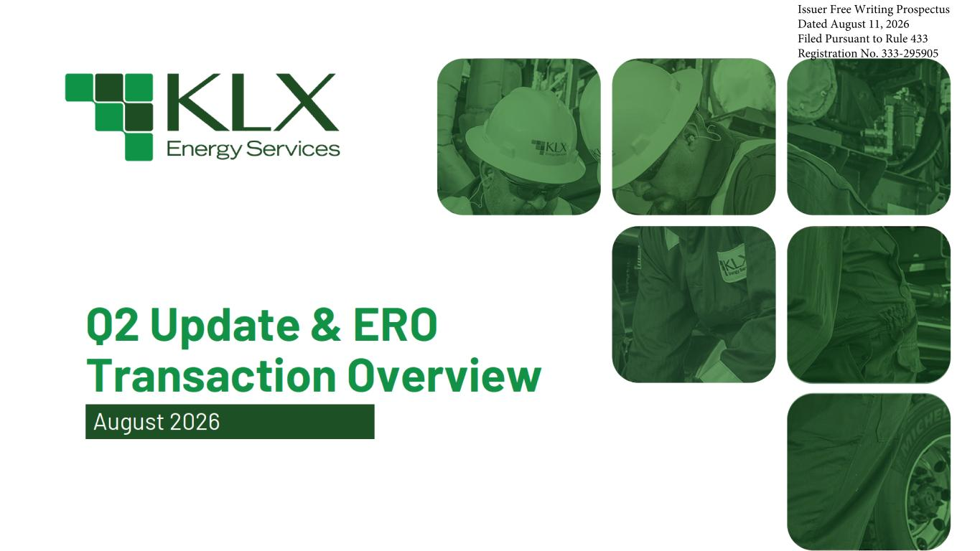
Issuer Free Writing Prospectus Dated August 11, 2026 Filed Pursuant to Rule 433 Registration No. 333-295905

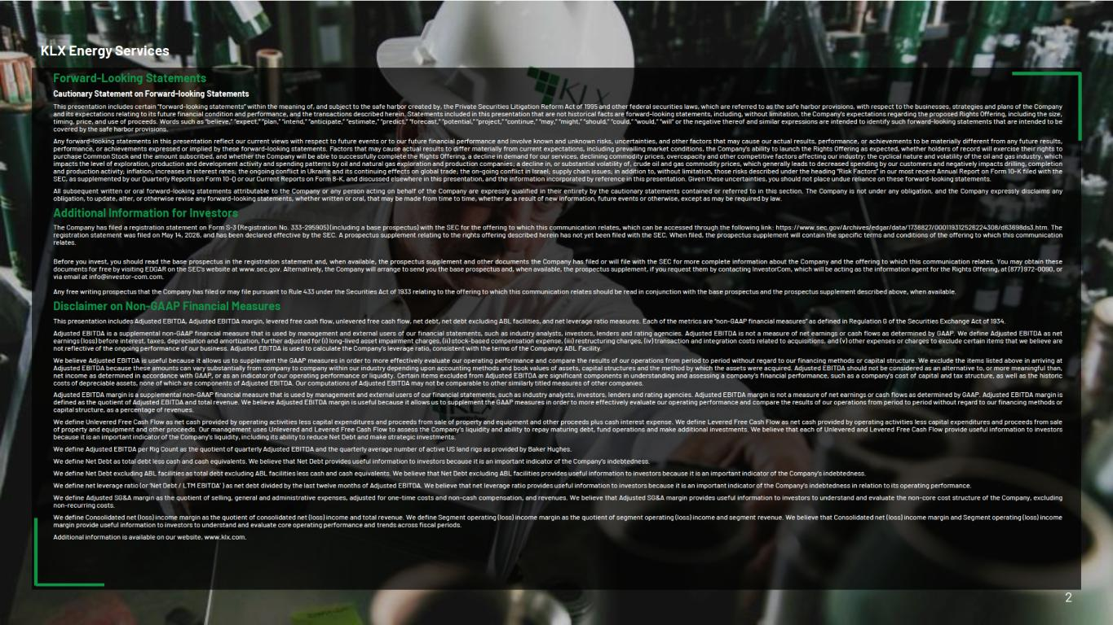

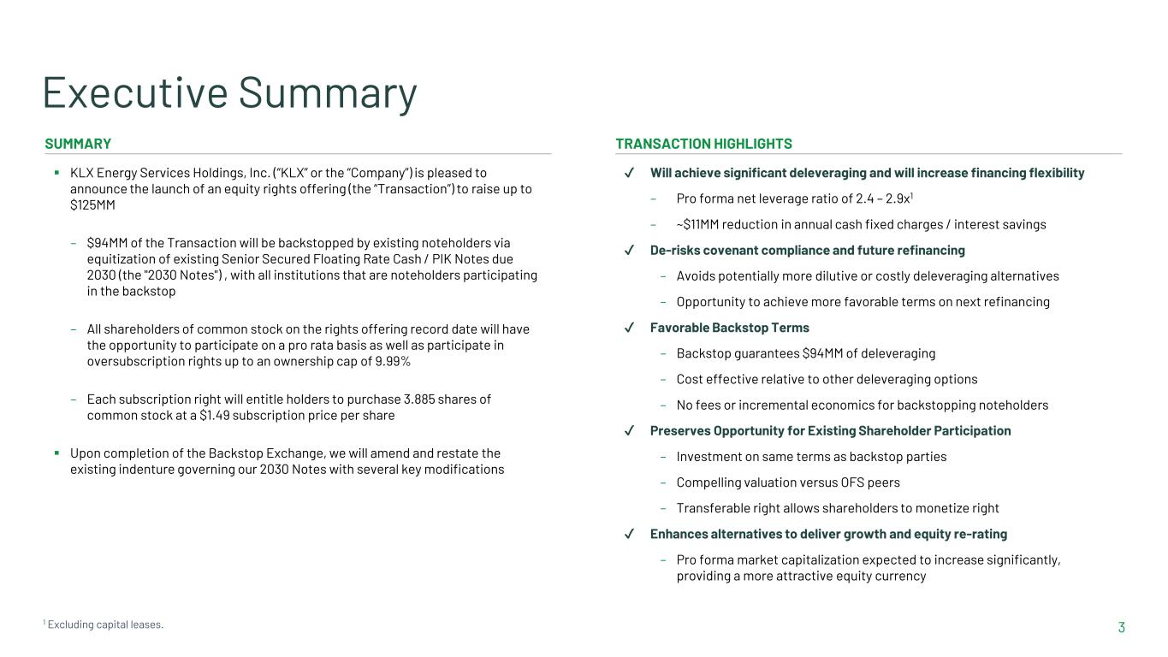
3 Executive Summary SUMMARY TRANSACTION HIGHLIGHTS ▪ KLX Energy Services Holdings, Inc. (“KLX” or the “Company”) is pleased to announce the launch of an equity rights offering (the “Transaction”) to raise up to $125MM – $94MM of the Transaction will be backstopped by existing noteholders via equitization of existing Senior Secured Floating Rate Cash / PIK Notes due 2030 (the "2030 Notes") , with all institutions that are noteholders participating in the backstop – All shareholders of common stock on the rights offering record date will have the opportunity to participate on a pro rata basis as well as participate in oversubscription rights up to an ownership cap of 9.99% – Each subscription right will entitle holders to purchase 3.885 shares of common stock at a $1.49 subscription price per share ▪ Upon completion of the Backstop Exchange, we will amend and restate the existing indenture governing our 2030 Notes with several key modifications ✔ Will achieve significant deleveraging and will increase financing flexibility – Pro forma net leverage ratio of 2.4 – 2.9x1 – ~$11MM reduction in annual cash fixed charges / interest savings ✔ De-risks covenant compliance and future refinancing – Avoids potentially more dilutive or costly deleveraging alternatives – Opportunity to achieve more favorable terms on next refinancing ✔ Favorable Backstop Terms – Backstop guarantees $94MM of deleveraging – Cost effective relative to other deleveraging options – No fees or incremental economics for backstopping noteholders ✔ Preserves Opportunity for Existing Shareholder Participation – Investment on same terms as backstop parties – Compelling valuation versus OFS peers – Transferable right allows shareholders to monetize right ✔ Enhances alternatives to deliver growth and equity re-rating – Pro forma market capitalization expected to increase significantly, providing a more attractive equity currency 1 Excluding capital leases.

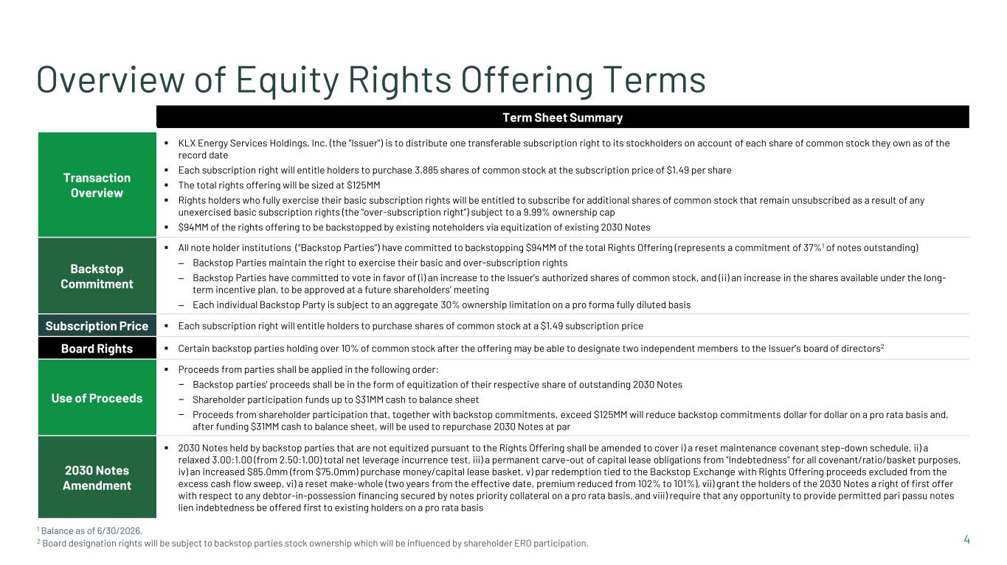
4 Overview of Equity Rights Offering Terms 1 Balance as of 6/30/2026. 2 Board designation rights will be subject to backstop parties stock ownership which will be influenced by shareholder ERO participation. Term Sheet Summary Transaction Overview ▪ KLX Energy Services Holdings, Inc. (the “Issuer”) is to distribute one transferable subscription right to its stockholders on account of each share of common stock they own as of the record date ▪ Each subscription right will entitle holders to purchase 3.885 shares of common stock at the subscription price of $1.49 per share ▪ The total rights offering will be sized at $125MM ▪ Rights holders who fully exercise their basic subscription rights will be entitled to subscribe for additional shares of common stock that remain unsubscribed as a result of any unexercised basic subscription rights (the “over-subscription right”) subject to a 9.99% ownership cap ▪ $94MM of the rights offering to be backstopped by existing noteholders via equitization of existing 2030 Notes Backstop Commitment ▪ All note holder institutions (“Backstop Parties”) have committed to backstopping $94MM of the total Rights Offering (represents a commitment of 37%1 of notes outstanding) – Backstop Parties maintain the right to exercise their basic and over-subscription rights – Backstop Parties have committed to vote in favor of (i) an increase to the Issuer’s authorized shares of common stock, and (ii) an increase in the shares available under the long- term incentive plan, to be approved at a future shareholders’ meeting – Each individual Backstop Party is subject to an aggregate 30% ownership limitation on a pro forma fully diluted basis Subscription Price ▪ Each subscription right will entitle holders to purchase shares of common stock at a $1.49 subscription price Board Rights ▪ Certain backstop parties holding over 10% of common stock after the offering may be able to designate two independent members to the Issuer’s board of directors2 Use of Proceeds ▪ Proceeds from parties shall be applied in the following order: − Backstop parties’ proceeds shall be in the form of equitization of their respective share of outstanding 2030 Notes − Shareholder participation funds up to $31MM cash to balance sheet − Proceeds from shareholder participation that, together with backstop commitments, exceed $125MM will reduce backstop commitments dollar for dollar on a pro rata basis and, after funding $31MM cash to balance sheet, will be used to repurchase 2030 Notes at par 2030 Notes Amendment ▪ 2030 Notes held by backstop parties that are not equitized pursuant to the Rights Offering shall be amended to cover i) a reset maintenance covenant step-down schedule, ii) a relaxed 3.00:1.00 (from 2.50:1.00) total net leverage incurrence test, iii) a permanent carve-out of capital lease obligations from "Indebtedness" for all covenant/ratio/basket purposes, iv) an increased $85.0mm (from $75.0mm) purchase money/capital lease basket, v) par redemption tied to the Backstop Exchange with Rights Offering proceeds excluded from the excess cash flow sweep, vi) a reset make-whole (two years from the effective date, premium reduced from 102% to 101%), vii) grant the holders of the 2030 Notes a right of first offer with respect to any debtor-in-possession financing secured by notes priority collateral on a pro rata basis, and viii) require that any opportunity to provide permitted pari passu notes lien indebtedness be offered first to existing holders on a pro rata basis

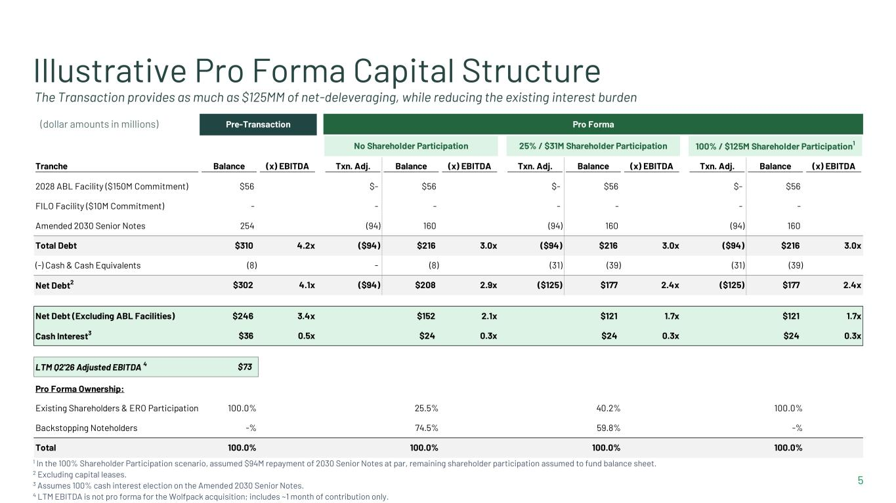
Pre-Transaction Pro Forma No Shareholder Participation 25% / $31M Shareholder Participation 100% / $125M Shareholder Participation1 Tranche Balance (x) EBITDA Txn. Adj. Balance (x) EBITDA Txn. Adj. Balance (x) EBITDA Txn. Adj. Balance (x) EBITDA 2028 ABL Facility ($150M Commitment) $56 $- $56 $- $56 $- $56 FILO Facility ($10M Commitment) - - - - - - - Amended 2030 Senior Notes 254 (94) 160 (94) 160 (94) 160 Total Debt $310 4.2x ($94) $216 3.0x ($94) $216 3.0x ($94) $216 3.0x (-) Cash & Cash Equivalents (8) - (8) (31) (39) (31) (39) Net Debt2 $302 4.1x ($94) $208 2.9x ($125) $177 2.4x ($125) $177 2.4x Net Debt (Excluding ABL Facilities) $246 3.4x $152 2.1x $121 1.7x $121 1.7x Cash Interest3 $36 0.5x $24 0.3x $24 0.3x $24 0.3x LTM Q2'26 Adjusted EBITDA 4 $73 Pro Forma Ownership: Existing Shareholders & ERO Participation 100.0% 25.5% 40.2% 100.0% Backstopping Noteholders -% 74.5% 59.8% -% Total 100.0% 100.0% 100.0% 100.0% 5 Illustrative Pro Forma Capital Structure The Transaction provides as much as $125MM of net-deleveraging, while reducing the existing interest burden (dollar amounts in millions) 1 In the 100% Shareholder Participation scenario, assumed $94M repayment of 2030 Senior Notes at par, remaining shareholder participation assumed to fund balance sheet. 2 Excluding capital leases. 3 Assumes 100% cash interest election on the Amended 2030 Senior Notes. 4 LTM EBITDA is not pro forma for the Wolfpack acquisition; includes ~1 month of contribution only.

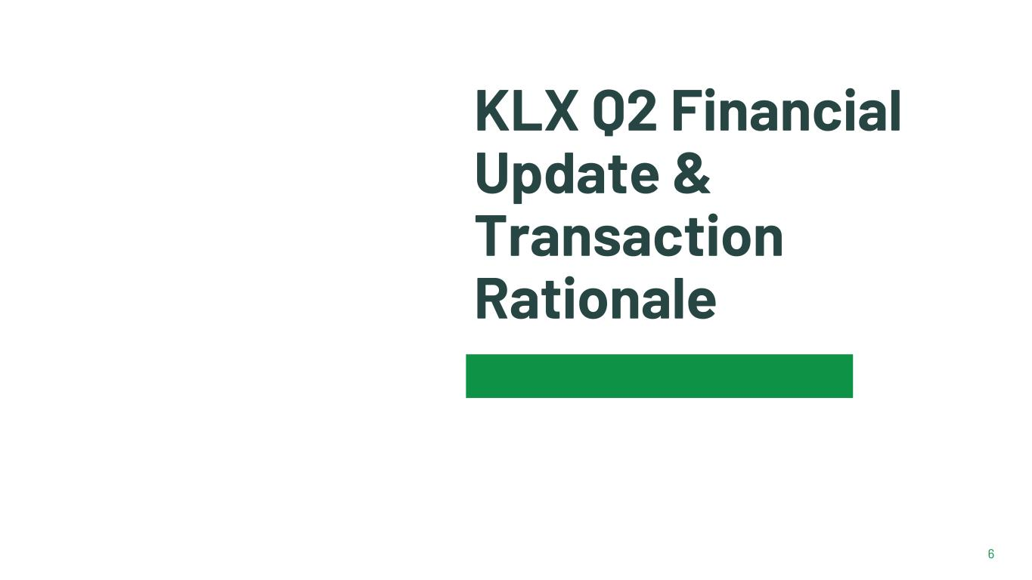
6 KLX Q2 Financial Update & Transaction Rationale

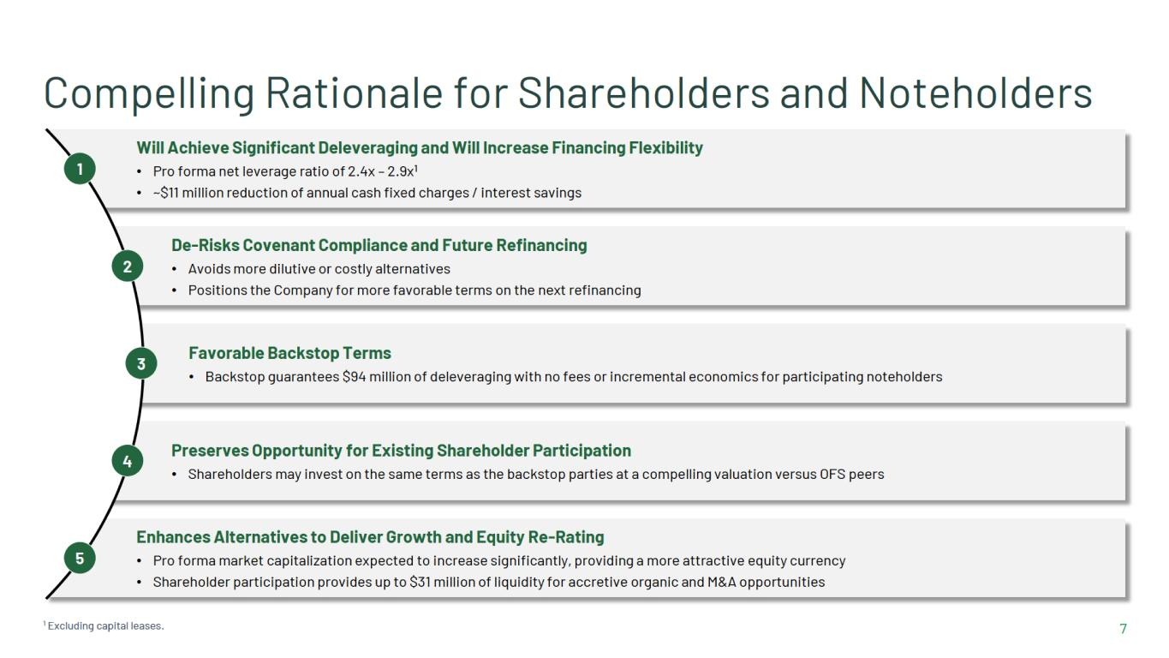

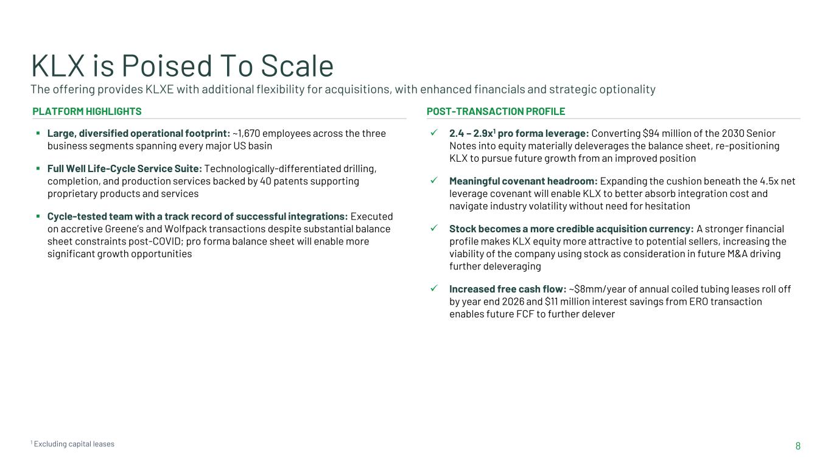
8 KLX is Poised To Scale The offering provides KLXE with additional flexibility for acquisitions, with enhanced financials and strategic optionality PLATFORM HIGHLIGHTS ▪ Large, diversified operational footprint: ~1,670 employees across the three business segments spanning every major US basin ▪ Full Well Life-Cycle Service Suite: Technologically-differentiated drilling, completion, and production services backed by 40 patents supporting proprietary products and services ▪ Cycle-tested team with a track record of successful integrations: Executed on accretive Greene’s and Wolfpack transactions despite substantial balance sheet constraints post-COVID; pro forma balance sheet will enable more significant growth opportunities POST-TRANSACTION PROFILE ✓ 2.4 – 2.9x1 pro forma leverage: Converting $94 million of the 2030 Senior Notes into equity materially deleverages the balance sheet, re-positioning KLX to pursue future growth from an improved position ✓ Meaningful covenant headroom: Expanding the cushion beneath the 4.5x net leverage covenant will enable KLX to better absorb integration cost and navigate industry volatility without need for hesitation ✓ Stock becomes a more credible acquisition currency: A stronger financial profile makes KLX equity more attractive to potential sellers, increasing the viability of the company using stock as consideration in future M&A driving further deleveraging ✓ Increased free cash flow: ~$8mm/year of annual coiled tubing leases roll off by year end 2026 and $11 million interest savings from ERO transaction enables future FCF to further delever 1 Excluding capital leases

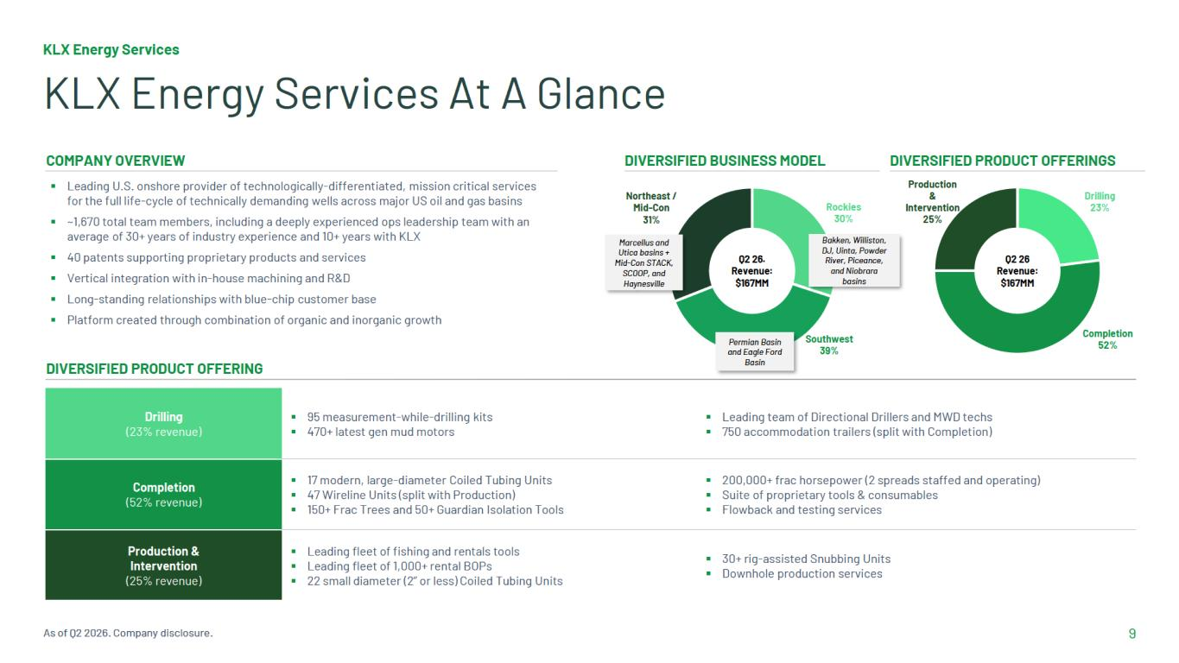

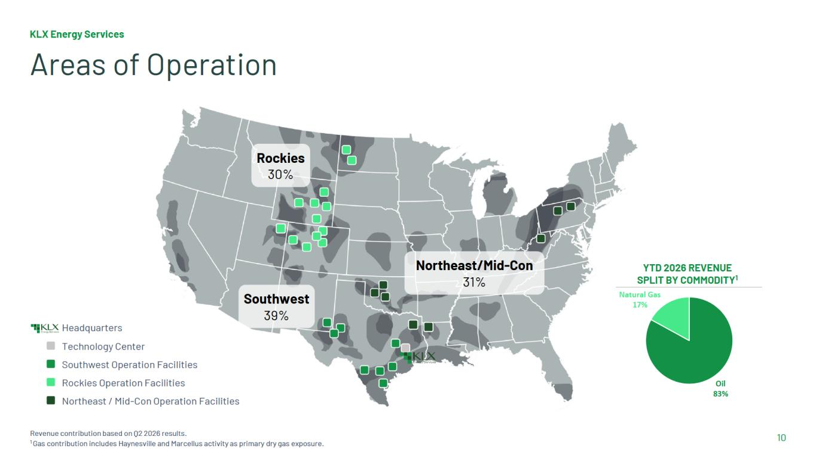

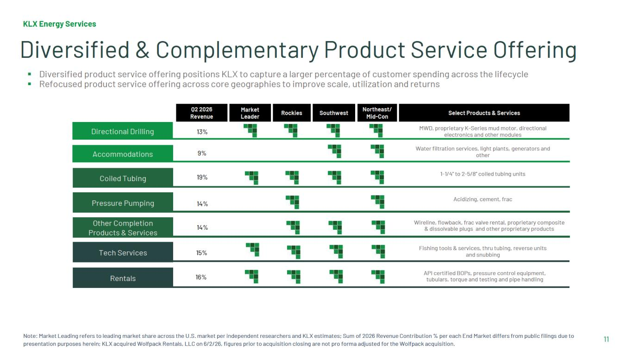

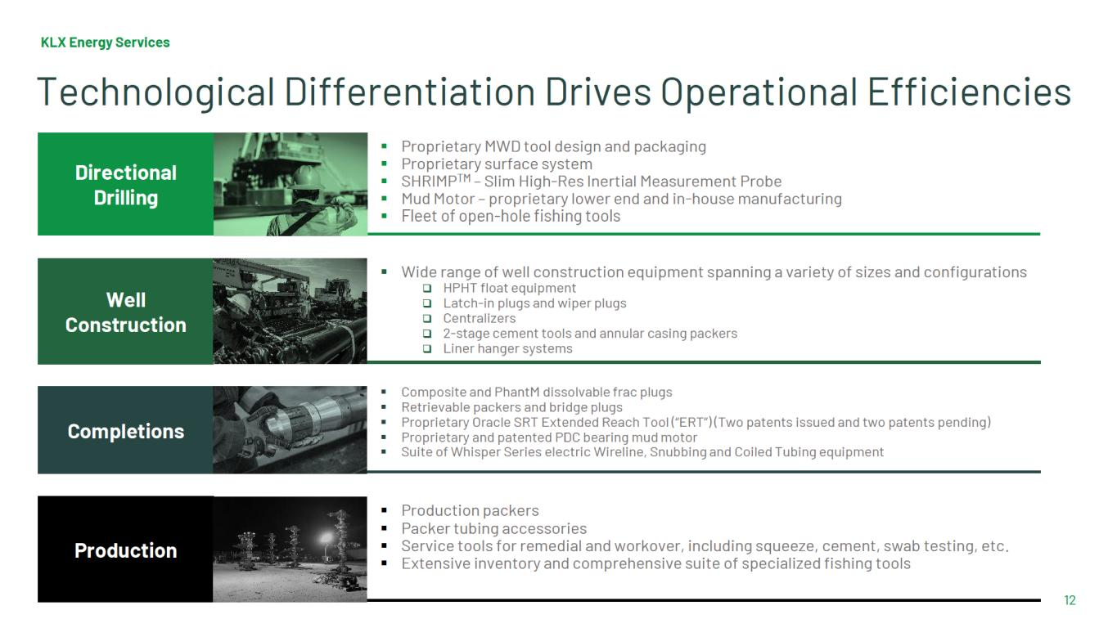

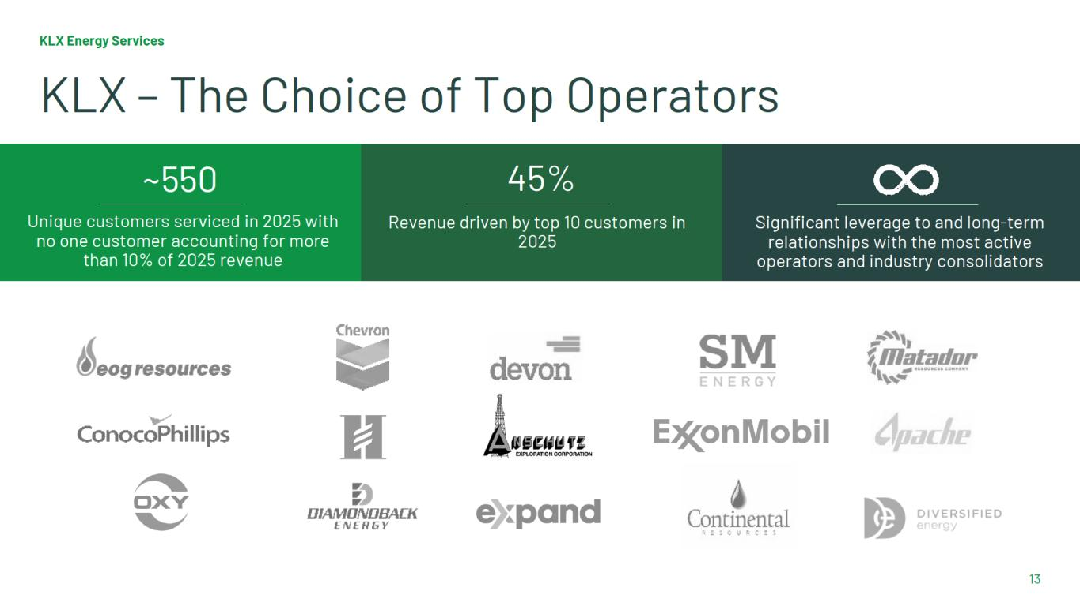

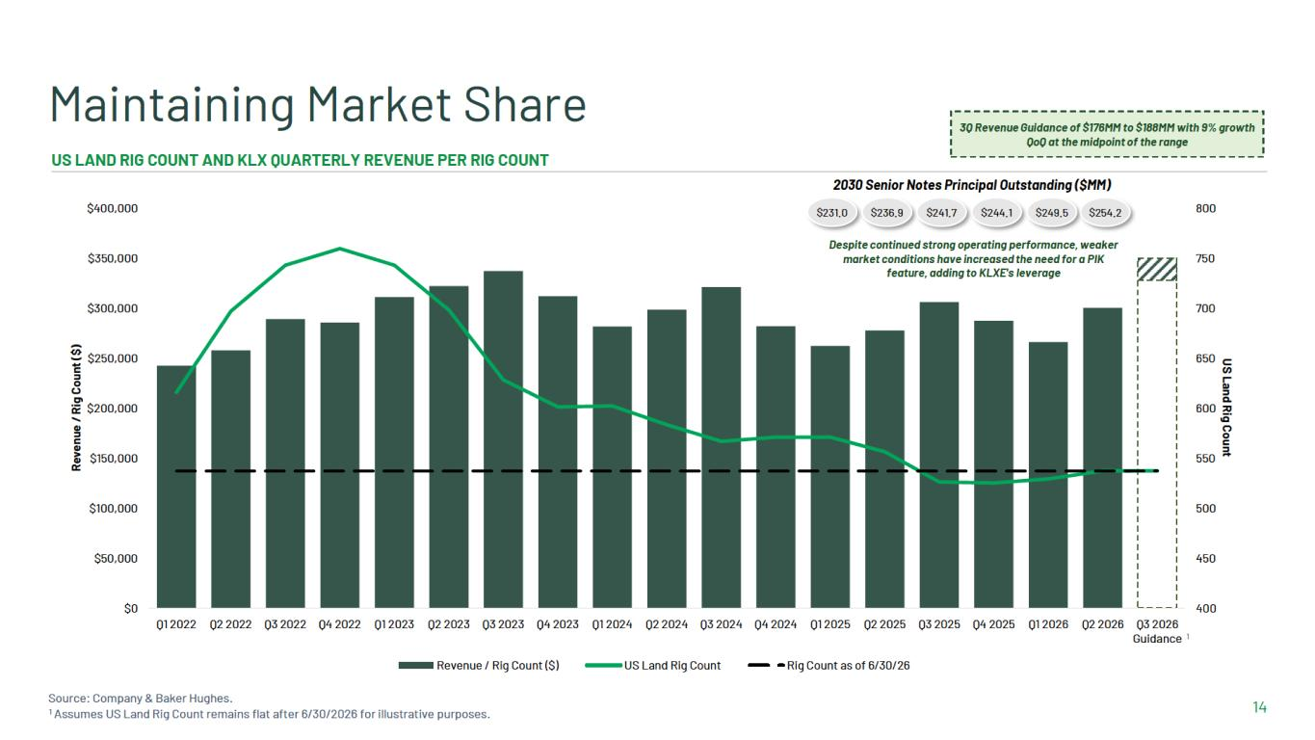

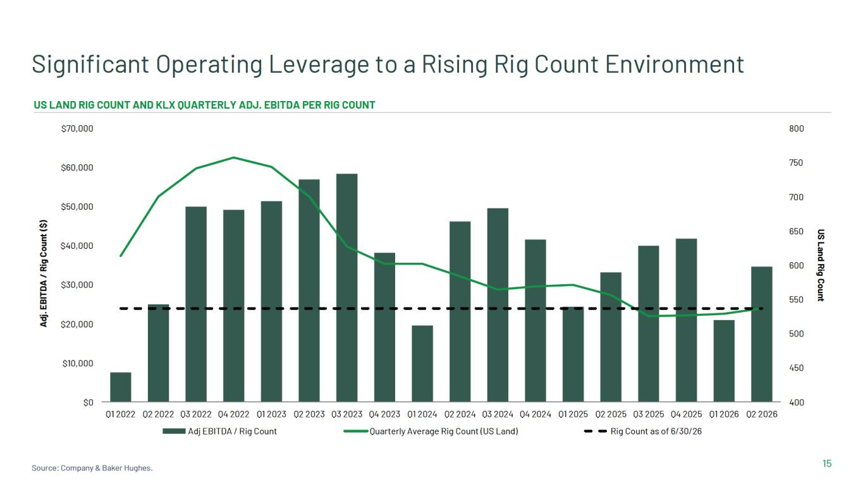

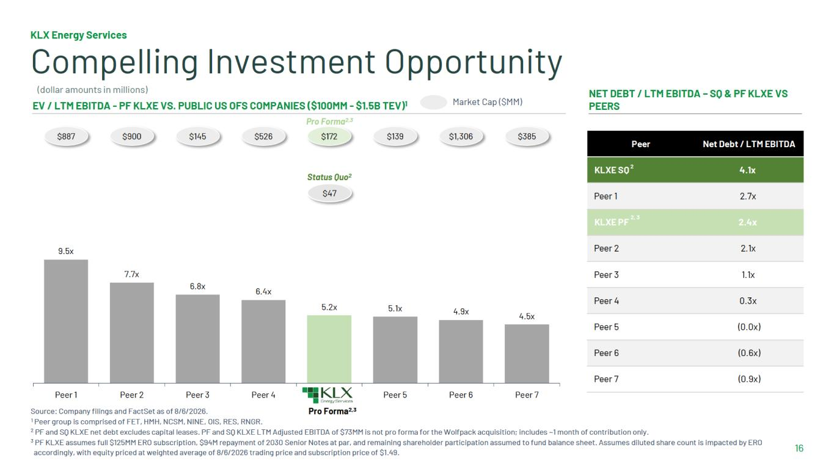

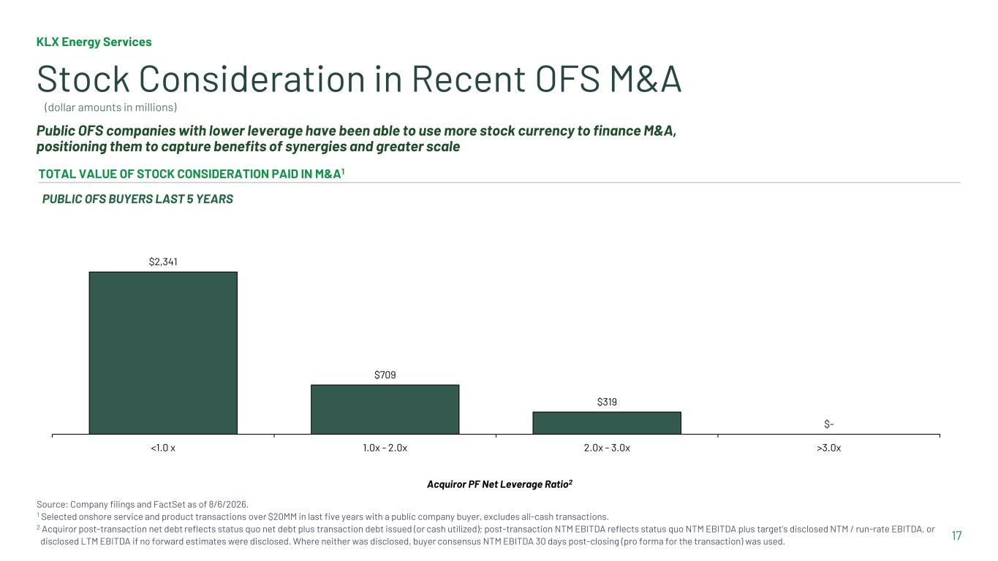
17 Stock Consideration in Recent OFS M&A TOTAL VALUE OF STOCK CONSIDERATION PAID IN M&A1 PUBLIC OFS BUYERS LAST 5 YEARS Public OFS companies with lower leverage have been able to use more stock currency to finance M&A, positioning them to capture benefits of synergies and greater scale Acquiror PF Net Leverage Ratio2 $2,341 $709 $319 $- <1.0 x 1.0x - 2.0x 2.0x - 3.0x >3.0x KLX Energy Services Source: Company filings and FactSet as of 8/6/2026. 1 Selected onshore service and product transactions over $20MM in last five years with a public company buyer, excludes all-cash transactions. 2 Acquiror post-transaction net debt reflects status quo net debt plus transaction debt issued (or cash utilized); post-transaction NTM EBITDA reflects status quo NTM EBITDA plus target’s disclosed NTM / run-rate EBITDA, or disclosed LTM EBITDA if no forward estimates were disclosed. Where neither was disclosed, buyer consensus NTM EBITDA 30 days post-closing (pro forma for the transaction) was used. (dollar amounts in millions)

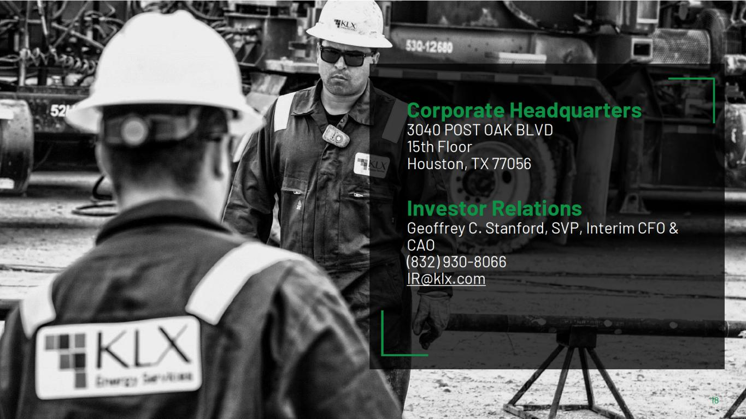

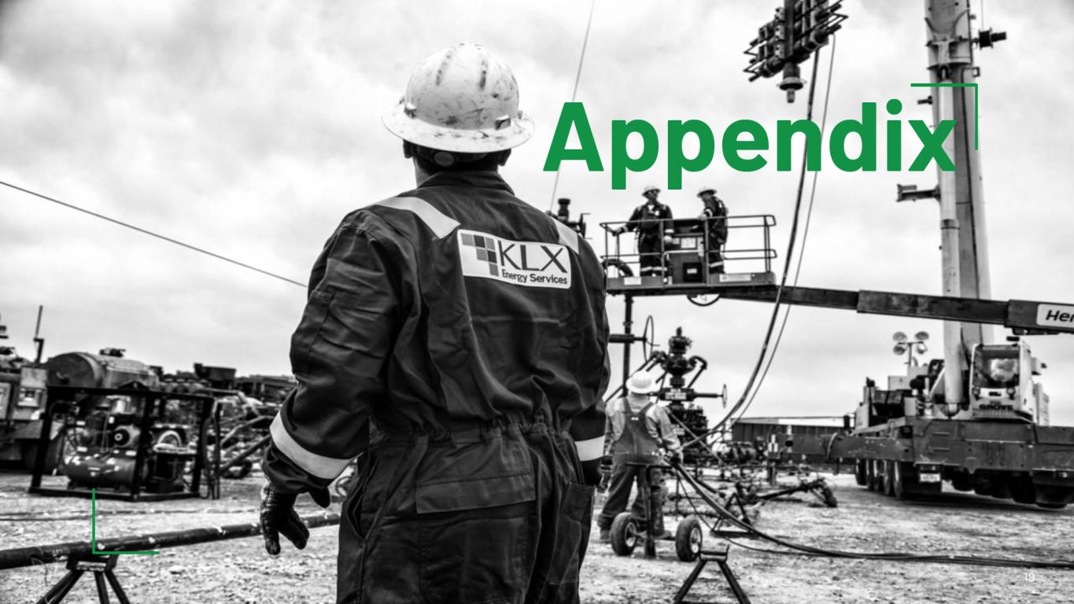

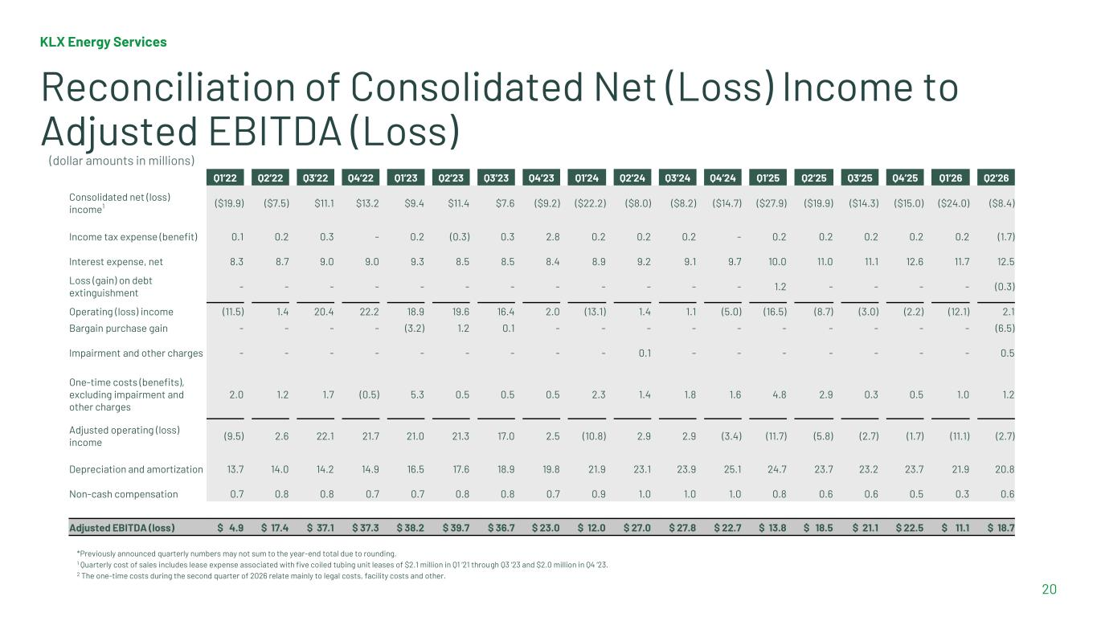
KLX Energy Services 20 Reconciliation of Consolidated Net (Loss) Income to Adjusted EBITDA (Loss) *Previously announced quarterly numbers may not sum to the year-end total due to rounding. 1 Quarterly cost of sales includes lease expense associated with five coiled tubing unit leases of $2.1 million in Q1 ‘21 through Q3 ‘23 and $2.0 million in Q4 ‘23. 2 The one-time costs during the second quarter of 2026 relate mainly to legal costs, facility costs and other. Q1’22 Q2’22 Q3’22 Q4’22 Q1’23 Q2’23 Q3’23 Q4’23 Q1’24 Q2’24 Q3’24 Q4’24 Q1’25 Q2’25 Q3’25 Q4’25 Q1’26 Q2’26 Consolidated net (loss) income1 ($19.9) ($7.5) $11.1 $13.2 $9.4 $11.4 $7.6 ($9.2) ($22.2) ($8.0) ($8.2) ($14.7) ($27.9) ($19.9) ($14.3) ($15.0) ($24.0) ($8.4) Income tax expense (benefit) 0.1 0.2 0.3 - 0.2 (0.3) 0.3 2.8 0.2 0.2 0.2 - 0.2 0.2 0.2 0.2 0.2 (1.7) Interest expense, net 8.3 8.7 9.0 9.0 9.3 8.5 8.5 8.4 8.9 9.2 9.1 9.7 10.0 11.0 11.1 12.6 11.7 12.5 Loss (gain) on debt extinguishment - - - - - - - - - - - - 1.2 - - - - (0.3) Operating (loss) income (11.5) 1.4 20.4 22.2 18.9 19.6 16.4 2.0 (13.1) 1.4 1.1 (5.0) (16.5) (8.7) (3.0) (2.2) (12.1) 2.1 Bargain purchase gain - - - - (3.2) 1.2 0.1 - - - - - - - - - - (6.5) Impairment and other charges - - - - - - - - - 0.1 - - - - - - - 0.5 One-time costs (benefits), excluding impairment and other charges 2.0 1.2 1.7 (0.5) 5.3 0.5 0.5 0.5 2.3 1.4 1.8 1.6 4.8 2.9 0.3 0.5 1.0 1.2 Adjusted operating (loss) income (9.5) 2.6 22.1 21.7 21.0 21.3 17.0 2.5 (10.8) 2.9 2.9 (3.4) (11.7) (5.8) (2.7) (1.7) (11.1) (2.7) Depreciation and amortization 13.7 14.0 14.2 14.9 16.5 17.6 18.9 19.8 21.9 23.1 23.9 25.1 24.7 23.7 23.2 23.7 21.9 20.8 Non-cash compensation 0.7 0.8 0.8 0.7 0.7 0.8 0.8 0.7 0.9 1.0 1.0 1.0 0.8 0.6 0.6 0.5 0.3 0.6 Adjusted EBITDA (loss) $ 4.9 $ 17.4 $ 37.1 $ 37.3 $ 38.2 $ 39.7 $ 36.7 $ 23.0 $ 12.0 $ 27.0 $ 27.8 $ 22.7 $ 13.8 $ 18.5 $ 21.1 $ 22.5 $ 11.1 $ 18.7 (dollar amounts in millions)

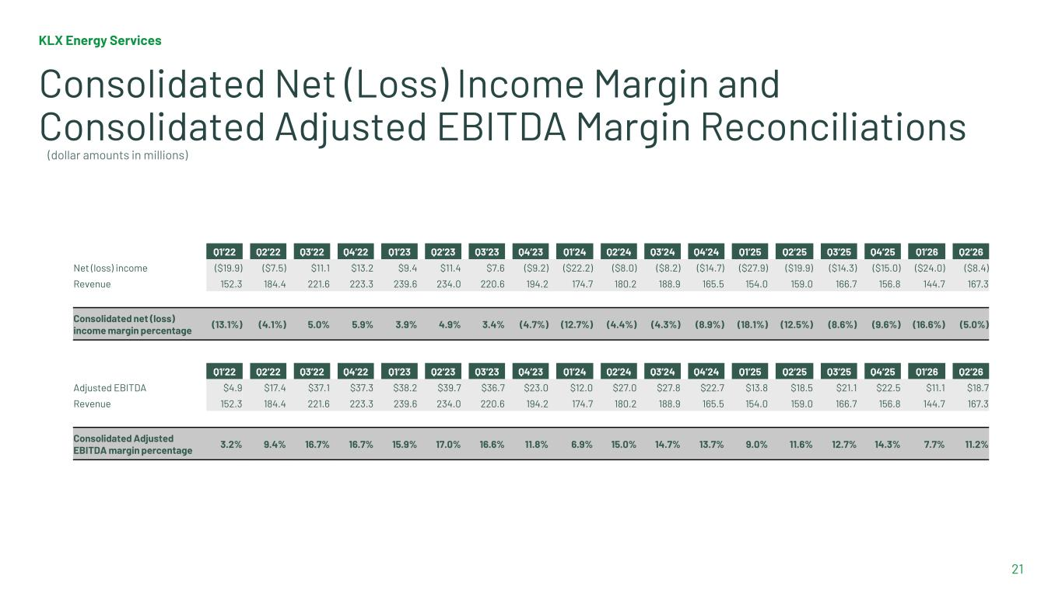
KLX Energy Services 21 Consolidated Net (Loss) Income Margin and Consolidated Adjusted EBITDA Margin Reconciliations Q1’22 Q2’22 Q3’22 Q4’22 Q1’23 Q2’23 Q3’23 Q4’23 Q1’24 Q2’24 Q3’24 Q4’24 Q1’25 Q2’25 Q3’25 Q4’25 Q1’26 Q2’26 Net (loss) income ($19.9) ($7.5) $11.1 $13.2 $9.4 $11.4 $7.6 ($9.2) ($22.2) ($8.0) ($8.2) ($14.7) ($27.9) ($19.9) ($14.3) ($15.0) ($24.0) ($8.4) Revenue 152.3 184.4 221.6 223.3 239.6 234.0 220.6 194.2 174.7 180.2 188.9 165.5 154.0 159.0 166.7 156.8 144.7 167.3 Consolidated net (loss) income margin percentage (13.1%) (4.1%) 5.0% 5.9% 3.9% 4.9% 3.4% (4.7%) (12.7%) (4.4%) (4.3%) (8.9%) (18.1%) (12.5%) (8.6%) (9.6%) (16.6%) (5.0%) Q1’22 Q2’22 Q3’22 Q4’22 Q1’23 Q2’23 Q3’23 Q4’23 Q1’24 Q2’24 Q3’24 Q4’24 Q1’25 Q2’25 Q3’25 Q4’25 Q1’26 Q2’26 Adjusted EBITDA $4.9 $17.4 $37.1 $37.3 $38.2 $39.7 $36.7 $23.0 $12.0 $27.0 $27.8 $22.7 $13.8 $18.5 $21.1 $22.5 $11.1 $18.7 Revenue 152.3 184.4 221.6 223.3 239.6 234.0 220.6 194.2 174.7 180.2 188.9 165.5 154.0 159.0 166.7 156.8 144.7 167.3 Consolidated Adjusted EBITDA margin percentage 3.2% 9.4% 16.7% 16.7% 15.9% 17.0% 16.6% 11.8% 6.9% 15.0% 14.7% 13.7% 9.0% 11.6% 12.7% 14.3% 7.7% 11.2% (dollar amounts in millions)

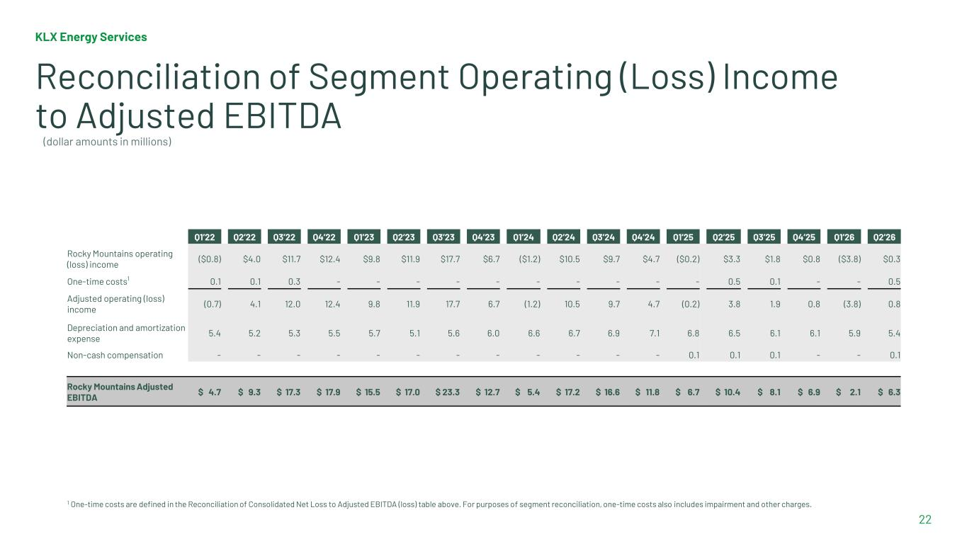
KLX Energy Services 22 Reconciliation of Segment Operating (Loss) Income to Adjusted EBITDA 1 One-time costs are defined in the Reconciliation of Consolidated Net Loss to Adjusted EBITDA (loss) table above. For purposes of segment reconciliation, one-time costs also includes impairment and other charges. Q1’22 Q2’22 Q3’22 Q4’22 Q1’23 Q2’23 Q3’23 Q4’23 Q1’24 Q2’24 Q3’24 Q4’24 Q1’25 Q2’25 Q3’25 Q4’25 Q1’26 Q2’26 Rocky Mountains operating (loss) income ($0.8) $4.0 $11.7 $12.4 $9.8 $11.9 $17.7 $6.7 ($1.2) $10.5 $9.7 $4.7 ($0.2) $3.3 $1.8 $0.8 ($3.8) $0.3 One-time costs1 0.1 0.1 0.3 - - - - - - - - - - 0.5 0.1 - - 0.5 Adjusted operating (loss) income (0.7) 4.1 12.0 12.4 9.8 11.9 17.7 6.7 (1.2) 10.5 9.7 4.7 (0.2) 3.8 1.9 0.8 (3.8) 0.8 Depreciation and amortization expense 5.4 5.2 5.3 5.5 5.7 5.1 5.6 6.0 6.6 6.7 6.9 7.1 6.8 6.5 6.1 6.1 5.9 5.4 Non-cash compensation - - - - - - - - - - - - 0.1 0.1 0.1 - - 0.1 Rocky Mountains Adjusted EBITDA $ 4.7 $ 9.3 $ 17.3 $ 17.9 $ 15.5 $ 17.0 $ 23.3 $ 12.7 $ 5.4 $ 17.2 $ 16.6 $ 11.8 $ 6.7 $ 10.4 $ 8.1 $ 6.9 $ 2.1 $ 6.3 (dollar amounts in millions)

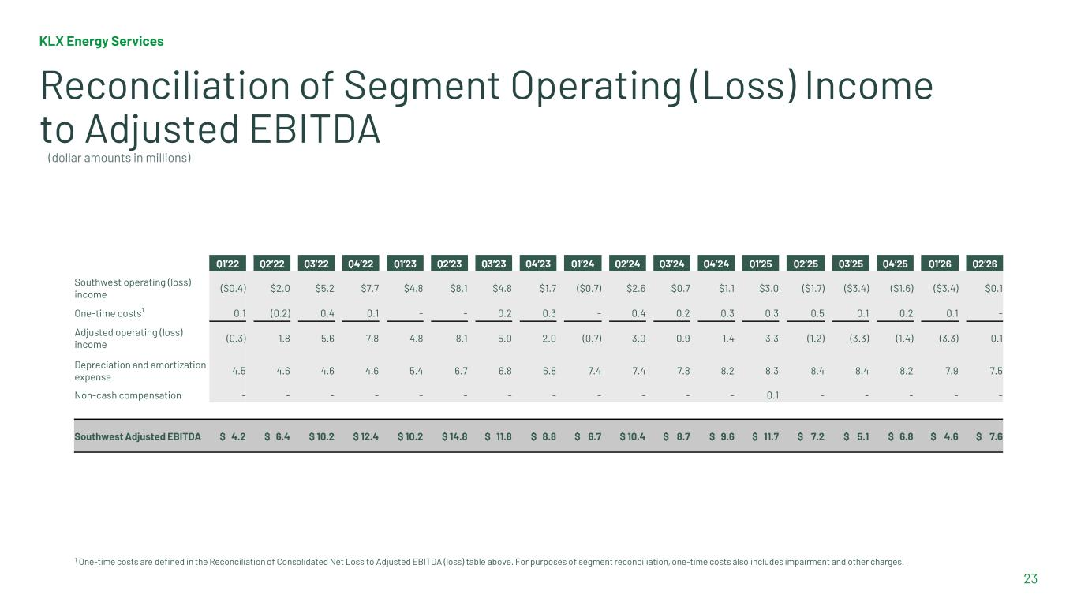
KLX Energy Services 23 Reconciliation of Segment Operating (Loss) Income to Adjusted EBITDA 1 One-time costs are defined in the Reconciliation of Consolidated Net Loss to Adjusted EBITDA (loss) table above. For purposes of segment reconciliation, one-time costs also includes impairment and other charges. Q1’22 Q2’22 Q3’22 Q4’22 Q1’23 Q2’23 Q3’23 Q4’23 Q1’24 Q2’24 Q3’24 Q4’24 Q1’25 Q2’25 Q3’25 Q4’25 Q1’26 Q2’26 Southwest operating (loss) income ($0.4) $2.0 $5.2 $7.7 $4.8 $8.1 $4.8 $1.7 ($0.7) $2.6 $0.7 $1.1 $3.0 ($1.7) ($3.4) ($1.6) ($3.4) $0.1 One-time costs1 0.1 (0.2) 0.4 0.1 - - 0.2 0.3 - 0.4 0.2 0.3 0.3 0.5 0.1 0.2 0.1 - Adjusted operating (loss) income (0.3) 1.8 5.6 7.8 4.8 8.1 5.0 2.0 (0.7) 3.0 0.9 1.4 3.3 (1.2) (3.3) (1.4) (3.3) 0.1 Depreciation and amortization expense 4.5 4.6 4.6 4.6 5.4 6.7 6.8 6.8 7.4 7.4 7.8 8.2 8.3 8.4 8.4 8.2 7.9 7.5 Non-cash compensation - - - - - - - - - - - - 0.1 - - - - - Southwest Adjusted EBITDA $ 4.2 $ 6.4 $ 10.2 $ 12.4 $ 10.2 $ 14.8 $ 11.8 $ 8.8 $ 6.7 $ 10.4 $ 8.7 $ 9.6 $ 11.7 $ 7.2 $ 5.1 $ 6.8 $ 4.6 $ 7.6 (dollar amounts in millions)

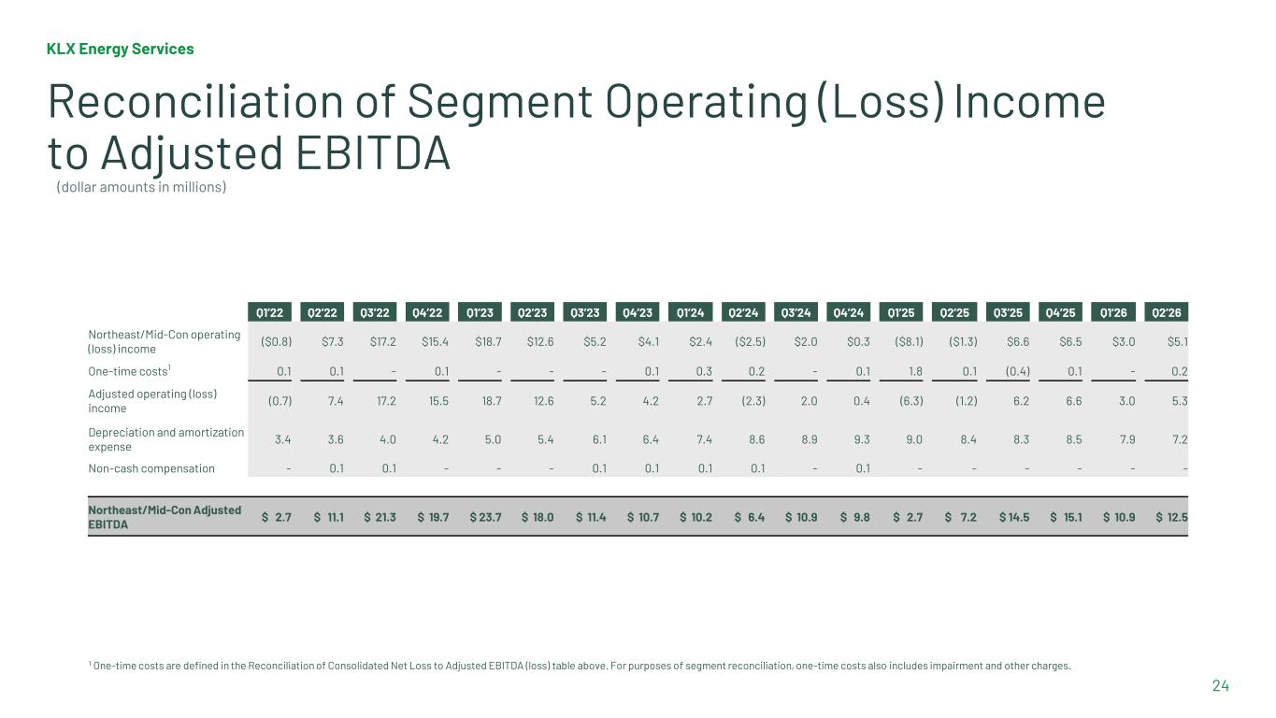
KLX Energy Services 24 Reconciliation of Segment Operating (Loss) Income to Adjusted EBITDA 1 One-time costs are defined in the Reconciliation of Consolidated Net Loss to Adjusted EBITDA (loss) table above. For purposes of segment reconciliation, one-time costs also includes impairment and other charges. Q1’22 Q2’22 Q3’22 Q4’22 Q1’23 Q2’23 Q3’23 Q4’23 Q1’24 Q2’24 Q3’24 Q4’24 Q1’25 Q2’25 Q3’25 Q4’25 Q1’26 Q2’26 Northeast/Mid-Con operating (loss) income ($0.8) $7.3 $17.2 $15.4 $18.7 $12.6 $5.2 $4.1 $2.4 ($2.5) $2.0 $0.3 ($8.1) ($1.3) $6.6 $6.5 $3.0 $5.1 One-time costs1 0.1 0.1 - 0.1 - - - 0.1 0.3 0.2 - 0.1 1.8 0.1 (0.4) 0.1 - 0.2 Adjusted operating (loss) income (0.7) 7.4 17.2 15.5 18.7 12.6 5.2 4.2 2.7 (2.3) 2.0 0.4 (6.3) (1.2) 6.2 6.6 3.0 5.3 Depreciation and amortization expense 3.4 3.6 4.0 4.2 5.0 5.4 6.1 6.4 7.4 8.6 8.9 9.3 9.0 8.4 8.3 8.5 7.9 7.2 Non-cash compensation - 0.1 0.1 - - - 0.1 0.1 0.1 0.1 - 0.1 - - - - - - Northeast/Mid-Con Adjusted EBITDA $ 2.7 $ 11.1 $ 21.3 $ 19.7 $ 23.7 $ 18.0 $ 11.4 $ 10.7 $ 10.2 $ 6.4 $ 10.9 $ 9.8 $ 2.7 $ 7.2 $ 14.5 $ 15.1 $ 10.9 $ 12.5 (dollar amounts in millions)

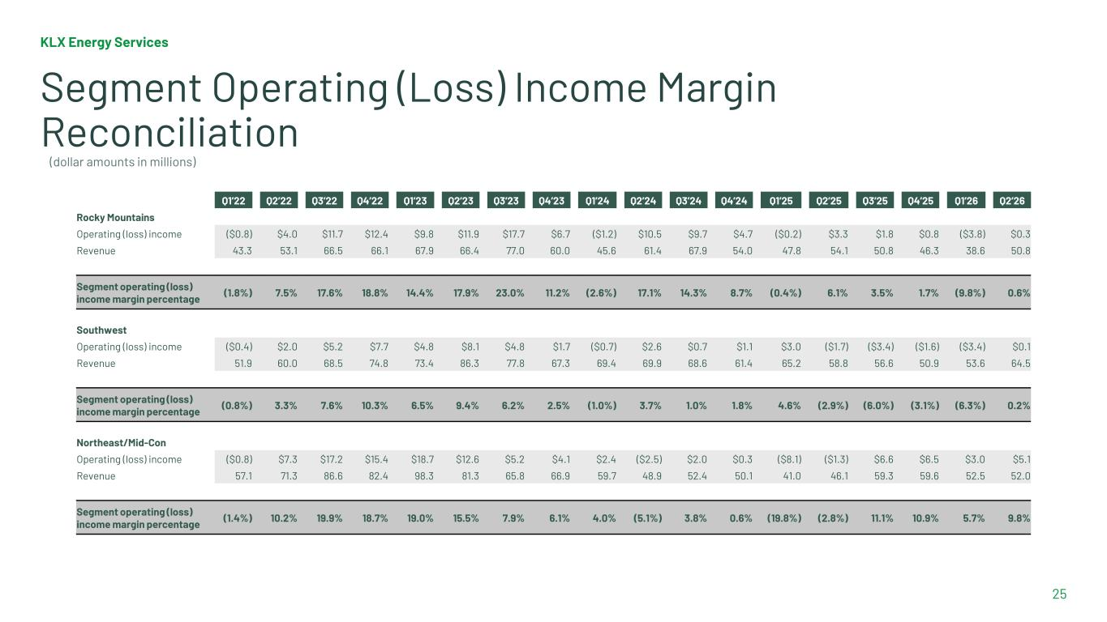
KLX Energy Services 25 Segment Operating (Loss) Income Margin Reconciliation Q1’22 Q2’22 Q3’22 Q4’22 Q1’23 Q2’23 Q3’23 Q4’23 Q1’24 Q2’24 Q3’24 Q4’24 Q1’25 Q2’25 Q3’25 Q4’25 Q1’26 Q2’26 Rocky Mountains Operating (loss) income ($0.8) $4.0 $11.7 $12.4 $9.8 $11.9 $17.7 $6.7 ($1.2) $10.5 $9.7 $4.7 ($0.2) $3.3 $1.8 $0.8 ($3.8) $0.3 Revenue 43.3 53.1 66.5 66.1 67.9 66.4 77.0 60.0 45.6 61.4 67.9 54.0 47.8 54.1 50.8 46.3 38.6 50.8 Segment operating (loss) income margin percentage (1.8%) 7.5% 17.6% 18.8% 14.4% 17.9% 23.0% 11.2% (2.6%) 17.1% 14.3% 8.7% (0.4%) 6.1% 3.5% 1.7% (9.8%) 0.6% Southwest Operating (loss) income ($0.4) $2.0 $5.2 $7.7 $4.8 $8.1 $4.8 $1.7 ($0.7) $2.6 $0.7 $1.1 $3.0 ($1.7) ($3.4) ($1.6) ($3.4) $0.1 Revenue 51.9 60.0 68.5 74.8 73.4 86.3 77.8 67.3 69.4 69.9 68.6 61.4 65.2 58.8 56.6 50.9 53.6 64.5 Segment operating (loss) income margin percentage (0.8%) 3.3% 7.6% 10.3% 6.5% 9.4% 6.2% 2.5% (1.0%) 3.7% 1.0% 1.8% 4.6% (2.9%) (6.0%) (3.1%) (6.3%) 0.2% Northeast/Mid-Con Operating (loss) income ($0.8) $7.3 $17.2 $15.4 $18.7 $12.6 $5.2 $4.1 $2.4 ($2.5) $2.0 $0.3 ($8.1) ($1.3) $6.6 $6.5 $3.0 $5.1 Revenue 57.1 71.3 86.6 82.4 98.3 81.3 65.8 66.9 59.7 48.9 52.4 50.1 41.0 46.1 59.3 59.6 52.5 52.0 Segment operating (loss) income margin percentage (1.4%) 10.2% 19.9% 18.7% 19.0% 15.5% 7.9% 6.1% 4.0% (5.1%) 3.8% 0.6% (19.8%) (2.8%) 11.1% 10.9% 5.7% 9.8% (dollar amounts in millions)

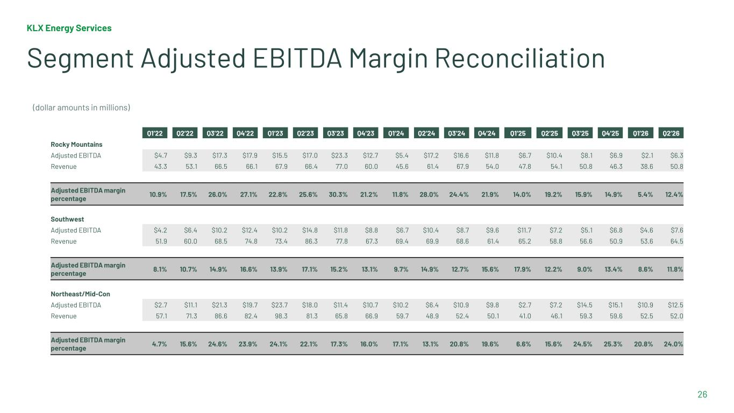
KLX Energy Services 26 Segment Adjusted EBITDA Margin Reconciliation Q1’22 Q2’22 Q3’22 Q4’22 Q1’23 Q2’23 Q3’23 Q4’23 Q1’24 Q2’24 Q3’24 Q4’24 Q1’25 Q2’25 Q3’25 Q4’25 Q1’26 Q2’26 Rocky Mountains Adjusted EBITDA $4.7 $9.3 $17.3 $17.9 $15.5 $17.0 $23.3 $12.7 $5.4 $17.2 $16.6 $11.8 $6.7 $10.4 $8.1 $6.9 $2.1 $6.3 Revenue 43.3 53.1 66.5 66.1 67.9 66.4 77.0 60.0 45.6 61.4 67.9 54.0 47.8 54.1 50.8 46.3 38.6 50.8 Adjusted EBITDA margin percentage 10.9% 17.5% 26.0% 27.1% 22.8% 25.6% 30.3% 21.2% 11.8% 28.0% 24.4% 21.9% 14.0% 19.2% 15.9% 14.9% 5.4% 12.4% Southwest Adjusted EBITDA $4.2 $6.4 $10.2 $12.4 $10.2 $14.8 $11.8 $8.8 $6.7 $10.4 $8.7 $9.6 $11.7 $7.2 $5.1 $6.8 $4.6 $7.6 Revenue 51.9 60.0 68.5 74.8 73.4 86.3 77.8 67.3 69.4 69.9 68.6 61.4 65.2 58.8 56.6 50.9 53.6 64.5 Adjusted EBITDA margin percentage 8.1% 10.7% 14.9% 16.6% 13.9% 17.1% 15.2% 13.1% 9.7% 14.9% 12.7% 15.6% 17.9% 12.2% 9.0% 13.4% 8.6% 11.8% Northeast/Mid-Con Adjusted EBITDA $2.7 $11.1 $21.3 $19.7 $23.7 $18.0 $11.4 $10.7 $10.2 $6.4 $10.9 $9.8 $2.7 $7.2 $14.5 $15.1 $10.9 $12.5 Revenue 57.1 71.3 86.6 82.4 98.3 81.3 65.8 66.9 59.7 48.9 52.4 50.1 41.0 46.1 59.3 59.6 52.5 52.0 Adjusted EBITDA margin percentage 4.7% 15.6% 24.6% 23.9% 24.1% 22.1% 17.3% 16.0% 17.1% 13.1% 20.8% 19.6% 6.6% 15.6% 24.5% 25.3% 20.8% 24.0% (dollar amounts in millions)

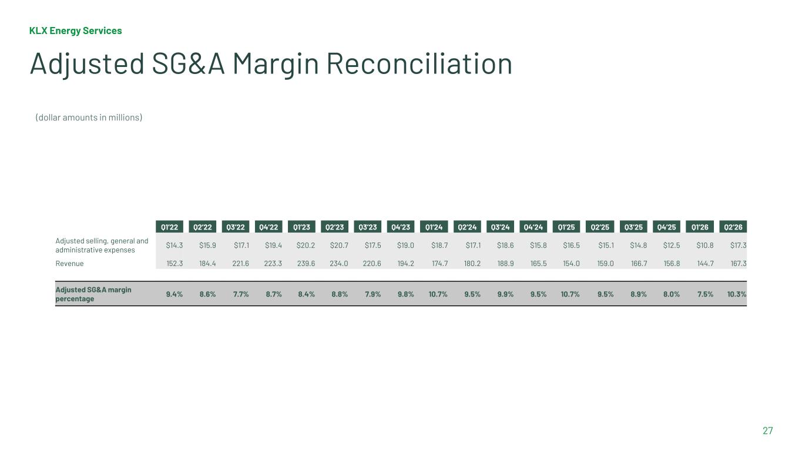
KLX Energy Services 27 Adjusted SG&A Margin Reconciliation Q1’22 Q2’22 Q3’22 Q4’22 Q1’23 Q2’23 Q3’23 Q4’23 Q1’24 Q2’24 Q3’24 Q4’24 Q1’25 Q2’25 Q3’25 Q4’25 Q1’26 Q2’26 Adjusted selling, general and administrative expenses $14.3 $15.9 $17.1 $19.4 $20.2 $20.7 $17.5 $19.0 $18.7 $17.1 $18.6 $15.8 $16.5 $15.1 $14.8 $12.5 $10.8 $17.3 Revenue 152.3 184.4 221.6 223.3 239.6 234.0 220.6 194.2 174.7 180.2 188.9 165.5 154.0 159.0 166.7 156.8 144.7 167.3 Adjusted SG&A margin percentage 9.4% 8.6% 7.7% 8.7% 8.4% 8.8% 7.9% 9.8% 10.7% 9.5% 9.9% 9.5% 10.7% 9.5% 8.9% 8.0% 7.5% 10.3% (dollar amounts in millions)

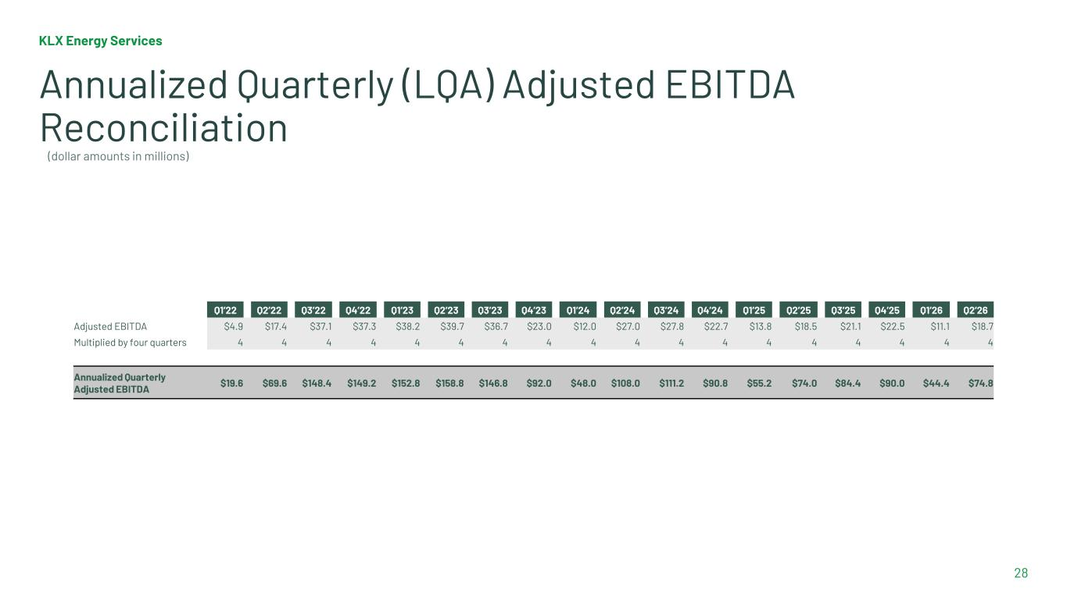
KLX Energy Services 28 Annualized Quarterly (LQA) Adjusted EBITDA Reconciliation Q1’22 Q2’22 Q3’22 Q4’22 Q1’23 Q2’23 Q3’23 Q4’23 Q1’24 Q2’24 Q3’24 Q4’24 Q1’25 Q2’25 Q3’25 Q4’25 Q1’26 Q2’26 Adjusted EBITDA $4.9 $17.4 $37.1 $37.3 $38.2 $39.7 $36.7 $23.0 $12.0 $27.0 $27.8 $22.7 $13.8 $18.5 $21.1 $22.5 $11.1 $18.7 Multiplied by four quarters 4 4 4 4 4 4 4 4 4 4 4 4 4 4 4 4 4 4 Annualized Quarterly Adjusted EBITDA $19.6 $69.6 $148.4 $149.2 $152.8 $158.8 $146.8 $92.0 $48.0 $108.0 $111.2 $90.8 $55.2 $74.0 $84.4 $90.0 $44.4 $74.8 (dollar amounts in millions)

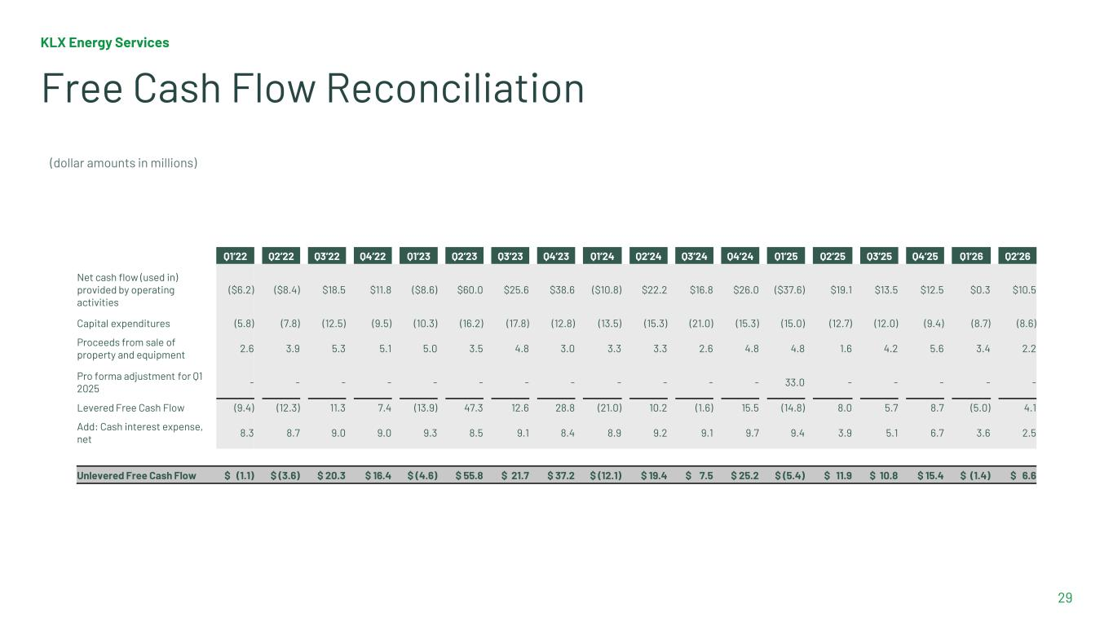
KLX Energy Services 29 Free Cash Flow Reconciliation Q1’22 Q2’22 Q3’22 Q4’22 Q1’23 Q2’23 Q3’23 Q4’23 Q1’24 Q2’24 Q3’24 Q4’24 Q1’25 Q2’25 Q3’25 Q4’25 Q1’26 Q2’26 Net cash flow (used in) provided by operating activities ($6.2) ($8.4) $18.5 $11.8 ($8.6) $60.0 $25.6 $38.6 ($10.8) $22.2 $16.8 $26.0 ($37.6) $19.1 $13.5 $12.5 $0.3 $10.5 Capital expenditures (5.8) (7.8) (12.5) (9.5) (10.3) (16.2) (17.8) (12.8) (13.5) (15.3) (21.0) (15.3) (15.0) (12.7) (12.0) (9.4) (8.7) (8.6) Proceeds from sale of property and equipment 2.6 3.9 5.3 5.1 5.0 3.5 4.8 3.0 3.3 3.3 2.6 4.8 4.8 1.6 4.2 5.6 3.4 2.2 Pro forma adjustment for Q1 2025 - - - - - - - - - - - - 33.0 - - - - - Levered Free Cash Flow (9.4) (12.3) 11.3 7.4 (13.9) 47.3 12.6 28.8 (21.0) 10.2 (1.6) 15.5 (14.8) 8.0 5.7 8.7 (5.0) 4.1 Add: Cash interest expense, net 8.3 8.7 9.0 9.0 9.3 8.5 9.1 8.4 8.9 9.2 9.1 9.7 9.4 3.9 5.1 6.7 3.6 2.5 Unlevered Free Cash Flow $ (1.1) $ (3.6) $ 20.3 $ 16.4 $ (4.6) $ 55.8 $ 21.7 $ 37.2 $ (12.1) $ 19.4 $ 7.5 $ 25.2 $ (5.4) $ 11.9 $ 10.8 $ 15.4 $ (1.4) $ 6.6 (dollar amounts in millions)



